Associations of early childhood body mass index trajectories with body composition and cardiometabolic markers at age 10 years: the Ethiopian iABC birth cohort study

Names of authors
Bikila S. Megersa^{1,2}, Gregers S. Andersen², Mubarek Abera³ , Alemseged Abdissa⁴, Beakal Zinab^{1,5}, Rahma Ali^{1,6}, Bitiya Admassu⁶, Elias Kedir⁷, Dorothea Nitsch⁸, Suzanne Filteau⁸, Tsinuel Girma⁹, Daniel Yilma¹⁰, Jonathan CK Wells¹¹, Henrik Friis¹, Rasmus Wibaek².
Author Affiliations
¹Department of Nutrition, Exercise and Sports, University of Copenhagen, Frederiksberg, Denmark
²Clinical Research, Steno Diabetes Center Copenhagen, Herlev, Denmark
³Department of Psychiatry, Faculty of Medical Sciences, Jimma University, Jimma, Ethiopia
⁴Armauer Hansen Research Institute, Addis Ababa, Ethiopia
⁵Department of Nutrition and Dietetics, Faculty of Public Health, Jimma University, Jimma, Ethiopia
⁶ Department of Population and Family Health, Jimma University, Jimma, Ethiopia
⁷Department of Radiology, Faculty of Medical Sciences, Jimma University, Jimma,
Ethiopia
⁸Faculty of Epidemiology and Population Health, London School of Hygiene and Tropical Medicine, London, United Kingdom
⁹Department of Pediatrics and Child Health, Faculty of Medical Sciences, Jimma University, Jimma, Ethiopia
¹⁰Department of Internal Medicine; Faculty of Medical Sciences, Jimma University, Jimma, Ethiopia
¹¹Childhood Nutrition Research Center, Population Policy and Practice Research and Teaching Department, UCL Great Ormond Street Institute of Child Health, London, United Kingdom

Abstract
Background: We have previously shown associations of rapid BMI growth in early childhood with adiposity and elevated cardiometabolic markers at 5 years. It is unknown how these associations track through later childhood, particularly in low-income settings.
Objectives: To assess associations of BMI trajectories from birth to 5 years with anthropometry, body composition, abdominal fat, and cardiometabolic markers at 10 years.
Methods: In the Ethiopian iABC birth cohort, we previously identified 4 distinct latent class trajectories based on BMI from birth to 5 years among 453 children: stable low BMI (19.2%), normal BMI (48.8%), rapid catch-up to high BMI (17.9%), and slow catch-up to high BMI (14.1%). In the current study, we obtained data from 320 children on anthropometry, body composition, abdominal fat, and cardiometabolic markers at age 10 years. Associations between the identified BMI trajectories and 10-year outcomes were analyzed using multiple linear regression.
Results: Compared to the normal BMI trajectory, rapid catch-up to high BMI had 1.71 cm (95%CI: 0.08, 3.34) larger waist circumference, and slow catch-up to high BMI had 0.63 kg/m² (95%CI: 0.09, 1.17) greater fat mass index and 0.19 cm (95%CI: 0.02, 0.37) greater abdominal subcutaneous fat, while stable low BMI had -0.28 kg/m² (95%CI: -0.59, 0.03) lower fat-free mass at 10 years. Furthermore, rapid catch-up to high BMI trajectory had 48.6% (95%CI: -1.4, 123.8) higher C-peptide, and slow catch-up to high BMI had 29.8% (95%CI: -0.8, 69.8) higher insulin and 30.3% (95%CI: -1.1, 71.6) higher HOMA-IR, whereas rapid catch-up had -0.23 mmol/L (95%CI: -0.47, 0.02) lower total cholesterol compared to the normal BMI trajectory. The trajectories were not associated with abdominal visceral fat, blood pressure, glucose, and other lipids at 10 years.
Conclusions: Children with rapid and slow catch-up to high BMI trajectories before 5 years showed higher measures of adiposity and markers of impaired glucose metabolism at 10 years of age.
Keywords: Body mass index trajectories, latent class trajectory modeling, fat mass, fat-free mass, subcutaneous fat, visceral fat, cardiometabolic markers.

Abstract word count = 308
Maximum word count = 300
Introduction
The increasing prevalence of childhood obesity is a major public health problem globally (1) and is an important predisposing factor for cardiovascular disease and type 2 diabetes in adulthood (2, 3). Several studies from high-income settings have reported associations of accelerated BMI growth in early childhood (0-5 years) with greater adiposity and cardiometabolic markers later in life (4-6). In middle-income countries, rapid weight gain in infancy and childhood has been associated with later lean mass rather than fat mass (7, 8). BMI is not a measure of body fatness, but it is a measure of weight relative to height (9). Therefore, faster BMI growth in childhood might indicate faster lean growth, fat growth or both depending on the child’s body composition (9, 10).
Studies have assessed body mass index (BMI) at a single point in time and related it to cardiometabolic risk factors in childhood (11, 12), and cardiometabolic diseases in adulthood (13-15). However, early childhood BMI growth trajectories better predicted later body composition and risk of obesity in childhood than a single-point time BMI measurement (6). Latent class trajectory modeling identifies subgroups of the study population with distinct growth patterns over time and helps to improve our understanding of relations between growth patterns and health outcomes (16, 17).
In high-income countries, associations of rapid BMI growth trajectories in early life with body composition and cardiometabolic risk track to later childhood or early adulthood (18, 19). There is, however, limited information on these associations from low- and middle-income countries (LMICs). Understanding how associations between rapid BMI growth in early childhood and cardiometabolic risk track to later childhood in LMICs is increasingly important to identify children at risk of cardiometabolic disease later in life and for providing timely intervention.
In the Ethiopian infant anthropometry and body composition (iABC) prospective birth cohort, we have previously identified four distinct BMI trajectories from birth to 5 years. In this cohort, children with rapid growth pattern in early childhood had larger body size, higher lean and fat mass, and concentrations of C-peptide and triglycerides compared to those reflected the average pattern BMI growth in the World Health Organization (WHO) growth standards up to 5 years of age (20). Thus, this study aimed to investigate associations of previously identified distinct BMI trajectories from birth to 5 years with anthropometry, body composition, abdominal subcutaneous and visceral fat, and cardiometabolic markers in Ethiopian children aged 10 years.
Methods
The iABC prospective birth cohort, based in Jimma town, Ethiopia, was established in December 2008. Participant selection and recruitment have previously been described in detail (21, 22). Briefly, mothers giving birth in the maternity ward of Jimma University Specialized Hospital, and their children were recruited within 48 hours after birth. Mother-child pairs were eligible based on the following criteria: living in Jimma town, healthy term (≥37 weeks of gestation) infant with a weight of ≥1,500 g, and without any medical complications and congenital malformations. From birth to 5 years of age the children were invited for a total of 12 visits (at birth, 1.5, 2.5, 3.5, 4.5, 6 months, 1, 1.5, 2, 3, 4, 5 years). As previously described (20), 4 distinct latent class trajectories were identified among 453 children who had at least 3 repeated measurements of weight and length/height from birth to 5 years. In this study, the previously identified BMI trajectories were used as categorical exposure variables.
We conducted the current follow-up visit from June 2019 to December 2020, when children were 7-12 years old, henceforth referred to as the 10-year follow-up. At the 10-year follow-up, mother/guardian-child pairs were invited for the visit with either a phone call or a home visit by the research team. We informed the mother/guardian-child pairs about the visit and data collection procedures including overnight fast. The trained research team collected the data at Jimma University Clinical and Nutrition Research Center (JUCAN). We studied the following outcomes at the 10-year follow-up: anthropometric measurements (height and waist circumference), body composition (fat mass index [FMI] and fat-free mass index [FFMI]), abdominal fat (subcutaneous and visceral), and cardiometabolic markers including blood pressure (systolic and diastolic), glucose metabolism (glucose, insulin, C-peptide, and homeostatic model assessment of insulin resistance [HOMA-IR]), lipids (total cholesterol, low-density lipoprotein cholesterol [LDL], high-density lipoprotein cholesterol [HDL], and triglycerides).
Anthropometric measurements from birth to 10 years
Weight and length/height were assessed at birth, 1.5, 2.5, 3.5, 4.5, 6 months, 1, 1.5, 2, 3, 4, 5 and 10 years of age. Length from birth up to 2 years was measured in the nearest 0.1 cm in a recumbent position using a Seca 416 Infantometer and height from 2-5 and at 10 years was measured in the standing position using a portable stadiometer (SECA, Hamburg, Germany) to the nearest 0.1 cm. Waist circumference was assessed in duplicate in standing position to the nearest 0.1 cm using non-stretchable measuring tape midway between the iliac crest and lowest costal margin above umbilicus and the average was used. Weight from birth to 6 months was assessed using an electronic scale attached to a PEA POD, an infant air displacement plethysmograph (ADP) (COSMED, Rome, Italy). Weight from 1 to 3 years was assessed to the nearest 0.1 kg using an electronic UNICEF scale (Seca, Hamburg, Germany), and from 4-5 and at 10 years using the attached electronic scale of the child/adult ADP instrument, the BOD POD. BMI in kg/m² was calculated by dividing weight in kilogram (kg) by length/height in meter (m) squared. BMI z-score at 10 years was calculated using the WHO 2007 AnthroPlus R package (version 0.9.0) (23, 24). Stunting was defined as height-for-age z-score <-2, wasting/thinness if BMI-for-age z-score <-2 and overweight/obese if BMI-for-age z-score >1.
Body composition measurement at 10 years
The research nurses calibrated the BOD POD every morning using a cylinder of standard volume before starting the actual body composition assessment. Before the ADP measurement, the child was asked to take off all his/her clothes and were provided tightly fitted underwear pants and a swimming cap to displace accumulated air in the hair (25). Fat mass (FM) and fat-free mass (FFM) were calculated using Archimedes principle using manufacturers’ equations (21). FMI and FFMI were calculated as FM (kg) or FFM (kg) divided by height in meters (m) squared (26).
Abdominal fat measurement at 10 years
An experienced radiologist measured abdominal subcutaneous and visceral fat using ultrasound following a standard protocol (27, 28). The measurements were performed in supine position using linear array probe 11MHz for subcutaneous adipose tissue and convex array probe 3.5MHz for visceral adipose tissue (GE Logic, Boston, America). The radiologist kept the probe on the upper median abdomen perpendicular to skin and performed an axial scan in the midpoint between the xiphoid appendix and the navel along the linea alba. Children were instructed to inhale deeply, exhale fully, and then hold their breath for a short period of time while the radiologist adjusted the image for the measurements. Abdominal subcutaneous fat was measured as the depth (cm) from the inner edge of the skin to outer edge of linea alba and visceral fat as the distance (cm) from the peritoneum to the front of lumbar spine.
Blood pressure measurement at 10 years
Research nurses measured blood pressure (in mmHg) using size-appropriate cuffs (Riester, Big Ben round, CE0124) after the child rested sitting for 5 minutes, with arm resting at the chest level. The measurements were performed in duplicate and the average value used.
Clinical biomarkers assessment at 10 years
An experienced laboratory technician collected overnight-fast intravenous blood sample from the antecubital fossa. Blood glucose concentration was measured in whole blood using the HemoCue Glucose 201 RT System (HemoCue, Ängelholm, Sweden) immediately after collecting blood. Fasting serum was obtained after centrifuging whole blood at 1107 g force (relative centrifugal force) for 10 minutes. The centrifuged samples were divided into a minimum of 3x0.3 mL aliquots and stored at -80°C prior to analysis. The samples were analyzed at Jimma University Specialized Hospital, Clinical Chemistry Unit. Insulin (μU/mL) and C-peptide (ng/mL) concentrations were measured using module e601 of the Cobas 6000 analyzer (Roche Diagnostics International Ltd., Rotkreuz, Switzerland), and concentrations of lipids (total, HDL, and LDL cholesterol, and triglycerides) in mmol/L were determined using module c501 of Cobas 600. We calculated the HOMA-IR as insulin (µU/mL) x glucose (mmoL/L)/22.5 (29).
Covariates
An interviewer-administered structured questionnaire was used to obtain information on maternal and child sociodemographic characteristics within 48 hours after delivery including maternal age, highest educational status, and family wealth status. Trained research nurses calculated child gestational age using the Ballard score (30). After obtaining information on household’s ownership of certain assets, family economic status was assessed using an International Wealth Index (IWI) (31). Maternal anthropometric measurements were performed within 48 hours of delivery. Maternal height was assessed to the nearest 0.1 cm using a SECA 214 stadiometer (SECA, Hamburg, Germany), and weight was assessed to the nearest 0.1 kg using the scale of the Tanita 418 Bioimpedance analyzer (Tanita Corp., US). Breastfeeding status was assessed between 4 and 6 months using a structured questionnaire and categorized based on the WHO classification as 1) exclusively breastfed (only breast milk with exception of vitamins, mineral supplements, or medications), 2) predominantly breastfed (breast milk is the predominant source of food, but vitamin and/or mineral supplements, water and water-based drinks, and fruit juice are allowed, and 3) partially breastfed (breast milk and solid or semi-solid food) or not breastfed (32).
Statistical analyses
BMI trajectories in early childhood
As previously described (20), we applied latent class trajectory modeling among 453 children who had at least 3 repeated measurements of weight and length/height from birth to 5 years (at birth, 1.5 to 6 months, and 1-5 years) (Supplementary Figure 1). The figure is already reported (20) and is included in supplementary material for information. Several models with different specifications of BMI as a function of age and number of subgroups (latent classes) were tested. The optimal number of trajectory classes was determined based on Bayesian Information Criterion (BIC), mean posterior probability of class membership (>70% in each class), class sizes (at least 5% of the participants in each identified trajectory class), and the adequacy of the selected model to address the research question (17, 33, 34). We ensured that average group membership probabilities for individuals in each class was above 80%. The trajectory classes for males and females were similar (20), so the trajectories were developed for both sexes combined. A 4-class trajectory model specified with natural cubic splines with internal knot points at 3, 6, 24, 48 months and boundary knot points at 0 and 60 months was identified as the best fitting model. The trajectories were stable low BMI (19.2%), normal BMI (48.8%), rapid catch-up to high BMI (17.9%), and slow catch-up to high BMI (14.1%). The patterns of BMI growth changes were mainly observed in the first 24 months, and from 48-month onwards they were almost similar (Supplementary Figure 1).
Descriptive analyses
Maternal and child characteristics were described across the trajectories using mean (standard deviation [SD]) for continuous normally distributed variables, median (interquartile range [IQR]) for skewed variables, and frequencies (n) and percentages (%) for categorical variables. Differences between trajectories were examined by one-way ANOVA F-test for continuous normally distributed variables, Kruskal-Wallis test for continuous skewed variables, Pearson’s chi-squared test for categorical variables if expected counts were >4, otherwise Fisher’s exact test was used. Significance level was a P value <0.05. Data were analyzed using R statistical software version 4.2.2 (R Foundation for Statistical Computing).
Associations of BMI trajectories with the 10-year outcomes
Associations between categorical exposure variables (latent BMI trajectories from birth 5 years) and the continuous outcomes at 10 years were analyzed using multiple linear regression. The Normal BMI trajectory which most closely reflected the average pattern in the WHO BMI growth standards in early childhood and had the highest proportion of children was selected as the reference group for the regression analysis. We tested all models for the assumptions of linear regression visually by histograms, normal distribution of residuals, and homoscedasticity. We observed a slightly skewed distribution for the outcomes including insulin, C-peptide, HOMA-IR, and triglycerides, so these were log-transformed prior to analysis. Models were adjusted for potential confounding variables in models 1-3 to assess whether the effect estimates of the exposure variables changed. All potential confounders included in models 1-3 were identified a priori from the literature (6, 35, 36). In model 4, we further adjusted for body size measurements at the 10-year follow-up (variables on the causal pathway) to assess the direct effect of the trajectories on the outcomes (35). Model 1 was adjusted for child’s sex and exact age at the 10-year follow-up visit. Model 2 was additionally adjusted for the child’s birth order, gestational age at birth, maternal age at delivery, maternal height, maternal highest educational status, and family socioeconomic status (wealth index). Model 3 which is considered as the main model in this study was further adjusted for birth weight to assess the associations of the BMI trajectories with the outcomes independent of the effect of prenatal growth. In model 4, we adjusted all outcomes for current BMI, except for FFMI which was adjusted for FMI, and waist circumference, FMI, and abdominal subcutaneous and visceral fat which were adjusted for current FFMI. The adjustment of FMI for the FFMI controlled for the fat component of BMI, whereas the adjustment of the adiposity outcomes for the FFMI controlled for the lean component of BMI.
Because FMI is a better capture of fatness than BMI (7, 8), in a sensitivity analysis we adjusted cardiometabolic outcomes for current FMI instead of BMI in model 4. In a sensitivity analysis we adjusted cardiometabolic outcomes for current FMI instead of BMI in model 4. In addition, we evaluated whether the associations between the trajectories and 10-year outcomes were modified by sex by including sex interaction terms in the regression models and observed no significant interactions between the trajectories and sex. Therefore, all the analyses were performed for both sexes combined. In addition to the main adjustments, we further accounted for breastfeeding status at 4-6 months in sensitivity analysis among 270 children having the data. Moreover, we performed sensitivity analysis controlling for multiple testing using Benjamini-Hochberg method in the final models (37). Regression analyses were performed as complete case analyses, only children with complete data on all covariates were included in the regression model.
Ethical consideration.
We obtained ethical clearance from the research ethics review board (RERB) of the College of Public Health and Medical Sciences of Jimma University, Ethiopia (RERB reference number: IHRPHD/333/18) and the ethics committee of the London School of Hygiene and Tropical Medicine (reference number: 15976). Prior to participation, written informed consent for participation was obtained from the mother/guardian of the child. Child assent was also obtained verbally after explaining about the study and data collection procedure in local language. Any child with serious medical condition was referred to the Pediatric Unit of Jimma University Specialized Hospital for further examination and treatment.

Results
Of 571 children included in the prospective birth cohort, 320 children attended the 10-year follow-up and 313 with complete data on all covariates were included in the regression analysis (Figure 1). Children who attended the 10-year follow-up had higher mean maternal age (24.7 vs 23.6 years; P=0.003), birth weight (3.1 vs 3.0 kg; p=0.006), and FFM (2.85 vs 2.77 kg/m²; P=0.007) compared to those who did not attend (Supplementary Table 1). There was no difference in maternal characteristics at delivery and child characteristics at birth and in infancy across the 4 trajectories (Table 1). Mean (SD) gestational age of the children was 39.0 (0.9) and 166 of children (51.9%) were male. Between 4 and 6 months, most children 227 (83.5%) were predominantly breastfed (Table 1).
Table 2 describes child anthropometry, body composition, abdominal fat, and cardiometabolic markers at the 10-year follow-up by trajectories. Mean age of the children at the 10-year follow-up was 9.8 (1.0) years. Children in slow catch-up to high BMI trajectory had the highest mean BMI z-score (-0.27; P <0.001) at 10 years. Based on the WHO growth standards, 27 (8.4%) of the children were stunted, 38 (11.9%) wasted, and 26 (8.1%) overweight/obese at 10 years of age. As expected, children in stable low BMI had the lowest mean waist circumference (54.3 cm), FMI (2.7 kg/m²), and FFMI (12.1 kg/m²) compared to the other trajectories (all P-values <0.05) (Table 2). Supplementary Table 2 describes child parameters for the total sample and based on sex at 10 years.

Mother-child pairs assessed at birth: n = 644
Included in the follow-up study: n= 571
Included in the regression model: n = 313
Attended the 10-year follow-up: n = 320
Not having at least 3 repeated weight and length/height measurements (at birth, 1.5 to 6 months, 1-5 years): n =118
Incomplete data on all covariates: n = 7
Preterm birth (<37 weeks of gestation): n = 10
Not living in Jimma town: n = 63
Included in 0- 5 years BMI trajectory modeling: n = 453 (total BMI measurements: n = 3952)
Not attending 10-year follow-up: n = 133

Figure 1 Flow diagram of the study participants

Table 1 Maternal and child characteristics according to BMI trajectories from birth to 5 years (n = 320)¹
 | Stable low BMI,  n=65 | Normal BMI,  n=153 | Rapid catch-up to  high BMI, n=56 | Slow catch-up to  high BMI, n=46 | P value² | Missing, n
Maternal characteristics after delivery
Age (years) | 25.4 (4.6) | 24.6 (4.6) | 24.1 (4.5) | 24.8 (5.5) | 0.53 | 1
Height (cm) | 157.4 (5.5) | 158.1 (5.9) | 157.7 (5.5) | 156.5 (6.3) | 0.42 | 3
Weight (kg) | 54.9 (8.7) | 56.8 (9.1) | 57.0 (9.7) | 58.8 (11.1) | 0.37 | 82
Body mass index (kg/m²) | 22.3 (3.1) | 22.6 (3.2) | 23.0 (3.4) | 23.8 (3.4) | 0.26 | 84
Maternal educational status |  |  |  |  | 0.46 | 0
No school | 4 [6.2] | 10 [6.5] | 1 [1.8] | 2 [4.3]
Primary school | 39 [60.0] | 99 [64.7] | 31 [55.4] | 26 [56.5]
Secondary school | 10 [15.4] | 26 [17.0] | 15 [26.8] | 13 [28.3]
Higher education | 12 [18.5] | 18 [11.8] | 9 [16.1] | 5 [10.9]
Family socioeconomic status (IWI) | 47.0 (16.3) | 45.8 (17.0) | 48.0 (17.1) | 47.4 (17.3) | 0.83 | 1
Child characteristics at birth
Mode of delivery |  |  |  |  | 0.68 | 0
Vaginal delivery | 61 [93.8] | 145 [94.8] | 51 [91.1] | 42 [91.3]
Caesarean section | 4 [6.2] | 8 [5.2] | 5 [8.9] | 4 [8.7]
Sex, male | 32 [49.2] | 79 [51.6] | 28 [50.0] | 27 [58.7] | 0.77 | 0
Gestational age (weeks) | 39.1 (0.9) | 39.1 (1.0) | 39.0 (0.9) | 38.8 (0.7) | 0.38 | 0
Birth weight (kg) | 3.1 (0.4) | 3.1 (0.4) | 3.0 (0.4) | 3.0 (0.5) | 0.42 | 0
Length (cm) | 49.2 (2.1) | 49.4 (1.9) | 49.3 (1.8) | 49.0 (2.1) | 0.65 | 0
Body mass index (kg/m²) | 12.7 (1.1) | 12.7 (1.1) | 12.3 (1.2) | 12.6 (1.3) | 0.20 | 0
Fat mass (kg) | 0.3 (0.2) | 0.2 (0.2) | 0.2 (0.1) | 0.2 (0.2) | 0.17 | 2
Fat-free mass (kg) | 2.8 (0.3) | 2.9 (0.3) | 2.8 (0.4) | 2.8 (0.4) | 0.85 | 2
Fat mass index (kg/m²) | 1.0 (0.8) | 0.9 (0.6) | 0.8 (0.6) | 0.9 (0.6) | 0.17 | 2
Fat-free mass index (kg/m²) | 11.7 (0.8) | 11.7 (0.9) | 11.6 (1.0) | 11.7 (1.0) | 0.76 | 2
Birth order |  |  |  |  | 0.15 | 2
First | 26 [40.6] | 66 [43.4] | 35 [62.5] | 25 [54.4]
Second | 18 [28.1] | 47 [30.9] | 12 [21.4] | 9 [19.6]
Third and above | 20 [31.2] | 39 [25.7] | 9 [16.1] | 12 [26.1]
Low birth weight³ | 4 [6.2] | 10 [6.5] | 6 [10.7] | 6 [13.0] | 0.41 | 0
Breastfeeding status at 4–6 months, n (%) |  |  |  |  | 0.64 | 48
Exclusive | 3 [5.3] | 17 [13.3] | 7 [14.9] | 3 [7.5]
Predominant | 51 [89.5] | 104 [81.2] | 38 [80.8] | 34 [85.0]
Partial or no | 3 [5.3] | 7 [5.5] | 2 [4.3] | 3 [7.5]
¹Data are mean (SD) for continuous and n [%] for categorical variables. ² Differences across trajectories were calculated by one-way ANOVA F-test for continuous variables, Pearson’s chi-squared test of independence for categorical variables with the expected counts > 4 in all cells and Fisher’s exact test of independence for categorical variables with expected count in any cell < 5. ³Birth weight <2500 g. IWI, international wealth index.
Table 2 Child anthropometry, body composition, abdominal fat, and cardiometabolic markers at 10 years by BMI trajectories from birth to 5 years (n = 320)¹
 | Stable low BMI,  n=65 | Normal BMI,  n=153 | Rapid catch-up to  high BMI, n=56 | Slow catch-up to  high BMI, 46 | P value² | Missing  , n
Anthropometry
Age (years) | 9.8 (0.9) | 9.9 (1.0) | 9.5 (1.0) | 9.8 (0.9) | 0.07 | 0
Weight (kg) | 25.7 (6.0) | 27.3 (5.7) | 27.6 (4.5) | 28.6 (7.2) | 0.07 | 0
Height (cm) | 131.4 (7.6) | 132.7 (7.7) | 132.1 (7.5) | 131.6 (8.0) | 0.65 | 0
Body mass index (kg/m²) | 14.8 (2.4) | 15.4 (2.0) | 15.8 (1.7) | 16.3 (2.5) | 0.001 | 0
Height-for-age z-score | -0.85 (0.92) | -0.81 (0.91) | -0.56 (0.85) | -0.85 (0.89) | 0.23 | 0
Stunted³ | 8 [12.3] | 13 [8.5] | 2 [3.6] | 4 [8.7] | 0.41 | 0
BMI-for-age z-score | -1.28 (1.37) | -0.85 (1.02) | -0.44 (0.93) | -0.27 (1.09) | <0.001 | 0
Wasted/thinness⁴ | 20 [30.8] | 16 [10.5] | 1 [1.8] | 1 [2.2] | <0.001 | 0
Overweight/obese⁵ | 5 [7.7] | 7 [4.6] | 7 [12.5] | 7 [15.2] | 0.06 | 0
Waist circumference (cm) | 54.3 (6.2) | 55.9 (5.1) | 56.9 (4.7) | 57.4 (6.6) | 0.012 | 0
Body composition
Fat mass (kg) | 4.8 (3.5) | 5.5 (3.3) | 6.0 (3.0) | 6.5 (4.0) | 0.049 | 2
Fat-free mass (kg) | 21.0 (3.6) | 21.9 (3.3) | 21.7 (2.7) | 22.0 (3.7) | 0.23 | 2
Fat mass index (kg/m²) | 2.7 (1.8) | 3.0 (1.6) | 3.4 (1.6) | 3.6 (1.8) | 0.018 | 2
Fat-free mass index (kg/m²) | 12.1 (1.2) | 12.4 (1.1) | 12.4 (0.9) | 12.6 (1.1) | 0.043 | 2
Abdominal fat
Subcutaneous (cm) | 0.6 (0.5) | 0.6 (0.5) | 0.7 (0.4) | 0.9 (0.8) | 0.016 | 4
Visceral (cm) | 3.9 (0.9) | 3.9 (0.9) | 3.9 (1.0) | 4.1 (0.9) | 0.40 | 4
Blood pressure
Systolic (mmHg) | 95.2 (6.5) | 95.1 (6.1) | 93.9 (7.5) | 94.5 (6.1) | 0.64 | 0
Diastolic (mmHg) | 57.6 (8.4) | 58.4 (7.4) | 58.3 (7.7) | 56.9 (7.2) | 0.68 | 0
Glucose metabolism
Glucose (mmol/L) | 5.1 (0.7) | 5.2 (0.7) | 5.2 (0.6) | 5.3 (0.6) | 0.71 | 5
Insulin (μU/mL)⁶ | 3.8 (2.2-5.8) | 3.7 (2.0-5.8) | 3.9 (2.3-6.9) | 4.0 (2.1-6.5) | 0.77 | 8
C-peptide (ng/mL) ⁶ | 0.3 (0.1-0.7) | 0.3 (0.1-0.7) | 0.6 (0.1-0.8) | 0.4 (0.1-1.0) | 0.61 | 8
HOMA-IR^{6,7} | 0.9 (0.5-1.3) | 0.9 (0.5-1.4) | 0.9 (0.5-1.4) | 0.8 (0.5-1.6) | 0.88 | 8
Lipids
Total cholestrol (mmol/L) | 3.3 (0.8) | 3.4 (0.8) | 3.2 (0.7) | 3.4 (0.7) | 0.29 | 7
LDL cholesterol (mmol/L) | 1.7 (0.5) | 1.7 (0.5) | 1.7 (0.5) | 1.7 (0.4) | 0.92 | 7
HDL cholesterol (mmol/L) | 1.0 (0.3) | 1.0 (0.3) | 1.0 (0.3) | 1.0 (0.3) | 0.90 | 7
Triglycerides (mmol/L)⁶ | 0.8 (0.7-0.9) | 0.8 (0.7-1.0) | 0.8 (0.6-1.0) | 0.8 (0.7-1.0) | 0.89 | 8
¹Data are mean (SD) for continuous normally distributed, median (IQR) for skewed, and n [%] for categorical variables. ²Differences across trajectories were calculated by one-way ANOVA F-test for continuous normally distributed variables, Kruskal-Wallis test for continuous skewed variables, Pearson’s chi-squared test of independence for categorical variables with the expected counts >4 in all cells and Fisher’s exact test of independence for categorical variables with expected count in any cell <5. ³Height-for-age z-score <2. ⁴BMI-for-age z-score <2. ⁵BMI-for-age z-score >1. ⁶Data are median (IQR). ⁷Homeostasis model assessment of insulin resistance (HOMA-IR) was calculated as insulin (μU/mL) × glucose (mmol/L)/22.5.

Associations of BMI trajectories with anthropometry, body composition, and abdominal fat
After adjusting for the potential confounding variables (model 3), children with rapid catch-up to high BMI trajectory had 1.7 cm (95% CI: 0.1, 3.3) greater waist circumference compared to those with normal BMI trajectory (Figure 2 and Supplementary Table 3). The association remained after further adjusting for current FFMI in model 4. Children with slow catch-up to high BMI trajectory had a tendency towards higher waist circumference, whereas those with stable low BMI had a tendency towards lower values compared to those with normal BMI (model 3).
Compared to children with normal BMI trajectory, those with rapid and slow catch-up to high BMI trajectories had 0.5 kg/m² (95% CI: -0.1, 1.0) and 0.6 kg/m² (95% CI: 0.1, 1.2) greater FMI, respectively (model 3). After further adjustment for current FFMI in model 4, the associations remained. Children with stable low BMI had a tendency towards lower FFMI compared to those with normal BMI trajectory (model 3). At 10 years, children with slow catch-up to high BMI trajectory had 0.2 cm (95% CI: 0.0, 0.4) higher abdominal subcutaneous fat compared to those with normal BMI trajectory (model 3), and the association remained significant after further accounting for current FFMI. None of the trajectories were associated with height or abdominal visceral fat in relation to normal BMI trajectory (Figure 2 and supplementary Table 3).

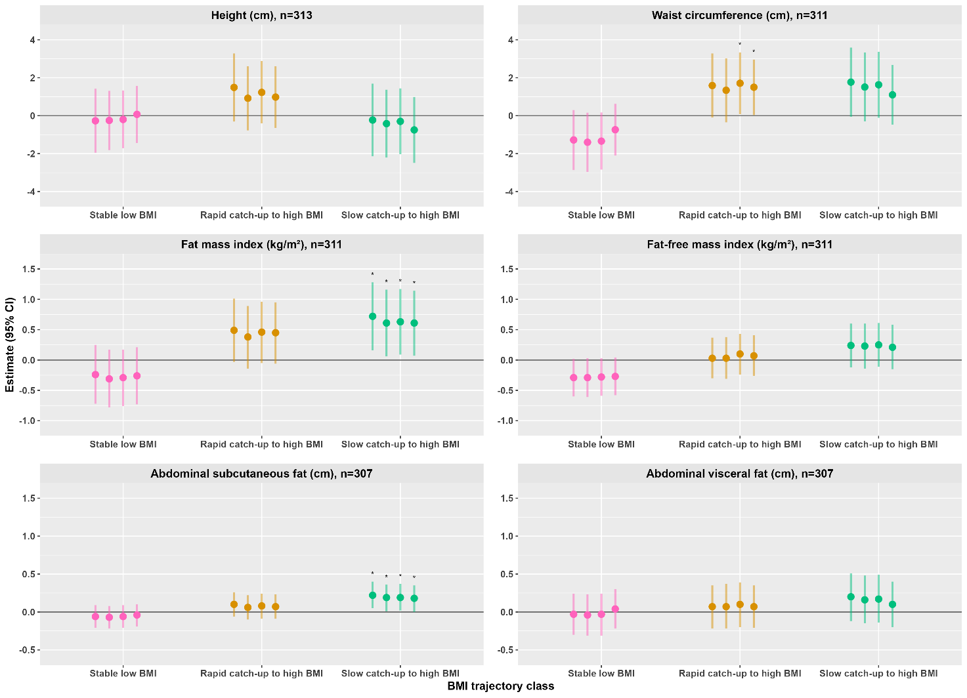
Figure 2 Associations of BMI trajectories from birth to 5 years with anthropometry, body composition, and abdominal fat at 10 years of age. The estimates (95% CI) were derived from multiple linear regression models and represent the mean differences of anthropometric measurements, body composition, and abdominal fat of each trajectory compared to the reference trajectory (normal BMI). We ran four separate models for each outcome variable, and the vertical bars from left to right represent models1, 2, 3, and 4, respectively. Each outcome is presented on the top of the exposure variables (BMI trajectories). Model 1 was adjusted for child’s sex and age at 10 years. Model 2 was additionally adjusted for childbirth order, gestational age at birth, maternal age at delivery, maternal height, maternal highest educational status, and family economic status. Model 3 was further adjusted for child’s birth weight. In addition to the preceding models, in model 4, we adjusted height for current BMI, waist circumference for fat-free mass index, fat mass index for fat-free mass index, fat-free mass index for fat mass index, and abdominal fat (subcutaneous and visceral) for current fat-free mass index. * = P≤0.05.

Associations of BMI trajectories with cardiometabolic markers
Compared to children with normal BMI, those with slow catch-up to high BMI trajectory had higher insulin and HOMA-IR and those with rapid catch-up to high BMI had higher C-peptide although the confidence intervals were wide and included the null value (model 3). The effect estimates were attenuated after further adjustment for current BMI in model 4 (Figure 3 and Supplementary Table 3). For example, children with slow catch-up to high BMI trajectory had 29.8% (95% CI: -0.8, 69.8) higher insulin and 30.3% (95% CI: -1.1, 71.6) higher HOMA-IR, whereas those with rapid catch-up to high BMI trajectory had 48.6% (95% CI: -1.4, 123.8) higher C-peptide compared to children with normal BMI trajectory (model 3).
Children with stable low BMI had a tendency towards a higher insulin concentration compared to those with normal BMI after accounting for current BMI in model 4. Children with rapid catch-up to high BMI had a tendency towards lower total cholesterol concentrations compared to children with normal BMI, and the effect estimate was increased after adjustment for current BMI in model 4. At 10 years, no evidence for associations were observed between the trajectories and other cardiometabolic markers including blood pressure, glucose, LDL cholesterol, HDL cholesterol, and triglyceride concentrations relative to normal BMI trajectory (Figure 3 and Supplementary Table 3).
After adjusting cardiometabolic markers for current FMI instead of BMI in sensitivity analysis, we only observed minor changes in the associations between the BMI trajectories and the outcomes compared to the main regression results (Supplementary Table 4). In addition, after controlling for breastfeeding status between 4 and 6 months in sensitivity analysis among 270 children having the data, children with rapid catch-up to high BMI trajectory had greater height compared to those with normal BMI. The associations observed between the trajectories and other outcomes are almost similar to the main results, except for the effect estimates of some cardiometabolic markers were slightly attenuated (Supplementary Figure 2). Moreover, in sensitivity analysis after controlling for multiple testing in model 3, none of the observed associations were remained significant (Supplementary Figure 3).

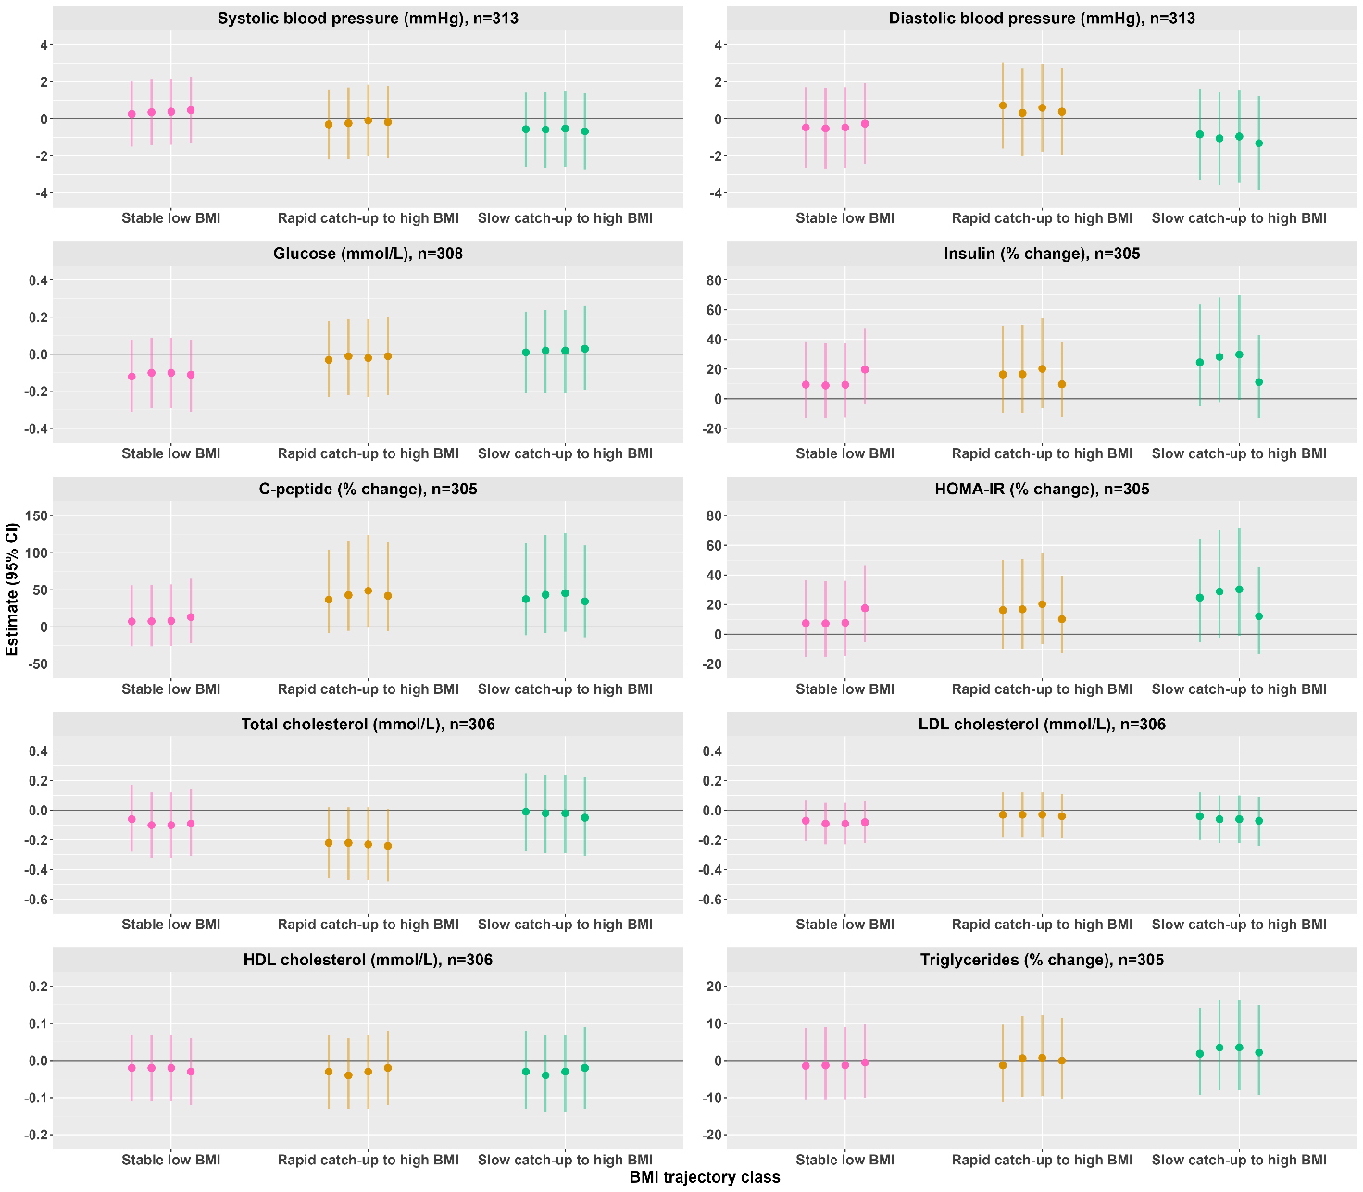
Figure 3 Associations of distinct BMI trajectories from birth to 5 years with cardiometabolic markers at 10 years of age. The estimates (95%CI) were derived from multiple linear regression models and represent the mean difference of cardiometabolic markers between each trajectory in relation to the reference trajectory (normal BMI). Skewed variables (insulin, C-peptide, HOMA-IR, and triglycerides) were log-transformed before the regression analyses, and the estimates of these variables were back-transformed and presented as percentage changes. Homeostasis model assessment of insulin resistance (HOMA-IR) was calculated as insulin (μU/mL) × glucose (mmol/L)/22.5. We ran four separate models for each outcome variable, and the vertical bars from left to right represent models 1, 2, 3, and 4, respectively. Each outcome is presented on the top of the exposure variables (BMI trajectories). Model 1 was adjusted for child’s sex and age at 10 years. Model 2 was additionally adjusted for childbirth order, gestational age at birth, maternal age at delivery, maternal height, maternal highest educational status, and family economic status. Model 3 was further adjusted for child’s birth weight. In addition to the preceding models, model 4 was adjusted for BMI at 10-year of age.

Discussion
In this prospective birth cohort study, we assessed associations of previously identified 4-class discrete BMI trajectories from birth to 5 years with anthropometry, body composition, abdominal fat, and cardiometabolic markers at 10 years of age. After accounting for potential confounders (model 3), children in the slow and rapid catch-up to high BMI trajectory had greater waist circumference and FMI and those in the slow catch-up to high BMI had greater abdominal subcutaneous fat, while those in the stable low BMI had lower FFMI at 10 years of age. Children in the slow catch-up to high BMI trajectory had higher insulin and HOMA-IR and those in the rapid catch-up to high BMI had higher C-peptide, whereas those in the rapid catch-up to high BMI had lower total cholesterol at 10 years. The trajectories were not associated with abdominal visceral fat, blood pressure, glucose, LDL cholesterol, HDL cholesterol, and triglyceride concentrations at 10 years.
In both this 10-year follow-up and the 5-year follow-up, children with rapid catch-up to high BMI trajectory had higher waist circumference (20) suggesting that early childhood central adiposity tracks to later childhood. Children in the rapid catch-up trajectory showed deficits in waist circumference compared to either males or females reference data from LMICs (38, 39). This highlights that children in the trajectory may only have larger waist circumstance than those in the normal BMI trajectory, but they might not be at increased risk of central adiposity at 10 years of age. Correspondingly, studies from high income settings assessing group-based BMI trajectories in childhood reported associations of stable high and accelerating BMI trajectories with greater waist circumference compared to stable low BMI trajectory (5, 40). Similar associations were also reported in adulthood (36).
We found that children in the two catch-up trajectories had higher FMI, whereas those with stable low BMI had lower FMI at both the 5-year and 10-year follow-ups (20). These consistent associations may highlight that those children who experienced high BMI growth patterns in early life are at greater risk of adiposity later in life. In addition, the association of stable low BMI trajectory with lower lean mass both at 5 and 10 years indicate that children who had lean mass deficit in early life might not be able to catch-up in FFM later in life (41). At 10-years, males and females in our cohort had lower mean FMI and FFMI compared to the UK reference data (42). Males and females had deficits in FMI of 0.42 and 1.16 kg/m2, respectively, while they had deficits in FFMI of 0.83 and 1.04 kg/m2, respectively. The trajectory with the highest mean FMI and FFMI (slow catch-up to high BMI) still showed deficits in both FMI and FFMI compared to either males or females UK reference data, except for FMI, which was slightly higher in the trajectory than males UK reference data (42). Therefore, in this population, children who experienced high BMI in early childhood may not be at increased risk of adiposity in later childhood. However, this relation might change after puberty given that these children are exposed to sedentary lifestyle.
In contrast to our current findings, children with rapid catch-up to high BMI trajectory had higher FFM at 5 years (20), and the lack of an association at 10 years might be attributed to that children in the rapid catch-up to high BMI gained lower lean mass than those in the normal BMI trajectory from 5 to 10 years. In line with our current findings, studies conducted in high-income countries reported that children with accelerated or stable high BMI trajectory had greater FMI in later childhood or in early adult life (6, 18, 43).
Children with slow catch-up to high BMI trajectory had greater abdominal subcutaneous fat at 10 years. Weight gain in early life has been associated with abdominal subcutaneous fat in childhood/adolescent, but the association with visceral fat becomes noticeable later in life (44). Similarly, the lack of association between the trajectories and abdominal visceral fat in our study might be observed after the children accrue visceral fat later in life. At 10 years, children in the trajectory with highest BMI z-score (slow catch-up to high BMI) still had mean BMI z-score deficit of -0.27 compared to the WHO growth standards. Although we did not find a study which directly assessed associations of early childhood BMI trajectories with later abdominal subcutaneous fat, studies mainly from high-income settings reported associations between early childhood rapid or stable high BMI trajectory and fatness later in life (6, 45).
We found that children in the slow catch-up to high BMI trajectory had higher insulin and HOMA-IR, and those with rapid catch-up to high BMI had higher C-peptide after accounting for maternal and child characteristics at birth. These could possibly be explained by variation in adiposity (46). As such, children in the two catch-up BMI trajectories had greater measures of FM and abdominal subcutaneous fat than those in the normal BMI trajectory at 10 years of age. Children in the catch-up BMI trajectories might also have higher concentrations of growth hormone/IGF-1, which is related with increase in insulin concentration and HOMA-IR (47). At the 5-year follow-up of this cohort, only children in the rapid catch-up to high BMI, but not those in the slow catch-up to high BMI trajectory showed higher insulin, C-peptide, and HOMA-IR.
Children in the slow and rapid catch-up to high BMI trajectories had lower median insulin and HOMA-IR, but slightly higher glucose concentrations at 10 years compared to either males or females European reference data (48). Therefore, higher values of insulin, C-peptide, and HOMA-IR observed in the two catch-up trajectories may not suggest impaired glucose metabolism; rather, it only means that those children had higher levels of the markers than the children in the reference trajectory. Correspondingly, studies from high-income countries also showed associations between accelerated/high BMI trajectories and higher insulin and HOMA-IR in adolescents or early adulthood (49, 50).
The mechanism underlying the observed association between rapid catch-up BMI growth in early childhood and lower total cholesterol in later childhood is unclear. In low-income settings, there is limited information whether rapid/catch-up growth in early life is related to poor health outcomes or has positive health effects later in life. Therefore, a comparable study from similar settings is warranted to investigate the consistency of our findings. Continued follow-up of the study population will also help to clarify if the observed associations between early childhood BMI trajectories and lipid profiles will continue after puberty. In contrast to the current findings, at 5 years follow-up of this cohort, we found that children in the rapid catch-up to high BMI had higher triglycerides in relation to those in the normal BMI trajectory (20). The differences in findings at 5 and 10 years with regard to lipid profile could be attributed to that children in this cohort had higher FMI at 5 years (51) but lower values at 10 years of age compared to UK reference data (42). In turn, higher FM accretion is associated with greater cholesterol concentrations in childhood (52). Furthermore, children in our cohort had mean BMI z-score deficit of -0.78 at 10 years compared to the WHO growth reference standards, indicating that these children may not have increased risk of dyslipidemia related to childhood adiposity.
Strengths and limitations
Our study has several strengths. First, a median of 9 repeated measurements of weight and length/height for each child from birth to 5 years was used for the trajectory modelling. Second, we assessed FM and FFM at 10 years using air displacement plethysmography, which is considered a safe, accurate and feasible method for assessing body composition. Third, the study applied latent class trajectory modeling, a data driven method to identify heterogenous growth patterns of BMI trajectories in early childhood.
However, the study also has limitations. First, compared to the 5-year follow-up, we had fewer children in each BMI trajectory class at the 10-year follow-up which could have resulted in false negative results (type 2 error). Second, because of the observational nature of the study design, it is not possible to ascertain causal-effect associations and we cannot rule out that the observed associations might be explained by other factors including maternal BMI before or during pregnancy, or early childhood characteristics such as food intake and physical activity. Third, the children who did not attend the 10-year follow-up may have had different associations between the trajectories and the 10-year outcomes because some differences were observed in the maternal and child characteristics between those who attended and did not (Supplementary Table 1). Finally, children included in this study may not be representative of the general population because the cohort included only healthy and term children from an urban setting.
Conclusions
We have shown that associations of early childhood BMI trajectories with measures of adiposity, body composition, and glucose metabolism track to later childhood. However, the associations between the trajectories and lipid profile in childhood are only transient suggesting that in this setting, the risk of dyslipidemia in adult may primarily emerge from adolescence onwards upon accumulation of FM. Continued follow-up of the cohort will help to understand whether those children with stable low and/or high BMI trajectories are at increased risk of cardiometabolic disease in later life.

Reference

1. Han JC, Lawlor DA, Kimm SY. Childhood obesity. Lancet. 2010;375(9727):1737-48.
2. Drozdz D, Alvarez-Pitti J, Wójcik M, Borghi C, Gabbianelli R, Mazur A, et al. Obesity and Cardiometabolic Risk Factors: From Childhood to Adulthood. Nutrients. 2021;13(11).
3. Faienza MF, Chiarito M, Molina-Molina E, Shanmugam H, Lammert F, Krawczyk M, et al. Childhood obesity, cardiovascular and liver health: a growing epidemic with age. World Journal of Pediatrics. 2020:1-8.
4. Giles LC, Whitrow MJ, Davies MJ, Davies CE, Rumbold AR, Moore VM. Growth trajectories in early childhood, their relationship with antenatal and postnatal factors, and development of obesity by age 9 years: results from an Australian birth cohort study. Int J Obes (Lond). 2015;39(7):1049-56.
5. Perez M, Winstone LK, Hernández JC, Curci SG, McNeish D, Luecken LJ. Association of BMI trajectories with cardiometabolic risk among low-income Mexican American children. Pediatr Res. 2022:1-6.
6. Aris IM, Chen LW, Tint MT, Pang WW, Soh SE, Saw SM, et al. Body mass index trajectories in the first two years and subsequent childhood cardio-metabolic outcomes: a prospective multi-ethnic Asian cohort study. Sci Rep. 2017;7(1):8424.
7. Wells JC, Hallal PC, Wright A, Singhal A, Victora CG. Fetal, infant and childhood growth: relationships with body composition in Brazilian boys aged 9 years. Int J Obes (Lond). 2005;29(10):1192-8.
8. Sachdev HS, Fall CH, Osmond C, Lakshmy R, Dey Biswas SK, Leary SD, et al. Anthropometric indicators of body composition in young adults: relation to size at birth and serial measurements of body mass index in childhood in the New Delhi birth cohort. Am J Clin Nutr. 2005;82(2):456-66.
9. Freedman DS, Wang J, Maynard LM, Thornton JC, Mei Z, Pierson RN, et al. Relation of BMI to fat and fat-free mass among children and adolescents. Int J Obes (Lond). 2005;29(1):1-8.
10. Maynard LM, Wisemandle W, Roche AF, Chumlea WC, Guo SS, Siervogel RM. Childhood body composition in relation to body mass index. Pediatrics. 2001;107(2):344-50.
11. Lycett K, Juonala M, Magnussen CG, Norrish D, Mensah FK, Liu R, et al. Body Mass Index From Early to Late Childhood and Cardiometabolic Measurements at 11 to 12 Years. Pediatrics. 2020;146(2).
12. Friedemann C, Heneghan C, Mahtani K, Thompson M, Perera R, Ward AM. Cardiovascular disease risk in healthy children and its association with body mass index: systematic review and meta-analysis. Bmj. 2012;345:e4759.
13. Perng W, Oken E, Dabelea D. Developmental overnutrition and obesity and type 2 diabetes in offspring. Diabetologia. 2019;62(10):1779-88.
14. Llewellyn A, Simmonds M, Owen CG, Woolacott N. Childhood obesity as a predictor of morbidity in adulthood: a systematic review and meta-analysis. Obes Rev. 2016;17(1):56-67.
15. Meyer JF, Larsen SB, Blond K, Damsgaard CT, Bjerregaard LG, Baker JL. Associations between body mass index and height during childhood and adolescence and the risk of coronary heart disease in adulthood: A systematic review and meta-analysis. Obes Rev. 2021;22(9):e13276.
16. Twisk J, Hoekstra T. Classifying developmental trajectories over time should be done with great caution: a comparison between methods. J Clin Epidemiol. 2012;65(10):1078-87.
17. Lennon H, Kelly S, Sperrin M, Buchan I, Cross AJ, Leitzmann M, et al. Framework to construct and interpret latent class trajectory modelling. BMJ Open. 2018;8(7):e020683.
18. Kwon S, Janz KF, Letuchy EM, Burns TL, Levy SM. Association between body mass index percentile trajectories in infancy and adiposity in childhood and early adulthood. Obesity (Silver Spring). 2017;25(1):166-71.
19. Yuan Y, Chu C, Zheng WL, Ma Q, Hu JW, Wang Y, et al. Body Mass Index Trajectories in Early Life Is Predictive of Cardiometabolic Risk. J Pediatr. 2020;219:31-7.e6.
20. Wibaek R, Vistisen D, Girma T, Admassu B, Abera M, Abdissa A, et al. Body mass index trajectories in early childhood in relation to cardiometabolic risk profile and body composition at 5 years of age. Am J Clin Nutr. 2019;110(5):1175-85.
21. Andersen GS, Girma T, Wells JC, Kaestel P, Leventi M, Hother AL, et al. Body composition from birth to 6 mo of age in Ethiopian infants: reference data obtained by air-displacement plethysmography. Am J Clin Nutr. 2013;98(4):885-94.
22. Andersen GS, Girma T, Wells JC, Kæstel P, Michaelsen KF, Friis H. Fat and fat-free mass at birth: air displacement plethysmography measurements on 350 Ethiopian newborns. Pediatr Res. 2011;70(5):501-6.
23. de Onis M, Garza C, Onyango AW, Rolland-Cachera MF. [WHO growth standards for infants and young children]. Arch Pediatr. 2009;16(1):47-53.
24. de Onis M, Onyango AW, Borghi E, Siyam A, Nishida C, Siekmann J. Development of a WHO growth reference for school-aged children and adolescents. Bull World Health Organ. 2007;85(9):660-7.
25. Dempster P, Aitkens S. A new air displacement method for the determination of human body composition. Med Sci Sports Exerc. 1995;27(12):1692-7.
26. Wells JC, Cole TJ. Adjustment of fat-free mass and fat mass for height in children aged 8 y. Int J Obes Relat Metab Disord. 2002;26(7):947-52.
27. Stolk RP, Wink O, Zelissen PM, Meijer R, van Gils AP, Grobbee DE. Validity and reproducibility of ultrasonography for the measurement of intra-abdominal adipose tissue. Int J Obes Relat Metab Disord. 2001;25(9):1346-51.
28. Rønn PF, Andersen GS, Lauritzen T, Christensen DL, Aadahl M, Carstensen B, et al. Abdominal visceral and subcutaneous adipose tissue and associations with cardiometabolic risk in Inuit, Africans and Europeans: a cross-sectional study. BMJ Open. 2020;10(9):e038071.
29. Matthews DR, Hosker JP, Rudenski AS, Naylor BA, Treacher DF, Turner RC. Homeostasis model assessment: insulin resistance and beta-cell function from fasting plasma glucose and insulin concentrations in man. Diabetologia. 1985;28(7):412-9.
30. Ballard JL, Novak KK, Driver M. A simplified score for assessment of fetal maturation of newly born infants. J Pediatr. 1979;95(5 Pt 1):769-74.
31. Smits J, Steendijk R. The international wealth index (IWI). Social indicators research. 2015;122(1):65-85.
32. Organization WH. Indicators for assessing infant and young child feeding practices: part 2: measurement: World Health Organization; 2010.
33. Kongsted A, Nielsen AM. Latent Class Analysis in health research. J Physiother. 2017;63(1):55-8.
34. Nagin DS, Odgers CL. Group-based trajectory modeling in clinical research. Annu Rev Clin Psychol. 2010;6:109-38.
35. Li X, Keown-Stoneman CDG, Lebovic G, Maguire JL, Omand JA, Sievenpiper JL, et al. Body Mass Index Mediates the Association between Growth Trajectories and Cardiometabolic Risk in Children. Child Obes. 2021;17(1):36-42.
36. Péneau S, Giudici KV, Gusto G, Goxe D, Lantieri O, Hercberg S, et al. Growth Trajectories of Body Mass Index during Childhood: Associated Factors and Health Outcome at Adulthood. J Pediatr. 2017;186:64-71.e1.
37. Benjamini Y, Hochberg Y. Controlling the false discovery rate: a practical and powerful approach to multiple testing. Journal of the Royal statistical society: series B (Methodological). 1995;57(1):289-300.
38. Kuriyan R, Thomas T, Lokesh DP, Sheth NR, Mahendra A, Joy R, et al. Waist circumference and waist for height percentiles in urban South Indian children aged 3-16 years. Indian Pediatr. 2011;48(10):765-71.
39. Ghouili H, Ouerghi N, Ben Khalifa W, Boughalmi A, Dridi A, Gmada N, et al. First reference curves of waist circumference and waist-to-height ratio for Tunisian children. Arch Pediatr. 2020;27(2):87-94.
40. Li X, Keown-Stoneman CDG, Lebovic G, Omand JA, Adeli K, Hamilton JK, et al. The association between body mass index trajectories and cardiometabolic risk in young children. Pediatr Obes. 2020;15(8):e12633.
41. Wells JC. The programming effects of early growth. Early Hum Dev. 2007;83(12):743-8.
42. Wells JC, Williams JE, Chomtho S, Darch T, Grijalva-Eternod C, Kennedy K, et al. Body-composition reference data for simple and reference techniques and a 4-component model: a new UK reference child. Am J Clin Nutr. 2012;96(6):1316-26.
43. Rzehak P, Oddy WH, Mearin ML, Grote V, Mori TA, Szajewska H, et al. Infant feeding and growth trajectory patterns in childhood and body composition in young adulthood. Am J Clin Nutr. 2017;106(2):568-80.
44. Araújo de França GV, De Lucia Rolfe E, Horta BL, Gigante DP, Yudkin JS, Ong KK, et al. Associations of birth weight, linear growth and relative weight gain throughout life with abdominal fat depots in adulthood: the 1982 Pelotas (Brazil) birth cohort study. Int J Obes (Lond). 2016;40(1):14-21.
45. Mattsson M, Maher GM, Boland F, Fitzgerald AP, Murray DM, Biesma R. Group-based trajectory modelling for BMI trajectories in childhood: A systematic review. Obes Rev. 2019;20(7):998-1015.
46. Maffeis C, Morandi A. Body composition and insulin resistance in children. Eur J Clin Nutr. 2018;72(9):1239-45.
47. Kim SH, Park MJ. Effects of growth hormone on glucose metabolism and insulin resistance in human. Ann Pediatr Endocrinol Metab. 2017;22(3):145-52.
48. Peplies J, Jiménez-Pavón D, Savva SC, Buck C, Günther K, Fraterman A, et al. Percentiles of fasting serum insulin, glucose, HbA1c and HOMA-IR in pre-pubertal normal weight European children from the IDEFICS cohort. Int J Obes (Lond). 2014;38 Suppl 2:S39-47.
49. Araujo J, Severo M, Barros H, Mishra GD, Guimaraes JT, Ramos E. Developmental trajectories of adiposity from birth until early adulthood and association with cardiometabolic risk factors. Int J Obes (Lond). 2015;39(10):1443-9.
50. Huang RC, de Klerk NH, Smith A, Kendall GE, Landau LI, Mori TA, et al. Lifecourse childhood adiposity trajectories associated with adolescent insulin resistance. Diabetes Care. 2011;34(4):1019-25.
51. Wibaek R, Vistisen D, Girma T, Admassu B, Abera M, Abdissa A, et al. Associations of fat mass and fat-free mass accretion in infancy with body composition and cardiometabolic risk markers at 5 years: The Ethiopian iABC birth cohort study. PLoS Med. 2019;16(8):e1002888.
52. Oliosa PR, Zaniqueli DDA, Barbosa MCR, Mill JG. Relationship between body composition and dyslipidemia in children and adolescentes. Cien Saude Colet. 2019;24(10):3743-52.

Supplementary materials
Supplementary Table 1 comparison of maternal and child characteristics between those who participated in the 10-year follow-up and did not attend¹
 | n | Attended | n | Not attended | P value² | Missing, n
Maternal characteristics after delivery
Age (years) | 319 | 24.7 (4.7) | 241 | 23.6 (4.5) | 0.003 | 11
Height (cm) | 317 | 157.7 (5.8) | 218 | 157.5 (5.9) | 0.79 | 36
Weight (kg) | 238 | 56.7 (9.4) | 170 | 55.8 (8.5) | 0.28 | 163
BMI (kg/m²) | 236 | 22.7 (3.3) | 170 | 22.4 (3.0) | 0.29 | 165
Maternal educational status, n (%) | 320 |  | 245 |  | 0.35 | 6
No school |  | 17 (5.3) |  | 21 (8.6)
Primary school |  | 195 (60.9) |  | 152 (62.0)
Secondary school |  | 64 (20.0) |  | 40 (16.3)
Higher education |  | 44 (13.8) |  | 32 (13.1)
Family Socioeconomic status (IWI) | 319 | 46.7 (16.8) | 239 | 43.8 (19.6) | 0.06 | 13
Child characteristics
Mode of delivery, n (%) | 320 |  | 240 |  | 0.42 | 11
Vaginal delivery |  | 299 (93.4) |  | 219 (91.2)
Caesarean section |  | 21 (6.6) |  | 21 (8.8)
Sex, male, n (%) | 320 | 166 (51.9) | 251 | 114 (45.4) | 0.15 | 0
Gestational age (weeks) | 320 | 39.0 (0.9) | 251 | 39.0 (1.0) | 0.98 | 0
Birth weight (kg) | 320 | 3.1 (0.4) | 251 | 3.0 (0.4) | 0.006 | 0
Length (cm) | 320 | 49.3 (2.0) | 251 | 48.9 (2.0) | 0.025 | 0
BMI (kg/m²) | 320 | 12.6 (1.1) | 251 | 12.4 (1.2) | 0.027 | 0
Fat mass (kg) | 318 | 0.2 (0.2) | 250 | 0.2 (0.1) | 0.11 | 3
Fat-free mass (kg) | 318 | 2.85 (0.32) | 250 | 2.77 (0.34) | 0.007 | 3
Fat mass index (kg/m²) | 318 | 0.9 (0.7) | 250 | 0.8 (0.6) | 0.15 | 3
Fat-free mass index (kg/m²) | 318 | 11.7 (0.9) | 250 | 11.6 (1.0) | 0.08 | 3
Child birth order, n (%) | 318 |  | 239 |  | 0.002 | 14
First |  | 152 (47.8) |  | 149 (62.3)
Second |  | 86 (27.0) |  | 51 (21.3)
Third and above |  | 80 (25.2) |  | 39 (16.3)
Low birth weight, n (%)³ | 320 | 26 (8.1) | 251 | 33 (13.2) | 0.07 | 0
Breastfeeding status at 4-6 months, n (%) | 272 |  | 118 |  | 0.67 | 181
Exclusive |  | 30 (11.0) |  | 13 (11.0)
Predominant |  | 227 (83.5) |  | 101 (85.6)
Partial or no |  | 15 (5.5) |  | 4 (3.4)
¹Data are mean (SD) for continuous normally distributed variables and n (%) for categorical variables. ²Differences between those who attended the 10-year follow-up and not attending were calculated by one-way ANOVA F-test for continuous variables, Pearson’s chi-squared test of independence for categorical variables with expected counts > 4 in all cells, and else Fisher’s exact test. ³Birth weight <2500 g. IWI, international wealth index.
Supplementary Table 2 Child anthropometry, body composition, abdominal fat, and cardiometabolic markers at 10 years by sex¹
 | Full sample (n=320) | n | Males | n | Females | Missing, n
Anthropometry
Weight (kg) | 27.2 (5.8) | 166 | 27.2 (6.0) | 154 | 27.4 (5.6) | 0
Height (cm) | 132.2 (7.7) | 166 | 132.0 (7.6) | 154 | 132.4 (7.8) | 0
BMI (kg/m²) | 15.5 (2.1) | 166 | 15.4 (2.1) | 154 | 15.5 (2.1) | 0
Height z-score | -0.78 (0.90) | 166 | -0.77 (0.92) | 154 | -0.80 (0.88) | 0
BMI z-score | -0.78 (1.14) | 166 | -0.82 (1.18) | 154 | -0.74 (1.09) | 0
Waist circumference (cm) | 55.9 (5.6) | 166 | 56.3 (5.8) | 154 | 55.5 (5.3) | 0
Body composition
Fat mass (kg) | 5.59 (3.43) | 165 | 5.29 (3.40) | 153 | 5.91 (3.45) | 2
Fat-free mass (kg) | 21.69 (3.32) | 165 | 21.92 (3.51) | 153 | 21.45 (3.10) | 2
Fat mass index (kg/m²) | 3.12 (1.70) | 165 | 2.95 (1.66) | 153 | 3.30 (1.72) | 2
Fat-free mass index (kg/m²) | 12.36 (1.08) | 165 | 12.52 (1.09) | 153 | 12.20 (1.04) | 2
Abdominal fat
Subcutaneous fat (cm) | 0.7 (0.5) | 163 | 0.6 (0.5) | 153 | 0.7 (0.5) | 4
Visceral fat (cm) | 3.9 (0.9) | 163 | 4.0 (0.9) | 153 | 3.8 (0.9) | 4
Blood pressure
Systolic (mmHg) | 94.8 (6.4) | 166 | 95.0 (6.6) | 154 | 94.6 (6.3) | 0
Diastolic (mmHg) | 58.0 (7.6) | 166 | 58.0 (7.4) | 154 | 58.0 (7.8) | 0
Glucose metabolism
Glucose (mmol/L) | 5.2 (0.7) | 163 | 5.3 (0.6) | 152 | 5.2 (0.7) | 5
Insulin (μU/mL) | 3.8 (2.1-6.1) | 163 | 3.4 (1.8-5.6) | 149 | 4.3 (3.0-6.2) | 8
C-peptide (ng/mL) | 0.3 (0.1-0.8) | 163 | 0.3 (0.1-0.8) | 149 | 0.3 (0.1-0.7) | 8
HOMA-IR³ | 0.9 (0.5-1.4) | 163 | 0.8 (0.4-1.3) | 149 | 1.0 (0.7-1.5) | 8
Lipids
Total cholestrol (mmol/L) | 3.3 (0.8) | 163 | 3.3 (0.8) | 150 | 3.4 (0.7) | 7
HDL cholesterol (mmol/L) | 1.0 (0.3) | 163 | 1.0 (0.3) | 150 | 1.0 (0.3) | 7
LDL cholesterol (mmol/L) | 1.7 (0.5) | 163 | 1.7 (0.5) | 150 | 1.8 (0.5) | 7
Triglycerides (mmol/L) | 0.8 (0.7-1.0) | 163 | 0.8 (0.6-0.9) | 149 | 0.8 (0.7-1.1) | 8
¹Data are mean (SD) for continuous normally distributed, median (IQR) for skewed, and n (%) for categorical variables. ²Homeostasis model assessment of insulin resistance (HOMA-IR) was calculated as insulin (μU/mL) × glucose (mmol/L)/22.5.

Supplementary Table 3 Associations of BMI trajectories from birth to 5 years with anthropometry, body composition, abdominal fat, and cardiometabolic risk factors at 10 years of age relative to normal BMI trajectory¹
 | N | Stable low BMI | P value | Rapid catch-up to high BMI | P value | Slow catch-up to high BMI | P value
 |  | β(95%CI) |  | β(95%CI) |  | β(95%CI)
Height (cm)
Model 1 | 313 | -0.27 (-1.95, 1.42) | 0.76 | 1.49 (-0.31, 3.28) | 0.10 | -0.23 (-2.14, 1.69) | 0.82
Model 2 | 313 | -0.25 (-1.81, 1.31) | 0.75 | 0.92 (-0.77, 2.61) | 0.29 | -0.42 (-2.21, 1.37) | 0.64
Model 3 | 313 | -0.20 (-1.71, 1.32) | 0.80 | 1.23 (-0.41, 2.88) | 0.14 | -0.30 (-2.04, 1.44) | 0.73
Model 4 | 313 | 0.07 (-1.44, 1.57) | 0.93 | 0.98 (-0.65, 2.61) | 0.24 | -0.75 (-2.49, 0.99) | 0.40
Waist circumference (cm)
Model 1 | 311 | -1.28 (-2.87, 0.30) | 0.11 | 1.59 (-0.10, 3.28) | 0.07 | 1.77 (-0.05, 3.59) | 0.06
Model 2 | 311 | -1.40 (-2.97, 0.16) | 0.08 | 1.34 (-0.35, 3.03) | 0.12 | 1.51 (-0.30, 3.33) | 0.10
Model 3 | 311 | -1.34 (-2.84, 0.17) | 0.08 | 1.71 (0.08, 3.34) | 0.040 | 1.63 (-0.11, 3.37) | 0.08
Model 4 | 311 | -0.74 (-2.09, 0.62) | 0.29 | 1.50 (0.03, 2.96) | 0.045 | 1.10 (-0.47, 2.67) | 0.17
Fat mass index (kg/m²)
Model 1 | 311 | -0.24 (-0.72, 0.25) | 0.34 | 0.49 (-0.03, 1.01) | 0.06 | 0.72 (0.16, 1.28) | 0.012
Model 2 | 311 | -0.31 (-0.78, 0.17) | 0.20 | 0.38 (-0.14, 0.89) | 0.15 | 0.61 (0.06, 1.16) | 0.030
Model 3 | 311 | -0.29 (-0.76, 0.17) | 0.22 | 0.46 (-0.05, 0.96) | 0.07 | 0.63 (0.09, 1.17) | 0.021
Model 4 | 311 | -0.26 (-0.73, 0.21) | 0.27 | 0.45 (-0.06, 0.95) | 0.08 | 0.61 (0.07, 1.14) | 0.028
Fat-free mass index (kg/m²)
Model 1 | 311 | -0.29 (-0.60, 0.02) | 0.07 | 0.03 (-0.30, 0.37) | 0.85 | 0.24 (-0.12, 0.60) | 0.19
Model 2 | 311 | -0.29 (-0.61, 0.03) | 0.07 | 0.03 (-0.31, 0.38) | 0.84 | 0.23 (-0.14, 0.60) | 0.23
Model 3 | 311 | -0.28 (-0.59, 0.03) | 0.08 | 0.10 (-0.24, 0.43) | 0.57 | 0.25 (-0.11, 0.61) | 0.18
Model 4 | 311 | -0.27 (-0.58, 0.04) | 0.09 | 0.07 (-0.26, 0.41) | 0.67 | 0.21 (-0.15, 0.58) | 0.25
Abdominal subcutaneous fat (cm)
Model 1 | 307 | -0.06 (-0.21, 0.09) | 0.46 | 0.10 (-0.06, 0.26) | 0.22 | 0.22 (0.05, 0.40) | 0.013
Model 2 | 307 | -0.07 (-0.22, 0.08) | 0.38 | 0.06 (-0.10, 0.22) | 0.48 | 0.19 (0.01, 0.36) | 0.035
Model 3 | 307 | -0.06 (-0.21, 0.09) | 0.40 | 0.08 (-0.09, 0.24) | 0.36 | 0.19 (0.02, 0.37) | 0.029
Model 4 | 307 | -0.04 (-0.19, 0.10) | 0.56 | 0.07 (-0.09, 0.23) | 0.40 | 0.18 (0.00, 0.35) | 0.047
Abdominal visceral fat (cm)
Model 1 | 307 | -0.03 (-0.30, 0.24) | 0.83 | 0.07 (-0.22, 0.35) | 0.64 | 0.20 (-0.12, 0.51) | 0.22
Model 2 | 307 | -0.04 (-0.31, 0.23) | 0.78 | 0.07 (-0.22, 0.37) | 0.63 | 0.16 (-0.15, 0.48) | 0.31
Model 3 | 307 | -0.03 (-0.31, 0.24) | 0.80 | 0.10 (-0.20, 0.39) | 0.52 | 0.17 (-0.14, 0.49) | 0.29
Model 4 | 307 | 0.04 (-0.22, 0.30) | 0.74 | 0.07 (-0.21, 0.35) | 0.62 | 0.10 (-0.20, 0.40) | 0.52
Systolic blood pressure (mmHg)
Model 1 | 313 | 0.27 (-1.50, 2.04) | 0.76 | -0.30 (-2.19, 1.59) | 0.75 | -0.56 (-2.58, 1.45) | 0.58
Model 2 | 313 | 0.36 (-1.43, 2.15) | 0.69 | -0.24 (-2.18, 1.69) | 0.81 | -0.58 (-2.64, 1.47) | 0.58
Model 3 | 313 | 0.39 (-1.40, 2.17) | 0.67 | -0.09 (-2.03, 1.84) | 0.93 | -0.53 (-2.58, 1.52) | 0.61
Model 4 | 313 | 0.47 (-1.32, 2.27) | 0.60 | -0.18 (-2.12, 1.77) | 0.86 | -0.67 (-2.75, 1.41) | 0.53
Supplementary Table 3 (continued) Associations of BMI trajectories from birth to 5 years with anthropometry, body composition, abdominal fat, and cardiometabolic risk factors at 10 years of age relative to normal BMI trajectory¹
 | N | Stable low BMI | P value | Rapid catch-up to high BMI | P value | Slow catch-up to high BMI | P value
 |  | β(95%CI) |  | β(95%CI) |  | β(95%CI)
Diastolic blood pressure (mmHg)
Model 1 | 313 | -0.47 (-2.65, 1.70) | 0.67 | 0.72 (-1.60, 3.04) | 0.54 | -0.84 (-3.31, 1.63) | 0.50
Model 2 | 313 | -0.52 (-2.71, 1.68) | 0.64 | 0.33 (-2.04, 2.70) | 0.79 | -1.05 (-3.57, 1.47) | 0.41
Model 3 | 313 | -0.47 (-2.65, 1.70) | 0.67 | 0.60 (-1.76, 2.96) | 0.62 | -0.95 (-3.45, 1.55) | 0.45
Model 4 | 313 | -0.26 (-2.44, 1.92) | 0.82 | 0.39 (-1.97, 2.76) | 0.74 | -1.31 (-3.83, 1.22) | 0.31
Glucose (mmol/L)
Model 1 | 308 | -0.12 (-0.31, 0.08) | 0.24 | -0.03 (-0.23, 0.18) | 0.78 | 0.01 (-0.21, 0.23) | 0.93
Model 2 | 308 | -0.10 (-0.29, 0.09) | 0.31 | -0.01 (-0.22, 0.19) | 0.89 | 0.02 (-0.21, 0.24) | 0.87
Model 3 | 308 | -0.10 (-0.29, 0.09) | 0.31 | -0.02 (-0.23, 0.19) | 0.84 | 0.02 (-0.21, 0.24) | 0.89
Model 4 | 308 | -0.11 (-0.31, 0.08) | 0.26 | -0.01 (-0.22, 0.20) | 0.92 | 0.03 (-0.19, 0.26) | 0.77
Insulin (% change)
Model 1 | 305 | 9.6 (-13.1, 38.2) | 0.44 | 16.4 (-9.3, 49.4) | 0.23 | 24.6 (-5.0, 63.4) | 0.11
Model 2 | 305 | 9.0 (-13.4, 37.2) | 0.46 | 16.6 (-9.2, 49.7) | 0.23 | 28.3 (-2.2, 68.3) | 0.07
Model 3 | 305 | 9.5 (-12.8, 37.5) | 0.44 | 20.2 (-6.3, 54.1) | 0.15 | 29.8 (-0.8, 69.8) | 0.06
Model 4 | 305 | 19.7 (-3.0, 47.7) | 0.09 | 9.8 (-12.7, 38.1) | 0.42 | 11.3 (-13.3, 42.9) | 0.40
C-peptide (% change)
Model 1 | 305 | 7.2 (-26.4, 56.0) | 0.72 | 36.6 (-8.7, 104.4) | 0.13 | 37.3 (-11.4, 112.7) | 0.16
Model 2 | 305 | 7.4 (-26.4, 56.7) | 0.71 | 42.7 (-5.4, 115.1) | 0.09 | 43.1 (-8.4, 123.5) | 0.11
Model 3 | 305 | 8.0 (-25.8, 57.2) | 0.69 | 48.6 (-1.4, 123.8) | 0.06 | 45.4 (-6.6, 126.5) | 0.10
Model 4 | 305 | 13.1 (-22.3, 64.7) | 0.52 | 41.8 (-5.9, 113.5) | 0.09 | 34.2 (-14.1, 109.8) | 0.20
HOMA-IR (% change)
Model 1 | 305 | 7.4 (-15.3, 36.3) | 0.55 | 16.3 (-10.0, 50.1) | 0.25 | 24.7 (-5.6, 64.6) | 0.12
Model 2 | 305 | 7.3 (-15.2, 35.8) | 0.56 | 16.8 (-9.6, 50.9) | 0.23 | 28.8 (-2.5, 70.0) | 0.07
Model 3 | 305 | 7.7 (-14.7, 36.0) | 0.53 | 20.2 (-6.8, 55.1) | 0.16 | 30.3 (-1.1, 71.6) | 0.06
Model 4 | 305 | 17.5 (-5.5, 46.0) | 0.15 | 10.1 (-13.1, 39.6) | 0.42 | 12.1 (-13.4, 45.2) | 0.38
Total cholesterol (mmol/L)
Model 1 | 306 | -0.06 (-0.28, 0.17) | 0.61 | -0.22 (-0.46, 0.02) | 0.08 | -0.01 (-0.27, 0.25) | 0.93
Model 2 | 306 | -0.10 (-0.32, 0.12) | 0.38 | -0.22 (-0.47, 0.02) | 0.07 | -0.02 (-0.29, 0.24) | 0.86
Model 3 | 306 | -0.10 (-0.32, 0.12) | 0.38 | -0.23 (-0.47, 0.02) | 0.07 | -0.02 (-0.29, 0.24) | 0.85
Model 4 | 306 | -0.09 (-0.31, 0.14) | 0.44 | -0.24 (-0.48, 0.01) | 0.06 | -0.05 (-0.31, 0.22) | 0.74

Supplementary Table 3 (continued) Associations of BMI trajectories from birth to 5 years with anthropometry, body composition, abdominal fat, and cardiometabolic risk factors at 10 years of age relative to normal BMI trajectory¹
 | N | Stable low BMI | P value | Rapid catch-up to high BMI | P value | Slow catch-up to high BMI | P value
 |  | β(95%CI) |  | β(95%CI) |  | β(95%CI)
LDL cholesterol (mmol/L)
Model 1 | 306 | -0.07 (-0.21, 0.07) | 0.34 | -0.03 (-0.18, 0.12) | 0.72 | -0.04 (-0.20, 0.12) | 0.61
Model 2 | 306 | -0.09 (-0.23, 0.05) | 0.21 | -0.03 (-0.18, 0.12) | 0.68 | -0.06 (-0.22, 0.10) | 0.47
Model 3 | 306 | -0.09 (-0.23, 0.05) | 0.21 | -0.03 (-0.18, 0.12) | 0.70 | -0.06 (-0.22, 0.10) | 0.48
Model 4 | 306 | -0.08 (-0.22, 0.06) | 0.26 | -0.04 (-0.19, 0.11) | 0.62 | -0.07 (-0.24, 0.09) | 0.39
HDL cholesterol (mmol/L)
Model 1 | 306 | -0.02 (-0.11, 0.07) | 0.74 | -0.03 (-0.13, 0.07) | 0.52 | -0.03 (-0.13, 0.08) | 0.63
Model 2 | 306 | -0.02 (-0.11, 0.07) | 0.63 | -0.04 (-0.13, 0.06) | 0.49 | -0.04 (-0.14, 0.07) | 0.52
Model 3 | 306 | -0.02 (-0.11, 0.07) | 0.64 | -0.03 (-0.13, 0.07) | 0.56 | -0.03 (-0.14, 0.07) | 0.54
Model 4 | 306 | -0.03 (-0.12, 0.06) | 0.56 | -0.02 (-0.12, 0.08) | 0.64 | -0.02 (-0.13, 0.09) | 0.67
Triglycerides (% change)
Model 1 | 305 | -1.5 (-10.7, 8.7) | 0.77 | -1.3 (-11.2, 9.6) | 0.81 | 1.8 (-9.2, 14.1) | 0.76
Model 2 | 305 | -1.3 (-10.6, 9.0) | 0.79 | 0.6 (-9.7, 12.0) | 0.91 | 3.5 (-8.0, 16.3) | 0.57
Model 3 | 305 | -1.3 (-10.6, 9.0) | 0.80 | 0.7 (-9.6, 12.3) | 0.89 | 3.5 (-7.9, 16.4) | 0.56
Model 4 | 305 | -0.5 (-10.0, 9.9) | 0.92 | -0.0 (-10.4, 11.4) | 0.99 | 2.1 (-9.3, 15.0) | 0.73
¹The coefficients (β) and (95 % CI) were derived from multiple linear regression, and represent the mean difference between the reference trajectory (normal BMI ) and each trajectory class. ²Homeostatic model assessment of insulin resistance (HOMA-IR) was calculated as insulin (μU/mL) × glucose (mmol/L)/22.5. Skewed variables (insulin, C-peptide, HOMA-IR, and triglycerides) were log-transformed prior to the regression analyses, and the estimates of these variables were back-transformed and presented as percentage changes. Model 1 was adjusted for child’s sex and age at 10 years. Model 2 was additionally adjusted for childbirth order, gestational age at birth, maternal age at delivery, maternal height, maternal highest educational status, and parental economic status. Model 3 was further adjusted for child’s birth weight. In addition to the preceding models, model 4 was adjusted for current BMI, except for waist circumference which was adjusted for fat-free mass index, fat mass index for fat-free mass index, fat-free mass index for fat mass index, abdominal fat (subcutaneous and visceral) for current fat-free mass index.

Supplementary Table 4: Sensitivity analyses of the associations between BMI trajectories from birth to 5 years and cardiometabolic markers at 10 years after adjusting for current FMI instead of BMI in Model 4¹
 | N | Stable low BMI | P value | Rapid catch-up to high BMI | P value | Slow catch-up to high BMI | P value
 |  | β(95%CI) |  | β(95%CI) |  | β(95%CI)
Systolic blood pressure (mmHg) | 311 | 0.42 (-1.38, 2.22) | 0.65 | -0.21 (-2.16, 1.75) | 0.84 | -0.59 (-2.69, 1.50) | 0.58
Diastolic blood pressure (mmHg) | 311 | -0.42 (-2.57, 1.73) | 0.70 | 0.19 (-2.15, 2.53) | 0.87 | -1.32 (-3.83, 1.19) | 0.30
Glucose (mmol/L) | 306 | -0.11 (-0.30, 0.09) | 0.28 | -0.01 (-0.23, 0.20) | 0.89 | 0.04 (-0.19, 0.27) | 0.71
Insulin (% change) | 303 | 17.1 (-5.1, 44.5) | 0.14 | 11.9 (-11.1, 40.8) | 0.34 | 13.4 (-11.8, 45.8) | 0.33
C-peptide (% change) | 303 | 12.7 (-22.2, 63.2) | 0.53 | 36.9 (-8.7, 105.2) | 0.13 | 33.9 (-14.0, 108.5) | 0.20
HOMA-IR (% change)² | 303 | 15.1 (-7.4, 43.0) | 0.20 | 12.1 (-11.6, 42.2) | 0.34 | 14.5 (-11.7, 48.5) | 0.31
Total cholesterol (mmol/L) | 304 | -0.09 (-0.32, 0.13) | 0.41 | -0.24 (-0.49, 0.00) | 0.05 | -0.04 (-0.31, 0.24) | 0.80
LDL cholesterol (mmol/L) | 304 | -0.08 (-0.22, 0.05) | 0.23 | -0.05 (-0.20, 0.10) | 0.54 | -0.07 (-0.23, 0.10) | 0.41
HDL cholesterol (mmol/L) | 304 | -0.02 (-0.11, 0.07) | 0.65 | -0.04 (-0.14, 0.07) | 0.49 | -0.04 (-0.15, 0.07) | 0.52
Triglycerides (% change) | 303 | -0.6 (-10.0, 9.8) | 0.91 | 0.7 (-9.7, 12.3) | 0.90 | 2.9 (-8.6, 16.0) | 0.64
¹The coefficients (β) and (95% CI) were derived from multiple linear regression, and represent the mean difference between the reference trajectory (normal BMI ) and each trajectory class. ²Homeostatic model assessment of insulin resistance (HOMA-IR) was calculated as insulin (μU/mL) × glucose (mmol/L)/22.5. Slightly skewed variables (insulin, C-peptide, HOMA-IR, and triglycerides) were log-transformed prior to the regression analyses, and the estimates of these variables were back-transformed and presented as percentage changes. Model 1 was adjusted for child’s sex and age at 10 years. Model 2 was additionally adjusted for childbirth order, gestational age at birth, maternal age at delivery, maternal height, maternal highest educational status, and parental economic status (wealth index). Model 3 was further adjusted for child’s birth weight. In addition to the preceding models, model 4 was adjusted for fat mass index at the 10 years follow-up.

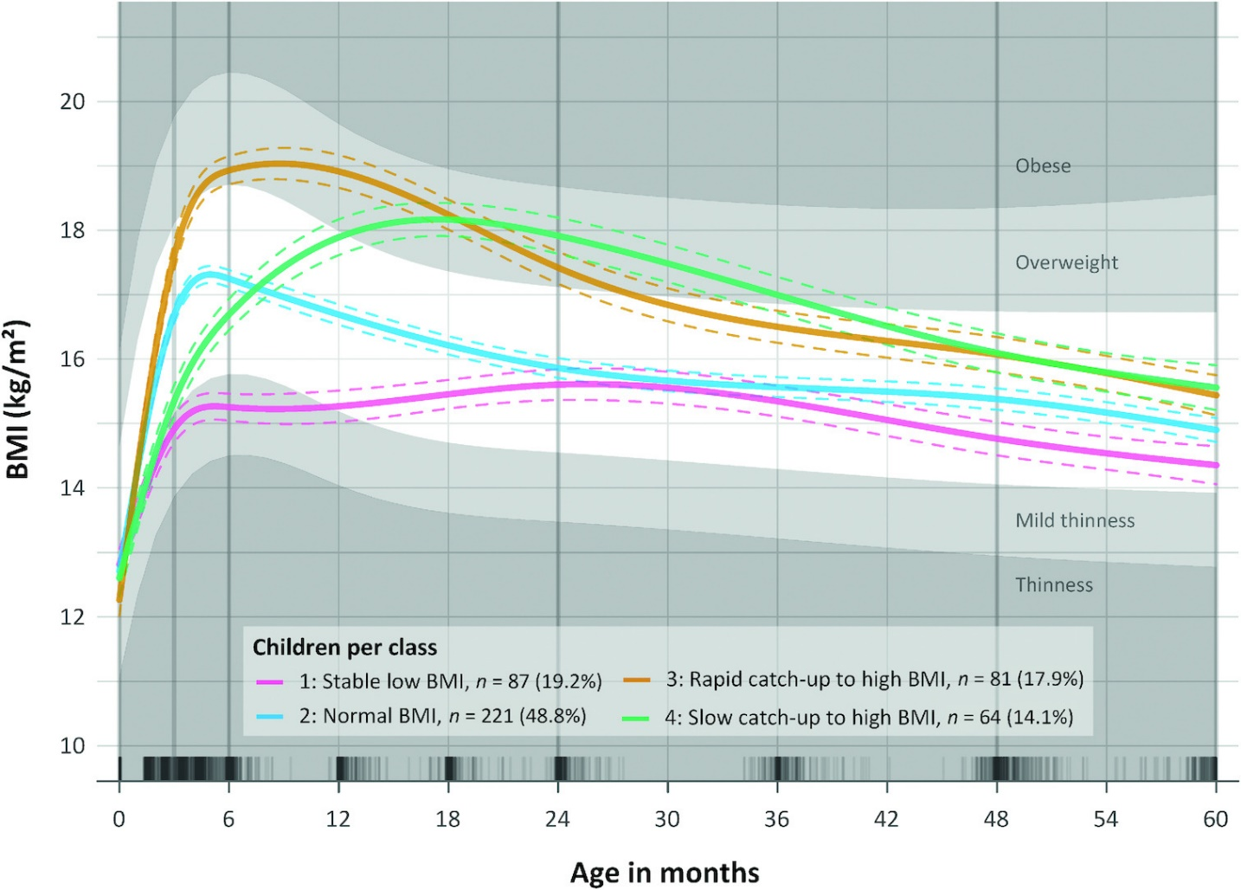
Supplementary Figure 1 Distinct BMI trajectory classes from birth to 60 months derived from latent class trajectory modeling (reproduced from Wibæk et al. 2019 with permission). The identified trajectories represent individual class average BMI as a function of age in months. The shaded area represents BMI for age in reference to the median WHO growth standard populations. Normal BMI (white) is defined as a BMI z-score (–1 to +1 SD), mild thinness (light gray) ≥−2 to <−1 SD, thinness (gray) <−2 SD, overweight (light gray) >1 to ≤2 SD, and obese (gray) >2 SD above the WHO median. The dashed lines with similar color for each mean BMI trajectory represent 95% CI, and the rug plot along the x-axis shows the density of BMI observations.

A)
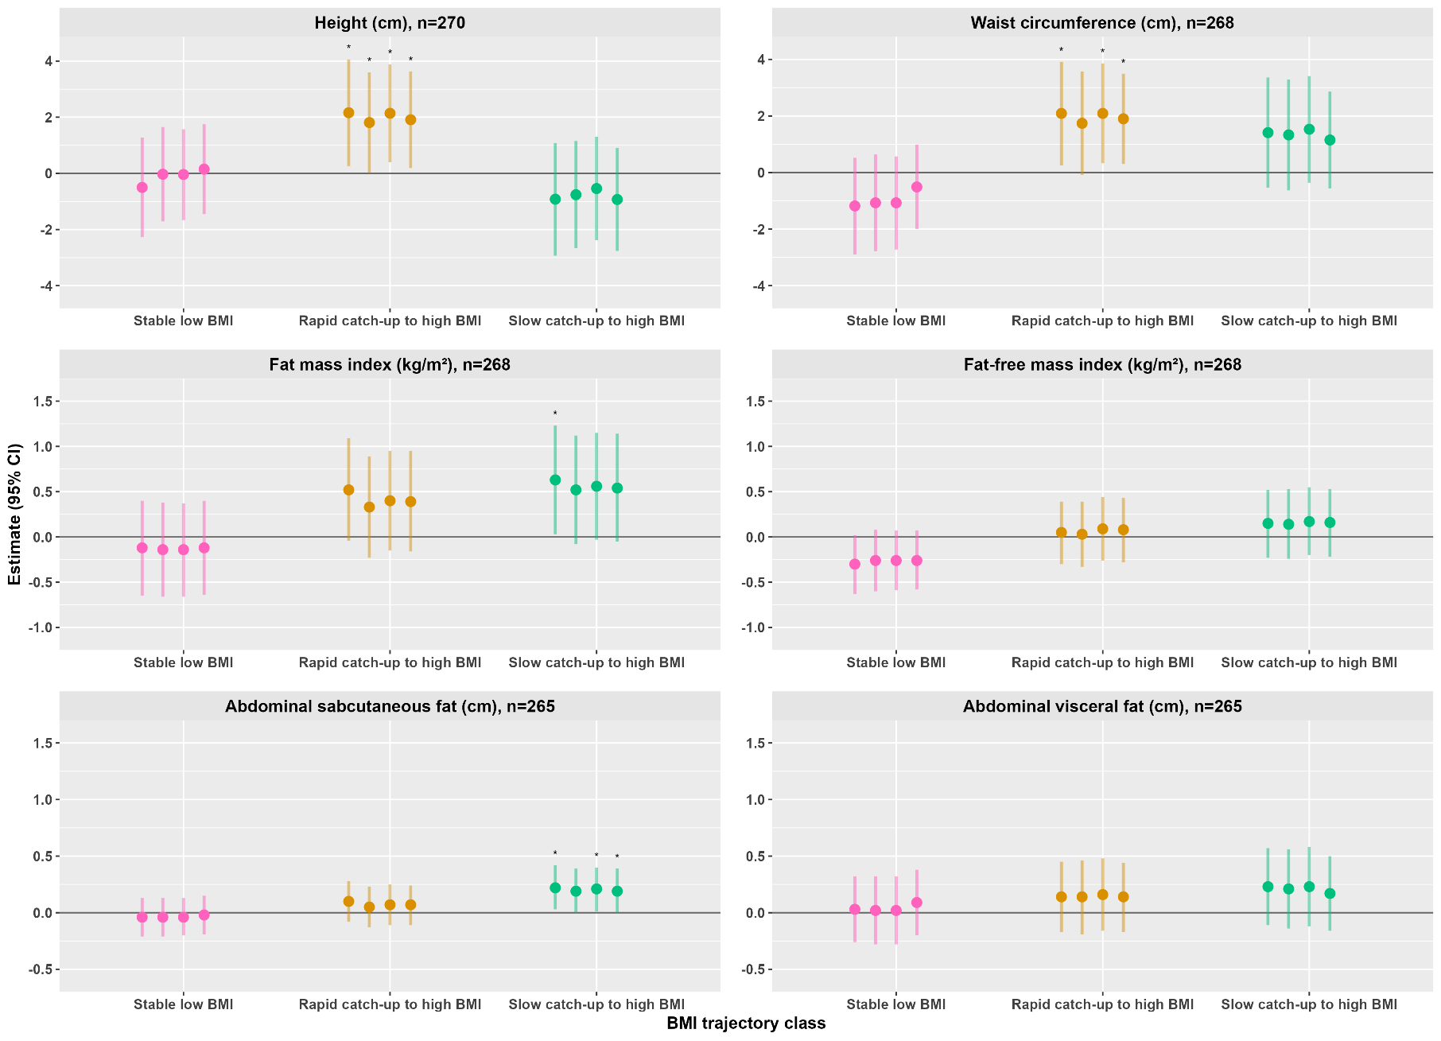
B)
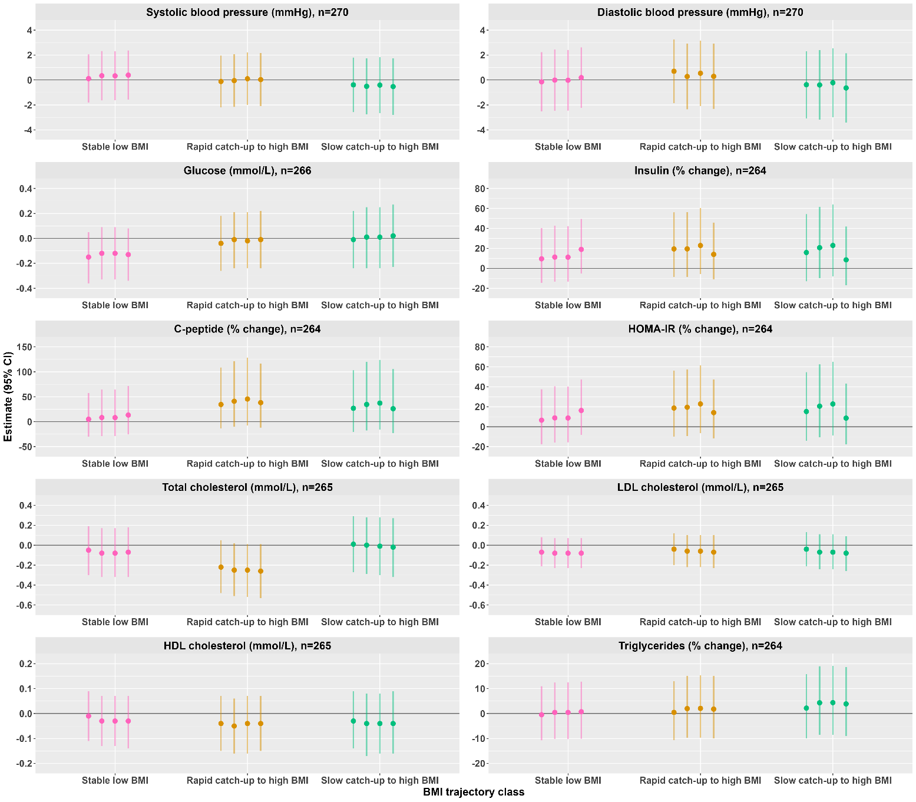
Supplemenatry Figure 2 Panels A and B show sensitivity analysis of associations between BMI trajectories from birth to 5 years and 10-year outcomes (anthropometry, body composition, abdominal fat, and cardiometabolic markers) after further adjusting for breastfeeding among 270 children having the data. The estimates (β) and (95 % CI) were derived from multiple linear regression, and represent the mean difference between the reference trajectory (normal BMI ) and each trajectory class. The vertical bars from left to right represent models 1-4 and each outcome presented on the top of exposure varibales (BMI trajectories). ²Homeostatic model assessment of insulin resistance (HOMA-IR) was calculated as insulin (μU/mL) × glucose (mmol/L)/22.5. Slightly skewed variables (insulin, C-peptide, HOMA-IR, and triglycerides) were log-transformed prior to the regression analyses, and the estimates of these variables were back-transformed and presented as percentage changes. We ran four separate models for each outcome variable, and the vertical bars from left to right represent models 1, 2,3,3, and 4, respectively. Each outcome variable was presented on the top of exposure variables (BMI trajectories). Model 1 was adjusted for child’s sex and age at 10 years. Model 2 was additionally adjusted for childbirth order, gestational age at birth, maternal age at delivery, maternal height, maternal highest educational status, and parental economic status. Model 3 was further adjusted for child’s birth weight. In addition to the preceding models, model 4 was adjusted for current BMI, except for waist circumference which was adjusted for fat-free mass index, fat mass index for fat-free mass index, fat-free mass index for fat mass index, abdominal fat (subcutaneous and visceral) for current fat-free mass index.

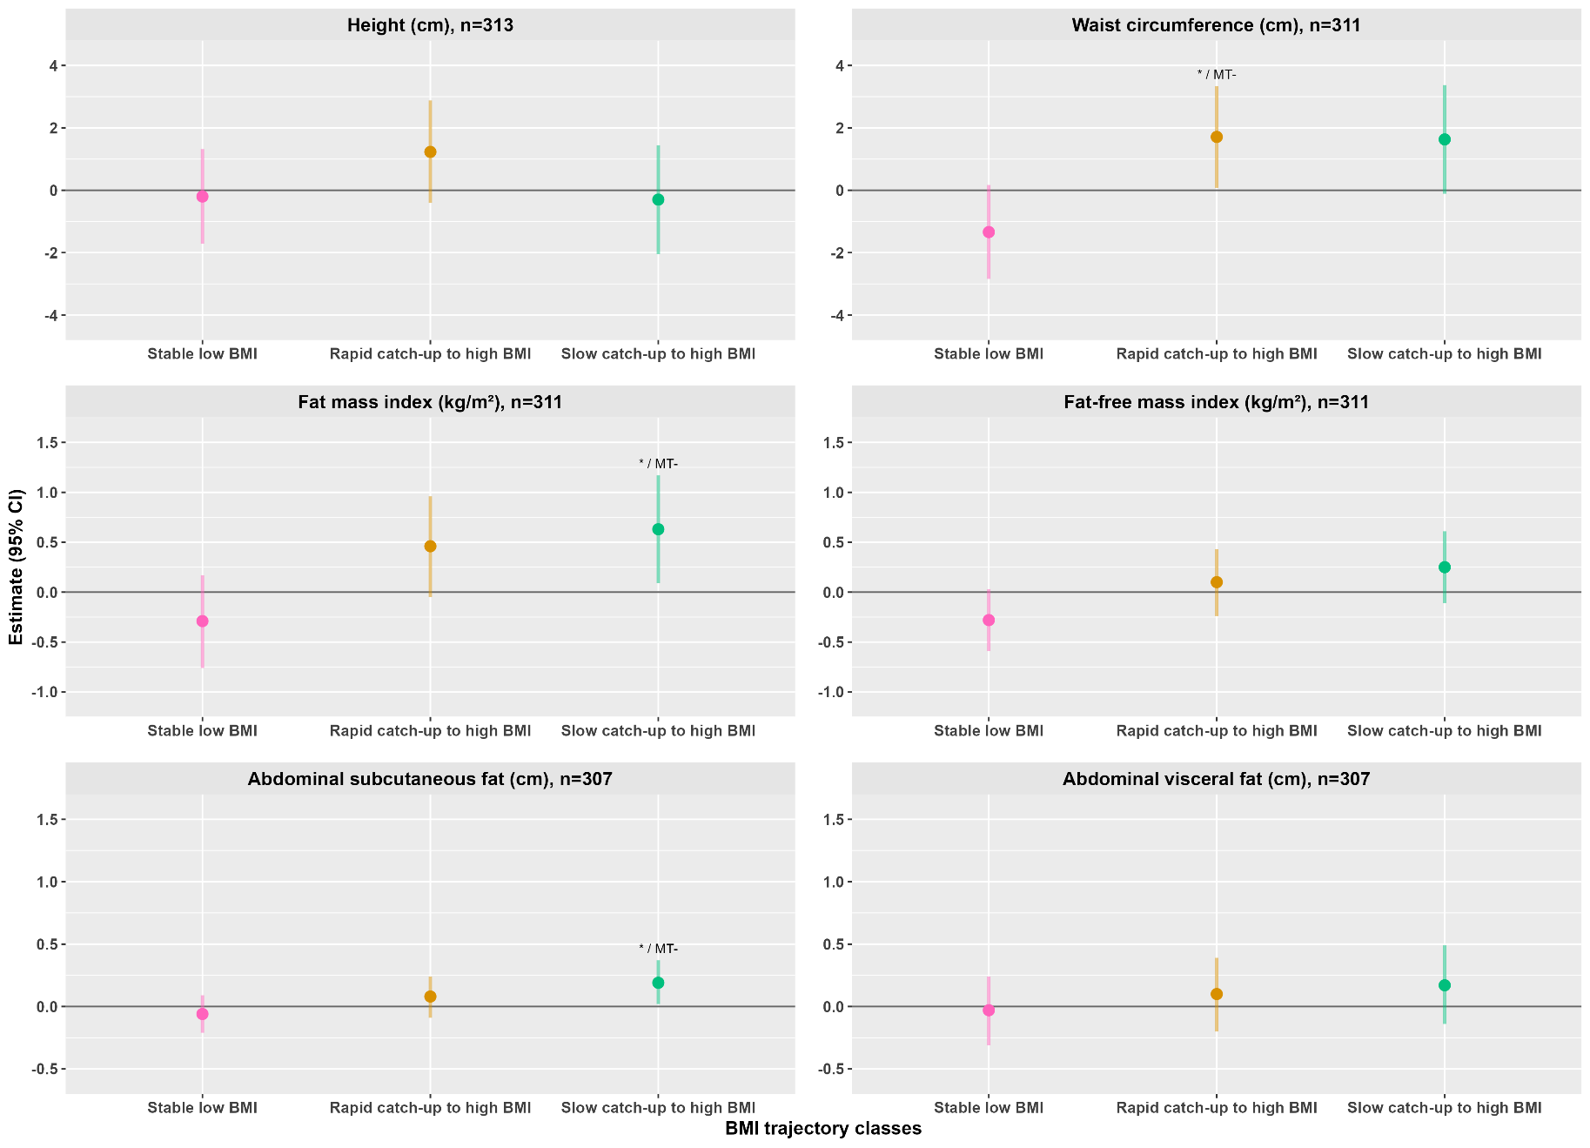
Figure 3 Sensitivity analysis of associations between BMI trajectories from birth to 5 years and 10-year outcomes (anthropometry, body composition, abdominal fat, and cardiometabolic markers) after accounting for multiple testing in the final model (model 3). We adjusted significant associations, P ≤ 0.05 for multiple testing using the Benjamin-Hochberg method. The significant stars (* P≤0.05) before the forward slash show significance levels before Benjamin-Hochberg adjustment, and the designated “MT+” indicates the remained significance, whereas “MT-” shows that no significance is left after the adjustment. The estimates (β) and (95% CI) were derived from multiple linear regression, and represent the mean difference between the reference trajectory (normal BMI ) and each trajectory. Each outcome variable is presented on the top of the exposure variables (BMI trajectories), and the vertical bar stands for the 95% CI of each outcome from model 3. The final model (model 3) was adjusted for child’s sex, age at 10 years, childbirth order, gestational age at birth, maternal age at delivery, maternal height, maternal highest educational status, parental economic status at delivery, and child’s birth weight. Each outcome variable is presented on top of the exposure variables (BMI trajectories).

