Time to scale up PrEP beyond the highest-risk populations? Modelling insights from high-risk women in sub-Saharan Africa

Hannah Grant (PhD)^{1,2}, Gabriela B. Gomez (PhD)¹, Katharine Kripke (PhD)³, Ruanne V. Barnabas (PhD)⁴, Charlotte Watts (PhD)¹, Graham F. Medley (PhD) ^{1,2}, Zindoga Mukandavire (PhD)^{5,6}.
¹ Department of Global Health and Development, Faculty of Public Health and Policy, London School of Hygiene and Tropical Medicine, London, UK
² Centre for Mathematical Modelling of Infectious Diseases, London School of Hygiene and Tropical Medicine, London, UK
³ Avenir Health, Washington, D.C., USA
⁴ Global Health and Medicine, University of Washington, Seattle, WA, USA
⁵ Center for Data Science, Coventry University, Coventry, UK
⁶ School of Computing, Electronics and Mathematics, Coventry University, Coventry, UK

Corresponding author contact information
Hannah Grant: Department of Global Health and Development, Faculty of Public Health and Policy, London School of Hygiene and Tropical Medicine, London, UK.
hannahmargaretgrant@gmail.com. Tel: +44 20 7636 8636.

Word count (Abstract, excluding heading names): 247

Word count (Short summary): 28

Word count (Main manuscript): 3500

Number of references: 81

Number of tables and figures: 6

Funding: None

Conflicts of interest: The authors declare no conflicts of interest.
GBG would like to declare that she has recently commenced employment with Sanofi Pasteur. She was employed by the London School of Hygiene and Tropical Medicine during the analysis and write up of the study presented. Her current role at Sanofi Pasteur does not relate to PrEP or HIV or South Africa.

Short summary: A study exploring strategies for scale-up of PrEP for women at population-level across sub-Saharan African countries spanning a range of HIV burden, weighing individual cost-effectiveness with population impact.

Abstract
Objectives: New HIV infections remain higher in women than men in sub-Saharan Africa. PrEP is an effective HIV prevention measure, currently prioritized for those at highest risk, such as female sex workers (FSW), for whom it is most cost-effective. However, the greatest number of HIV infections in sub-Saharan Africa occur in women in the general population. As countries consider wider PrEP scale-up, there is need to weigh the population-level impact, cost and relative cost-effectiveness to inform priority-setting.
Methods: We developed mathematical models of HIV risk to women and derived tools to highlight key considerations for PrEP programming. The models were fitted to South Africa, Zimbabwe and Kenya, spanning a range of HIV burden in sub-Saharan Africa. The impact, cost and cost-effectiveness of PrEP scale-up for adolescent girls and young women (AGYW), women 25-34 years and women 35-49 years were assessed, accounting for differences in population sizes and the low program retention levels reported in demonstration projects.
Results: PrEP could avert substantially more infections a year among women in general population than among FSW. The greatest number of infections could be averted annually among AGYW in South Africa (24-fold that for FSW). In Zimbabwe, the greatest number of infections could be averted among women 25-34 years (8-fold that for FSW), and in Kenya similarly between AGYW and women 25-34 years (3-fold that for FSW). However, the unit costs of PrEP delivery for AGYW, women 25-34 years and women 35-49 years would have to reduce considerably (by 70.8-91.0% across scenarios) for scale-up to these populations to be as cost-effective as for FSW.
Conclusions: PrEP has the potential to substantially reduce new HIV infections in HIV-endemic countries in sub-Saharan Africa. This will necessitate PrEP being made widely available beyond those at highest individual risk, and continued integration into a range of national services and at community level to significantly bring down the costs and improve cost-effectiveness.

Key words: HIV, pre-exposure prophylaxis, female sex workers, adolescent girls and young women, scale-up, women, impact, cost-effectiveness, sub-Saharan Africa

Introduction
Women remain the most affected by the global HIV epidemic. In sub-Saharan Africa, the region with the greatest HIV burden, 59% of new adult infections are among women¹. In 2018, a quarter of all new infections were among adolescent girls and young women (AGYW) aged 15-24 years², whilst female sex workers (FSW) are up to 20 times more likely to be HIV positive than women in the general population³.

Oral pre-exposure prophylaxis (PrEP) has shown HIV prevention efficacy in randomised controlled trials (up to 99% risk reduction, depending on drug adherence and study population)^{4,5}. It is hoped PrEP will address some of the drivers of HIV in women, which include lack of agency to negotiate sex and condom use¹. Aside from women in sero-discordant relationships⁶, PrEP demonstration projects have faced challenges in retaining women^{7–9}, raising concerns about the ability of programs to avert infections when scaled-up¹. A recently completed PrEP demonstration project among FSW in South Africa reported 22% 12-month program retention rates⁷. Early results from programming in Kenya^{9,10,11} and Zimbabwe¹² show even lower retention rates in AGYW than FSW.

As PrEP is rolled out in countries in sub-Saharan Africa in line with 2016 normative guidance, its use has been prioritised for populations at substantial risk of HIV¹³, including FSW, AGYW and individuals with history of low condom use, STIs, multiple concurrent partnerships and transactional sex^{14–23}. PrEP programs are being hosted by services tailored for groups at highest risk of infection, or in general services with screening tools used to identify those most at risk. There have been challenges with the sensitivity and specificity of screening tools, which may serve better as an initiator of client-provider dialogue rather than as a determinator of eligibility^{13,24–27}. Increasingly, there is pressure for countries to move towards universal access to PrEP as part of a rights-based approach to health²⁸. The rights-based language of PrEP programming is shifting to refer to populations who could benefit from PrEP, rather than focus on an individual’s level of risk²⁸.

Whilst FSW are typically women at highest HIV risk², HIV incidence among women in the general population varies significantly by age range across countries in sub-Saharan Africa², To date, six of the eight finalised population-based HIV impact assessments (PHIA) undertaken in sub-Saharan African countries reveal higher levels of incidence in women 25-34 years or 35-49 years than in AGYW 15-24 years^{29–36}. Policy makers are having to weigh the potential benefits and challenges of scaling up PrEP for groups of women at lower individual levels of risk, but in whom the total number of new infections is greater due to differences in population sizes¹.

Decisions around PrEP scale-up are taking place in a context of limited external resources for HIV, constraints in domestic budgets and a global push for countries to prioritize resources to reach the 90-90-90 treatment targets¹. These decisions mirror those previously faced by policy makers in determining whether to scale up antiretroviral treatment (ART) for individuals at higher CD4 counts, balancing comparatively lower benefits for individuals with potential for greater population-level prevention effects¹³.

Several modelling studies have evaluated the cost-effectiveness and impact of PrEP for high-risk populations in sub-Saharan Africa^{37–41}; between key populations and men/ women in the general population^{42,43}; between groups in the general population^{44–47}; relative to other HIV prevention interventions and ART^{40,44,45,48–51}. Studies typically find PrEP to be less cost-effective than other established prevention interventions or scaling up ART, but cost-effective as part of a combination prevention approach for those at greatest risk. To date no study has assessed the scale-up of PrEP from highest-risk populations (e.g. FSW) to groups of women across the general population at comparatively lower risk, weighing cost-effectiveness on an individual basis with the need to avert the greatest number of infections at a population level.

Our study aims to build simple mathematical models to highlight key considerations to feed into policy making, as countries consider scaling-up PrEP across a more broadly defined group of women at risk in sub-Saharan Africa. It aims to present decision makers with a range of important considerations, including PrEP cost-effectiveness, cost and estimated number of HIV infections averted on PrEP for different groups of women at population-level. We use case studies of three HIV-endemic countries: South Africa, Zimbabwe and Kenya. These countries, spanning a range of HIV burden levels in the region, have each adopted a national PrEP strategies^{19–21}, and been at the forefront of PrEP roll-out in sub-Saharan Africa²⁸. This study makes a first attempt to address a gap in the literature, given the limited use of real-world PrEP retention and use-effectiveness data in parameterizing modelling studies⁵².

Materials and Methods
As the contexts in which the models are being applied are stable generalised high prevalence HIV epidemics¹, we adopted static mathematical models of HIV risk^{53–55}. Static models are a comparatively easier tool for use and communication with policy makers, and have been shown to be robust to inform policy making around the introduction of new HIV interventions over short-medium time horizons in stabilised epidemics⁵⁶.

The mathematical models take the Bernoulli formulation of HIV risk⁵⁶. In this model formulation, women’s sexual partners are assumed to come from one or more population groups, each with a given level of HIV prevalence. Women are assumed to have a certain number of partners from each of these population groups per year, with whom they have an average number of sex acts each per year. Sex acts are assumed to be peno-vaginal, which is the predominant pathway of HIV transmission to heterosexual women in sub-Saharan Africa¹. Condoms are assumed to be used with partners from each population group with a given level of consistency (% of time that they are used). The risk-reduction efficacy of condoms is taken to be 85% (range 80-90%)^{57,58}. We used estimates for women from the Partners Demonstration Project⁵⁹ to relate levels of PrEP adherence to levels of HIV risk reduction. We used the 12-month PrEP programme retention levels reported in the South African TAPS demonstration project in FSW⁷ (the only study to date from which there is empirical evidence of 12-month PrEP retention levels in women in sub-Saharan Africa)$.$ The models also account for STI levels, levels of viral load suppression due to ART in HIV positive partners, and male circumcision. Analyses were conducted over a one-year timeframe, as PrEP is intended to cover ‘seasons’ of HIV risk, and few PrEP demonstration programs have achieved significant retention in women in this context beyond the first 12 months^{7,9}. The mathematical models, basic rules derived from them, and data used to parameterise and calibrate the models are given in the Supplementary Materials: Supplementary Methods section. All models were programmed in R version 3.3.2.

Tools to help guide PrEP programme decision making
Heatmaps were developed to help guide programme decision making using a basic set of information typically available to PrEP programmes⁶⁰. They are intended to apply to women from any age group, to help programmers understand their underlying HIV risk and evaluate whether PrEP may be of benefit to them. The first set of heatmaps helps decision makers estimate the annual HIV incidence in women by number of monthly sex acts, average condom use and underlying epidemic setting (i.e. HIV prevalence in the partner population). The number of monthly sex acts, average condom use and HIV prevalence in the partner population are simulated over a range of possible levels in the sub-Saharan African context – spanning women who have very low to very high risk behaviours.

The second set of heatmaps helps decision makers estimate the relative unit cost at which it will be cost-effective to scale up PrEP from a comparatively higher- (e.g. FSW) to comparatively lower-risk woman (e.g. AGYW). The cost-effectiveness ratio is defined as the incremental cost of PrEP per infection averted, per year. It accounts for the level of PrEP program retention and average PrEP adherence. The cost-effectiveness ratio and further details are given in Supplementary Materials: Supplementary Methods section 2.2 and equation S2.5. In the absence of willingness-to-pay thresholds, relative cost-effectiveness was assessed by comparing estimates of cost per infection averted between populations. It was assumed that the higher-risk group had 22% PrEP program retention levels and all women retained had PrEP adherence levels of 70-85% (corresponding to risk-reduction of 73-99%⁵⁹), consistent with the South African TAPS demonstration project in FSW⁷. Given this paucity of empirical data, PrEP program retention for the lower-risk group was simulated between $±$25% of the 22% retention levels of the higher-risk group (i.e. 16.5%-27.5%), consistent with the difference between 6-month AGYW and FSW retention in Kenya⁹ for the lower bound, and for the upper bound to account for data uncertainty. For lower-risk women retained in the PrEP program, it was assumed that PrEP adherence was the same as the higher-risk group.

Country case studies
In order to highlight key considerations to feed into decision making as countries consider scaling-up PrEP beyond those at highest-individual risk, we assessed the cost-effectiveness, cost and impact of scaling-up PrEP for women across a spectrum of high HIV risk in South Africa, Zimbabwe and Kenya. Given their significantly higher individual HIV risk¹, FSW were taken as the benchmark for assessment. In comparison, we considered the scale-up of PrEP to three groups of women at high HIV risk in the general population^{61–63}: AGYW, women 25-34 years and women 35-49 years. No further targeting of PrEP was assumed. Women aged 50+ were not evaluated given paucity of information available to parameterise and fit the models in all three country contexts^{29,64–67}.

FSW were assumed to have partners drawn from two populations: regular partners and clients. AGYW were assumed to have partners drawn from their own age group (15-24 years) and the 25-34 years age group, given that 17% and 14% women 15-19 years report relationships with men at least 10 years older in Zimbabwe⁶⁵ and Kenya⁶⁶ respectively, and 36% South African women 15-19 years report relationships with men at least 5 years older⁶¹. Women 25-34 years and women 35-49 years were assumed to have partners drawn from their own age groups given lack of data to suggest otherwise. This assumption was explored further through structural sensitivity analysis (see below section). Data to parameterise the models were drawn from the literature and fitted to the latest national estimates of HIV incidence^{29,68–75} using Bayesian Monte Carlo Filtering with Latin Hypercube Sampling. See Supplementary Materials: Table S2 for all data used in parameterising and fitting the models.

FSW were assumed to have 12-month PrEP program retention and adherence levels consistent with the TAPS demonstration project⁷. All other women were assumed to have program retention levels between $±$25% of these 12-month FSW retention levels⁹, and the same adherence levels as FSW retained in the program. To explore the role of adherence, the parametric uncertainty analyses were repeated with 1) 25% lower HIV risk-reduction across all groups, and 2) 25% lower HIV risk-reduction across AGYW, women 25-34 years and women 35-49 years (unchanged among FSW).

As a comparison, we estimated the current unit costs of PrEP program delivery per person retained after 12-months (Table 1). We assumed FSW were offered PrEP through programmes with outreach and community mobilisation components and all other women were offered PrEP through sexual and reproductive health services, with AGYW having larger counselling components. Further information on the methodology and assumptions are set out in Supplementary Materials: Supplementary Methods section 2.2 and in the assumptions column in Table 1.

Structural sensitivity analysis
We explored how the model outcomes change if women aged 25-34 years have an additional partner group from an older male population (35-49 years); illustratively assuming 50% the number of partners a year from this age group as had by women 35-49 years.

Further details on the methods are set out in Supplementary Materials: Supplementary Methods, and all data used in the study in Supplementary Materials: Table S2.

Results
Figure 1 shows the estimated annual HIV incidence in women, according to their number of monthly sex acts and their average condom use. The estimates are shown for four cases: underlying HIV prevalence in partner population of 5%, 10%, 20% and 40%.

Figure 1 shows that where women’s partners come from a population with HIV prevalence of up to 5%, women will be below the 3%¹³ WHO-recommended annual HIV incidence threshold for PrEP where the number of sex acts a month is up to 10 and average condom use is at least 50% (areas shaded yellow). As the underlying HIV prevalence in the partner population increases, women will need higher levels of condom consistency or to engage in fewer sex acts a month to be below the WHO incidence threshold for PrEP (areas shaded orange-red). Where women’s partner population have a prevalence of 40%, women will almost uniformly be above the threshold for PrEP.

The relative cost at which PrEP will be equally as cost-effective to be scaled-up in the lower-risk group as it will be in the higher-risk group, is demonstrated in Figure 2 for four scenarios: underlying HIV prevalence in the lower-risk women’s partner population of 10%, 20%, 30% and 40%, with HIV prevalence in the higher-risk women partner population of 40%. The equivalent figure corresponding to 20% HIV prevalence in the higher-risk women’s partner population is given in Supplementary Materials: Figure S4. The relative cost at which PrEP will be equally as cost-effective is shown by the relative average condom use in the lower-risk group compared to the higher-risk group (x-axis), and the relative number of sex acts a month for women in the lower-risk group compared to the higher-risk group (y-axis).

Where HIV prevalence in the lower-risk women’s partner population is 10%, the results show that the unit cost of PrEP in the lower-risk group will have to be much lower than in the higher-risk group for PrEP roll-out to be equally as cost-effective (areas shaded yellow), other than where the numbers of monthly sex acts in the lower-risk group exceeds that of the higher-risk group (areas shaded green). This is independent of the levels of condom use by either the higher- or lower-risk women. As HIV prevalence increases in the lower-risk women’s partner population relative to the higher-risk women’s partner population, PrEP will be equally cost-effective between the two groups at increasingly higher unit costs for the lower-risk group relative to the higher-risk group. Relative cost-effectiveness does not, however, imply affordability at either individual or population level⁴⁰.

In Figure 2, 100% on the axes represents the point at which condom use or the number of sex acts per month in the “lower-risk” woman goes from being lower than to the same as in the “higher-risk woman”. This may represent the case that, for example, an AGYW engaging in transactional sex has higher risk behaviours (e.g. lower condom use) than a FSW (e.g. with relatively high levels of condom use).

Country case studies
The model fits to HIV incidence for South Africa, Zimbabwe and Kenya are given in Supplementary Materials: Figures S1-S3.
Figure 3 shows the maximum unit cost of PrEP for AGYW, women 25-34 years and women 35-49 years, relative to the unit cost of PrEP for FSW, for scale-up to be equally as cost-effective as it is in FSW. This is shown for South Africa (blue), Zimbabwe (orange) and Kenya (green). As comparators, the estimated current relative unit costs are shown (cream). The underlying data for Figure 3 are given in Table 2.

For example, in the case of AGYW in South Africa, Figure 3 shows that PrEP will be equally cost-effective for AGYW as for FSW at a maximum median relative unit cost of 23.3 % (95% CrI: 13.3%, 36.8%) (furthest left blue boxplot). The current estimated unit cost of PrEP in AGYW relative to FSW in South Africa is median 79.8 % (95% CrI: 73.0%, 87.0 %) (furthest left cream boxplot). If the cost of PrEP for AGYW in South Africa dropped by median 70.8% (95% CrI: 53.2%, 83.4 %) it would be equally as cost-effective as for FSW.
Otherwise, across all other scenarios in all three countries, the current unit cost of PrEP for AGYW, women 25-34 years and women 35-49 years would have to drop between median 71.8-91.0% (95% CrIs spanning: 50.8%, 96.5%) to be equally as cost-effective.

Figure 4 illustrates the estimated number of infections that could be averted a year due to PrEP in each high-risk women population group, in each country, for every $100,000 available for PrEP programming.

Given the differences in relative population sizes, Figure 5 demonstrates the relative number of infections that could be averted a year with PrEP at equal coverage levels in AGYW, women 25-34 years and women 35-49 years as in FSW. In comparison to the number of infections averted annually in FSW in South Africa, a median 24 times (95% CrI:12, 45) the number of HIV infections could be averted in AGYW, median 14 times (95% CrI:7, 27) in women 25-34 years, and median 8 times (95% CrI:4, 17) in women 35-49 years, if PrEP were rolled out at the same coverage levels across populations. However, the cost of these programmes relative to the cost of programmes for FSW would be a median 28.3-, 26.7- and 18.7-fold higher for AGYW, for women 25-34 years and for women 35-49 years, respectively (Supplementary Materials: Table 4a).
In Zimbabwe, a median 4 times (95% CrI:2, 9) the number of annual HIV infections could be averted in AGYW, median 8 times (95% CrI:3, 14) in women 25-34 years, and median 3 times (95% CrI:2, 5) in women 35-49 years, in comparison to FSW with equal PrEP program coverage. However, the cost of these programmes relative to the cost of programmes for FSW would be a median 21.9-, 15.2- and 7.0-fold higher for AGYW, for women 25-34 years and for women 35-49 years, respectively.
In Kenya, a median 3 times (95% CrI:2, 8) the number of HIV infections could be averted in AGYW, median 3 times (95% CrI:1, 5) in women 25-34 years, and median 1 times (95% CrI:1, 3) in women 35-49 years, in comparison to FSW with equal PrEP program coverage. However, the cost of these programmes relative to the cost of programmes for FSW would be a median 27.4-, 16.4- and 8.5-fold higher for AGYW, for women 25-34 years and for women 35-49 years, respectively.

Sensitivity analyses
Repeating the analyses shown in Figures 3 and 5 with 25% reduced adherence-related HIV risk-reduction across all female groups led to <0.01% change across the scenarios (Supplementary Materials: Tables S9 and S10). Repeating these analyses with 25% reduced adherence-related HIV risk reduction among all non-FSW women groups led to <0.3% change across the scenarios (Supplementary Materials: Tables S11 and S12). Repeating these analyses under the structural sensitivity analysis led to <1% change across scenarios (Supplementary Materials: Tables S13 and S14).

Discussion
This is the first study to assess the potential impact and relative cost-effectiveness of PrEP scale-up from FSW to groups of women in the general population groups among countries in sub-Saharan Africa, using updated data from PrEP programming to highlight key considerations for decision making. Our findings may be of interest to national policy makers as they consider adopting PrEP policies based on more inclusive definitions of people at risk in line with conclusions from other studies that PrEP will only have substantial effect on generalised epidemics if scaled-up beyond highest-risk groups^{40,45,46}. PrEP should be offered to women at highest HIV risk, such FSW, for whom it is most cost-effective. However, only by extending PrEP to women at comparatively lower risk will new HIV infections reduce substantially.
We developed tools to guide PrEP programming: heatmaps to estimate the annual HIV incidence in women (Figure 1) and relative cost-effectiveness between higher- and lower-risk women (Figure 2). By adapting the models to three countries spanning the spectrum of high HIV burden contexts in sub-Saharan Africa, we have shown that the unit costs of PrEP delivery for AGYW, women 25-34 years and women 35-49 years would have to reduce considerably (by median 70.8-91.0% across scenarios) for scale-up to these populations to be as cost-effective as for FSW.
Rolling out PrEP for women in the general population has potential to substantially impact on the countries’ HIV epidemics. In South Africa, PrEP has the potential to avert approximately 24 times the number of infections annually in AGYW as in FSW when scaled up at equal coverage levels, and approximately 14 and 8 times the number in women 25-34 and 35-49 years respectively. In Zimbabwe approximately 8 times the number of infections could be averted annually in women 25-34 years as in FSW, and approximately 4 and 3 times the number in AGYW and women 35-49 years respectively. In Kenya, approximately 3 times the number of infections could be averted annually in AGYW and in women 25-34 years as in FSW, and around the same number in women 35-49 years as in FSW.
However, scaling up PrEP programs among the general population is likely to be costly and pose challenges of affordability. This study has shown that scaling up PrEP programs for AGYW, women 25-34 years and women 35-49 years would cost a median 18.7-28.3 times (across scenarios) the cost of programmes with equal coverage levels among FSW in South Africa. In Zimbabwe, programmes for these groups of women with equal coverage would cost a median 7.0-21.9 times the cost of programmes for FSW, and in Kenya, a median 8.5-27.4 times the cost of programmes for FSW.
Policy makers will need to weigh these prospects for population-level impact against affordability, in view of current program costs, budget constraints and program sustainability (although PrEP is for seasons of risk, rather than long-term use, so may be more feasibly scaled back as population incidence decreases). Relative cost-effectiveness does not indicate affordability at individual or population level⁴⁰. Scaling up PrEP for women in the general population has the potential to drive cost reductions through economies of scale. This will require countries to continue to integrate PrEP into a range of health, non-health and community services for women in the general population^{19–21}, which in some instances (e.g. education) may be challenging in local cultural contexts. Future long-acting PrEP formulations under investigation^{76–78}, may also help improve cost-effectiveness, if they increase HIV prevention use-effectiveness through improved product adherence and retention. This study complements the ongoing effort to use mathematical models as tools to understand PrEP scale-up in other countries outside of South Africa^{37–43},^{44–51,79,80}.

Limitations
This study was conducted using static mathematical models, given their comparative ease for use in policy making and they require a narrower and more readily available set of data in comparison to the more complex dynamic models typically used to HIV decision making. However, these models do not assess long-term cost-effectiveness⁸¹ or capture downstream infections averted in partner populations. Studies have shown that introducing HIV prevention interventions to high-risk groups has greatest impact on reducing onwards transmission early in epidemics when prevalence is low and the basic reproductive rate is high, than in endemic high-burden contexts^{82,83}, such as those in which our model is applied¹. Therefore, if the study were extended to look at the impact of PrEP beyond its recipients, the estimated number of infections averted would likely increase, the costs per infection averted would likely decrease, and modest changes would be expected comparing the relative impact between high-risk populations.

The heatmap tools in Figures 1 and 2 were developed to help PrEP programmers estimate women’s HIV risk using a basic set of information typically available to PrEP programmes (number of sex acts/ month, condom use, estimated HIV prevalence in partner population)⁶⁰. They do not account for more granular information, such as the presence of STIs in sexual partnerships, ART use or viral suppression among HIV positive partners, and male circumcision levels. Such information is needed to estimate a woman’s HIV risk more accurately. As such, the heatmap tools should be taken to be indicative, rather than precise, tools for estimating a woman’s HIV risk.

Much of the data used to characterise women are limited by age and lack of reliable data on numbers of partners and sex acts. Sexual behaviour data is subject to under-reporting, and when collected through demographic health surveys, reporting as percentages makes it difficult to derive meaningful limits or statistic distributions for the underlying data. Cost estimates are limited by assumptions on how subgroups are reached and scarcity of empirical data. Data uncertainty is addressed to some extent through the uncertainty analysis.

This study was parameterised using population averages for broadly defined groups. It does not account for significant behavioural heterogeneity that exists within each of these groups nor in differences in HIV burden at local-levels, potentially masking important risk groups and population interactions. Accordingly, reported population mixing between women 15-19 years and men 5-10 years older in these countries was represented by AGYW (15-24 years) drawing partners from male populations 15-24 years and 25-34 years. Lack of available data to parameterize women 50 years+ meant it was not possible to explore the scale-up of PrEP to this population group.

This assessment is limited by a paucity of empirical 12-month PrEP programme retention data for women in sub-Saharan Africa^{7,11}. Potential differences in PrEP programme retention by female population group were accounted for to some extent in the sensitivity analyses. Should future PrEP programmes be able to retain women for longer than 12-months, it is possible that greater programme efforts will be needed to maintain programme retention and drug adherence (e.g. retention support, client follow up), which may reduce the cost-effectiveness of programmes over longer time horizons. This study also does not explicitly account for other PrEP program cascade factors, such as uptake. Doing so would affect the relative estimates of PrEP effectiveness where at least one female population has materially different program uptake than the others.

Conclusion
PrEP has the potential to significantly reduce the numbers of new HIV infections in HIV-endemic countries in sub-Saharan Africa, even considering low levels of PrEP program retention in women. This will necessitate PrEP being made widely available beyond those at highest individual risk, including to women in the general population. Wide-scale roll out will require integration of PrEP into a wide range of national services and at community level, in order to significantly bring down the costs and improve cost-effectiveness.

Country | Population | Current unit cost  (min - max) | Service delivery excl. drugs | Drugs only  (min - max) | Specific Assumptions
South Africa | FSW | 190 – 210 | 130 | 57 - 80 | Unit costs measured during a demonstration project in Johannesburg and Pretoria via FSW clinics. Costs reported by Eakle et al⁷ included direct costs (eg, antiretrovirals, laboratory tests and consumables, labour and equipment) and indirect costs (eg, management, utilities, and transportation). We allocated outreach, demand creation and HCT costs to a unit cost of per person-year on PrEP as these were reported separately.
South Africa | AGYW (15-24 years) | 149 – 169 | 89 | 57 - 80 | Unit costs estimated from local data and with input from several demonstration projects in South Africa. Costs reported by Meyer-Rath et al⁸⁴ included direct costs (eg, antiretrovirals, laboratory tests and consumables, labour and equipment), indirect costs (eg, management, utilities, and transportation), and outreach, demand creation and HCT costs. These estimates reflect the authors’ estimation of costs among female adolescents.
South Africa | Women (25-34 years) | 128 – 148 | 68 | 57 - 80 | Unit costs estimated from local data and with input from several demonstration projects in South Africa. Costs reported by Meyer-Rath et al⁸⁴ included direct costs (eg, antiretrovirals, laboratory tests and consumables, labour and equipment), indirect costs (eg, management, utilities, and transportation), and outreach, demand creation and HCT costs. These estimates reflect the authors’ estimation of costs among young women.
South Africa | Women (35-49 years) | 87 – 107 | 27 | 57 - 80 | Unit costs estimated from local data and with input from several demonstration projects in South Africa. Costs reported by Meyer-Rath et al⁸⁴ included direct costs (eg, antiretrovirals, laboratory tests and consumables, labour and equipment), indirect costs (eg, management, utilities, and transportation), and outreach, demand creation and HCT costs. These estimates reflect the authors estimation of costs among pregnant women - we assumed for this lowest risk population, the cost will be similar to those attending ANC.
Zimbabwe | FSW | 293 – 317 | 237 | 57 - 80 | Drug costs were kept constant and we adjusted service costs in South Africa using PPP index.⁸⁵
Zimbabwe | AGYW (15-24 years) | 219 – 243 | 163 | 57 - 80 | Drug costs were kept constant and we adjusted service costs in South Africa using PPP index.⁸⁵
Zimbabwe | Women (25-34 years) | 181 - 204 | 124 | 57 - 80 | Drug costs were kept constant and we adjusted service costs in South Africa using PPP index.⁸⁵
Zimbabwe | Women (35-49 years) | 106 - 130 | 50 | 57 - 80 | Drug costs were kept constant and we adjusted service costs in South Africa using PPP index.⁸⁵
Kenya | FSW | 399 - 423 | 343 | 57 - 80 | Unit costs measured in preparation for a demonstration project in Nairobi via SWOP clinics (for FSW). Costs reported by Cremin et al⁸⁶ included direct costs (eg, antiretrovirals, laboratory tests and consumables, labour and equipment), related costs (eg, outreach and demand creation), and indirect costs (eg, management, utilities, and transportation).
Kenya | AGYW (15-24 years) | 358 - 382 | 302 | 57 - 80 | Unit costs measured as part of a demonstration project aiming to integrate PrEP into routine maternal and child health and family planning clinics in western Kenya. Costs reported by Roberts et al⁸⁷ included fixed (start-up costs, such as microplanning and training, capital, overheads (e.g. building costs, transportation, and airtime) and administrative and supervisory personnel) or variable (drugs, clinical personnel direct service costs, laboratory testing, and other supplies). These estimates reflect the authors measurement of costs among the highest risk subpopulation in the general population.
Kenya | Women (25-34 years) | 294 - 318 | 238 | 57 - 80 | Unit costs measured as part of a demonstration project aiming to integrate PrEP into routine maternal and child health and family planning clinics in western Kenya. Costs reported by Roberts et al⁸⁷ included fixed (start-up costs, such as microplanning and training, capital, overheads (e.g. building costs, transportation, and airtime) and administrative and supervisory personnel) or variable (drugs, clinical personnel direct service costs, laboratory testing, and other supplies). These estimates reflect the authors measurement of costs among all women.
Kenya | Women (35-49 years) | 185 - 209 | 129 | 57 - 80 | Unit costs measured as part of a demonstration project aiming to integrate PrEP into routine maternal and child health and family planning clinics in western Kenya. Costs reported by Roberts et al⁸⁷ included fixed (start-up costs, such as microplanning and training, capital, overheads (e.g. building costs, transportation, and airtime) and administrative and supervisory personnel) or variable (drugs, clinical personnel direct service costs, laboratory testing, and other supplies). These estimates reflect the authors measurement of costs among all women excluding screening costs.

Table 1: Current unit cost estimates per person retained on PrEP after 12-months by population and country.
The estimated current unit costs for FSW, AGYW, women 25-34 years and women 35-49 years are shown disaggregated by the portion that is service delivery costs and the portion that is drug costs. The costs were calculated in line with the methodology set out in Supplementary Materials: Methods section 2.2. Service delivery costs were taken from demonstration projects and previous costing publications in Kenya^{86,87} and South Africa⁷. For Zimbabwe, non-tradable components of the South African estimates were transferred using purchasing power parities⁸⁸. Costs in USD 2017. Ranges were only available for drug unit costs. The far right hand side column of the table sets out specific assumptions made in the calculations.
*For these calculations, we replaced reported drug costs by a range of USD57-80. The low bound is the internationally traded value of USD3.75 (https://www.theglobalfund.org/media/5813/ppm_arvreferencepricing_table_en.pdf) plus 25% top up of freight and distribution costs in country (15% shipping and handling charges, and 10% for drug distribution costs). The high bound is the highest reported price for drugs in the demonstration projects - 30 days TDF/FTC at USD6.75.
**transferability of costs between countries followed standard guidelines (https://pdfs.semanticscholar.org/36ab/74fd24fb883db703c475364c34ad574a3f35.pdf)
*** Purchasing Power Parities (PPP)

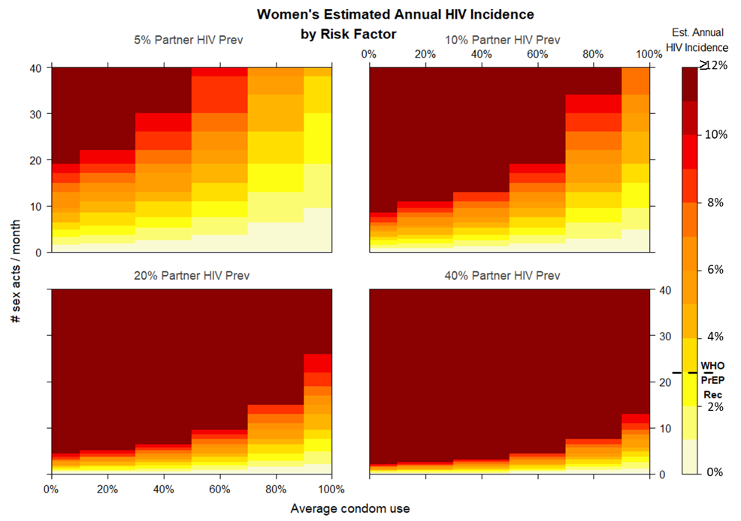
Figure 1: Women’s estimated HIV incidence by risk factor.
The heatmaps show the estimated annual HIV incidence in women according to their number of sex acts per month (number of partners multiplied by average number of sex acts with each per month), and average condom use. The estimated annual HIV incidence is shown by colour (according to the colour key on the right-hand side of the graph) in incidence increments of 1% or 1 per 100 person years. An annual incidence of at least 3% or 3 per 100 person years is coloured light orange and corresponds to the WHO recommended threshold for PrEP eligibility¹³. The 4 heatmaps correspond respectively (left to right, top to bottom) to underlying partner HIV prevalence of 5%, 10%, 20% and 40%. The heatmaps are calculated using equation (S1.1) from the Supplementary Materials: Supplementary Methods, section Model Structure, assuming that a women’s partners are drawn from a single population and no women are on PrEP.

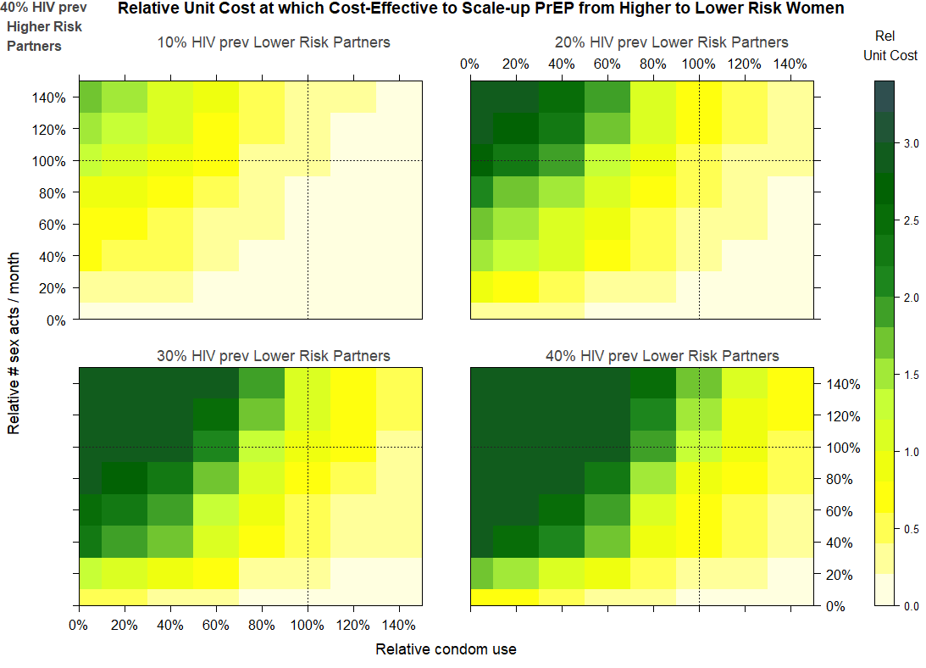
Figure 2: Relative unit cost at which it is cost-effective to scale up PrEP from a higher- to lower-risk women group.
The heatmaps show the relative unit cost at which it is cost-effective to scale up PrEP from a higher- to a lower-risk group. The relative unit cost at which PrEP is cost-effective is shown by the relative average condom use in the lower-risk group compared to the higher-risk group (x-axis), and the relative number of sex acts a month for women in the lower-risk group compared to the higher-risk group (y-axis). 100% on the axes represents the point at which the condom use or number of sex acts in the lower-risk group goes from being lower than to higher than in the levels in the higher-risk group.
The unit cost of PrEP in the lower-risk group relative to the higher-risk group at which PrEP is equally cost-effective between the two groups is shown by colour, according to the colour key on the right-hand side of the graph. A colour within the yellow spectrum denotes that the relative unit cost of PrEP in the lower-risk group relative to the higher-risk group has to be less than 1 for it to be equally as cost cost-effective. A colour within the green spectrum denotes that the relative unit cost of PrEP in the lower-risk group relative to the higher-risk group will be greater than 1 for it to be equally as cost cost-effective. The 4 heatmaps correspond respectively (left to right, top to bottom) to underlying partner HIV prevalence of 10%, 20%, 30% and 40% in the lower-risk group’s partner population and all of them corresponding to 40% HIV prevalence in the higher-risk women’s partner population. The heatmaps are calculated using equation (S1.5) from the Supplementary Materials: Supplementary Methods, section Model Structure, assuming that women’s partners are drawn from a single population each. The higher-risk group are assumed to have 12-month PrEP program retention levels of 22%⁷ and adherence levels of 70-85% (corresponding to a risk reduction of 73-99%⁵⁹). The PrEP program retention levels for the lower-risk group were simulated between +/- 25% the retention of the higher-risk group⁹. For those lower-risk women retained in the PrEP program, it was assumed that PrEP adherence was the same as the higher-risk group. The axes were capped at 140% relative condom use or number of sex acts/ month, in order to depict the most pertinent trends for programmers in the heatmaps.

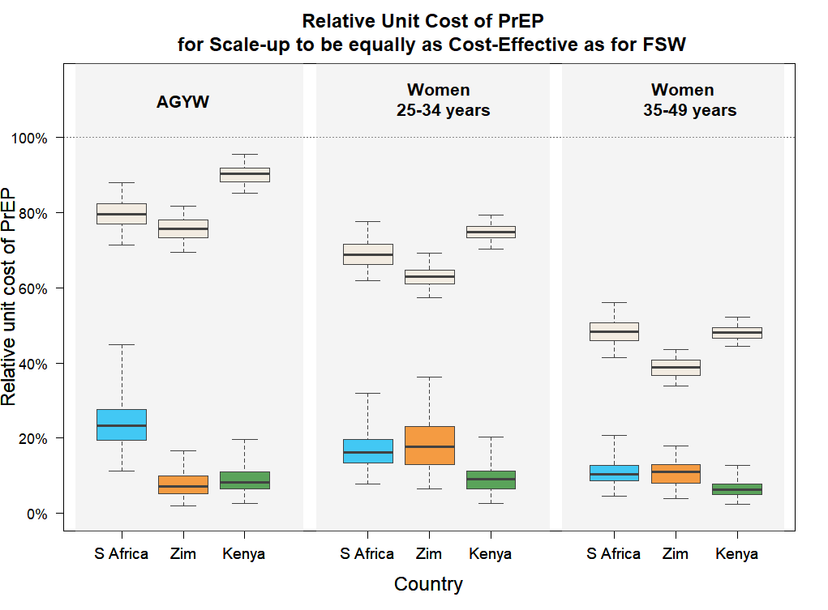
Figure 3: Relative unit cost of PrEP for scale-up to be equally as cost-effective as for FSW.
The boxplot shows the maximum unit cost of PrEP per year for AGYW, women 25-34 years or women 35-49 years relative to the unit cost of PrEP for FSW, for PrEP scale-up in these populations to be equally as cost-effective as it is for FSW (bright-coloured boxes). The maximum relative unit costs are shown, grouped left to right, for AGYW, women 25-34 years or women 35-49 years. Within each age grouping, the results are show by country, left to right, for South Africa (in blue), Zimbabwe (in orange) and Kenya (in green). The maximum relative unit costs are calculated using equation (S2.5) from Supplementary Materials: Supplementary Methods, section Model Structure and assume that 12-month PrEP program retention in AGYW, women 25-34 years or women 35-49 years is within +/-25% of retention levels for FSW, taken to be 22%, in line with the results of the TAPS demonstration project⁷. As comparisons, current estimates of the unit costs of PrEP for AGYW, women 25-34 years and women 35-49 years, relative to the unit cost of PrEP for FSW are shown for all countries (in cream), calculated using data from Table 1. The abbreviations used in the graph are as follows: AGYW denotes adolescent girls and young women 15-24 years, S Africa denotes South Africa and Zim denotes Zimbabwe.

 |  | Women Population Group
Country | Unit Cost Relative to FSWs | AGYW (15-24 years) | Women 25-34 years | Women 35-49 years
South Africa | Maximum Relative Unit Cost to be as Cost-Effective as for FSW | 23.3 % ( 13.3 % , 36.8 % ) | 16.2 % ( 9.1 % , 26.0 % ) | 10.5 % ( 5.7 % , 18.0 % )
 | Estimated Current Unit Cost Relative to FSW | 79.6 % ( 72.4 % , 86.7 % ) | 68.7 % ( 62.7 % , 75.8 % ) | 48.3 % ( 42.4 % , 54.7 % )
 | % Reduction in Current Unit Cost Needed to be Equally as Cost-Effective as for FSW | -70.8 % ( -83.4 % , -53.2 % ) | -76.2 % ( -87.0 % , -62.6 % ) | -78.4 % ( -88.1 % , -61.8 % )
Zimbabwe | Maximum Relative Unit Cost to be as Cost-Effective as for FSW | 7.1 % ( 2.7 % , 14.9 % ) | 17.7 % ( 7.1 % , 31.2 % ) | 11.0 % ( 5.5 % , 17.2 % )
 | Estimated Current Unit Cost Relative to FSW | 75.6 % ( 70.8 % , 80.8 % ) | 63.0 % ( 58 % , 67.7 % ) | 38.8 % ( 34.1 % , 42.7 % )
 | % Reduction in Current Unit Cost Needed to be Equally as Cost-Effective as for FSW | -90.4 % ( -96.5 % , -80.6 % ) | -71.8 % ( -88.9 % , -50.8 % ) | -72.0 % ( -86.1 % , -53.6 % )
Kenya | Maximum Relative Unit Cost to be as Cost-Effective as for FSW | 8.1 % ( 3.9 % , 18.5 % ) | 9.1 % ( 3.6 % , 17.7 % ) | 6.4 % ( 3.1 % , 11.6 % )
 | Estimated Current Unit Cost Relative to FSW | 90.3 % ( 86.2 % , 94.8 % ) | 74.9 % ( 71.1 % , 78.4 % ) | 48.1 % ( 45.1 % , 51.6 % )
 | % Reduction in Current Unit Cost Needed to be Equally as Cost-Effective as for FSW | -91 % ( -95.7 % , -79.6 % ) | -88 % ( -95.3 % , -76.6 % ) | -86.7 % ( -93.7 % , -75.4 % )
Table 2: Maximum Unit Costs of PrEP for AGYW, Women 25-34 years and Women 35-49 years to be Equally as Cost-Effective as for FSW, with Estimates of Current Relative Unit Costs.

For each country, the table displays three rows of information. The first row shows the maximum relative unit costs of PrEP in AGYW, women 25-34 years and women 35-49 years relative to the unit costs of PrEP for FSW, for PrEP to be equally as cost-effective. This is calculated using equation S1.5 in Supplementary Materials: Methods, considering the estimated relative annual HIV risk reduction on PrEP between the population groups.
The second row shows the estimated current relative unit costs between the populations, calculated using the data set out in Table 1.
The third row shows the % reduction in the current unit cost needed for PrEP to be equally as cost-effective for AGYW, women 25-34 years or women 35-49 years as for FSW, considering the data set out in Table 1.
The comparisons are shown separately for South Africa, Zimbabwe and Kenya. The values shown in the table outside the brackets are the median values, and the values shown in the brackets are the 95% credible intervals (CrIs).

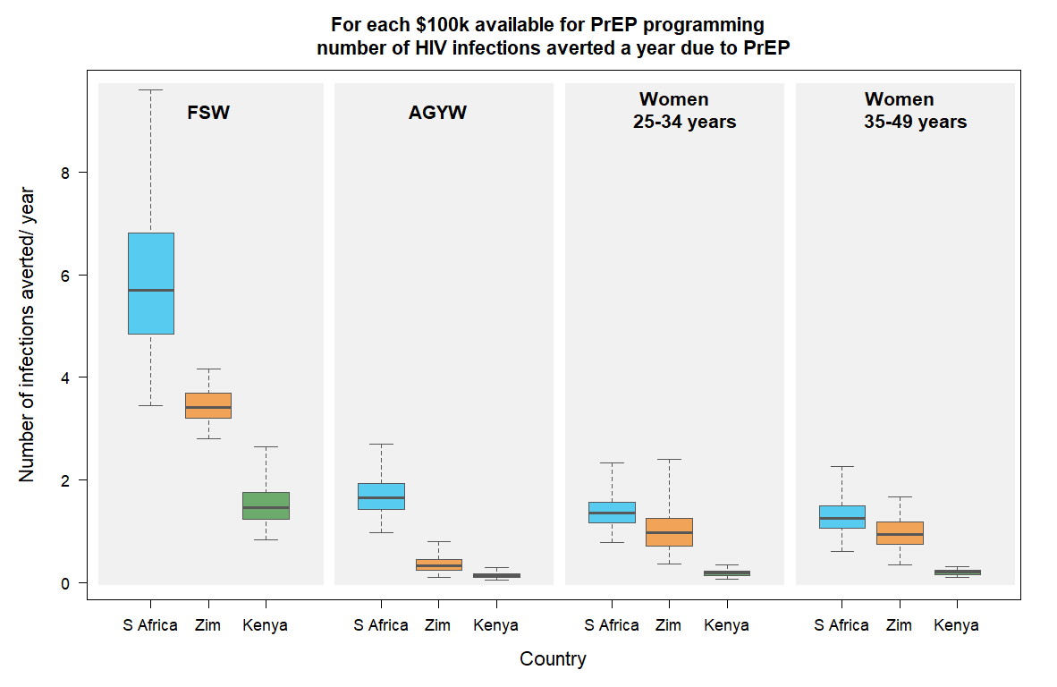
Figure 4: Boxplot of the number of HIV infections that could be averted a year due to PrEP, for each $100k available for PrEP programming.
The boxplot shows, for each $100k available for PrEP programming a year for FSW, AGYW, women 25-34 years and women 35-49 years, the total number of infections that could be averted a year due to PrEP. The number of infections that could be averted a year for each $100k available for PrEP are shown, grouped left to right, for FSW, AGYW, women 25-34 years or women 35-49 years. Within each age grouping, the results are shown by country, left to right, for South Africa (in blue), Zimbabwe (in orange) and Kenya (in green). The number of infections averted a year is calculated using equation (S2.10) from Supplementary Materials: Supplementary Methods, section Model Structure and assumes that 12-month PrEP program retention in AGYW, women 25-34 years or women 35-49 years is within +/-25% of retention levels for FSW, taken to be 22%, in line with the results of the TAPS demonstration project⁷. The unit costs of PrEP for each high-risk women group are as stated in Table 1. These estimates hold until PrEP saturation (determined by retention levels and population size) has been reached in the smallest population group – in this case, FSW. After this point, no additional financial resources will be able to reduce infections per year in this population group.
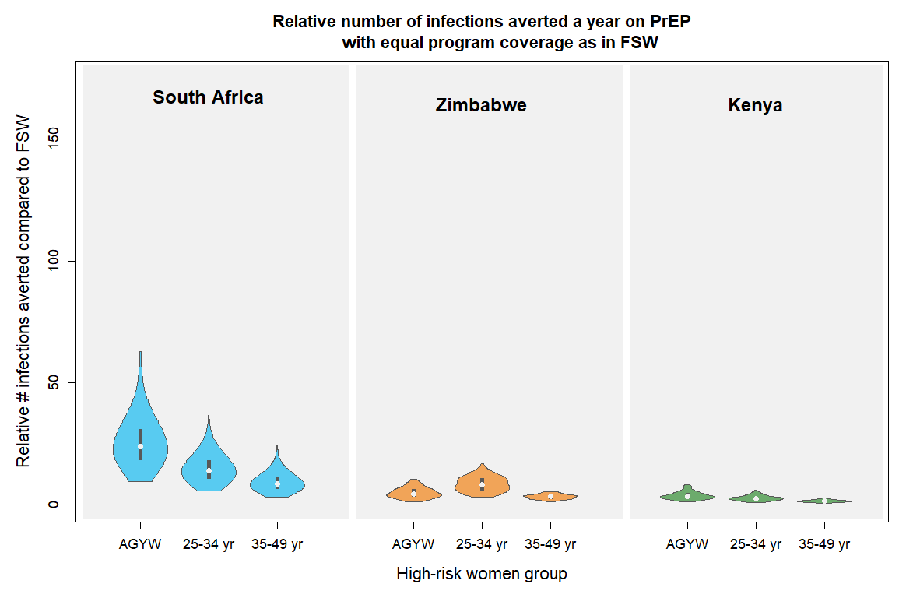
Figure 5: Violin plot of the relative number of infections averted a year on PrEP with equal program coverage as in FSW.
The violin plot shows the relative number of infections that could be averted a year in HIV negative AGYW, women 25-34 years or women 35-49 years, compared to in FSW, if PrEP were scaled up at the same coverage levels as in HIV negative FSW. The relative number of infections that could be averted are shown, grouped left to right, for South Africa (in blue), Zimbabwe (in orange) and Kenya (in green). In the violin plots, the white dots represent the median values, the thick black vertical lines represent the interquartile range, the vertical length of the violin represents the range of values and the width of the violin represents the frequency with which those values occur. The relative number of infections that could be averted are calculated using equation (S2.9) from Supplementary Materials: Supplementary Methods, section Model Structure and assumes that 12-month PrEP program retention in AGYW, women 25-34 years or women 35-49 years is within +/-25% of retention levels for FSW, taken to be 22%, in line with the results of the TAPS demonstration project⁷. If these comparisons were applied to more narrowly defined sub-population groups, the wide variability in the violin plot estimates highlight that decisions around PrEP scale-up will depend on the specific characteristics of the sub-population groups under consideration. The abbreviations used in the graph are as follows: AGYW denotes adolescent girls and young women 15-24 years, 25-34 yr denotes women 25-34 years and 35-49 yr denotes women 35-49 years in each country.

References
1. UNAIDS. Miles to Go: Closing Gaps, Breaking Barriers, Righting Injustices. Global AIDS Update 2018. Geneva; 2018.
2. UNAIDS. Communities at the Centre: Defending Rights, Breaking Barriers, Reaching People With HIV Services. Global AIDS Update 2019. Geneva; 2019.
3. Scorgie F, Chersich MF, Ntaganira I, Gerbase A, Lule F, Lo Y-R. Socio-Demographic Characteristics and Behavioral Risk Factors of Female Sex Workers in Sub-Saharan Africa: A Systematic Review. AIDS Behav. 2012 May 13;16(4):920–33.
4. Fonner VA, Dalglish SL, Kennedy CE, Baggaley R, O’Reilly KR, Koechlin FM, et al. Effectiveness and safety of oral HIV preexposure prophylaxis for all populations. AIDS. 2016;30(12):1973–83.
5. Grant, RM, Anderson, PL, McMahan, V, Liu, A, Amico, KR, and Mehrotra M. Results of the iPrEx open-label extension (iPrEx OLE) in men and transgender women who have sex with men: PrEP uptake, sexual practices, and HIV incidence. In: 20th International AIDS Conference. Melbourne; 2014.
6. Baeten JM, Heffron R, Kidoguchi L, Mugo NR, Katabira E, Bukusi EA, et al. Integrated Delivery of Antiretroviral Treatment and Pre-exposure Prophylaxis to HIV-1–Serodiscordant Couples: A Prospective Implementation Study in Kenya and Uganda. Siegfried N, editor. PLOS Med. 2016 Aug 23;13(8):e1002099.
7. Eakle R, Gomez GB, Naicker N, Bothma R, Mbogua J, Cabrera Escobar MA, et al. HIV pre-exposure prophylaxis and early antiretroviral treatment among female sex workers in South Africa: Results from a prospective observational demonstration project. Bekker L-G, editor. PLOS Med. 2017 Nov 21;14(11):e1002444.
8. Mboup A, Béhanzin L, Guédou FA, Geraldo N, Goma-Matsétsé E, Giguère K, et al. Early antiretroviral therapy and daily pre-exposure prophylaxis for HIV prevention among female sex workers in Cotonou, Benin: a prospective observational demonstration study. J Int AIDS Soc. 2018 Nov 1;21(11):e25208.
9. Kyongo J. How long will they take it? Oral pre-exposure prophylaxis (PrEP) retention for female sex workers, men who have sex with men and young women in a demonstration project in Kenya. In: 22nd International AIDS Conference. Amsterdam; 2018.
10. Mugwanya, K, Kinuthia, J, Pintye, J, Dettinger, JC, Begnel, E, Abuna, F, Lagat, H, Sila, J, John-Stewart, G, Baeten J. Persistence with PrEP use in African Adolescents and Young Women initiating PrEP in Maternal Child Health and Family Planning Clinics. In: CROI. 2019.
11. Inwani, I, Buttolph, J, Kawango, A et al. PrEP cohort results from MP3 youth combination HIV prevention pilot study. In: 9th IAS Conference on HIV Science. Paris, France; 2017.
12. Gwavava E. Understanding the Uptake and Retention Patterns of PrEP Users in Zimbabwe by Subpopulation. In: AIDS 2018. 2018.
13. World Health Organisation. Consolidated guidelines on the use of antiretroviral drugs for treating and preventing HIV infection Recommendations for a public health approach - Second edition. 2016.
14. Ministry of Health of Lesotho. National Guidelines on the use of Antiretroviral Therapy For HIV Prevention and Treatment: Fifth Edition. 2016.
15. Ministry of Health of Botswana. Handbook of the Botswana 2016 Integrated HIV Clinical Care Guidelines (May 2016). 2016.
16. Ministry of Health and Social Services of Namibia. National Guidelines for Antiretroviral Therapy. 2016.
17. Ministry of Health of Uganda. Consolidated Guidelines for the Prevention and Treatment of HIV and AIDS in Uganda. 2018.
18. Ministry of Health of Zambia. Zambia Consolidated Guidelines for Prevention and Treatment of HIV Infection. 2018.
19. Ministry of Health and Child Care. Implementation Plan for HIV Pre-Exposure Prophylaxis in Zimbabwe 2018-2020.
20. Kenya Ministry of Health; Kenya National AIDS and STI Control Programme. Framework for the Implementation of Pre-Exposure Prophylaxis of HIV In Kenya. 2017;1–84.
21. Department of Health: Republic of South Africa. National Policy on HIV Pre-exposure Prophylaxis (PrEP) and Test and Treat (T&T). 2016.
22. PEPFAR PrEP Expert Working Group. Recommendations on the Use of PrEP for All Populations PEPFAR Scientific Advisory Board (SAB): Submitted by the PrEP Expert Working Group (EWG) to the SAB. 2015.
23. U.S. President’s Emergency Plan for AIDS Relief. Dreaming of an AIDS-Free Future: DREAMS. 2018.
24. Wilton J, Kain T, Fowler S, Hart TA, Grennan T, Maxwell J, et al. Use of an HIV-risk screening tool to identify optimal candidates for PrEP scale-up among men who have sex with men in Toronto, Canada: disconnect between objective and subjective HIV risk. J Int AIDS Soc. 2016 Jan 1;19(1):20777.
25. Krakower DS, Mayer KH. The role of healthcare providers in the roll out of preexposure prophylaxis. Curr Opin HIV AIDS. 2016 Jan;11(1):41–8.
26. Calabrese SK. Implementation guidance needed for PrEP risk-prediction tools. Lancet HIV. 2019 Oct 1;6(10):e649.
27. PrEP Watch. Risk Assessment Tools and the Identification of Individuals at High-Risk of HIV infection in the Delivery of Oral PrEP Analysis and Recommendations Prepared by Megan Dunbar. 2018.
28. Rivet Amico K, Bekker L-G. Global PrEP roll-out: recommendations for programmatic success. lancet HIV. 2019 Feb 1;6(2):e137–40.
29. Ministry of Health and Child Care, Zimbabwe. Zimbabwe Population-Based HIV Impact Assessment: ZIMPHIA 2016. 2017.
30. Ministry of Health, Zambia. Zambia Population-based HIV Impact Assessment: ZAMPHIA 2016. 2019.
31. Tanzania Commission for AIDS (TACAIDS) and Zanzibar AIDS Commission (ZAC). Tanzania HIV Impact Survey: THIS 2016-2017. 2018.
32. Ministry of Health, Lesotho, Centers for Disease Control and Prevention (CDC), and ICAP at Columbia University. Lesotho Population-Based HIV Impact Assessment: LePHIA 2016-2017. 2019.
33. Government of the Kingdom of Eswatini. Swaziland HIV Incidence Measurement Survey 2. SHIMS2 2016-2017. Final Report. Mbabane: Government of the Kingdom of Eswatini. 2019.
34. Ministry of Health, Uganda. Uganda Population-based HIV Impact Assessment: UPHIA 2016-2017. 2019.
35. Ministry of Health Malawi. Malawi Population-based HIV Impact Assessment. MPHIA 2015-2016. Final Report. 2018.
36. Ministry of Health and Social Services of Nambia and US Centers for Disease Control. Namibia Population-Based HIV Impact Assessment: NAMPHIA 2017. 2019.
37. Gomez GB, Borquez A, Case KK, Wheelock A, Vassall A, Hankins C. The Cost and Impact of Scaling Up Pre-exposure Prophylaxis for HIV Prevention: A Systematic Review of Cost-Effectiveness Modelling Studies. Salomon JA, editor. PLoS Med. 2013 Mar 12;10(3):e1001401.
38. Walensky RP, Park J-E, Wood R, Freedberg KA, Scott CA, Bekker L-G, et al. The Cost-effectiveness of Pre-Exposure Prophylaxis for HIV Infection in South African Women. Clin Infect Dis. 2012 May 15;54(10):1504–13.
39. Schnure, M, Kripke, K, Forsythe, S, Hamilton, M, Dent, J, Reidy, M, Glaubius, R, Castor, D, Pretorius, C. Oral Pre-Exposure Prophylaxis (PrEP) modeling for strategic planning: Results from thirteen countries. In: AIDS 2018. 2018.
40. Meyer-Rath G, Van Rensburg C, Larson B, Jamieson L, Rosen S. Revealed willingness-to-pay versus standard cost-effectiveness thresholds: Evidence from the South African HIV Investment Case. PLoS One. 2017 Oct 1;12(10).
41. Chiu C, Johnson LF, Jamieson L, Larson BA, Meyer-Rath G. Designing an optimal HIV programme for South Africa: Does the optimal package change when diminishing returns are considered? BMC Public Health. 2017 Jan 31;17(1):1–9.
42. McGillen JB, Anderson S-J, Dybul MR, Hallett TB. Optimum resource allocation to reduce HIV incidence across sub-Saharan Africa: a mathematical modelling study. Lancet HIV. 2016 Sep 1;3(9):e441–8.
43. Anderson S-J, Cherutich P, Kilonzo N, Cremin I, Fecht D, Kimanga D, et al. Maximising the effect of combination HIV prevention through prioritisation of the people and places in greatest need: a modelling study. Lancet. 2014 Jul 19;384(9939):249–56.
44. Pretorius C, Stover J, Bollinger L, Bacaër N, Williams B. Evaluating the Cost-Effectiveness of Pre-Exposure Prophylaxis (PrEP) and Its Impact on HIV-1 Transmission in South Africa. Myer L, editor. PLoS One. 2010 Nov 5;5(11):e13646.
45. Cremin I, Alsallaq R, Dybul M, Piot P, Garnett G, Hallett TB. The new role of antiretrovirals in combination HIV prevention. AIDS. 2013 Jan;27(3):447–58.
46. Verguet S, Stalcup M, Walsh JA. Where to deploy pre-exposure prophylaxis (PrEP) in sub-Saharan Africa? Sex Transm Infect. 2013;89(8):628–34.
47. Walensky RP, Jacobsen MM, Bekker L-G, Parker RA, Wood R, Resch SC, et al. Potential Clinical and Economic Value of Long-Acting Preexposure Prophylaxis for South African Women at High-Risk for HIV Infection. J Infect Dis. 2016 May 15;213(10):1523–31.
48. Bekker L-G, Johnson L, Cowan F, Overs C, Besada D, Hillier S, et al. Combination HIV prevention for female sex workers: what is the evidence? Lancet. 2015 Jan 3;385(9962):72–87.
49. Mukandavire Z, Mitchell KM, Vickerman P. Comparing the impact of increasing condom use or HIV pre-exposure prophylaxis (PrEP) use among female sex workers. Epidemics. 2016 Mar 1;14:62–70.
50. McGillen JB, Anderson S-J, Hallett TB. PrEP as a feature in the optimal landscape of combination HIV prevention in sub-Saharan Africa. J Int AIDS Soc. 2016 Oct 18;19(7 (Suppl 6)).
51. Smith JA, Anderson S-J, Harris KL, McGillen JB, Lee E, Garnett GP, et al. Maximising HIV prevention by balancing the opportunities of today with the promises of tomorrow: a modelling study. Lancet HIV. 2016 Jul 1;3(7):e289–96.
52. Case KK, Gomez GB, Hallett TB. The impact, cost and cost‐effectiveness of oral pre‐exposure prophylaxis in sub‐Saharan Africa: a scoping review of modelling contributions and way forward. J Int AIDS Soc. 2019 Sep 19;22(9).
53. Foss AM, Vickerman PT, Heise L, Watts CH. Shifts in condom use following microbicide introduction: Should we be concerned? AIDS. 2003;17(8):1227–37.
54. Williams BG, Lloyd-Smith JO, Gouws E, Hankins C, Getz WM, Hargrove J, et al. The Potential Impact of Male Circumcision on HIV in Sub-Saharan Africa. Deeks S, editor. PLoS Med. 2006 Jul 11;3(7):e262.
55. Grant H, Mukandavire Z, Eakle R, Prudden H, Gomez GB, Rees H, et al. When are declines in condom use while using PrEP a concern? Modelling insights from a Hillbrow, South Africa case study. J Int AIDS Soc. 2017;20(1):1–8.
56. Grant, H, Foss, A, Watts C, Medley, G, Mukandavire, Z. Is modelling complexity always needed? Insights from modelling PrEP introduction in South Africa. J Public Health (Bangkok). 2020;
57. Pinkerton, SD, and Abramson P. Effectiveness of condoms in preventing HIV transmission. Soc Sci Med. 1997;44:1303–1312.
58. Pinkerton, SD, Abramson, PR and Turk M. Updated estimates of condom effectiveness. J Assoc Nurses AIDS Care. 1998;9:88–89.
59. Haberer J, Kidoguchi L, Heffron R, Mugo N, Bukusi E, Katabira E, et al. Alignment of adherence and risk for HIV acquisition in a demonstration project of pre-exposure prophylaxis among HIV serodiscordant couples in Kenya and Uganda: a prospective analysis of prevention-effective adherence. J Int AIDS Soc. 2017;20:21842.
60. World Health Organization. WHO Implementation Tool for Pre-Exposure Phrophylaxis (PrEP) of HIV Infection, July 2017. 2017.
61. Human Science Research Council. South African National HIV Prevalence, Incidence, Behaviour and Communication Survey, 2017, Summary. 2018.
62. Zimbabwe National and Sub-National AIDS & TB Programme, Ministry Of Health And Child Care. HIV Estimates Report 2017. 2018.
63. National AIDS Control Council, Kenya. Kenya HIV Estimates Report 2018. 2018.
64. Statistic South Africa. South Africa Demographic and Health Survey 2016: Key Indicator Report. 2017.
65. Zimbabwe National Statistics Agency. Zimbabwe Demographic and Health Survey, 2015. 2016.
66. Kenya National Bureau of Statistics. Kenya 2014 Demographic and Health Survey. 2015;
67. Human Sciences Research Council SA. South African National HIV Prevalence, Incidence, Behaviour and Communication Survey 2017 - Launch Presentation. 2018.
68. McKinnon LR, Izulla P, Nagelkerke N, Munyao J, Wanjiru T, Shaw SY, et al. Risk Factors for HIV Acquisition in a Prospective Nairobi-Based Female Sex Worker Cohort. AIDS Behav. 2015 Dec 20;19(12):2204–13.
69. Priddy FH, Wakasiaka S, Hoang TD, Smith DJ, Farah B, del Rio C, et al. Anal sex, vaginal practices, and HIV incidence in female sex workers in urban Kenya: implications for the development of intravaginal HIV prevention methods. AIDS Res Hum Retroviruses. 2011 Oct;27(10):1067–72.
70. Chersich MF, Bosire W, King’ola N, Temmerman M, Luchters S. Effects of hazardous and harmful alcohol use on HIV incidence and sexual behaviour: a cohort study of Kenyan female sex workers. Global Health. 2014 Apr 3;10(1):22.
71. Ministry of Health and Child Care, Zimbabwe. Global Aids Response Progress Report, 2018. 2017.
72. van Loggerenberg F, Mlisana K, Williamson C, Auld S, Morris L, Gray C, et al. Establishing a cohort at high risk of HIV infection in South Africa: challenges and experiences of the CAPRISA 002 acute infection study. PLoS One. 2008;3:e1954.
73. UNAIDS. UNAIDS 2018 Estimates [Internet]. 2017 [cited 2019 Jan 30]. Available from: http://aidsinfo.unaids.org/
74. Human Sciences Research Council, South Africa. HIV Impact Assessment Summary. 2018.
75. Johnson LF, Dorrington RE, Moolla H. Progress towards the 2020 targets for HIV diagnosis and antiretroviral treatment in South Africa. South Afr J HIV Med. 2017;18(1):694.
76. Nel A. Safety, Adherence and HIV-1 Seroconversion in DREAM – An Open-label Dapivirine Vaginal Ring Trial. In: 9th South African AIDS Conference. 2019.
77. HIV Prevention Trials Network. HPTN 083 A Phase 2b/3 Double Blind Safety and Efficacy Study of Injectable Cabotegravir Compared to Daily Oral Tenofovir Disoproxil Fumarate/Emtricitabine (TDF/FTC), For Pre-Exposure Prophylaxis in HIV-Uninfected Cisgender Men and Transgender Women who have Sex with Men. 2018.
78. HIV Prevention Trials Network. HPTN 084: A Phase 3 Double Blind Safety and Efficacy Study of Long-Acting Injectable Cabotegravir Compared to Daily Oral TDF/FTC for Pre-Exposure Prophylaxis in HIV-Uninfected Women. 2017.
79. Mitchell KM, Lépine A, Terris-Prestholt F, Torpey K, Khamofu H, Folayan MO, et al. Modelling the impact and cost-effectiveness of combination prevention amongst HIV serodiscordant couples in Nigeria. AIDS. 2015 Sep 24;29(15):2035–44.
80. Cremin I, Morales F, Jewell BL, O’Reilly KR, Hallett TB. Seasonal PrEP for partners of migrant miners in southern Mozambique: a highly focused PrEP intervention. J Int AIDS Soc. 2015;18(4 Suppl 3):19946.
81. Bill and Melinda Gates Foundation. The Gates Reference Case: Methods for Economic Evaluation Project (MEEP). 2014.
82. Garnett GP, Anderson RM. Strategies for limiting the spread of HIV in developing countries: conclusions based on studies of the transmission dynamics of the virus. J Acquir Immune Defic Syndr Hum Retrovirology. 1995 Aug 15;9(5):500–13.
83. Stover J, Walker N, Garnett GP, Salomon JA, Stanecki KA, Ghys PD, et al. Can we reverse the HIV/AIDS pandemic with an expanded response? Lancet. 2002 Jul 6;360(9326):73–7.
84. Meyer-Rath G, van Rensburg C, Chiu C, Leuner R, Jamieson L, Cohen S. The per-patient costs of HIV services in South Africa: Systematic review and application in the South African HIV Investment Case. McCreesh N, editor. PLoS One. 2019 Feb 26;14(2):e0210497.
85. The World Bank. PPP conversion factor, GDP (LCU per international $) | Data [Internet]. 2018 [cited 2019 Feb 24]. Available from: https://data.worldbank.org/indicator/PA.NUS.PPP
86. Cremin I, McKinnon L, Kimani J, Cherutich P, Gakii G, Muriuki F, et al. PrEP for key populations in combination HIV prevention in Nairobi: a mathematical modelling study. Lancet HIV. 2017 May 1;4(5):e214–22.
87. Roberts, A, Barnabas, RV, Abuna, F, Lagat, H, Kinuthia, J, Pintye, J, Bochner, A, Baeten, J, John-Stewart, G, Levine C. The Cost of PrEP Delivery in Kenyan Antenatal, Postnatal, and Family Planning Clinics. In: CROI. 2019.
88. The World Bank. PPP conversion factor, GDP (LCU per international $), 2017 [Internet]. 2019 [cited 2019 Apr 15]. Available from: https://data.worldbank.org/indicator/PA.NUS.PPP

