The burden of HIV, syphilis and schistosome infection and associated factors among adults in the fishing communities in northwestern Tanzania

Saidi Kapiga^{1,2}, Christian H Hansen^{3,4}, Jennifer A. Downs^{5,6}, Simon Sichalwe¹, Ramadhan Hashim¹, Julius Mngara⁷, Govert J. van Dam⁸, Paul L.A.M. Corstjens⁹, Justin R. Kingery^{5,6}, Robert N. Peck^{1,5,6}, Heiner Grosskurth^{1,4}

¹Mwanza Intervention Trials Unit, National Institute for Medical Research, Mwanza, Tanzania
²Department of Infectious Diseases Epidemiology, London School of Hygiene & Tropical Medicine, UK
³MRC/UVRI and LSHTM Uganda Research Unit, Entebbe, Uganda
⁴MRC Tropical Epidemiology Group, London School of Hygiene & Tropical Medicine, UK
⁵Department of Medicine, Weill Bugando School of Medicine, Mwanza, Tanzania
⁶Center for Global Health, Weill Cornell Medicine, New York, USA
⁷National Institute for Medical Research, Mwanza, Tanzania
⁸Department of Parasitology, Leiden University Medical Center, Leiden, the Netherlands
⁹Department of Cell and Chemical Biology, Leiden University Medical Center, Leiden, the Netherlands

Keywords: HIV/AIDS, schistosomiasis, syphilis, Tanzania, epidemiology, prevention and control

ABSTRACT

Objectives
We conducted a study to quantify the burden of HIV, syphilis and schistosome infection and associated risk factors among adults living in seven fishing communities of Lake Victoria in northwest Tanzania.

Methods
A cross-sectional study was conducted between 2015-2016 in the selected communities. In each community, we randomly selected a sample of adults from the general population and from three putative risk groups including: 1) fishermen, 2) fish processors and traders, and 3) women working in the recreational facilities. Participants were interviewed to obtain information about potential risk factors, and venous blood was collected for detection of HIV, syphilis and schistosome infections. We used logistic regression models to quantify the associations between potential risk factors and HIV, and also between schistosome infection and HIV.

Results
We enrolled 1128 people from selected fishing communities. The overall prevalence of HIV, syphilis and schistosome infection was 14.2%, 15.6% and 83.1% respectively. Female recreational facility workers had the highest prevalence of HIV (30.4%) and syphilis (24%). The odds of being HIV infected were generally higher in all age categories. Transactional sex was commonly reported and receiving gifts for sex was especially found to be strongly associated with HIV (adjusted OR = 2.50; 95% CI: 1.44-4.34, p=0.008). Confirmed serological syphilis was associated with increased odds of having HIV infection. HIV was not associated with schistosome infection in a combined dataset, and when we examined this separately for men and women alone.

Conclusions
We observed a high burden of HIV, syphilis, and schistosome infections in the fishing communities. Targeted efforts to treat and control infections have the potential to improve health among residents of these communities.
INTRODUCTION

Fishing communities in both Africa and Asia have HIV infection prevalence rates 4 to 14 times higher than the national average, indicating that this epidemic disproportionately affects fishermen, fish traders and others involved in fishing activities [1]. Risk-taking behaviour is common in these population groups. Previous research has shown that transactional sex is common, and residents frequently report multiple sex partners [2]. HIV infection risk is exacerbated by a range of individual and structural factors, including a high mobility among fishermen, whose occupation often requires living away from their families, and by peer norms which frequently include alcohol use and other risk-taking behaviours [1–3]. Limited access to health care facilities and fatalistic attitudes towards their risk of death, both while fishing and due to acquiring HIV, may also play a role [4]. While studies regarding the prevalence of HIV infection and associated risk behaviours have been reported from communities situated on the shores of Uganda and Kenya, data from Tanzania, which comprises one of the largest fishing population in East Africa, are lacking [5–8].

Given the high background prevalence of HIV infection in fishing communities compounded by further spread of HIV when fishermen return home [2], efforts to identify modifiable factors associated with HIV transmission or acquisition are a major public health priority. In particular, schistosome infections have been associated with increased risk of HIV acquisition in women in longitudinal studies in Zambia and Tanzania [9,10]. In contrast, in Lake Victoria fishing communities where only S. mansoni is hyper-endemic, an association between S. mansoni and HIV was found neither in a cross-sectional nor in a longitudinal study [11,12]. Interestingly, the longitudinal study in Uganda did find an increased risk of HIV acquisition in individuals who reported not having been treated for schistosome infections in the past two years [12]. Other causes of genital tract disease, such as bacterial sexually transmitted infections (STIs), are also known to be associated with increased risk of HIV and their treatment and prevention holds potential to control HIV transmission in these communities.

We conducted a cross-sectional study to quantify the burden of HIV and associated infections, and to assess risk-taking behaviours among adults living in selected fishing communities of Lake Victoria in northwest Tanzania. This was done in preparation for future intervention studies to address HIV and improve health in lakeshore communities. We hypothesized that we would observe a high community prevalence of HIV associated with a substantial burden of potentially treatable infections (such as syphilis and schistosomiasis). We further sought to investigate the relationship between schistosome infection and HIV in the study setting in which the prevalence of both infections was expected to be high.

METHODS

Study settings and data collection procedures
We conducted a cross-sectional study in three districts (Muleba, Sengerema and Ukerewe) along Lake Victoria in Tanzania, which were selected due to their large fishing populations. Within these districts, we purposefully selected seven fishing communities (Figure 1) with the following characteristics: a large number of men involved in fish catching and trading activities; large concentration of bars, hotels and other recreational facilities where alcohol is served; and a large number of women involved in fish processing and as workers in recreational facilities. In each community, we randomly selected a sample of adults from the general population and from three putative risk groups including: 1) fishermen and boat crews, 2) fish processors and traders, and 3) women working in the recreational facilities listed above. Participants selected in any of the three risk groups were excluded from the general population sample. In each population group, those aged >18 years who were willing to provide written informed consent and participate in the study procedures were eligible to join the study.

Before data collection activities started, we organized meetings with community representatives to provide information about the study and research procedures. Later, we invited potential participants to attend a meeting in a central community location to receive detailed information about the study. Those interested in participating provided written informed consent before being interviewed by interviewers of the same sex in a private setting. During the interviews, we collected information about socio-demographic characteristics, sexual behaviours, male circumcision status, STI-related symptoms, history of STI diagnosis and treatment, and other potential risk factors. After the interview, HIV/STI counselling was provided before venous blood was collected for HIV and syphilis testing, and long-term storage.

Among those who reported STI-related symptoms, clinical examination was performed to confirm reported symptoms objectively. All those with STI syndromes and laboratory confirmed syphilis were treated following national management guidelines. Partners of study participants with confirmed STI syndromes and/or syphilis were also invited (using invitation slips delivered by the index study volunteer) to come to the study site for treatment which was provided at no cost.

Laboratory methods
Point-of-care HIV-1 testing was done by certified research staff using rapid test kits following Tanzanian national diagnostic algorithms. Determine™ HIV1/2 (Alere Medical Co. Ltd., Mitsudo-shi, Chiba, Japan) was used as a first-line test and negative results were recorded as such. Positive samples were confirmed by Uni-Gold™ HIV (Trinity Biotech, Plc, Bray, Co.Wicklow, Ireland). In case of discrepant results, HIV 1/2 STAT-PAK® (Chembio Diagnostic Systems, Medford, NY, USA) was performed as a tie-breaker.

Syphilis was tested on the spot using a rapid Treponema pallidum hemagglutination assay (TPHA) and remaining blood was processed in a central lab in Mwanza with the Rapid Plasma Reagin (RPR) card test. Study subjects were considered to have confirmed syphilis if both TPHA test was positive and RPR titer was greater than 1:8.

Schistosome testing was performed on stored serum samples approximately 1.5 years after sample collection by quantifying circulating anodic antigen (CAA) with a lateral flow (LF) assay utilizing an upconverting phosphorescent (UCP) label as previously described [13]. A CAA value > 30pg/mL was considered positive [14], and results were stratified into low to moderate intensity (30 – 2999.99 pg/mL) or high intensity (≥ 3000 pg/mL) [15].

Statistical methods
We estimated the prevalence (and corresponding 95% confidence interval (CI)) of HIV, syphilis and schistosome infection separately for each of the four population groups outlined above. The burden of HIV was also summarised by (i) socio-demographic characteristics, (ii) self-reported sexual behaviours, and (iii) clinical factors including circumcision (men only), syphilis status and other STI symptoms. The associations between these potential risk factors and HIV were also summarised using crude and adjusted odds ratios from univariate and multivariable logistic regression respectively. The multivariable analysis sought to estimate the independent associations with HIV after adjusting for the potentially confounding effects of sex, age and population group. The analysis of associations with clinical factors was further adjusted by self-reported sexual behaviours with strong univariate associations with HIV. Finally, we investigated the independent association between schistosome infection and HIV using multivariable logistic regression adjusted for the same potential confounders as in the analysis of associations between HIV and other infections. Analyses were performed in men and women separately. We also modelled the relationship between HIV and CAA in a logistic regression with the (log) CAA concentration included as a linear term for each sex.

Ethical considerations
Permission for the conduct of this study was obtained from the Tanzania National Institute for Medical Research (NIMR/MR/53/100/339), and exemption for the analysis of de-identified data was obtained from Weill Cornell Medicine (#1709018560). All study participants provided written informed consent for participation and were offered free treatment for themselves and their partners as indicated for infections that were diagnosed during the study. Results were available to study participants within 1-2 hours and were provided within the context of post-test counselling. HIV-infected participants were referred to HIV/AIDS care and treatment centres for free standard of care treatment. In these fishing communities in which most people have near-daily exposure to contaminated water, anti-schistosome praziquantel treatment is routinely provided free of charge through community programs supported by the Ministry of Health. Participants also agreed to de-identified storage of blood samples for future testing related to HIV infection.

RESULTS

Characteristics of the study population
Between August 2015 and September 2016 we enrolled 1121 people from seven fishing communities, including 253 (22.6%) from the general population; 355 (31.7%) fishermen and boat crew; 227 (20.2%) fish processors and traders; and 286 (25.5%) female recreational facility workers (Table 1). About half of the study participants were male, the median age was 33 years, 80% were Christian, 56% were married or cohabiting and 86% had completed only primary education or below. The median age at first sex was 16 and 18 years for women and men respectively. During the past year, about 48% reported to have three or more sex partners and 67% reported to have received or given a gift in exchange for sex. About 22% reported to have experienced abnormal genital discharge during the past year and the majority of men (92%) included in the study reported to be circumcised.

Of note, among the total study population, 79% of participants reported having been tested previously for HIV infection: 37% in the past year, 36% between one and five years ago, and 6% more than five years ago. Among those who had previously sought HIV testing, the median reported walking time to reach the nearest testing site was between 31 and 60 minutes, and 47% reported that the nearest site was greater than one-hour walk away.

Prevalence of HIV and syphilis and associated factors
The overall proportions with HIV and syphilis in the study sample was 14.2% (95% CI: 12.2-16.4) and 15.6% (95% CI: 13.5-17.8) respectively. Female recreational facility workers had the highest prevalence of HIV (30.4%; 95% CI: 25.1-36.1) and syphilis (24%; 95% CI: 19.2-29.4) (Table 2). The prevalence of HIV was higher among females (22%) than males (7%), driven by the very high prevalence among women working in the recreational facilities. Muslims (22%) and those widowed (39%) or separated/divorced (27%), and those in their late 20s and 30s also had a higher observed HIV prevalence, as did those with little formal education (Table 3), although the effect of education was no longer evident after adjusting for sex, age and population group. The odds of being HIV infected were generally higher in all age categories when compared to those age 18-24 years.

Generally, the risk of HIV infection decreased with age at first sex and increased with the number of sexual partners, however neither of these factors remained independently associated with HIV after adjusting for sex, age and population group. Transactional sex (as measured by self-report of whether participants had received or given gifts for sex in the last year) was commonly reported and receiving gifts was especially found to be strongly associated with HIV, including in the adjusted model (adjusted OR = 2.50; 95% CI: 1.44-4.34, p=0.008). We found a strong association in the unadjusted analysis between frequent condom use and HIV infection, but this was no longer associated with HIV after adjusting for sex, age and population group.

The prevalence of HIV was not associated with reported circumcision status among men. Combined, 49% (547/1121) of volunteers had experienced symptoms related to genital infections and/or were diagnosed to have an STI during the past year, however despite evidence of univariate associations with HIV, only syphilis remained strongly associated after adjusting for demographic and behavioural factors. Confirmed serological syphilis was associated with more than doubling of the risk of the odds of having HIV infection with an adjusted odds ratio of 2.38 (95% CI: 1.34-4.22).

Prevalence of schistosome infection and association with HIV
Schistosome infection was detected in 924 out of 1112 (83.1%; 95% CI: 80.8-85.3) people tested (Table 2). The prevalence of schistosome infection ranged from 77% among female recreational facility workers to 90% among fishermen or boat crew. The prevalence of schistosome infection was higher in males than females (85% vs. 80%). Study participants who were aged 50 years and above, and those with the highest monthly income, had relatively lower prevalence of schistosome infection when compared to other study participants (data not shown). In Table 3, we present the associations between HIV and intensity of schistosome infection. In general, a consistent trend towards a higher HIV prevalence among those with higher intensity of schistosome infection was observed when we examined this in a combined dataset of women and men, and when we examined this separately for men and women alone. However, none of this was statistically significant after we adjusted for demographic and behavioural factors. In addition, schistosome infection was not significantly associated with a history of genital discharge, genital sore, or a diagnosis of STI in the past 12 months, nor was it associated with current genital itch (data not shown).

In an exploratory analysis restricted to male participants only, we found a significant association between CAA and HIV infection (OR = 1.12; 95% CI: 1.01-1.24, p=0.035) for each unit increase in (log) CAA (Supplementary Figure 1). However, among female participants we found no evidence of an association between CAA and HIV (OR=1.00; 95% CI: 0.94-1.07, p=0.939).

DISCUSSION

Our results indicate the enormous burden of treatable infections currently afflicting residents of the rural fishing communities surrounding Lake Victoria in Tanzania. We document rates of HIV infection in fishing communities that are over six times higher than the national HIV prevalence of 4.6% for women working in recreational facilities [16], and double the national prevalence for other community members including fishermen, fish processors or traders, and local residents. Syphilis prevalence in all occupation groups was also markedly higher than the prevalence of 2.5% to 5.4% reported from antenatal clinics [17,18]. Additionally, the observed community prevalence of schistosome infection of 83% is among the highest reported globally.

We report the alarming finding that more than 15% of adults residing in Tanzanian fishing communities on Lake Victoria have syphilis infection, a treatable STI that poses major risks for neonatal mortality and is associated with an increased risk of HIV acquisition [19]. Syphilis was documented in approximately 1 in 10 community members and 1 in 4 female recreational facility workers. Primary syphilis, during which a genital ulcer is present, is likely the time of greatest risk of HIV acquisition and also of onward HIV transmission due to increased HIV-1 genital viral shedding and the compromised mucosal barrier [20,21]. Although we did not collect data about the history of treatment, a meta-analysis suggests that a majority of East Africans with syphilis remain untreated thereby remaining with high-titer, ongoing disease [22]. Prophylactic doxycycline in high-risk populations, either daily or used as post-exposure prophylaxis, has been reported to have significantly decreased the incidence of syphilis and other bacterial STIs [23,24]. Daily doxycycline would also have the benefit of treating latent syphilis given its status as a second-line agent against T. pallidum [25]. Multiple trials are currently ongoing to assess the utility of doxycycline prophylaxis among high risk populations such as men who have sex with men [26]. Our data further identify fishing communities as another important target group to consider for such interventional studies.

We further report that one in five participants had never been screened for HIV infection and an additional 25% of study participants had not been screened in the previous five years and that the median transport time to the closest HIV testing site was up to one hour. These data highlight the urgent need to improve community health in these fishing areas, communities with extremely high burdens of treatable infections. Given the high prevalence of disease in these communities as compared to others, they may represent the areas of greatest potential impact on HIV care. Therefore, our data highlight the critical need to strengthen accessible, targeted health care services for the vulnerable fishing communities surrounding Lake Victoria.

Consistent with other studies in fishing communities [11,12], we did not observe a statistically significant association between schistosome and HIV infections in persons of either sex. Notably, our findings diverge from longitudinal studies in Tanzania and Zambia that were conducted among populations with a greater prevalence of S. haematobium infection and varying levels of HIV-risk behaviour, in which incident HIV was associated with prior schistosome infection [9,10]. While not specifically delineated in our study, it is likely that the vast majority of infections we observed were caused by S. mansoni and not S. haematobium as this is the pathogen prevalent in this region [11,27]. Although our study did find a significant positive association between the intensity of schistosome infection and HIV prevalence in men in the univariate analysis, we found no evidence of such an association in women. An association between HIV infection and intensity of schistosome infection has been previously reported in women [13]. Taken together, these findings suggest that there may be some interactions between schistosome and HIV infections but that they may be of relatively low consequence in contexts in which other genital infections and high-risk sexual behaviour more strongly drive ongoing HIV transmission.

This study has some limitations. Given the cross-sectional design, we were unable to determine causality or to document temporal trends, such as RPR titers or CAA levels. This information could provide insight into infection acquisition and treatment patterns. Further, it is difficult to assess schistosome infection as a risk factor in a setting where over 80% of people have schistosome infections. In areas of such high endemicity, those who are not schistosome-infected may have some unique immunologic or epidemiologic factor that causes them to remain uninfected [28–30]. It is also possible that reporting bias led to underestimation of the effects of STI symptoms or risky sexual behaviour on HIV infection in this community. Several known HIV risk factors including age at first sex, condom use, and exchanging gifts for sex trended towards positive associations but did not reach significance in the multivariable model.

In conclusion, we have identified a high burden of treatable infectious diseases including HIV, syphilis, and schistosome infections in both men and women living in fishing communities. Targeted efforts to treat and control infections among residents of these communities have the potential to improve not only the health of those entire communities, but additionally to prevent the spread of diseases to other lower-risk communities when seasonal fishing workers return home to their families. Our data suggests that studies to determine the most effective ways to implement prophylactic and treatment interventions should be strong priorities for these vulnerable communities.

Conflict of interest statement
The authors declare that they have no competing interests.

Authors’ contributions
The study was designed by SK, CHH and HG. Field activities were coordinated by SS with input from SK, HG, RNP, JRK, and RH. Laboratory work was planned and supervised by JM, JAD, GJD, and PLC. Analysis of data was performed by CHH and SK and JAD prepared the first draft of the manuscript. All co-authors contributed critically to the manuscript and approved the final version.

Acknowledgement

We wish to thank all study participants for their time and commitment to the study. In addition, we would like to acknowledge the important institutional support and practical input received from the regional fisheries authorities of Kagera and Mwanza regions, Tanzania. The study was implemented as part of the Lake Victoria Health Research Consortium, and was sponsored by the International AIDS Vaccine Initiative (IAVI) with generous funding support of the American people through the United States Agency for International Development (USAID). The contents are the responsibility of the authors and do not necessarily reflect the views of USAID or the United States Government.

Figures
Figure 1 Map of project area, NW-Tanzania
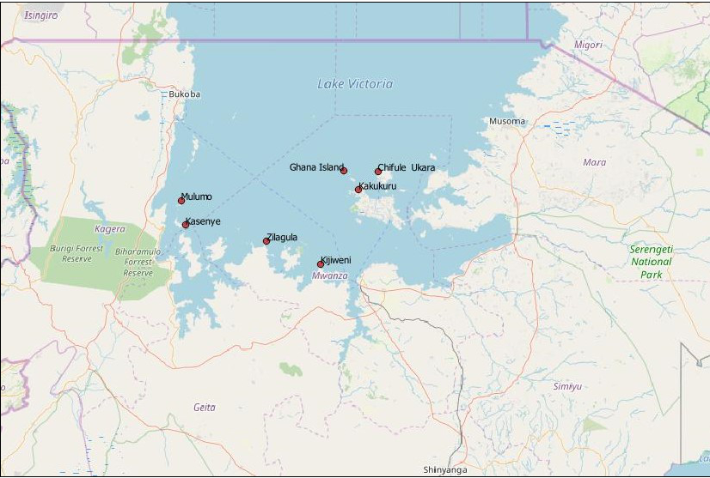

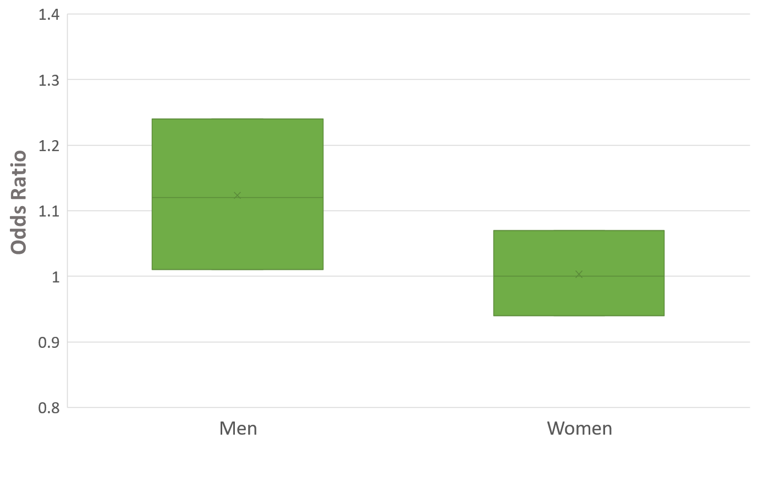
Supplementary Figure 1. Odds of HIV Infection Per Unit Increase of Serum Schistosome Circulating Anodic Antigen (CAA).
The odds of HIV infection was 1.12 (95% confidence interval, 1.01 – 1.24) per pg/mL increase in serum CAA in men. The odds of HIV infection was 1.00 (0.94 – 1.07) per pg/mL increase in serum CAA in women. Odds ratios are shown with horizontal lines and the 95% confidence intervals are represented with boxes.

REFERENCES

1. Kissling E, Allison EH, Seeley JA, Russell S, Bachmann M, Musgrave SD, et al. Fisherfolk are among groups most at risk of HIV: cross-country analysis of prevalence and numbers infected. AIDS [Internet]. 2005 Nov 18 [cited 2019 Dec 31];19(17):1939–46. Available from: https://insights.ovid.com/crossref?an=00002030-200511180-00001
2. Smolak A. A meta-analysis and systematic review of HIV risk behavior among fishermen. AIDS Care [Internet]. 2014 Mar 4 [cited 2019 Dec 31];26(3):282–91. Available from: http://www.ncbi.nlm.nih.gov/pubmed/23941609
3. Sileo KM, Kintu M, Chanes-Mora P, Kiene SM. &quot;Such Behaviors Are Not in My Home Village, I Got Them Here&quot;: A Qualitative Study of the Influence of Contextual Factors on Alcohol and HIV Risk Behaviors in a Fishing Community on Lake Victoria, Uganda. AIDS Behav [Internet]. 2016 Mar 29 [cited 2019 Dec 31];20(3):537–47. Available from: http://link.springer.com/10.1007/s10461-015-1077-z
4. Sileo KM, Bogart LM, Wagner GJ, Musoke W, Naigino R, Mukasa B, et al. HIV fatalism and engagement in transactional sex among Ugandan fisherfolk living with HIV. SAHARA J [Internet]. 2019 Jan 1 [cited 2019 Dec 31];16(1):1–9. Available from: https://www.tandfonline.com/doi/full/10.1080/17290376.2019.1572533
5. Asiki G, Mpendo J, Abaasa A, Agaba C, Nanvubya A, Nielsen L, et al. HIV and syphilis prevalence and associated risk factors among fishing communities of Lake Victoria, Uganda. Sex Transm Infect [Internet]. 2011 Oct 1 [cited 2016 Nov 16];87(6):511–5. Available from: http://sti.bmj.com/cgi/doi/10.1136/sti.2010.046805
6. Seeley J, Nakiyingi-Miiro J, Kamali A, Mpendo J, Asiki G, Abaasa A, et al. High HIV Incidence and Socio-Behavioral Risk Patterns in Fishing Communities on the Shores of Lake Victoria, Uganda. Sex Transm Dis [Internet]. 2012 Jun [cited 2016 Nov 16];39(6):433–9. Available from: http://content.wkhealth.com/linkback/openurl?sid=WKPTLP:landingpage&an=00007435-201206000-00007
7. Mafigiri R, Matovu JKB, Makumbi FE, Ndyanabo A, Nabukalu D, Sakor M, et al. HIV prevalence and uptake of HIV/AIDS services among youths (15–24 Years) in fishing and neighboring communities of Kasensero, Rakai District, South Western Uganda. BMC Public Health [Internet]. 2017 Dec 14 [cited 2019 Dec 31];17(1):251. Available from: http://www.ncbi.nlm.nih.gov/pubmed/28288604
8. Kwena ZA, Njuguna SW, Ssetala A, Seeley J, Nielsen L, De Bont J, et al. HIV prevalence, spatial distribution and risk factors for HIV infection in the Kenyan fishing communities of Lake Victoria. Ciccozzi M, editor. PLoS One [Internet]. 2019 Mar 25 [cited 2019 Dec 31];14(3):e0214360. Available from: http://www.ncbi.nlm.nih.gov/pubmed/30908555
9. Downs JA, Dupnik KM, van Dam GJ, Urassa M, Lutonja P, Kornelis D, et al. Effects of schistosomiasis on susceptibility to HIV-1 infection and HIV-1 viral load at HIV-1 seroconversion: A nested case-control study. Hsieh MH, editor. PLoS Negl Trop Dis [Internet]. 2017 Sep 25 [cited 2017 Oct 19];11(9):e0005968. Available from: http://dx.plos.org/10.1371/journal.pntd.0005968
10. Wall KM, Kilembe W, Vwalika B, Dinh C, Livingston P, Lee Y-M, et al. Schistosomiasis is associated with incident HIV transmission and death in Zambia. Bustinduy AL, editor. PLoS Negl Trop Dis [Internet]. 2018 Dec 13 [cited 2018 Dec 15];12(12):e0006902. Available from: http://www.ncbi.nlm.nih.gov/pubmed/30543654
11. Mazigo HD, Dunne DW, Wilson S, Kinung’hi SM, Pinot de Moira A, Jones FM, et al. Co-infection with Schistosoma mansoni and Human Immunodeficiency Virus-1 (HIV-1) among residents of fishing villages of north-western Tanzania. Parasit Vectors [Internet]. 2014 Jan [cited 2015 May 28];7:587. Available from: http://www.pubmedcentral.nih.gov/articlerender.fcgi?artid=4271490&tool=pmcentrez&rendertype=abstract
12. Ssetaala A, Nakiyingi-Miiro J, Asiki G, Kyakuwa N, Mpendo J, Van Dam GJ, et al. Schistosoma mansoni and HIV acquisition in fishing communities of Lake Victoria, Uganda: a nested case-control study. Trop Med Int Heal [Internet]. 2015 Sep [cited 2015 Sep 9];20(9):1190–5. Available from: http://www.pubmedcentral.nih.gov/articlerender.fcgi?artid=4529482&tool=pmcentrez&rendertype=abstract
13. Downs JA, van Dam GJ, Changalucha JM, Corstjens PLAM, Peck RN, de Dood CJ, et al. Association of schistosomiasis and HIV infection in Tanzania. Am J Trop Med Hyg [Internet]. 2012 Oct 1 [cited 2012 Nov 1];87(5):868–73. Available from: http://www.ncbi.nlm.nih.gov/pubmed/23033399
14. Corstjens PLAM, De Dood CJ, Kornelis D, Fat EMTK, Wilson RA, Kariuki TM, et al. Tools for diagnosis, monitoring and screening of Schistosoma infections utilizing lateral-flow based assays and upconverting phosphor labels. Parasitology [Internet]. 2014 Dec [cited 2015 Jan 24];141(14):1841–55. Available from: http://www.ncbi.nlm.nih.gov/pubmed/24932595
15. Polman K, de Vlas SJ, Gryseels B, Deelder a M. Relating serum circulating anodic antigens to faecal egg counts in Schistosoma mansoni infections: a modelling approach. Parasitology [Internet]. 2000 Dec;121 Pt 6:601–10. Available from: http://www.ncbi.nlm.nih.gov/pubmed/11155931
16. UN AIDS. United Republic of Tanzania [Internet]. 2018 [cited 2019 Dec 31]. Available from: https://www.unaids.org/en/regionscountries/countries/unitedrepublicoftanzania
17. Manyahi J, Jullu BS, Abuya MI, Juma J, Ndayongeje J, Kilama B, et al. Prevalence of HIV and syphilis infections among pregnant women attending antenatal clinics in Tanzania, 2011. BMC Public Health [Internet]. 2015 May 22 [cited 2019 Dec 31];15(1):501. Available from: http://bmcpublichealth.biomedcentral.com/articles/10.1186/s12889-015-1848-5
18. Hokororo A, Kihunrwa AF, Hoekstra P, Kalluvya SE, Changalucha J, Fitzgerald D, et al. High prevalence of sexually transmitted infections in pregnant adolescent girls in Tanzania: a multi-community cross-sectional study. Sex Transm Infect. 2015;91(7):473–8.
19. Mehta SD, Ghanem KG, Rompalo AM, Erbelding EJ. HIV Seroconversion Among Public Sexually Transmitted Disease Clinic Patients. J Acquir Immun Defic Syn [Internet]. 2006 May [cited 2020 Jan 12];42(1):116–22. Available from: http://www.ncbi.nlm.nih.gov/pubmed/16763500
20. Hughes JP, Baeten JM, Lingappa JR, Magaret AS, Wald A, de Bruyn G, et al. Determinants of per-coital-act HIV-1 infectivity among African HIV-1-serodiscordant couples. J Infect Dis [Internet]. 2012 Feb 1 [cited 2015 Sep 10];205(3):358–65. Available from: http://www.pubmedcentral.nih.gov/articlerender.fcgi?artid=3256946&tool=pmcentrez&rendertype=abstract
21. Johnson LF, Lewis DA. The effect of genital tract infections on HIV-1 shedding in the genital tract: a systematic review and meta-analysis. Sex Transm Dis [Internet]. 2008 Nov [cited 2016 Nov 20];35(11):946–59. Available from: http://www.ncbi.nlm.nih.gov/pubmed/18685546
22. Torrone EA, Morrison CS, Chen P-L, Kwok C, Francis SC, Hayes RJ, et al. Prevalence of sexually transmitted infections and bacterial vaginosis among women in sub-Saharan Africa: An individual participant data meta-analysis of 18 HIV prevention studies. Byass P, editor. PLoS Med [Internet]. 2018 Feb 27 [cited 2020 Jan 12];15(2):e1002511. Available from: https://dx.plos.org/10.1371/journal.pmed.1002511
23. Bolan RK, Beymer MR, Weiss RE, Flynn RP, Leibowitz AA, Klausner JD. Doxycycline Prophylaxis to Reduce Incident Syphilis among HIV-Infected Men Who Have Sex With Men Who Continue to Engage in High-Risk Sex. Sex Transm Dis [Internet]. 2015 Feb [cited 2020 Jan 12];42(2):98–103. Available from: http://www.ncbi.nlm.nih.gov/pubmed/25585069
24. Molina J-M, Charreau I, Chidiac C, Pialoux G, Cua E, Delaugerre C, et al. Post-exposure prophylaxis with doxycycline to prevent sexually transmitted infections in men who have sex with men: an open-label randomised substudy of the ANRS IPERGAY trial. Lancet Infect Dis [Internet]. 2018 Mar [cited 2020 Jan 12];18(3):308–17. Available from: http://www.ncbi.nlm.nih.gov/pubmed/29229440
25. Workowski K, Bolan G. Sexually Transmitted Diseases Treatment Guidelines, 2015. Morb Mortal Wkly Rep. 2015;64(RR3):1–137.
26. Grant JS, Stafylis C, Celum C, Grennan T, Haire B, Kaldor J, et al. Doxycycline prophylaxis for bacterial sexually transmitted infections. Clin Infect Dis [Internet]. 2019 Sep 1 [cited 2019 Dec 31];[Epub ahea. Available from: https://academic.oup.com/cid/advance-article/doi/10.1093/cid/ciz866/5557867
27. Downs JA, De Dood CJ, Dee HE, McGeehan M, Khan H, Marenga A, et al. Schistosomiasis and human immunodeficiency virus in men in Tanzania. Am J Trop Med Hyg. 2017;96(4):856–62.
28. Karanja DMS, Hightower AW, Colley DG, Mwinzi PNM, Galil K, Andove J, et al. Resistance to reinfection with Schistosoma mansoni in occupationally exposed adults and effect of HIV-1 co-infection on susceptibility to schistosomiasis: a longitudinal study. Lancet [Internet]. 2002 Aug 24;360(9333):592–6. Available from: http://www.ncbi.nlm.nih.gov/pubmed/12241930
29. Oliveira RR, Figueiredo JP, Cardoso LS, Jabar RL, Souza RP, Wells MT, et al. Factors associated with resistance to Schistosoma mansoni infection in an endemic area of Bahia, Brazil. Am J Trop Med Hyg [Internet]. 2012 Feb [cited 2013 May 21];86(2):296–305. Available from: http://www.pubmedcentral.nih.gov/articlerender.fcgi?artid=3269284&tool=pmcentrez&rendertype=abstract
30. Souza R da P, Araújo MI, Lopes DM, Almeida TVVS, Page B, Oliveira RR, et al. Characterization of memory T cells in individuals resistant to Schistosoma mansoni infection. Parasit Immunol [Internet]. 2019 Dec 8 [cited 2020 Jan 12];41(12):e12671. Available from: http://www.ncbi.nlm.nih.gov/pubmed/31532832

TABLES

Table 1. Socio-demographic characteristics of the study population among fishing communities around Lake Victoria in NW Tanzania

 | N | (%)
Sex
Male | 584 | 52.7
Female | 537 | 47.9
Population group
General population | 253 | 22.6
Fishermen or boat crew | 355 | 31.7
Fish processors & traders | 227 | 20.2
Recreational facility workers | 286 | 25.5
Religion
Christian | 895 | 79.8
Muslim | 115 | 10.3
Other | 111 | 9.9
Age group
18-24 years | 180 | 16.3
25-29 years | 220 | 19.9
30-39 years | 437 | 39.5
40-49 years | 200 | 18.1
≥50 years | 69 | 6.2
Marital status
Married or cohabiting | 624 | 55.7
Widowed | 31 | 2.8
Separated or divorced | 347 | 30.9
Single – never married | 119 | 10.6
Education
No formal schooling | 103 | 9.2
Incomplete primary school | 251 | 22.4
Completed primary school | 608 | 54.2
Incomplete secondary (form 1-4) | 92 | 8.2
Secondary or higher education | 67 | 6.0
Sexual partners (in the last year)*
Zero or one | 279 | 30.3
Two | 202 | 21.9
Three or four | 242 | 26.3
Five or more | 198 | 21.5
Male circumcision (men only)**
Circumcised | 534 | 91.6
Not circumcised | 49 | 8.4
*Missing from 200 participants who reported not to be sexually active in the past 12 months; **This information was obtained from men only

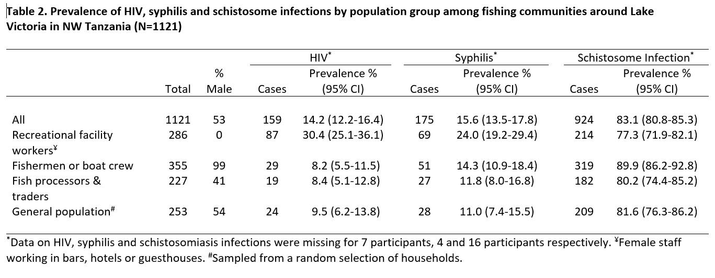

Table 3. Associations between HIV infection and sociodemographic, behavioural and clinical factors among fishing communities around Lake Victoria in NW Tanzania

 | N | HIV+  n (%) | Odds ratio  (95% CI) | p | Adjusted odds ratio (95% CI) § | p
SOCIO-DEMOGRAPHIC FACTORS
Sex
Male | 584 | 43 ( 7) | 1 | <0.001 | 1 | 0.040
Female | 537 | 116 (22) | 3.47 (2.39 to 5.03) |  | 2.01 (1.03 to 3.90)
Population group
General population | 253 | 24 ( 9) | 1 | <0.001 | 1 | <0.001
Fishermen or boat crew | 355 | 29 ( 8) | 0.85 (0.48 to 1.50) |  | 1.12 (0.56 to 2.26)
Fish processors & traders | 227 | 19 ( 8) | 0.87 (0.46 to 1.64) |  | 0.71 (0.37 to 1.37)
Recreational facility workers | 286 | 87 (30) | 4.17 (2.56 to 6.81) |  | 3.11 (1.73 to 5.61)
Religion
Christian | 895 | 119 (13) | 1 | 0.053 | 1 | 0.039
Muslim | 115 | 25 (22) | 1.81 (1.12 to 2.94) |  | 1.96 (1.16 to 3.30)
Other | 111 | 15 (14) | 1.02 (0.57 to 1.82) |  | 1.22 (0.66 to 2.25)
Age group
18-24 years | 180 | 15 ( 8) | 1 | 0.012 | 1 | 0.017
25-29 years | 220 | 45 (20) | 2.83 (1.52 to 5.27) |  | 2.75 (1.45 to 5.23)
30-39 years | 437 | 64 (15) | 1.89 (1.04 to 3.41) |  | 2.72 (1.47 to 5.05)
40-49 years | 200 | 26 (13) | 1.64 (0.84 to 3.21) |  | 3.05 (1.49 to 6.24)
≥50 years | 69 | 7 (10) | 1.24 (0.48 to 3.19) |  | 2.54 (0.95 to 6.82)
Marital status
Married or cohabiting | 624 | 43 ( 7) | 1 | <0.001 | 1 | <0.001
Widowed | 31 | 12 (39) | 8.53 (3.89 to 18.7) |  | 6.36 (2.67 to 15.1)
Separated or divorced | 347 | 94 (27) | 5.02 (3.40 to 7.41) |  | 2.87 (1.72 to 4.76)
Single – never married | 119 | 10 ( 8) | 1.24 (0.60 to 2.54) |  | 1.62 (0.72 to 3.63)
Education
No formal schooling | 103 | 21 (20) | 1 | 0.117 | 1 | 0.821
Incomplete primary school | 251 | 39 (16) | 0.72 (0.40 to 1.29) |  | 0.90 (0.47 to 1.73)
Completed primary school | 608 | 84 (14) | 0.63 (0.37 to 1.07) |  | 0.87 (0.48 to 1.59)
Incomplete secondary (form 1-4) | 92 | 11 (12) | 0.53 (0.24 to 1.17) |  | 0.80 (0.34 to 1.90)
Secondary or higher education | 67 | 4 ( 6) | 0.25 (0.08 to 0.76) |  | 0.49 (0.15 to 1.58)
BEHAVIOURAL FACTORS
Age at first sex
13 years or younger | 78 | 12 (15) | 1 | 0.015 | 1 | 0.489
14-15 years | 207 | 41 (20) | 1.36 (0.67 to 2.75) |  | 1.38 (0.64 to 2.97)
16-17 years | 276 | 45 (16) | 1.07 (0.54 to 2.14) |  | 1.25 (0.59 to 2.64)
18-20 years | 419 | 52 (12) | 0.78 (0.39 to 1.54) |  | 1.12 (0.53 to 2.34)
21 years or older | 102 | 6 ( 6) | 0.34 (0.12 to 0.96) |  | 0.61 (0.20 to 1.79)
Sexual partners (in the last year)
Zero or one | 279 | 30 (11) | 1 | 0.219 | 1 | 0.403
Two | 202 | 22 (11) | 1.01 (0.57 to 1.82) |  | 1.04 (0.55 to 1.96)
Three or four | 242 | 29 (12) | 1.13 (0.66 to 1.94) |  | 1.03 (0.54 to 1.94)
Five or more | 198 | 33 (17) | 1.66 (0.98 to 2.83) |  | 1.58 (0.83 to 3.00)
Sex while drunk (in last month)
No | 749 | 94 (13) | 1 | 0.012 | 1 | 0.707
Yes | 211 | 41 (19) | 1.68 (1.12 to 2.52) |  | 1.09 (0.70 to 1.71)
Gifts for sex (in the last year)
No gifts given or received | 373 | 33 ( 9) | 1 | <0.001 | 1 | 0.008
Yes, received | 287 | 81 (28) | 4.05 (2.61 to 6.29) |  | 2.50 (1.44 to 4.34)
Yes, given | 324 | 26 ( 8) | 0.90 (0.53 to 1.54) |  | 1.23 (0.63 to 2.40)
Yes, received and given | 133 | 19 (14) | 1.72 (0.94 to 3.14) |  | 1.28 (0.66 to 2.51)
Frequency of condom use
Never | 418 | 40 (10) | 1 | <0.001 | 1 | 0.312
Sometimes | 349 | 41 (12) | 1.26 (0.79 to 1.99) |  | 1.18 (0.71 to 1.97)
Most of the time | 287 | 61 (21) | 2.55 (1.66 to 3.93) |  | 1.59 (0.92 to 2.74)
Always | 63 | 17 (27) | 3.49 (1.83 to 6.65) |  | 1.73 (0.82 to 3.65)
CLINICAL FACTORS
Circumcision (men only)
Circumcised | 534 | 37 ( 7) | 1 | 0.179 | 1 | 0.467
Not circumcised | 49 | 6 (12) | 1.87 (0.75 to 4.69) |  | 1.63 (0.44 to 6.12)
Genital sores (in the last year)
No | 937 | 121 (13) | 1 | 0.006 | 1 | 0.093
Yes | 184 | 38 (21) | 1.76 (1.17 to 2.63) |  | 1.65 (0.92 to 2.95)
Abnormal discharge (in last year)
No | 873 | 106 (12) | 1 | <0.001 | 1 | 0.222
Yes | 248 | 53 (21) | 1.97 (1.36 to 2.83) |  | 1.42 (0.81 to 2.49)
Genital itching currently
No | 975 | 128 (13) | 1 | 0.013 | 1 | 0.339
Yes | 143 | 30 (21) | 1.76 (1.13 to 2.74) |  | 1.41 (0.70 to 2.88)
STI diagnosis in the past year
No | 936 | 125 (13) | 1 | 0.065 | 1 | 0.076
Yes | 183 | 34 (19) | 1.48 (0.98 to 2.25) |  | 1.72 (0.95 to 3.14)
Syphilis
Negative | 944 | 116 (12) | 1 | <0.001 | 1 | 0.003
Positive | 175 | 41 (23) | 2.18 (1.46 to 3.26) |  | 2.38 (1.34 to 4.22)
Schistosome infection (all)*
Negative | 190 | 22 (12) | 1 | 0.489 | 1 | 0.392
Low to moderate | 484 | 68 (14) | 1.25 (0.75 to 2.09) |  | 1.29 (0.63 to 2.65)
Highly positive | 434 | 66 (15) | 1.37 (0.82 to 2.29) |  | 1.65 (0.78 to 3.46)
Schistosome infection (males)*
Negative | 86 | 2 ( 2) | 1 | 0.091 | 1 | 0.130
Low to moderate | 238 | 16 ( 7) | 3.03 (0.68 to 13.4) |  | 3.54 (0.43 to 29.0)
Highly positive | 258 | 25 (10) | 4.51 (1.05 to 19.4) |  | 6.64 (0.80 to 55.4)
Schistosome infection (females)*
Negative | 104 | 20 (19) | 1 | 0.715 | 1 | 0.813
Low to moderate | 246 | 52 (21) | 1.13 (0.63 to 2.00) |  | 0.98 (0.42 to 2.31)
Highly positive | 176 | 41 (23) | 1.28 (0.70 to 2.32) |  | 1.24 (0.50 to 3.08)

Variables with missing data were: age (15 participants), age at first sex (39), number of sexual partners in the past year (200), sex while drunk (161), gifts (4), condom use (4), genital itching (3), STI diagnosis (2) and syphilis (2). CI = Confidence Interval. §All associations were adjusted for sex (pooled analysis for males and females), population group and age. In addition, associations with clinical factors were adjusted for behavioural factors. *Schistosomiasis infection intensity evaluated using CAA (Circulating Anodic Antigen) concentration (Negative: 0 – 29.99 pg/mL; Low to moderate: 30 – 2999.99 pg/mL; Highly positive: ≥ 3000 pg/mL).

