Title: The risk of multidrug or rifampicin-resistance in men versus women with TB

Authors: C. Finn M^{c}Quaid¹(PhD), Katherine C. Horton²(MPH), Anna S. Dean³(PhD), Gwenan M. Knight¹(PhD), Richard G. White⁴(PhD)

Affiliations:
¹TB Modelling Group, TB Centre, AMR Centre and Centre for Mathematical Modelling of Infectious Diseases, Department of Infectious Disease Epidemiology, London School of Hygiene and Tropical Medicine, London, UK
²TB Modelling Group, TB Centre and Centre for Mathematical Modelling of Infectious Diseases, Department of Clinical Research, London School of Hygiene and Tropical Medicine, London, UK
³Global TB Programme, World Health Organization, Geneva, Switzerland
⁴ TB Modelling Group, TB Centre and Centre for Mathematical Modelling of Infectious Diseases, Department of Infectious Disease Epidemiology, London School of Hygiene and Tropical Medicine, London, UK

Corresponding author: C. Finn M^{c}Quaid; finn.mcquaid@lshtm.ac.uk. +44 (0)20 7636 8636

Address: London School of Hygiene and Tropical Medicine, Keppel Street, WC1E 7HT, London, United Kingdom.

Take-home message: Globally, the risk of drug-resistance, among those with TB, is the same for men as for women. However, local differences in high-burden risk groups lead to a need for a gender-differentiated approach to TB case-finding and care in some settings

Keywords:
Risk, Gender, Men, Women, Male, Female, Resistance, Burden, Prison, Migration, Foreign-born

Men are at an increased risk of Tuberculosis disease compared to women. Several risk factors for multidrug-resistant (MDR) or rifampicin-resistant (RR) TB disease are also more common in men, hence male TB patients may have a higher relative risk of MDR/RR-TB than female TB patients.

We used sex-disaggregated data of TB patients reported to the World Health Organization for 106 countries to calculate male-to-female (M:F) risk ratios of having MDR/RR-TB.

There was no evidence of either sex being more at risk of MDR/RR-TB in 81%(86/106) of countries, with an overall random-effects weighted M:F risk ratio of 1.04[95% confidence interval 0.97-1.11]. In 12%(13/106) of countries there was evidence that men were more at risk, while in 7%(7/106) women were more at risk. The risk of having TB that was MDR/RR increased for men compared to women as MDR/RR-TB incidence increased, and was higher for men than women in the Former Soviet Union, where the risk ratio was 1.16[1.06-1.28]. Conversely, the risk increased for women compared to men as GDP increased, and was higher for women than men in countries where the majority of TB burden was found in the foreign-born population, where the risk ratio was 0.84[0.75-0.94].

In general, the risk of MDR/RR-TB, among those with TB, is the same for men as for women. However, men in higher MDR/RR-TB burden countries, particularly the Former Soviet Union, face an increased risk that their infection is MDR/RR-TB, highlighting the need for a gender-differentiated approach to TB case-finding and care.

INTRODUCTION

Tuberculosis (TB) is the leading infectious cause of death globally, responsible for 1.5 million deaths in 2018. With around 214,000 of these deaths attributable to multidrug- or rifampicin-resistant (MDR/RR) TB disease,¹ TB contributes a third of all antimicrobial resistance (AMR) deaths globally, more than any other single infection.²

Of an estimated 10 million new cases of TB notified in 2018, 6.3 million were male and 3.7 million were female.¹ Men make up a greater proportion of undiagnosed prevalent TB, with over twice as many cases being missed among men as compared to women in low- and middle-income countries.³ Furthermore, once diagnosed men have poorer treatment outcomes than women.⁴ Despite clear evidence of substantial sex disparities in the burden of TB, whether these sex disparities extend to MDR/RR-TB is not well-understood.

Potential risk factors for drug-resistance may be more common in one sex, particularly men, than the other, which might be expected to further compound the known difference in risk in TB between sexes. Examples include a previous history of TB disease and treatment, reduced treatment adherence, longer duration of illness, imprisonment, smoking, and concurrent illnesses such as chronic obstructive pulmonary disease.^{5,6} These risk factors will likely vary by setting. For example, in countries of the Former Soviet Union there have been high levels of past TB drug exposure combined with a degraded health system which may lead to reduced treatment support,⁷ and hence high rates of MDR/RR-TB.

United Nations Member States have committed to addressing the global threats of both TB⁸ and AMR.⁹ To tackle these public health threats efficiently, groups at risk must be identified in order to ensure the most effective allocation of resources. Identifying groups with a higher burden of MDR/RR-TB is critical, particularly when empiric treatment is widely used, given the severe impact of the disease on health, increased mortality, long duration of treatment, potential toxicity of treatment and associated high costs.⁷ In terms of the patient pathway, a lack of rapid drug susceptibility testing and the need to treat patients with the correct regimen quickly often results in empirical-evidence-based treatment.¹⁰ It is therefore important to understand whether patient sex, including accompanying confounders, affects risk for drug-resistance.

We analysed country-level data on MDR/RR-TB reported to the World Health Organization (WHO) to calculate and compare risk ratios for MDR/RR-TB for men and women in this dataset. We compared male-to-female (M:F) risk ratios across settings and assessed the role of setting-specific risk groups in contributing to sex differences at a national level.

METHODS

Data

We used country-level sex-disaggregated data on new and previously treated cases collected by national TB programmes and reported to WHO. These data recorded the number of TB patients who underwent drug susceptibility testing (DST) before starting their current course of treatment, and had resistance results for rifampicin and isoniazid (MDR-TB, 2000-2015) or rifampicin (MDR/RR-TB, 2016-2018). Data were collected either through periodic, nationally representative drug-resistance surveys of a sample of patients, or through continuous surveillance by the routine collection of DST results for the majority of patients. We excluded data where drug resistance was not reported separately for men and women, or where data were not available for >80% of bacteriologically confirmed new TB cases.

Geographic segregation

To investigate any geographic differences, we compared WHO regions and two particular settings of interest; the Former Soviet Union, which has the highest proportions of MDR/RR-TB globally,¹ and low TB burden countries where most TB was found in the foreign-born population, such that the majority of MDR/RR-TB does not reflect local transmission.¹¹ In our dataset we identified Former Soviet Union countries as Armenia, Azerbaijan, Belarus, Estonia, Georgia, Kazakhstan, Latvia, Lithuania, Republic of Moldova, Tajikistan, Turkmenistan, Ukraine and Uzbekistan. We identified selected low TB burden high-income countries were more than 50% of TB notifications were found in the foreign-born population as Australia, Austria, Belgium, Canada, Denmark, Germany, Israel, Italy, Luxembourg, Netherlands, New Zealand, Norway, Sweden, Switzerland, UK and USA, as well as Finland, Greece, Ireland and Slovenia where at least 25% of TB notifications were found amongst the foreign-born population.¹¹

Analysis

We pooled data over time for countries with multiple years of available data, including pooling RR- and MDR-TB cases together, where these drugs were presumed to have the same M:F risk ratio. We calculated the ratio of the proportion of all male TB patients with a DST result that had MDR/RR-TB compared to the proportion of all female TB patients with a DST result that had MDR/RR-TB for each country separately. That is, the M:F risk ratio for each country. We conducted a random-effects meta-analysis on the country data to estimate the M:F risk ratio for MDR/RR-TB within TB patients globally, where we decided that high setting-specific variability in MDR/RR-TB burden and confounders warranted this approach over a fixed-effects meta-analysis as there was likely to be a distribution of true effects. We also conducted random-effects meta-analyses on country data by WHO geographic region, estimating heterogeneity using the I² statistic.¹²

We also compared M:F risk ratios for MDR/RR-TB across countries based on MDR/RR-TB burden and economic characteristics. We used WHO estimates¹³ of the incidence of MDR/RR-TB per 100,000 population and the proportion of MDR/RR-TB among both new and retreatment pulmonary TB cases. We also used World Bank Group data¹⁴ on country Gross Domestic Product Purchase Power Parity (GDP). We conducted weighted regression analyses (weighted by sample size) to identify any effect of MDR/RR-TB burden or GDP on the M:F risk ratio for MDR/RR-TB.

Using previously published data¹⁵, we conducted a random-effects meta-analysis to identify the relative burden of MDR-TB compared to all TB in the foreign-born population in these selected low TB burden countries. We used United Nations data¹⁶ on the foreign-born and foreign population to compare the sex of foreign-born individuals from high TB burden countries¹ in these selected low TB burden countries.

All analyses were conducted using the meta package¹⁷ in the software R,¹⁸ and results plotted using the ggplot2 package.¹⁹ We considered there to be strong evidence of an association between sex and risk of MDR/RR-TB if the p-value for the M:F risk ratio was less than 0.01 and the strength of association was meaningful, in this case an effect size of >10%. We considered there to be some evidence of an association if the p-value was less than 0.05 and the effect size was >10%, and weak evidence (but cause for further investigation) if the p-value was less than 0.1 but the effect size was very large, in this case >25%. If the effect size was small (<10%) or the p-value large (>0.05 with a meaningful, but limited, effect size<25%), we considered that there was no evidence to conclude there was an association between sex and risk of MDR/RR-TB. We considered an I²>25% to reflect an important level of heterogeneity¹², although we note that due to differences in confounding from surveillance and risk groups, a reasonable degree of heterogeneity is to be expected in our results.

Sensitivity analyses

We repeated the above analyses separately for data that were collected from drug resistance surveys versus through continuous surveillance, as the separate methods of data collection (representative samples of all notified cases compared to larger samples of only those notified patients receiving a DST) might have implications for gender bias. We also repeat the analyses separately for periods with data on MDR-TB (2000-2015) compared to RR-TB only (2016-2018).

We analysed how the M:F risk ratio changed according to the total proportion of all TB cases in the country (clinically or bacteriologically confirmed) who received a DST, conducting a weighted regression analyses (weighted by sample size). We used WHO estimates¹³ of the total number of TB cases notified (including clinically diagnosed) and the number of notified TB cases tested for rifampicin resistance to characterise countries.

We compared different approaches to pooling data from multiple years. Firstly, we repeated the above geographic random-effects meta-analysis for the M:F risk ratio, but considered each year of data as separate, for countries that had data from multiple years. Secondly, we conducted fixed-effects meta-analyses on data by year for each country that had data over multiple years, where the setting and population were presumed to be invariant enough over time to warrant this approach to determining the true effect. Thirdly, we considered results if we only used the most recent year of data for each country.

RESULTS

Sex-disaggregated data were available for 106 countries and territories, out of 164 that report drug-resistance TB data to WHO¹ (see Fig 1 and supplementary material Table S1), for 264,842 male and 137,374 female TB patients from 2002 to 2018. These data represented a total of 267 country-years, out of a total of 1422 reported; sex-disaggregated data were not available for the remaining country-years. In these data, at the global level, there was no evidence for an association between sex and MDR/RR-TB risk in TB patients (M:F risk ratio of 1.04 [95% confidence interval 0.97-1.11] and I²=81%, see Fig 2). Nor was there evidence for an association between sex and risk in 86 (81%) countries (see Fig 1 and Supplementary Material Table S1 and Fig S1).

There was evidence of a M:F risk ratio greater than 1, i.e. men were more at risk of MDR/RR-TB than women, in 13 out of 106 (12%) countries - strong evidence of an association between sex and risk in Belarus, Georgia, Kazakhstan, Latvia, Lesotho, Lithuania, Malaysia, Peru, Poland, R. Moldova and Serbia and weak evidence in Eritrea and Jordan.

There was evidence of a M:F risk ratio less than 1, i.e. women were more at risk of MDR/RR-TB than men, in 7 out of 106 (7%) countries. The evidence of an association between sex and risk was strong in Eswatini, Netherlands, Namibia, Singapore and the USA, and weak in Pakistan and Oman).

Regional M:F risk ratios

There was strong evidence of an association between male sex and risk in the Former Soviet Union, where the M:F risk ratio was 1.16 (95% confidence interval [CI] 1.06-1.28, I²=91%). Although 12 out of 13 countries had a risk ratio greater than 1, large sample sizes led to narrow confidence intervals with poor overlap.

There was strong evidence that in low TB burden countries where the majority of TB notifications occur in the foreign-born population¹¹ (see Table 1) there was an association between female sex and risk of MDR/RR-TB in women, with a M:F risk ratio of 0.84 (95% CI 0.75-0.94, I²=31%). The strength of this evidence remained the same if we included countries where at least 25% of TB notifications were found in the foreign-born population (Finland, Greece, Ireland and Slovenia in our dataset), with a M:F risk ratio of 0.83 (95% CI 0.75-0.92, I²=15%).

Trends in M:F risk ratios

There was evidence that the M:F risk ratio increased with increasing MDR/RR-TB incidence per 100,000 population, but no evidence of an increase with increasing proportion of MDR/RR-TB in either new and retreatment cases (see Fig 3).

There was strong evidence that the M:F risk ratio decreased with increasing GDP (see Fig 4). GDP was inversely correlated with the measures of MDR/RR-TB burden described above.

Foreign-born population

There was very strong evidence that, for selected high-income countries where the majority of notified TB cases occurred in the foreign-born population, the ratio of MDR-TB cases that were found in the foreign-born compared to general population (i.e. the number of cases in each population) was larger than the ratio for all TB cases.

The foreign-born population from WHO high TB burden countries in these selected countries were also consistently more likely to be women than men (see Table 1).

Sensitivity analysis
If we considered survey and surveillance data separately (54 countries each, where 2 countries had both forms of data available), neither group showed a M:F risk ratio different from 1. The above trend of changing risk with GDP and MDR/RR-TB incidence were present in the data from continuous surveillance (with reduced strength of evidence) but were not present in the survey data. This may be because few countries with a high GDP, or Former Soviet Union countries with a high MDR/RR-TB burden, rely on survey data. If we consider MDR-TB data and RR-TB data separately, only 5 countries reported RR-TB results: Eritrea, Lao PDR, Mongolia, Togo and UR Tanzania. Of these, only Mongolia had data for both MDR-TB and RR-TB, where separately analysing these data did not qualitatively change our conclusion that there was no evidence of an association between sex and risk of MDR/RR-TB in Mongolia.

There was no evidence in either the survey or surveillance data that the M:F risk ratio increased with an increase in the DST rate in the country in general.

If we considered each year of data for a country separately, there was still no evidence that the global M:F risk ratio was different to 1, with a M:F risk ratio of 1.03 (95% CI 0.98-1.09, I²=75%). However, there was evidence of an association between female sex and risk in the Region of the Americas, and between male sex and risk in the European region (primarily as a result of inclusion of countries of the Former Soviet Union). There remained strong evidence of an association between male sex and risk in the Former Soviet Union. If we considered countries with multiple years of data and conducted a fixed-effects meta-analysis on each separate year, rather than simply pooling the data, our results were largely unchanged except in terms of the strength of evidence. If we considered only the most recent year of data, of those countries with multiple years of data only Kazakhstan and Georgia retained evidence of an association between sex and risk.

DISCUSSION

Our analysis showed that there was no evidence of an association between sex and risk of MDR/RR-TB in TB patients both globally and nationally in the majority (81%, 86/106) of countries, with an overall random-effects weighted M:F risk ratio of 1.04 [95% confidence interval 0.97-1.11]. However, the high level of heterogeneity in our results suggest that this association may vary significantly between settings. In 12% (13/106) of countries there was evidence that men were more at risk than women, while in 7% (7/106) there was evidence that women were more at risk than men. There was evidence that the risk of having TB that was MDR/RR increased for men compared to women as MDR/RR-TB incidence increased, and was higher for men than women in the Former Soviet Union where the M:F risk ratio was 1.16 [1.06-1.28]. Conversely, there was strong evidence that the risk of having TB that was MDR/RR increased for women compared to men as GDP increased, and was higher for women than men in countries where the majority of TB burden was found in the foreign-born population, where the M:F risk ratio was 0.84 [0.75-0.94].

Our analysis provides the most comprehensive analysis to date of the relationship between MDR/RR-TB and sex. While men are at greater risk than women of developing TB, men with TB are at no greater risk of MDR/RR-TB than women with TB. Men’s excess of several risk factors that are associated with MDR/RR-TB, such as non-adherence and smoking,^{5,6} do not result in an increased risk of MDR/RR-TB globally. Our results are consistent with previous global analyses suggesting that men with TB are no more at risk of MDR/RR-TB than women, while reinforcing the observation that this risk is strongly modified by setting.^{5,20} Indeed, some setting-specific studies suggest an increased risk of MDR/RR-TB (in varying forms) amongst men,²¹⁻²⁶ while others suggest an increased risk amongst women,²⁷⁻³² and still others find no evidence that sex is a factor.³³⁻³⁷

Our results provide no evidence that there is a biological reason for either sex to be at a higher risk of MDR/RR-TB than the other, although this cannot be ruled out. However, heterogeneity in our results by setting suggests that there could be some role for gender (i.e. the role of males versus females in society) in determining either risk or detection of MDR/RR-TB. Specifically, variation between settings in the risk of MDR/RR-TB by sex may be due to differences in surveillance systems resulting in biases (such as coverage of DST or rates of clinical diagnosis) or a reflection of the local context (such as setting-specific differences in the M:F ratio among groups at risk, including prisoners, miners or foreign-born populations). In settings where there is evidence of a difference in risk of MDR/RR-TB between men and women, the interpretation depends on several considerations, and further investigation into confounding factors is required. We can only conclude that a particular group could be driving sex-related differences in MDR/RR-TB risk if there is simultaneously: (i) a higher rate of MDR/RR-TB as a proportion of all TB in the group than in the general population, (ii) a large enough fraction of TB in the population attributable to the group, and (iii) a large enough discrepancy in the sex ratio of the risk group.

Our results provided evidence that the risk of having TB that was MDR/RR increased for men compared to women as the MDR/RR-TB incidence, but not rate (in terms MDR/RR-TB as a proportion of all TB) increased. This was likely a result of the higher risk for men than women in the high MDR/RR-TB burden countries of the Former Soviet Union, which was consistent with previous results.^{5,20} The high M:F risk ratios for MDR/RR-TB in these countries could be related to factors such as alcohol dependency or incarceration;^{20,38} for example, high per capita rates of TB³⁹ as well as MDR/RR-TB⁴⁰ in prison populations in these countries, combined with a high proportion of TB cases attributable to prisons⁴¹ could increase the M:F risk ratio given that prisoners are more often male than female.⁴²

Conversely, there was strong evidence that the risk of having TB that was MDR/RR increased for women compared to men as GDP increased. The risk was also higher for women than men in countries where a high proportion of the national TB burden occurred in the foreign-born population, where countries with a high GDP are likely to see a greater proportion of TB in foreign-born populations. This could be due to the combined increased risk of MDR/RR-TB in foreign-born populations and the fact that women accounted for more than 50% of documented foreign-born individuals originating from high TB burden countries. MDR/RR-TB is also primarily a result of reactivation in these countries and may be influenced by poor living conditions and barriers to accessing care. In contrast to low and middle-income countries, this may affect women more than men amongst migrants in these countries as they are less likely to be active in the workforce.⁴³ However, these data do not take into account undocumented migrants, which may bias the findings.

Our dataset did not allow a comparison of whether men or women were more likely to have DST performed. These data are not routinely collected, and few studies report DST rate by sex (although see, for example, ⁴⁴). However, In countries where the coverage of TB patients with DST was lower (which are more likely to be those with data from only periodic surveys) the higher likelihood for women compared to men to be clinically diagnosed rather than bacteriologically confirmed could affect the M:F risk ratios we observed. This, in turn, could be influenced by factors relating to access to appropriate diagnostics services. With an increasing number of countries recommending Xpert MTB/RIF for all TB cases,⁴⁵ any previous difference in access to DST according to sex (if such a difference exists) should be overcome. However, practical implementation of these policies is of course challenging and achieving 100% coverage of DST will take some time.

The dataset also did not distinguish new and previously treated cases by sex, which may have allowed the identification of factors that increased risk for either sex for acquiring MDR/RR-TB through direct transmission or during treatment of a drug-susceptible strain. However, we note that sex is not known to modify the association between previous treatment and MDR-TB²¹.Due to a lack of sex-disaggregated data, we were also not able to assess sex disparities in risk of extensively drug-resistant TB, where there has been some suggestion that women might be at an increased risk.⁴⁶⁻⁵⁰

Finally, sex-disaggregated data were not available for 11 of the 30 high MDR/RR-TB burden countries, including Angola, DPR Korea, DR Congo, Ethiopia, India, Indonesia, Kyrgyzstan, Papua New Guinea, Russian Federation, South Africa and Zimbabwe. It is vital that laboratory networks and case recording and reporting systems in these and other high MDR/RR-TB burden countries be strengthened.

Conclusions
At a global level, the risk of MDR/RR-TB among TB patients is the same for men as for women, unless directly linked to a particular risk group, despite men having a known higher risk of TB. However, men in higher MDR/RR-TB burden countries, particularly the Former Soviet Union, face not just an increased risk of TB disease, but also a further increased risk that their infection is multidrug- or rifampicin-resistant. This highlights the need for a gender-differentiated approach to TB case-finding and care. Access to rapid, universal DST at the time of TB diagnosis is required to inform an appropriate treatment regimen, improve the outcomes of treatment, reduce costs faced by patients and those associated with health systems, and prevent onward transmission for both men and women.

CONTRIBUTORS
CFM and KCH conceived and designed the study. CFM performed all the data analysis and wrote a first draft of the article. CFM, KCH, ASD, GMK, and RGW designed the methodology and critiqued the results. All authors contributed to editing the final draft.

DECLARATION OF INTERESTS
We declare no competing interests.

ACKNOWLEDGEMENTS
We thank Daniel Grint (LSHTM) for valuable advice on data analysis. CFM was funded by the Bill and Melinda Gates Foundation (TB MAC OPP1135288). GMK was supported by a fellowship from the UK MRC (MR/P014658/1). RGW was funded by the UK Medical Research Council (MRC) and the UK Department for International Development (DFID) under the MRC/DFID Concordat agreement that is also part of the EDCTP2 programme supported by the European Union (MR/P002404/1), the Bill and Melinda Gates Foundation (TB Modelling and Analysis Consortium: OPP1084276/OPP1135288, CORTIS: OPP1137034/OPP1151915, Vaccines: OPP1160830), UNITAID (4214-LSHTM-Sept15; PO 8477-0-600), and ESRC (ES/P008011/1).

REFERENCES
1. World Health Organization. Global Tuberculosis Report 2019. Geneva, Switzerland, 2019.
2. Interagency Coordination Group on Antimicrobial Resistance. No Time to Wait: Securing the Future from Drug-Resistant Infections. Report to the Secretary-General of the United Nations. Geneva, Switzerland, 2019.
3. Horton KC, MacPherson P, Houben RM, White RG, Corbett EL. Sex Differences in Tuberculosis Burden and Notifications in Low- and Middle-Income Countries: A Systematic Review and Meta-analysis. PLoS medicine 2016; 13(9): e1002119.
4. Van den Hof S, Najlis CA, Bloss E, Straetemans M. A systematic review on the role of gender in tuberculosis control. The Hague, Netherlands: KNCV Tuberculosis Foundation., 2010.
5. Pradipta IS, Forsman LD, Bruchfeld J, Hak E, Alffenaar JW. Risk factors of multidrug-resistant tuberculosis: A global systematic review and meta-analysis. The Journal of infection 2018; 77(6): 469-78.
6. Wang M-G, Huang W-W, Wang Y, et al. Association between tobacco smoking and drug-resistant tuberculosis. Infection and drug resistance 2018; 11: 873-87.
7. The Economist Intelligence Unit. It’s Time to End Drug-Resistant Tuberculosis: the Case for Action, 2019.
8. United Nations General Assembly. Political Declaration of the High-Level Meeting of the United Nations General Assembly on the Fight against Tuberculosis. New York, USA: United Nations General Assembly; 2018.
9. United Nations General Assembly. Political Declaration of the High-Level Meeting of the General Assembly on Antimicrobial Resistance. New York, USA: United Nations General Assembly; 2016.
10. Theron G, Peter J, Dowdy D, Langley I, Squire SB, Dheda K. Do high rates of empirical treatment undermine the potential effect of new diagnostic tests for tuberculosis in high-burden settings? The Lancet Infectious Diseases 2014; 14(6): 527-32.
11. Pareek M, Greenaway C, Noori T, Munoz J, Zenner D. The impact of migration on tuberculosis epidemiology and control in high-income countries: a review. Bmc Med 2016; 14: 48.
12. Higgins JPT, Thompson SG, Deeks JJ, Altman DG. Measuring inconsistency in meta-analyses. BMJ 2003; 327(7414): 557.
13. World Health Organization. World Health Organization Global TB Database. https://www.who.int/tb/country/data/download/en/ (accessed 12 March 2019).
14. World Bank Group. GDP per capita, PPP (current international $). https://data.worldbank.org/indicator/NY.GDP.PCAP.PP.CD (accessed 01 August 2019).
15. van der Werf MJ, Hollo V, Kodmon C. Multidrug-resistant tuberculosis and migration to Europe. Clin Microbiol Infec 2017; 23(8).
16. United Nations DoEaSA. Trends in International Migrant Stock: Migrants by Destination and Origin. United Nations database, POP/DB/MIG/Stock/Rev.2015, 2015.
17. Schwarzer G. meta: an R package for meta-analysis. R News 2007; 7: 40-5.
18. R Core Team. R: A Language and Environment for Statistical Computing. Vienna, Austria: R Foundation for Statistical Computing; 2017.
19. Wickham H. ggplot2: Elegant Graphics for Data Analysis: Springer-Verlag New York; 2009.
20. World Health Organization. Multidrug and extensively drugresistant TB (M/XDR-TB): 2010 global report on surveillance and response. Geneva, Switzerland: WHO, 2010.
21. Faustini A, Hall AJ, Perucci CA. Risk factors for multidrug resistant tuberculosis in Europe: a systematic review. Thorax 2006; 61(2): 158-63.
22. Aznar ML, Rando-Segura A, Moreno MM, et al. Prevalence and risk factors of multidrug-resistant tuberculosis in Cubal, Angola: a prospective cohort study. The International Journal of Tuberculosis and Lung Disease 2019; 23(1): 67-72.
23. Bantubani N, Kabera G, Connolly C, et al. High Rates of Potentially Infectious Tuberculosis and Multidrug-Resistant Tuberculosis (MDR-TB) among Hospital Inpatients in KwaZulu Natal, South Africa Indicate Risk of Nosocomial Transmission. PLOS ONE 2014; 9(3): e90868.
24. Banu S, Rahman MT, Ahmed S, et al. Multidrug-resistant tuberculosis in Bangladesh: results from a sentinel surveillance system. Int J Tuberc Lung Dis 2017; 21(1): 12-7.
25. Mor Z, Goldblatt D, Kaidar-Shwartz H, Cedar N, Rorman E, Chemtob D. Drug-resistant tuberculosis in Israel: risk factors and treatment outcomes. The International Journal of Tuberculosis and Lung Disease 2014; 18(10): 1195-201.
26. Ahmad A, Akhtar S, Hasan R, Khan J, Hussain S, Rizvi N. Risk factors for multidrug-resistant tuberculosis in urban Pakistan: A multicenter case-control study. International journal of mycobacteriology 2012; 1(3): 137-42.
27. Dalton T, Cegielski P, Akksilp S, et al. Prevalence of and risk factors for resistance to second-line drugs in people with multidrug-resistant tuberculosis in eight countries: a prospective cohort study. Lancet 2012; 380(9851): 1406-17.
28. Ejaz M, Siddiqui AR, Rafiq Y, et al. Prevalence of multi-drug resistant tuberculosis in Karachi, Pakistan: identification of at risk groups. Transactions of the Royal Society of Tropical Medicine and Hygiene 2010; 104(8): 511-7.
29. Vashakidze L, Salakaia A, Shubladze N, et al. Prevalence and risk factors for drug resistance among hospitalized tuberculosis patients in Georgia. The international journal of tuberculosis and lung disease : the official journal of the International Union against Tuberculosis and Lung Disease 2009; 13(9): 1148-53.
30. Lomtadze N, Aspindzelashvili R, Janjgava M, et al. Prevalence and risk factors for multidrug-resistant tuberculosis in the Republic of Georgia: a population-based study. Int J Tuberc Lung Dis 2009; 13(1): 68-73.
31. Pavlenko E, Barbova A, Hovhannesyan A, et al. Alarming levels of multidrug-resistant tuberculosis in Ukraine: results from the first national survey. Int J Tuberc Lung Dis 2018; 22(2): 197-205.
32. Andrews JR, Shah NS, Weissman D, Moll AP, Friedland G, Gandhi NR. Predictors of multidrug- and extensively drug-resistant tuberculosis in a high HIV prevalence community. PLoS One 2010; 5(12): e15735.
33. Tembo BP, Malangu NG. Prevalence and factors associated with multidrug/rifampicin resistant tuberculosis among suspected drug resistant tuberculosis patients in Botswana. Bmc Infect Dis 2019; 19(1471-2334 (Electronic)).
34. Hang NTL, Maeda S, Lien LT, et al. Primary Drug-Resistant Tuberculosis in Hanoi, Viet Nam: Present Status and Risk Factors. PLOS ONE 2013; 8(8): e71867.
35. Balaji V, Daley P, Anand AA, et al. Risk factors for MDR and XDR-TB in a tertiary referral hospital in India. PLoS One 2010; 5(3): e9527.
36. Shen X, DeRiemer K, Yuan ZA, et al. Drug-resistant tuberculosis in Shanghai, China, 2000-2006: prevalence, trends and risk factors. The International Journal of Tuberculosis and Lung Disease 2009; 13(2): 253-9.
37. Baghaei P, Tabarsi P, Chitsaz E, et al. Risk Factors Associated with Multidrug-Resistant Tuberculosis Tanaffos 2009; 8(3): 17-21.
38. Grady J, Maeurer M, Atun R, et al. Tuberculosis in prisons: anatomy of global neglect. European Respiratory Journal 2011; 38(4): 752.
39. Dolan K, Wirtz AL, Moazen B, et al. Global burden of HIV, viral hepatitis, and tuberculosis in prisoners and detainees. The Lancet 2016; 388(10049): 1089-102.
40. Biadglegne F, Rodloff AC, Sack U. Review of the prevalence and drug resistance of tuberculosis in prisons: a hidden epidemic. Epidemiol Infect 2015; 143(5): 887-900.
41. Baussano I, Williams BG, Nunn P, Beggiato M, Fedeli U, Scano F. Tuberculosis Incidence in Prisons: A Systematic Review. PLOS Medicine 2010; 7(12): e1000381.
42. Institute for Criminal Policy Research. World Prison Brief. https://www.prisonstudies.org/highest-to-lowest/female-prisoners?field_region_taxonomy_tid=All (accessed 01 July 2019).
43. International Organization for Migration. Migration Data Portal: the Bigger Picture. https://migrationdataportal.org/themes/gender (accessed 01 July 2019).
44. Bastos ML, Hussain H, Weyer K, et al. Treatment outcomes of patients with multidrug-resistant and extensively drug-resistant tuberculosis according to drug susceptibility testing to first- and second-line drugs: an individual patient data meta-analysis. Clin Infect Dis 2014; 59(10): 1364-74.
45. World Health Organization. Automated real-time nucleic acid amplification technology for rapid and simultaneous detection of tuberculosis and rifampicin resistance: Xpert MTB/RIF assay for the diagnosis of pulmonary and extrapulmonary TB in adults and children: policy update. Geneva: World Health Organization, 2013.
46. Dalton T, Cegielski P, Akksilp S, et al. Prevalence of and risk factors for resistance to second-line drugs in people with multidrug-resistant tuberculosis in eight countries: a prospective cohort study. Lancet 2012; 380(9851): 1406-17.
47. Gallo JF, Pinhata JMW, Simonsen V, Galesi VMN, Ferrazoli L, Oliveira RS. Prevalence, associated factors, outcomes and transmission of extensively drug-resistant tuberculosis among multidrug-resistant tuberculosis patients in São Paulo, Brazil: a cross-sectional study. Clinical microbiology and infection : the official publication of the European Society of Clinical Microbiology and Infectious Diseases 2018; 24(8): 889-95.
48. Jeon CY, Hwang SH, Min JH, et al. Extensively drug-resistant tuberculosis in South Korea: risk factors and treatment outcomes among patients at a tertiary referral hospital. Clin Infect Dis 2008; 46(1): 42-9.
49. O'Donnell MR, Zelnick J, Werner L, et al. Extensively drug-resistant tuberculosis in women, KwaZulu-Natal, South Africa. Emerging infectious diseases 2011; 17(10): 1942-5.
50. Tang S, Tan S, Yao L, et al. Risk factors for poor treatment outcomes in patients with MDR-TB and XDR-TB in China: retrospective multi-center investigation. PloS one 2013; 8(12): e82943-e.
51. Gallant V, Duvvuri V, McGuire M. Tuberculosis in Canada - Summary 2015. Can Commun Dis Rep 2017; 43(3-4): 77-82.
52. Reported Tuberculosis in the United States, 2015. Atlanta, GA: Centers for Disease Control and Prevention (CDC), 2016.
53. Tuberculosis surveillance and monitoring in Europe 2017. Stockholm: European Centre for Disease Prevention and Control/WHO Regional Office for Europe, 2017.
54. Tuberculosis in New Zealand: Annual Report 2015. Porirua, New Zealand: Porirua: ESR, 2018.

FIGURES AND TABLES
Table 1: Foreign-born and foreign population from high TB burden countries by sex in 2015 based on official statistics,¹⁶ as well as number of TB and MDR-TB cases,^{15,51-54} for selected countries where >50% of TB incidence is in the foreign-born population.¹¹
Country | Men | Women | MDR/RR-TB MF ratio | TB cases (foreign-born in []) | MDR-TB cases (foreign-born in [])
Australia | 931,365 | 1,036,116 | 0.90
Austria | 63,034 | 78,322 | 0.80 | 583 [364] | 12 [12]
Belgium | 72,608 | 78,592 | 0.92 | 988 [519] | 15 [13]
Canada | 1,352,339 | 1,549,093 | 0.87 | 1,639 [1,169] | 22
Denmark | 48,809 | 69,886 | 0.70 | 357 [242] | 6 [4]
Germany | 1,481,691 | 1,843,541 | 0.80 | 5,864 [3969] | 120 [109]
Israel | 207,640 | 253,145 | 0.82 | 280 [233] | 11
Italy | 679,994 | 920,734 | 0.74 | 3,769 [1,764] | 70
Luxembourg | 1,329 | 1,602 | 0.83 | 30 [20] | 0 [0]
Netherlands | 201,321 | 252,283 | 0.80 | 867 [625] | 10 [10]
New Zealand | 153,171 | 163,564 | 0.94 | 253 [217] | 2 [2]
Norway | 74,313 | 109,176 | 0.68 | 318 [282] | 5 [5]
Sweden | 131,461 | 172,289 | 0.76 | 821 [735] | 22 [21]
Switzerland | 91,695 | 151,948 | 0.60 | 564 [428] | 11
United Kingdom | 1,591,934 | 1,759,494 | 0.90 | 6,240 [4,312] | 49 [42]
USA | 5,301,978 | 6,052,656 | 0.88 | 9,557 [6,350] | 73 [63]

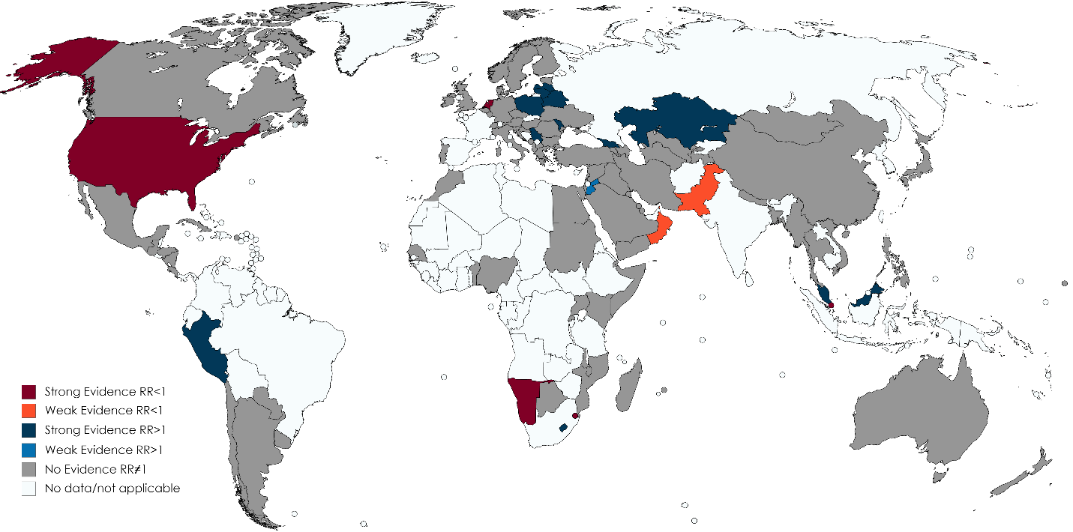
Figure 1: Countries with WHO-reported drug resistance survey/surveillance data disaggregated by sex, showing those with strong evidence (p-value<0.01 and effect size>10%), or weak evidence (0.05<p-value<0.1 and effect size>25%) for an association between sex and risk of MDR/RR-TB amongst TB patients. In blue, there is evidence of an association between male sex and risk, in red between female sex and risk. Countries in grey have sex disaggregated data but no evidence of an association.

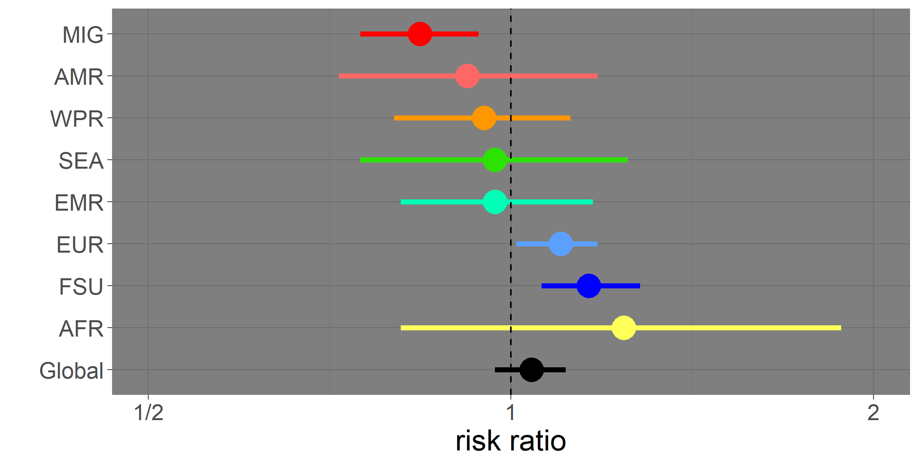
Figure 2: Forest plot showing MDR/RR-TB M:F risk ratio and 95% confidence interval for by WHO region or setting of interest (countries where the majority of TB is found in the foreign-born population MIG, Region of the Americas AMR, Western Pacific Region WPR, South-East Asia Region SEA, Eastern Mediterranean Region EMR, European Region EUR, Former Soviet Union FSU and African Region AFR). Data among all (new and retreated) cases are presented.

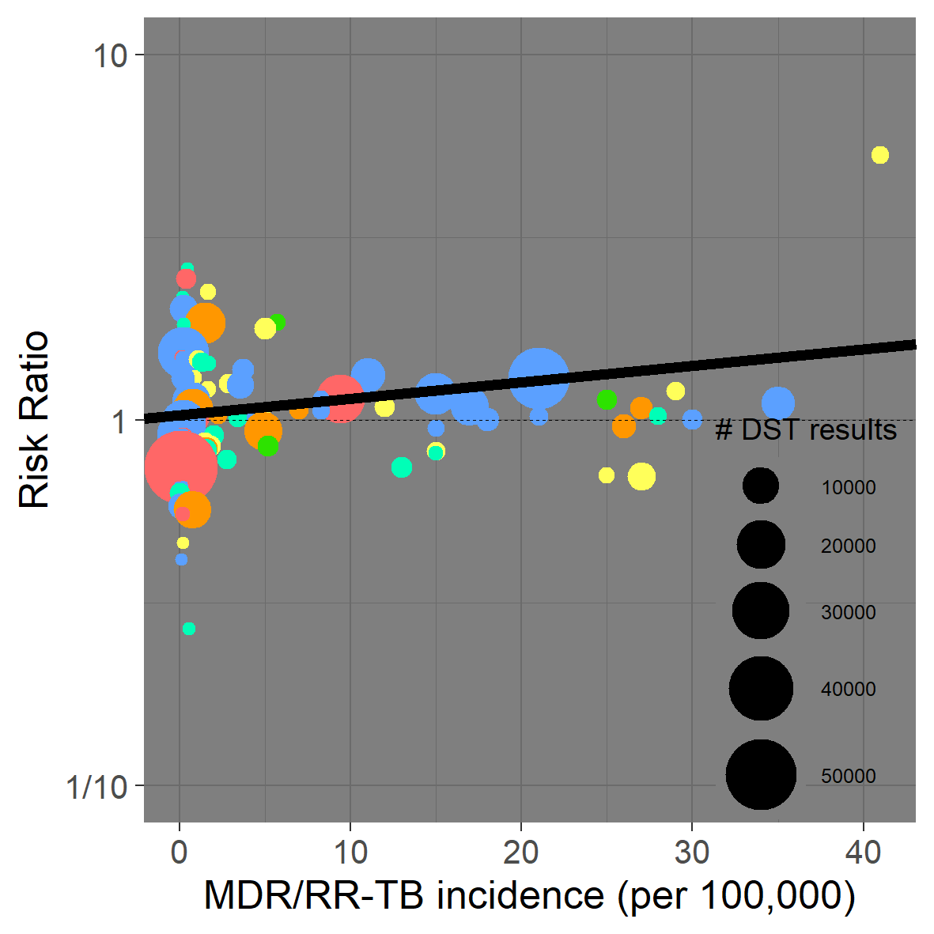
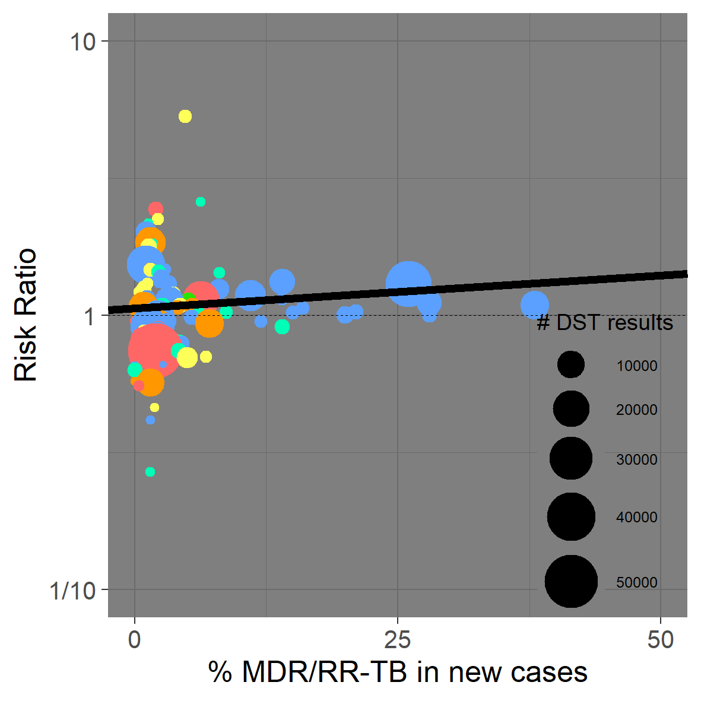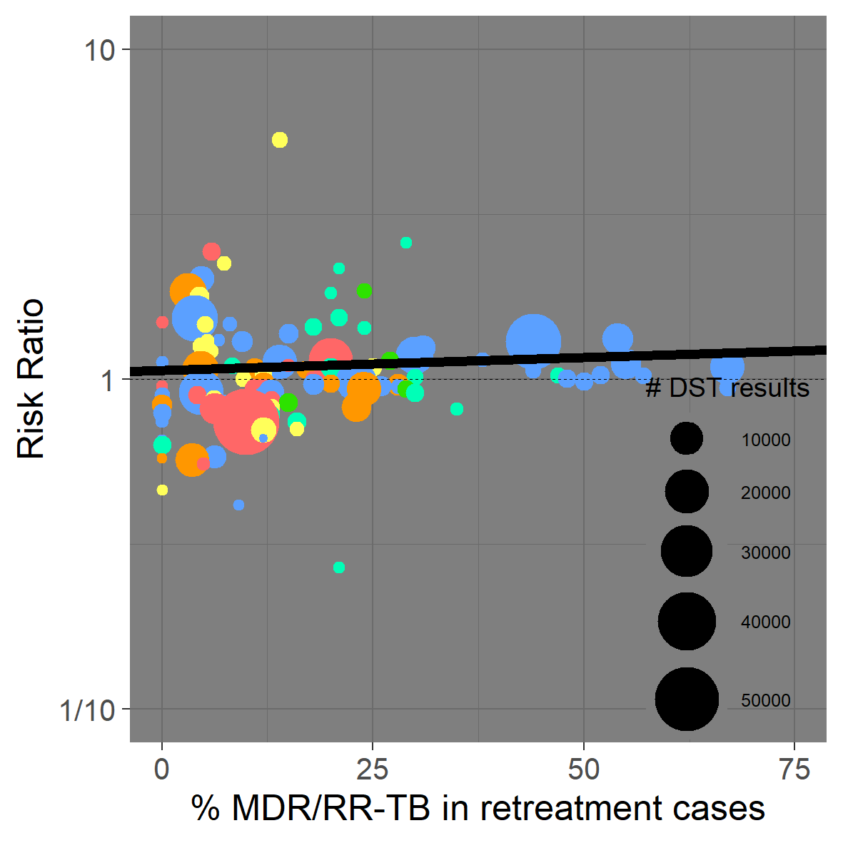
Figure 3: MDR/RR-TB burden compared to MDR/RR-TB M:F risk ratio by country. Data among all (new and retreated) cases are presented, where each circle represents a country where the size is scaled to the number of sex-disaggregated DST results available. Black lines indicate the weighted linear regression best-fit. Colours indicate the WHO region for each country (African Region in yellow, Region of the Americas in red, Eastern Mediterranean Region in turquoise, European Region in blue, South-East Asia Region in green and Western Pacific Region in orange). A risk ratio greater than 1 suggests that, among those with TB, men were more at risk of MDR/RR-TB than women, while a risk ratio less than 1 suggests that, among those with TB, women were more at risk of MDR/RR-TB than men.
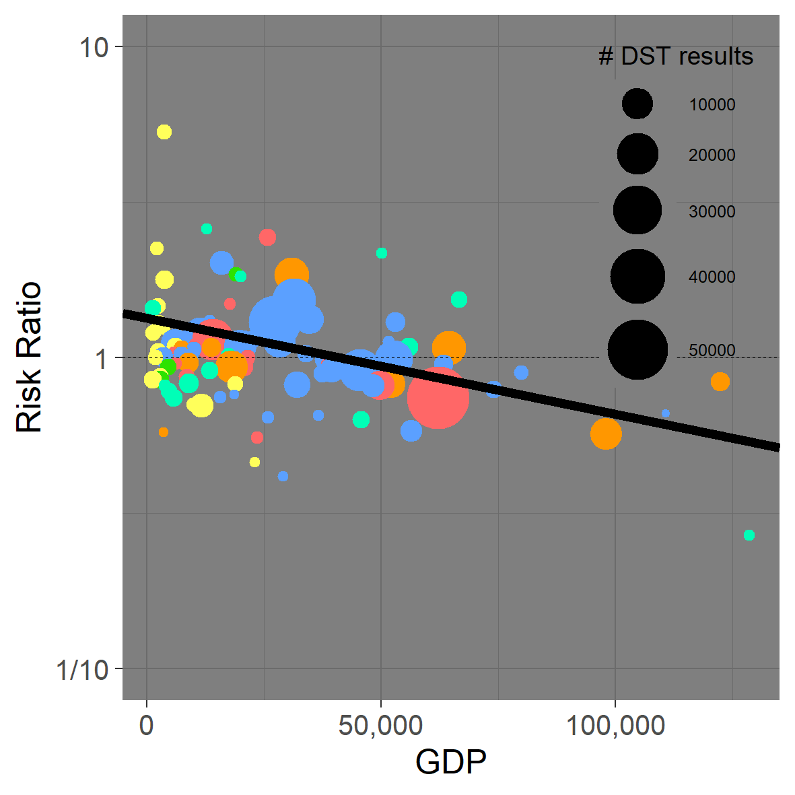
Figure 4: Gross Domestic Product Purchase Power Parity compared to MDR/RR-TB M:F risk ratio by country. Data among all (new and retreated) cases are presented, where each circle represents a country where the size is scaled to the number of sex-disaggregated DST results available. The black line indicates the weighted linear regression best-fit. Colours indicate WHO region for each country (African Region in yellow, Region of the Americas in red, Eastern Mediterranean Region in turquoise, European Region in blue, South-East Asia Region in green and Western Pacific Region in orange). A risk ratio greater than 1 suggests that, among those with TB, men were more at risk of MDR/RR-TB than women, while a risk ratio less than 1 suggests that, among those with TB, women were more at risk of MDR/RR-TB than men.

