Title: Surgery and adjuvant radiotherapy for unilateral ductal carcinoma in situ (DCIS) in women aged over 70 years: a population based cohort study

Author names and affiliations:
Yasmin Jauhari (Y.J.)¹ ⁷, Melissa Ruth Gannon (M.R.G.)¹ ², Carmen Tsang (C.T.)² ³, Kieran Horgan (K.H.)⁴,
David Dodwell (D.D) ⁵, Karen Clements (K.C.)⁶, Jibby Medina (J.M.)¹, Sarah Tang (S.T.)⁶,
Ruth Pettengell (R.P.)⁶ and David Alan Cromwell (D.A.C.)¹ ²

Institutions
¹ Clinical Effectiveness Unit, The Royal College of Surgeons of England, London, UK
² Department of Health Services Research & Policy, London School of Hygiene & Tropical Medicine, London, UK
³ Centre for Surgical Research, Bristol Medical School: Population Health Sciences, University of Bristol, Bristol, UK
⁴ Department of Breast Surgery, St James’s University Hospital, Leeds, UK
⁵ Nuffield Department of Population Health, University of Oxford, Oxford, UK
⁶ Public Health England, 1st Floor, 5 St Philip’s Place, Birmingham, UK
⁷ St Georges Healthcare NHS Trust, London, UK

Corresponding author:
Yasmin Jauhari (yjauhari@rcseng.ac.uk)
Clinical Effectiveness Unit, The Royal College of Surgeons of England, 35 – 43 Lincoln Inn’s Fields, London, WC2A 3PE
Phone: 020 7869 6606

Manuscript category: original article

Previous presentation: Association of Breast Surgery conference, Birmingham, June 2018.
Abstract publication: Jauhari Y, Gannon M, Medina J, Clements K, Horgan K, Dodwell D, et al. Treatment patterns for unilateral, non-invasive breast cancer in women diagnosed in England: Data from a population-based cohort. European Journal of Surgical Oncology. 2018;44(6).

Role of the funding source:
This study was undertaken as part of the work by the National Audit of Breast Cancer in Older Patients. The Audit is commissioned by the Healthcare Quality Improvement Partnership (HQIP) as part of the National Clinical Audit and Patient Outcomes Programme, and funded by NHS England and the Welsh Government (www.hqip.org.uk/national-programmes). Neither HQIP nor the funders had any involvement in the study design; in the collection, analysis, and interpretation of data; in the writing of the report; or in the decision to submit the article for publication. The authors had full independence from the Healthcare Quality Improvement Partnership.

The aim of NABCOP is to evaluate the care of older women with breast cancer in England and Wales, and support NHS providers to improve the quality of hospital care for these women. More information can be found at: www.nabcop.org.uk

Ethics approval
The study is exempt from UK National Research Ethics Committee approval as it involved secondary analysis of an existing dataset of anonymised data. The NABCOP has approval for processing health care information under Section 251 (reference number: 16/CAG/0079) for all NHS patients aged 50 years and over diagnosed with breast cancer in England and Wales.

Data sharing:
No additional data available. Data on English cancer registrations can be accessed via the Office for Data Release at Public Health England. https://www.gov.uk/government/publications/accessing-public-health-england-data/about-the-phe-odr-and-accessing-data

Abstract
Background:
There is little clinical evidence to guide treatment decisions for ductal carcinoma in situ (DCIS) in older women. This study evaluated how the management of DCIS in women aged 70 or more compared with women aged 50-69 in England and Wales.
Method:
The study identified women aged ≥50 years with new unilateral DCIS diagnosed between 2014-2016 from linked cancer registration and routine hospital datasets for England and Wales. Rates of surgery and adjuvant radiotherapy were examined by age, deprivation, fitness measures (comorbidity and frailty), method of presentation and tumour grade using multilevel logistic regression.
Results:
12,716 women were diagnosed with unilateral DCIS between 2014-2016, of whom 2,754 (22%) were aged ≥70 years and 74% were screen detected. High grade DCIS was common, irrespective of age and method of presentation. Fewer women aged ≥70 had surgery compared to women aged 50–69 (81% vs. 94%), which was only partly explained by poor fitness. Use of radiotherapy following breast conserving surgery was strongly associated with grade, and was received by less than 16% of all patients with low grade tumours. Over 70% of women aged 50-69 with high grade DCIS received radiotherapy, but this fell to 35% among women aged ≥80. Use of radiotherapy was not associated with patient fitness.
Conclusion:
Treatment decisions for women with DCIS varied by age at diagnosis. Lower rates of surgery and adjuvant radiotherapy in older women were only partly explained by patient fitness. Better evidence is needed to aid treatment selection for older women with DCIS.

Keywords: DCIS, breast cancer, geriatric oncology

Introduction

Ductal carcinoma in situ (DCIS) is typically diagnosed among women aged between 50 and 70 years, as a consequence of their participation in population-level breast screening programmes^{1, 2}. DCIS accounts for around 6 – 9% of all breast cancers in women aged ≥70 years^{3, 4} and chronological age remains a significant risk factor^{1, 2}. A diagnosis of DCIS increases the risk of developing invasive breast cancer⁵ but there is uncertainty concerning the natural history, rate of progression⁶ and long term survival outcomes⁷. It has been estimated that between 5-30% of all DCIS cases might progress to invasive breast cancer within 10 years⁶.

The current recommended treatment for DCIS is surgical resection with or without radiotherapy⁸. Surgery for DCIS can be in the form of breast conserving surgery (BCS) or mastectomy, depending on the size of the tumour relative to the breast, presence of multi-centricity and patient preference. However, the effectiveness of treatments for different patient subgroups is under debate. It is suggested that surgery for low grade DCIS is unlikely to confer a survival benefit⁷. Additionally, although radiotherapy reduces the risk of recurrence, randomised trials have reported that it has no influence on breast cancer specific or overall survival⁹⁻¹¹.

Treatment decisions for older women can also be affected by the higher prevalence of comorbid conditions or frailty because both factors may reduce life expectancy^{12, 13}. However, clinical guidelines do not provide advice on how treatments for DCIS should be tailored for these women¹⁴. The current non-stratified approach to the management of DCIS risks under or over-treatment, yet there is a lack of strong evidence to support omission of comprehensive treatment in the older population¹⁴. This study was undertaken to evaluate clinical patterns of care among women with DCIS in England and Wales, and to determine the extent to which increasing age and patient fitness affected the care received.

Materials and methods

Data sources
The study was undertaken as part of the National Audit of Breast Cancer in Older Patients (NABCOP)¹⁵. NABCOP uses pseudonymised patient-level datasets provided by the National Cancer Registration and Analysis Service for England, and Wales Cancer Network for Wales. The datasets included national cancer registrations, which provides data on patient demographics and tumour information, and extracts from the routine hospital admission databases for NHS hospitals (the English Hospital Episode Statistics (HES) and the Patient Episode Database for Wales (PEDW)). Use of radiotherapy was reported in the Radiotherapy Dataset (RTDS) for English patients and as part of the cancer registration dataset for Welsh patients. The methodology used to identify patients who received radiotherapy within the two datasets was equivalent.

Study population and definitions
Full details of the NABCOP cohort are detailed in the annual report¹⁵. For this analysis, the study cohort included all women aged 50 and over, diagnosed with a new unilateral DCIS (ICD-10 code: D05.1) from 1 January 2014 to 31 December 2016 in NHS hospitals in England and Wales. Women with synchronous invasive breast cancers (defined as cancers diagnosed within six months of the DCIS diagnosis¹⁶) were not included (Appendix A). Each woman was allocated to an NHS trust (England) or local health board (Wales) based on their hospital of diagnosis. These are referred to as NHS organisations in this study.

Information on patient demographics (age, deprivation), date of diagnosis, method of presentation and tumour characteristics were obtained from cancer registration datasets. Molecular markers such as hormone receptor status are not routinely collected for DCIS in many NHS organisations in the UK¹⁷. Area-level socioeconomic deprivation was measured using the Index of Multiple Deprivation (IMD), with the IMD values for the relevant geographical area in Wales¹⁸ and England¹⁹ converted to quintiles. Patient fitness was assessed using comorbidity and frailty measures. Comorbidity burden was measured using the Royal College of Surgeons of England Charlson Comorbidity Index (CCI) excluding malignancy²⁰. This index was calculated based on the presence of specific medical problems, identified using ICD-10 diagnostic information in HES and PEDW in the two years prior to the date of cancer diagnosis²¹. The study also used a measure of frailty²², a distinct concept from comorbidity that describes the dynamic and heterogeneous manifestation of age-related decline in physiological reserve and increased vulnerability to stressors²³⁻²⁵. Frailty was measured by adapting the electronic Frailty Index (eFI)²⁶ for use within routine hospital databases. This involved mapping each of the 36 eFI frailty deficits (excluding polypharmacy) to appropriate ICD-10 diagnosis codes and counting how many were recorded in HES and PEDW records in the two years prior to the date of diagnosis¹⁵.

Primary surgery was defined by the first type of surgical procedure performed within six months of the date of diagnosis as recorded in HES or PEDW. Surgical procedures were described in the datasets using Office of Population Censuses and Surveys (OPCS) procedure codes, from which we distinguished between BCS (OPCS codes: B28.1, B28.2, B28.3, B28.5, B28.7, B28.8 and B28.9), mastectomy (any B27 code) with or without reconstruction (OPCS codes as per Mennie et al²⁷), sentinel node biopsy (SNB)(T86.2, T87.3 and T91.1) and axillary node dissection (T85.2). Subsequent reoperations within six months of primary surgery were identified by the aforementioned mastectomy and BCS codes (with the inclusion of B28.4: re-excision of margins), with the same laterality code (Z94) as the primary surgery. Re-excision of margins was not limited to the specific OPCS code (B28.4) because it was inconsistently used across NHS organisations. Surgery performed within one week of the primary procedure was not considered to be a subsequent procedure because this was likely to have been performed for postoperative complications. Adjuvant radiotherapy was defined as the receipt of radiotherapy within six months of the last reoperation procedure.

Statistical analysis
Older women were defined as those aged ≥70 years to reflect the current national cut-off age of 70 years for invitation to the NHS Breast Screening programme and Breast Test Wales. The differences between categorical variables were statistically assessed using chi-square tests.

Multilevel logistic regression was used to investigate the relationships between the rates of breast surgery, SNB and adjuvant radiotherapy, respectively, and patient and tumour characteristics (level 1), and to evaluate whether the treatment rates differed between NHS organisations (level 2). Patient factors included in the regression models were age, deprivation quintile, (nuclear) grade, method of tumour detection, CCI and eFI. Additionally, the model for radiotherapy included the number of reoperations and the model for SNB included the type of breast surgery performed. These models included a random intercept for each NHS organisation and evidence of between-organisation variation is described by the variance of the random intercepts. The c-statistic (a measure of discrimination i.e. how well the model can distinguish between patients according to whether they experienced the outcome of interest or not) was used to assess how well the regression models fitted the data. Missing values were imputed using the multiple imputation by chained equations (MICE) method and model estimates produced from the 20 imputed datasets were combined using Rubin’s rules²⁸. Missing data (grade, CCI and eFI) were assumed to be “missing at random”. Analysis for this study was conducted using Stata 15.1 (StataCorp LP, College Station, Texas USA). All statistical tests were two sided, and p values <0.05 were considered to be statistically significant.

Results

Between 1 January 2014 and 31 December 2016, 126,111 women aged ≥50 years in England and Wales were diagnosed with breast cancer. Among these, 12,716 women were diagnosed with unilateral DCIS – 11,807 (92.9%) in England and 909 (7.2%) in Wales. The median age was 63.5 years (range: 50 – 101) and 2,752 (21.6%) women were aged ≥70 years. Mammographic (screen) detection was the mode of presentation in 9,414 (74.0%) women, but the proportion varied among women of different ages. The clinical and pathological characteristics of the study cohort are summarised by age group and method of presentation in Table 1.

Primary treatment for DCIS
In total, 11,554 (90.9%) women had a surgical resection; this differed by age with fewer women aged ≥70 having surgery compared to women aged 50–69 (80.5% vs. 93.7%). The observed rate of surgery decreased with increasing age (Figure 1) and among women with lower grade DCIS (Figure 2). BCS was the most common surgical procedure (79.0%). Among the remaining 21.0% of women having mastectomy, immediate breast reconstruction was rarely utilised among women aged ≥75 years (Table 1).

Table 2 describes the proportion of women not receiving surgery in relation to patient and tumour characteristics. In addition to age and grade, the proportion of women who did not have surgery also varied by method of presentation and patient fitness. The associations between not having surgery and individual variables were attenuated after adjustment for potential confounding, but remained statistically significant. In particular, the adjusted odds ratios for the older age categories were much closer to one, and only for women aged ≥ 80 years was the increased likelihood of not having surgery statistically significant.

The multilevel regression model results showed that, after taking case mix into account, the rates of surgery differed between NHS organisations (Appendix B). The variation in the rate of surgery between NHS organisations was substantial among women aged ≥70 years, with the 10th and 90th centiles of the adjusted organisational rates being 74% and 90%, respectively. In comparison, for the cohort of women aged 50–69 years, these rates were 94% and 98%, respectively (see Appendix B. for funnel plots).

Axillary surgery in women having primary surgery for DCIS
In the group of 11,540 women who received primary surgery, 3,597 (31.2%) also underwent axillary surgery; 97.7% of these axillary procedures were SNB. Over 85% of women who underwent mastectomy had a SNB (50–69 years: 88.8% vs. ≥70 years: 85.1%). Fewer women who received BCS had a SNB (50–69 years: 14.6% vs. ≥70 years: 17.3%). Overall, less than 0.5% of all women who had a SNB proceeded to have an axillary node dissection. There were found to be differences in the average adjusted rates of SNB across NHS organisations (Appendix B).

Rate of radiotherapy within six months of primary BCS
The proportion of women who had radiotherapy within six months of primary BCS was 55.6%. Women rarely received radiotherapy following mastectomy (2.5%). Women aged ≥70 years were less likely to undergo post-BCS radiotherapy compared to those aged 50 – 69 years (respectively, 43.1% vs. 58.4%). Over 70% of women aged 50-69 years with high grade tumours received radiotherapy, but this fell to 35% among women aged ≥80 years (figure 3).

Radiotherapy following BCS was received less commonly in older women, those with lower grade DCIS, screen detected presentation and those undergoing reoperations (Table 3). Deprivation and burden of comorbidity or frailty were not found to be associated with non-receipt of radiotherapy. Differences in the use of radiotherapy following BCS among the NHS organisations were more than expected from random variation alone (Appendix B).

Discussion

Between 2014 and 2016, DCIS was diagnosed in over 4,000 women aged ≥50 years annually in England and Wales. One in five of these women were aged 70 and over. Despite the cessation of inclusion into national breast screening programmes, almost half of the women aged ≥70 years presented with DCIS through screening. This may be an effect of self-referral for mammographic screening or involvement in the AgeX trial on extending the NHS breast screening age to women over 70 in England²⁹.

Breast cancer clinicians have insufficient evidence on which to base decisions about the management of DCIS in older women. The principal treatment decision focuses on whether or not a woman has surgery. This study found that while most women are receiving surgery, these decisions appear to be influenced by several factors. In particular, lower rates of surgery were observed among women aged ≥70 years. The effect of increased age on rate of surgery was mitigated when grade, comorbidity and frailty were taken into account but was still apparent among women aged 80 years or more.

We observed that one in three women who had surgery also had an axillary procedure, despite the lack of evidence to support this practice ³⁰. However, the majority of women who received SNB underwent mastectomy, which is in accordance with UK guidelines⁸ and is likely to reflect the proportion of women who were considered to be at high risk for invasive disease e.g. with a palpable mass. Among the women who underwent BCS, less than one in five received SNB.

Fewer older women received adjuvant radiotherapy following BCS. However, this was not found to be related to burden of comorbidity or frailty, possibly because women in poorer physical health had not undergone surgery and consequently, were not candidates for radiotherapy. Additionally, older women who received surgery may have been offered but declined radiotherapy due to other factors (that could not be accounted for in this study). For example, the travel time to radiotherapy centres³¹ may have deterred some older women from post-BCS radiotherapy.

The results from multilevel regression models showed that there was significant variation across NHS organisations in their adjusted rates of surgery, SNB and adjuvant radiotherapy post-BCS. This is perhaps to be expected given the limited evidence available to guide clinicians¹⁴. This study could not account for the influence of patient preferences on treatment decisions, but a study by Bleicher et al. reported patient age to have minimal influence on DCIS treatment choices and level of involvement in decision making³⁸.

Strengths and Limitations
The study has several strengths. Women were identified using the national cancer registries in England and Wales, reducing the risk of selection bias, and a focus on unilateral DCIS improved the homogeneity of the patient cohort. The use of national hospital datasets also ensures complete capture of all NHS hospital admissions for these patients reducing the risk of underreporting surgery rates. Lastly, this study utilised measures of comorbidity and frailty which are known to influence the patterns of care for older women. Whilst there is no “gold-standard” measure of frailty, the study adapted the eFI frailty measure³² based on the concept of frailty being an accumulation of deficits³³. The eFI was incorporated into general practitioner patient care records in 2017³⁴ and, although this adaptation requires further evaluation, the increasing prevalence of frailty in older women observed in this study is consistent with other studies^{32, 35}.

The study has some limitations. Routinely collected hospital data are subject to potential inaccuracies in coding and data entry, which could influence the estimated treatment rates. However, validation work has shown HES to be an accurate data source with 90-93% agreement with data provided by surgeons³⁶. Additionally, the linkage of several datasets allowed a series of checks to be performed for consistency across shared data items, in order to minimise the effect of coding errors. The incomplete data on tumour size meant that this factor could not be taken into account during the analyses of primary surgery patterns and use of radiotherapy. However, it was reassuring to observe that, where recorded, the majority of tumour sizes were 2cm or less (irrespective of age) as would be expected from published evidence³⁷. Moreover, the logistic regression models demonstrated a good fit with the data (c-statistics between 0.75-0.80) and so the absence of tumour size is unlikely to influence our conclusions about the impact of age on treatment patterns. Lastly, 1,162 women in this study did not have surgery and so the diagnosis of DCIS was not confirmed by the pathology results from the resected tissue. Mammographic lesions may harbour foci of invasive cancer in up to 20% of instances⁵, thus there is some uncertainty in the accuracy of the diagnosis among these patients. Nonetheless, this affects a small proportion of the overall cohort.

Comparison with other studies
The finding that older age was an independent risk factor for not receiving primary surgery or radiotherapy for DCIS is consistent with published studies in both invasive^{38, 39} and non-invasive breast cancer^{4, 7}. As the regression models demonstrated, age is only one of many factors that influence treatment decisions. Indeed, the higher rate of surgery and radiotherapy in women with high grade DCIS compared to those with intermediate and low grade suggests a risk-stratified approach to managing DCIS in women aged ≥70⁴⁰⁻⁴². However, the variation in the adjusted rate of surgery and radiotherapy in women aged ≥70 years between NHS organisations suggests local factors are contributing to different practices between organisations. A small number of women in this study will have been part of the randomised trial comparing surgery with active monitoring for low risk DCIS (LORIS)⁴³. This is unlikely to have significant impact on the study findings as LORIS trial recruitment only commenced in July 2014 and 75% of women in this study do not meet the inclusion criteria of having low or intermediate, screen-detected DCIS. Nonetheless, the results of LORIS and other similar ongoing trials^{44, 45} will provide important contributions to the evidence base on the effectiveness of treatments for women with DCIS, and the enrolment of eligible patients into these trials is encouraged.

In older women, the risk of mortality due to poor fitness can outweigh the benefit of comprehensively treating DCIS, but there is an absence of studies which report on survival using patient fitness measures^{7, 14}. Health professionals can be inconsistent in their estimation of life expectancy in older frail women⁴⁶. Furthermore, it is estimated that fewer than 30% of cases progress to an invasive cancer within 10 years⁶. Further research is therefore essential to determine how patient fitness affects treatment decisions and survival after a diagnosis of DCIS.

Conclusion
In conclusion, between 2014 and 2016, 12,716 women aged 50 and over presented with DCIS in England and Wales. One in five of these women were aged 70 and over, despite the cessation of invitations to the NHS breast screening programme at age 70. Treatment decisions for women with DCIS vary by age at diagnosis, with older women having lower rates of surgery and adjuvant radiotherapy. The differences in treatment decisions across age groups is only partly explained by patient fitness. There is a need for in depth review of age-based clinical decision making and better evidence to aid treatment selection for older women with DCIS.

References
1. Virnig BA, Tuttle TM, Shamliyan T, Kane RL. Ductal Carcinoma In Situ of the Breast: A Systematic Review of Incidence, Treatment, and Outcomes. JNCI: Journal of the National Cancer Institute. 2010;102(3):170-8.
2. Ernster VL, Ballard-Barbash R, Barlow WE, Zheng Y, Weaver DL, Cutter G, et al. Detection of Ductal Carcinoma In Situ in Women Undergoing Screening Mammography. JNCI: Journal of the National Cancer Institute. 2002;94(20):1546-54.
3. Cancer Research UK. In-situ breast carcinoma statistics 2018 [22/06/2018]. Available from: http://www.cancerresearchuk.org/health-professional/cancer-statistics/statistics-by-cancer-type/breast-cancer/incidence-in-situ#ref-.
4. Ward EP, Weiss A, Blair SL. Incidence and treatments of DCIS in octogenarians: grade matters. Breast Cancer Research and Treatment. 2017;165(2):403-9.
5. Lopez‐Garcia MA, Geyer FC, Lacroix‐Triki M, Marchió C, Reis‐Filho JS. Breast cancer precursors revisited: molecular features and progression pathways. Histopathology. 2010;57(2):171-92.
6. Ozanne EM, Shieh Y, Barnes J, Bouzan C, Hwang ES, Esserman LJ. Characterizing the impact of 25 years of DCIS treatment. Breast Cancer Research and Treatment. 2011;129(1):165-73.
7. Sagara Y, Mallory M, Wong S, et al. Survival benefit of breast surgery for low-grade ductal carcinoma in situ: A population-based cohort study. JAMA Surgery. 2015;150(8):739-45.
8. National Institute for Health and Care Excellence. NICE guidelines (CG101). Early and locally advanced breast cancer: diagnosis and treatment. NICE, 2018.
9. Donker M, Litière S, Werutsky G, Julien J-P, Fentiman IS, Agresti R, et al. Breast-Conserving Treatment With or Without Radiotherapy in Ductal Carcinoma In Situ: 15-Year Recurrence Rates and Outcome After a Recurrence, From the EORTC 10853 Randomized Phase III Trial. Journal of Clinical Oncology. 2013;31(32):4054-9.
10. Early Breast Cancer Trialists’ Collaborative Group. Overview of the Randomized Trials of Radiotherapy in Ductal Carcinoma In Situ of the Breast. Journal of the National Cancer Institute Monographs. 2010;2010(41):162-77.
11. Narod SA, Iqbal J, Giannakeas V, Sopik V, Sun P. Breast cancer mortality after a diagnosis of ductal carcinoma in situ. JAMA Oncology. 2015;1(7):888-96.
12. Stotter A, Reed MW, Gray LJ, Moore N, Robinson TG. Comprehensive Geriatric Assessment and predicted 3-year survival in treatment planning for frail patients with early breast cancer. British Journal of Surgery. 2015;102(5):525-33.
13. Satariano WA, Ragland DR. THe effect of comorbidity on 3-year survival of women with primary breast cancer. Annals of Internal Medicine. 1994;120(2):104-10.
14. Biganzoli L, Wildiers H, Oakman C, Marotti L, Loibl S, Kunkler I, et al. Management of elderly patients with breast cancer: updated recommendations of the International Society of Geriatric Oncology (SIOG) and European Society of Breast Cancer Specialists (EUSOMA). Lancet Oncol. 2012;13.
15. Healthcare Quality Improvement Partnership (HQIP). National Audit of Breast Cancer in Older Patients (NABCOP): 2018 annual report. 2018.
16. Londero AP, Bernardi S, Bertozzi S, Angione V, Gentile G, Dri C, et al. Synchronous and Metachronous Breast Malignancies: A Cross-Sectional Retrospective Study and Review of the Literature. BioMed Research International. 2014;2014:250727.
17. The Royal College of Pathologists. Pathology reporting of breast disease in surgical excision specimens in incorporating the dataset for histological reporting of breast cancer. 2016.
18. Llywodraeth Cymru Welsh Government. Welsh Index of Multiple Deprivation 2014. Available from: https://gov.wales/statistics-and-research/welsh-index-multiple-deprivation/?lang=en.
19. Communities and Local Government. The English Indices of Deprivation 2015 2015. Available from: https://www.gov.uk/government/statistics/english-indices-of-deprivation-2015.
20. Armitage JN, van der Meulen JH, Royal College of Surgeons Co-morbidity Consensus G. Identifying co-morbidity in surgical patients using administrative data with the Royal College of Surgeons Charlson Score. Br J Surg. 2010;97(5):772-81.
21. Preen DB, Holman CDAJ, Spilsbury K, Semmens JB, Brameld KJ. Length of comorbidity lookback period affected regression model performance of administrative health data. Journal of Clinical Epidemiology. 2006;59(9):940-6.
22. Wildiers H, Heeren P, Puts M, Topinkova E, Janssen-Heijnen MLG, Extermann M, et al. International Society of Geriatric Oncology Consensus on Geriatric Assessment in Older Patients With Cancer. Journal of Clinical Oncology. 2014;32(24):2595-603.
23. Xue Q-L. The Frailty Syndrome: Definition and Natural History. Clinics in geriatric medicine. 2011;27(1):1-15.
24. Gill TM, Gahbauer EA, Allore HG, Ham L. Transitions between frailty states among community-living older persons. Arch Intern Med. 2006;166.
25. Campbell JB, DM.;. Unstable disability and fluctuations of frailty. Age and Ageing. 1997;26:315 - 8.
26. Clegg A, Bates C, Young J, Ryan R, Nichols L, Ann Teale E, et al. Development and validation of an electronic frailty index using routine primary care electronic health record data. Age and Ageing. 2016.
27. Mennie JC, Mohanna PN, O'Donoghue JM, Rainsbury R, Cromwell DA. National trends in immediate and delayed post-mastectomy reconstruction procedures in England: A seven-year population-based cohort study. European Journal of Surgical Oncology (EJSO). 2017;43(1):52-61.
28. Little RJA and Rubin DB. Statistical Analysis with Missing Data 2nd ed. Hoboken, NJ: Wiley; 2002.
29. NHS Breast Screening Programme. AgeX Trial 2016. Available from: http://www.agex.uk/.
30. Nicholson S, Hanby A, Clements K, Kearins O, Lawrence G, Dodwell D, et al. Variations in the management of the axilla in screen-detected Ductal Carcinoma In Situ: Evidence from the UK NHS Breast Screening Programme audit of screen detected DCIS. European Journal of Surgical Oncology. 2015;41(1):86-93.
31. Schroen AT, Brenin DR , Kelly MD, Knaus WA , Slingluff CL. Jr. Impact of Patient Distance to Radiation Therapy on Mastectomy Use in Early-Stage Breast Cancer Patients. Journal of Clinical Oncology. 2005;23(28):7074-80.
32. Clegg A, Bates C, Young J, Ryan R, Nichols L, Ann Teale E, et al. Development and validation of an electronic frailty index using routine primary care electronic health record data. Age and Ageing. 2016;45(3):353-60.
33. Mitnitski AB, Mogilner AJ, Rockwood K. Accumulation of deficits as a proxy measure of aging. The Scientific World. 2001;1.
34. NHS England. Updated guidance on supporting routine frailty identification and frailty care through the GP contract 2017/8. 2017.
35. Gilbert T, Neuburger J, Kraindler J, Keeble E, Smith P, Ariti C, et al. Development and validation of a Hospital Frailty Risk Score focusing on older people in acute care settings using electronic hospital records: an observational study. The Lancet. 2018.
36. West Midlands Cancer Intelligence Unit. Breast Cancer Clinical Outcome Measures. Quantifying the completeness of national breast cancer data (cases diagnosed in 2006): Executive Summary. 2009.
37. Alvarado R, Lari SA, Roses RE, Smith BD, Yang W, Mittendorf EA, et al. Biology, Treatment, and Outcome in Very Young and Older Women with DCIS. Annals of surgical oncology. 2012;19(12):10.1245/s10434-012-2413-4.
38. Richards P, Ward S, Morgan J, Lagord C, Reed M, Collins K, et al. The use of surgery in the treatment of ER+ early stage breast cancer in England: Variation by time, age and patient characteristics. European Journal of Surgical Oncology. 2016;42(4):489-96.
39. Bates T, Evans T, Lagord C, Monypenny I, Kearins O, Lawrence G. A population based study of variations in operation rates for breast cancer, of comorbidity and prognosis at diagnosis: Failure to operate for early breast cancer in older women. European Journal of Surgical Oncology (EJSO). 2014;40(10):1230-6.
40. Cheung S, Booth ME, Kearins O, Dodwell D. Risk of subsequent invasive breast cancer after a diagnosis of ductal carcinoma in situ (DCIS). The Breast. 2014;23(6):807-11.
41. Thompson AM, Clements K, Cheung S, Pinder SE, Lawrence G, Sawyer E, et al. Management and 5-year outcomes in 9938 women with screen-detected ductal carcinoma in situ: the UK Sloane Project. European Journal of Cancer. 2018;101:210-9.
42. van Maaren MC, Lagendijk M, Tilanus-Linthorst MMA, de Munck L, Pijnappel RM, Schmidt MK, et al. Breast cancer–related deaths according to grade in ductal carcinoma in situ: A Dutch population–based study on patients diagnosed between 1999 and 2012. European Journal of Cancer. 2018;101:134-42.
43. Francis A, Thomas J, Fallowfield L, Wallis M, Bartlett JMS, Brookes C, et al. Addressing overtreatment of screen detected DCIS; the LORIS trial. European Journal of Cancer. 2015;51(16):2296-303.
44. ClinicalTrials.gov. Comparison of operative monitoring and endocrine therapy (COMET) trial for low risk DCIS 2016 [08/01/2019]. Available from: https://clinicaltrials.gov/ct2/show/NCT02926911.
45. Wesseling J., Elshof LE., Tryfonidis K., Poncet C., Aalders K., van Leeuwen-Stok E., et al. Abstract OT3-07-01: Update of the randomized, non-inferiority LORD trial testing safety of active surveillance for women with screen-detected low risk ductal carcinoma in situ (EORTC-1401-BCG/BOOG 2014-04, DCIS) [abstract]. In: Proceedings of the 2017 San Antonio Breast Cancer Symposium; 2017 Dec 5-9; San Antonio, TX. Philadelphia (PA): AACR. Cancer Res. 2018;78:4 Suppl.
46. Healthcare Quality Improvement Partnership (HQIP). National Audit of Breast Cancer in Older Patients (NABCOP): annual report. 2017.

Figure 1: Type of surgical treatment recorded in women diagnosed with DCIS in NHS organisations in England and Wales, by age group at diagnosis.

Figure 2: Proportion of women recorded to have received primary surgery for DCIS in NHS organisations in England and Wales, by age group at diagnosis and DCIS grade.

Figure 3: Proportion of women recorded to have received adjuvant radiotherapy following breast conserving surgery for DCIS in NHS organisations in England and Wales, by age group at diagnosis and DCIS grade.

Table 1: Baseline clinical and pathological characteristics, and type of recorded treatment for unilateral DCIS in women diagnosed in NHS Hospitals in England and Wales between January 2014 and December 2016, by screen detected status.
(* Note: p-values from analysis of the overall group)
 | Screen detected
 | Yes |  |  | No |  |  |  | Total | P-value (group)
 | 50-69 years | ≥70 years |  | 50-69 years |  | ≥70 years
Total number of women | 8134 (86%) | 1280 (14%) |  | 1828 (55%) |  | 1474 (45%) |  | 12716
Non-invasive grade
High | 5042 (65%) | 727 (61%) |  | 914 (56%) |  | 574 (47%) |  | 7257 | <0.001
Intermediate | 2019 (26%) | 355 (30%) |  | 492 (30%) |  | 462 (38%) |  | 3328
Low | 637 (8%) | 119 (10%) |  | 236 (14%) |  | 196 (16%) |  | 1188
Unknown | 436 | 79 |  | 186 |  | 242 |  | 943
Tumour size (cm)
0 - ≤ 1 | 1135 (50%) | 180 (51%) |  | 176 (41%) |  | 141 (42%) |  | 1632 | <0.001
> 1 - ≤ 2 | 847 (38%) | 124 (35%) |  | 175 (41%) |  | 141 (42%) |  | 1287
2 + | 273 (12%) | 52 (15%) |  | 78 (18%) |  | 50 (15%) |  | 616
Unknown | 5879 | 924 |  | 1399 |  | 1142 |  | 9344
Charlson Comorbidity Index (CCI)
0 | 7125 (91%) | 1064 (85%) |  | 1447 (85%) |  | 966 (71%) |  | 10602 | <0.001
1 | 577 (7%) |  | 143 (11%) |  | 191 (11%) |  | 248 (18%) | 1159
2 + | 137 (2%) | 39 (3%) |  | 62 (4%) |  | 149 (11%) |  | 387
Unknown | 295 | 34 |  | 128 |  | 111 |  | 568
Number of frailty deficiencies (eFI)
0 | 6452 (82%) | 843 (68%) |  | 1208 (71%) |  | 660 (48%) |  | 9163 | <0.001
1 | 717 (9%) | 168 (13%) |  | 232 (14%) |  | 170 (12%) |  | 1287
2 | 367 (5%) | 131 (11%) |  | 142 (8%) |  | 180 (13%) |  | 820
3 + | 303 (4%) | 104 (8%) |  | 118 (7%) |  | 353 (26%) |  | 878
Unknown | 295 | 34 |  | 128 |  | 111 |  | 568
IMD quintile
1 - most deprived | 1080 (13%) | 268 (15%) |  | 136 (11%) |  | 216 (15%) |  | 1700 | 0.005
2 | 1383 (17%) | 321 (18%) |  | 204 (16%) |  | 265 (18%) |  | 2173
3 | 1646 (20%) | 387 (21%) |  | 260 (20%) |  | 317 (22%) |  | 2610
4 | 1952 (24%) | 404 (22%) |  | 326 (25%) |  | 326 (22%) |  | 3008
5 – least deprived | 2073 (25%) | 448 (25%) |  | 354 (28%) |  | 350 (24%) |  | 3225
Type of treatment
No surgery | 255 (14%) | 445 (30%) |  | 373 (5%) |  | 89 (7%) |  | 1162 | <0.001
BCS | 1134 (62%) | 722 (49%) |  | 6312 (78%) |  | 962 (75%) |  | 9130
Simple mastectomy | 226 (12%) | 282 (19%) |  | 686 (8%) |  | 177 (14%) |  | 1371
Mx + reconstruction | 213 (12%) | 25 (2%) |  | 763 (9%) |  | 52 (4%) |  | 1053

Table 2: Proportion of women recorded to have no surgery for DCIS in NHS organisations in England and Wales between January 2014 and December 2016.
 | Total number of women | Proportion receiving no surgery | Unadjusted OR | Adjusted OR | 95% confidence interval | P-value
Age at diagnosis (years)
50 - 54 | 2798 | 7% | 1 | 1 |  | < 0.001
55 - 59 | 2248 | 7% | 0.99 | 1.07 | 0.85 to 1.36
60 - 64 | 2241 | 6% | 0.96 | 0.98 | 0.78 to 1.25
65 - 69 | 2675 | 6% | 0.84 | 0.78 | 0.61 to 0.98
70 - 74 | 1399 | 9% | 1.32 | 1.00 | 0.77 to 1.29
75 - 79 | 632 | 16% | 2.91 | 1.32 | 0.99 to 1.77
80 - 84 | 365 | 43% | 5.10 | 1.98 | 1.43 to 2.74
85 + | 358 | 61% | 24.03 | 8.81 | 6.49 to 11.97
Non-invasive grade
High | 7750 | 6% | 1 | 1 |  | < 0.001
Intermediate | 3646 | 11% | 2.06 | 1.74 | 1.47 to 2.05
Low | 1320 | 21% | 4.24 | 3.64 | 2.99 to 4.44
Screen detected status
Yes | 9414 | 7% | 1 | 1 |  | < 0.001
No | 3302 | 18% | 5.36 | 2.73 | 2.34 to 3.2
Charlson comorbidity Index
0 | 11072 | 6% | 1 | 1 |  | 0.003
1 | 1226 | 11% | 2.87 | 1.36 | 1.01 to 1.83
2+ | 418 | 17% | 5.96 | 1.99 | 1.35 to 2.94
Frailty deficiencies
0 | 9551 | 6% | 1 | 1 |  | 0.001
1 | 1351 | 11% | 1.72 | 1.25 | 0.96 to 1.62
2 | 874 | 17% | 2.90 | 1.53 | 1.12 to 2.08
3+ | 940 | 30% | 6.32 | 2.11 | 1.47 to 3.02
IMD quintile
1 - most deprived | 1700 | 11% | 1 | 1 |  | 0.193
2 | 2173 | 9% | 0.72 | 0.79 | 0.62 to 1.01
3 | 2610 | 10% | 0.82 | 0.95 | 0.76 to 1.20
4 | 3008 | 8% | 0.70 | 0.85 | 0.67 to 1.07
5 – least deprived | 3225 | 9% | 0.79 | 0.98 | 0.78 to 1.24

Table 3: Proportion of women recorded to have no radiotherapy following breast conserving surgery for DCIS in NHS organisations England and Wales between January 2014 and December 2016.
 | Total number of women | Proportion receiving no radiotherapy | Unadjusted OR | Adjusted OR | 95% confidence interval | P-value
Age at diagnosis (years)
50 - 54 | 1984 | 44% | 0 | 1 |  | <0.001
55 - 59 | 1643 | 38% | 0.78 | 0.89 | 0.76 to 1.04
60 - 64 | 1699 | 40% | 0.80 | 0.99 | 0.85 to 1.16
65 - 69 | 2063 | 43% | 0.83 | 1.04 | 0.90 to 1.21
70 - 74 | 997 | 51% | 1.21 | 1.35 | 1.12 to 1.62
75 - 79 | 392 | 58% | 1.96 | 1.40 | 1.07 to 1.85
80+ | 274 | 76% | 6.63 | 3.81 | 2.69 to 5.39
Non-invasive grade
High | 5403 | 27% | 1 | 1 |  | < 0.001
Intermediate | 2713 | 66% | 3.20 | 6.19 | 5.52 to 6.94
Low | 907 | 85% | 9.51 | 19.67 | 15.77 to 24.55
Screen detected status
Yes | 7220 | 41% | 1 | 1 |  | < 0.001
No | 1832 | 57% | 2.81 | 1.49 | 1.29 to 1.71
Charlson comorbidity Index
0 | 8072 | 43% | 1 | 1 |  | 0.21
1 | 773 | 52% | 1.61 | 1.16 | 0.91 to 1.47
2+ | 204 | 50% | 2.14 | 0.84 | 0.54 to 1.31
No. of frailty deficiencies
0 | 7033 | 42% | 1 | 1 |  | 0.263
1 | 960 | 50% | 1.32 | 1.16 | 0.97 to 1.39
2 | 563 | 50% | 1.53 | 1.00 | 0.78 to 1.29
3+ | 493 | 54% | 2.26 | 1.24 | 0.89 to 1.71
Number of reoperations
0 | 6546 | 43% | 1 | 1 |  | < 0.001
1 | 2101 | 43% | 0.45 | 1.14 | 1.01 to 1.28
2+ | 405 | 72% | 1.60 | 7.07 | 5.47 to 9.14
IMD quintile
1 - most deprived | 1157 | 47% | 1 | 1 |  | 0.525
2 | 1551 | 41% | 0.76 | 0.86 | 0.71 to 1.04
3 | 1837 | 44% | 0.87 | 0.98 | 0.81 to 1.18
4 | 2178 | 44% | 0.83 | 0.94 | 0.79 to 1.13
5 – least deprived | 2329 | 45% | 0.84 | 0.93 | 0.78 to 1.12

Appendix A
A flow diagram on the processes of defining the study population from the datasets provided by English and Welsh cancer registries
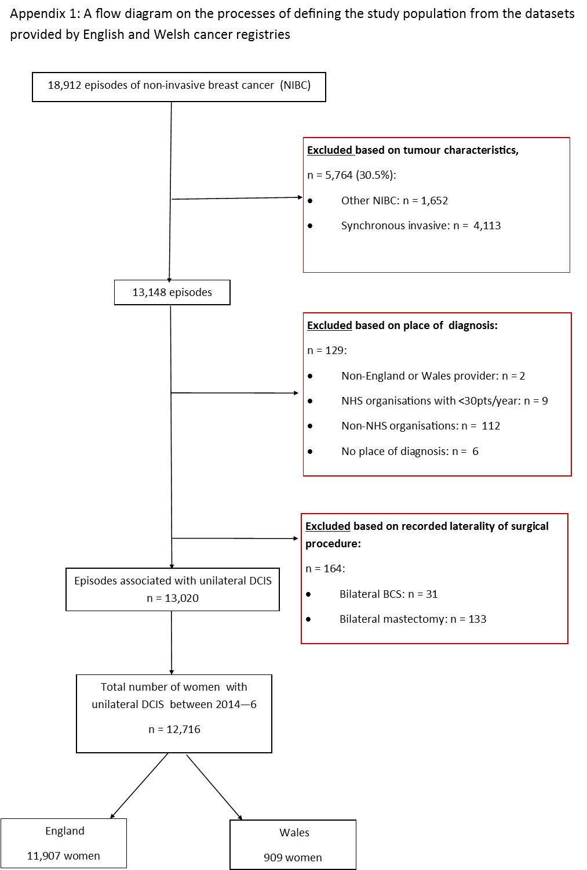

Appendix B: Statistical results related to variation between NHS organisations

Multilevel logistic regression were fitted to account for the clustering of women treated within NHS organisations; such models enabled evaluation of the variance of treatment rates at NHS organisation level. Between organisation variation is described by the variance of the random intercepts, with evidence for there being significant differences between NHS organisations if the 95% confidence interval for the variance does not include 0.

All the regression models used to analyse the relationship between the rates of surgery, SNB (in all surgery) and radiotherapy following BCS, and patient factors; found evidence of differences between NHS organisations in England and Wales. This is demonstrated by the estimated variances of the random intercepts shown in the table below.

 | Variance of random intercept (95% confidence interval) | c-statistic
Primary surgery for DCIS | 0.16 (0.09 to 0.30) | 0.80
SNB in women having surgery for DCIS | 0.36 (0.28 to 0.46) | 0.76
Post-BCS radiotherapy | 0.68 (0.50 to 0.80) | 0.79

The table also contains the values of the c-statistic, a measure of the ability of the model to discriminate between women who did and did not have the outcome of interest. All of the multilevel logistic regression models demonstrated a good fit with the data.

Funnel plots describing the variation in the adjusted rates of primary surgery for DCIS between NHS organisations in England and Wales are shown below.

Risk adjusted rates for surgical treatment of DCIS in women aged 50 – 69 years in NHS organisations in England and Wales between 2014 and 2016.
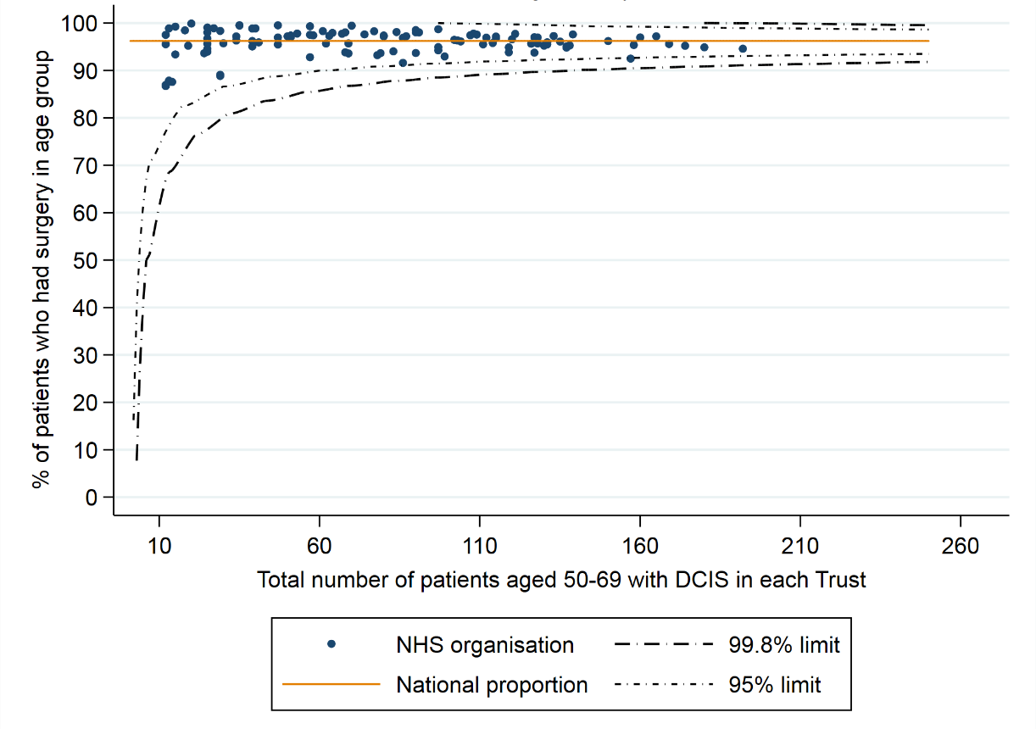

Risk adjusted rates for surgical treatment of DCIS in women aged ≥70 years in NHS organisations in England and Wales between 2014 and 2016.

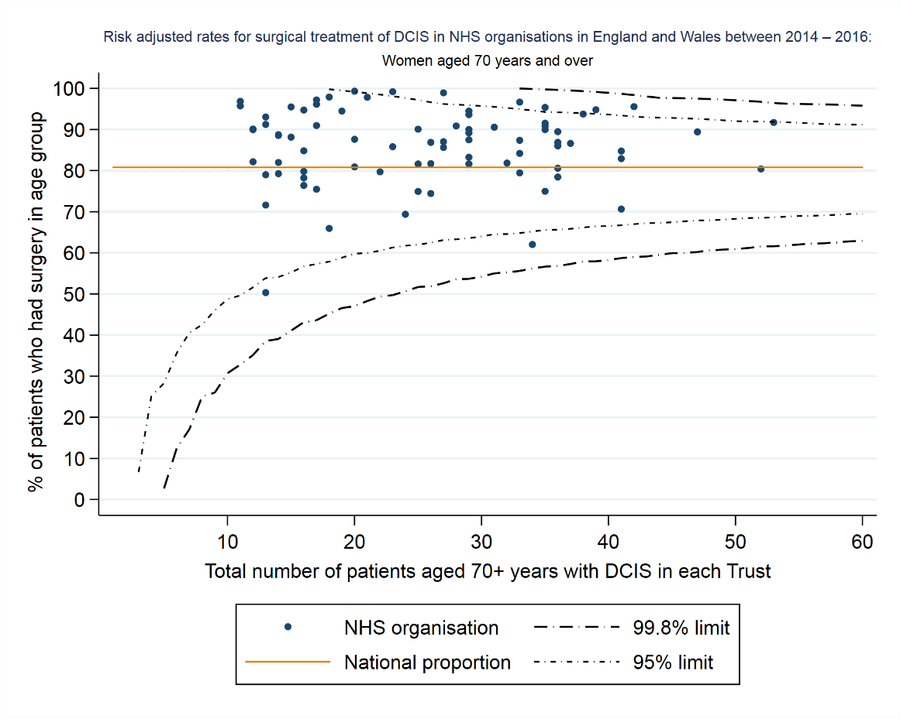

Abbreviations: BCS – breast conserving surgery, CCI – Charlson Comorbidity score, DCIS – ductal carcinoma in situ, eFI – electronic Frailty Index, HES – Hospital Episode Statistics, IMD – Index of multiple deprivation, Mx - mastectomy, NABCOP – National Audit of Breast Cancer in Older Patients, PEDW - Patient Episode Database for Wales, RTDS - Radiotherapy Dataset, OPCS - Office of Population Censuses and Surveys, SNB – sentinel node biopsy

