

**Figure 1. Reported age at which men were circumcised (years) by survey year** (2013: N=267; 2 men missing data on age in years but reported being circumcised aged >15; 2014/15: N=400; 1 man missing data on age in years but reported being circumcised aged >15)

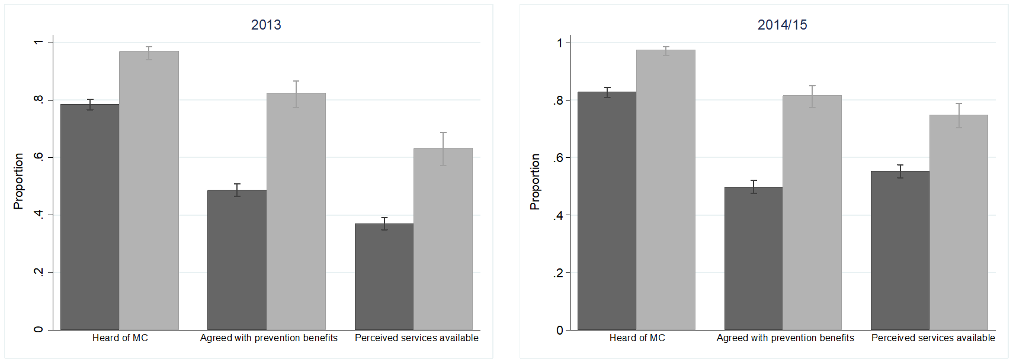

Figure 2 Prevalence of variables related to demand for male circumcision services and perceived service availability by self-reported circumcision status, 2013 and 2014/15 (N=2,354 and N=2,331) (Key: MC – male circumcision; light grey = circumcised men, dark grey= uncircumcised men)

**

Figure 3. Cluster-level determinants of demand for voluntary medical male circumcision and perceived availability of services among uncircumcised men in 2013 and 2014/15

VMMC – voluntary medical male circumcision; bars = means of cluster-level summaries; dots = individual study sites)