**Supplementary Material**

**Evaluating the cost-effectiveness of needle and syringe programmes in preventing Hepatitis C transmission in people who inject drugs**

## Methods

### Estimation of Costs

#### Data Collection

Data collected incorporates the costs for different modalities of NSP provision (pharmacy, specialised and mobile sites) within each city. Each area provided a different range of modalities. In Bristol, one fixed site NSP which also provided outreach and sub-contracted NSP services to 25 pharmacies. In Dundee, there was one fixed-site NSP and five pharmacies overseen by a team of specialist nurses. Finally, in Walsall there was one fixed-site NSP which sub-contracted to 12 pharmacies, 1 out-of-hours pharmacy, and one drop-in centre. In total, we collected cost data for three fixed sites (one per city), six pharmacies (two per city), and three ‘other’ modalities (including mobile outreach, out-of-hours pharmacy services, and a drop-in centre), which could potentially enable scale-up of output and coverage levels. Only a sub-sample of pharmacies was costed in detail due to time and cost limitations for the study. The costs of remaining pharmacies in each area were estimated using their output data and unit cost data from the pharmacies where detailed costings were undertaken to give an overall cost estimate per area.

The cost analysis covers a period of one financial year (2013-14), the most recent for which data was fully available, and takes a provider perspective. We estimated the total and unit economic costs for distributing clean needles to people who inject drugs. Our approach to costing was incremental to existing services, and was focused on needle and syringe exchange. We took an ingredients-based approach in costing, first estimating the resources used in delivering NSP services and then applying current market prices (2014 pounds sterling) to all resources in order to estimate a cost. Where the market price did not accurately reflect the value of resources (for example volunteer time), we estimate a ‘shadow cost’ based on equivalent salary rates for the position in question (1, 2). Overhead and support costs were estimated from programme records, and a portion allocated to NSP services.

In collecting resource use data, where possible, data were extracted from existing reporting mechanisms including budget and expenditure records, human resources records and the management information system. In addition, we carried out direct observations of staff time and activities in order to confirm supply use estimates, and allocate resources which are shared between the NSP and other harm reduction services (such as staff time, building space, equipment or vehicle operation). Shared resources were allocated to services as a proportion of total services delivered and total time spent on each service. Data were collated in a standardized MS Excel spreadsheet. Data collection was primarily conducted by one researcher, and quality-controlled by a second researcher.

Due to the nature of pharmacy-based needle exchange, there was far less detailed output data available within pharmacies. We therefore took a number of assumptions in estimating the outputs at pharmacies. The type of data available for pharmacy-based needle distribution in each city varied; in Bristol pharmacies reported on the total number of visits, while in Dundee pharmacies reported on both the number of visits and the total number of needles distributed. Walsall pharmacies reported on the number of packs distributed. Based on feedback both from pharmacies and fixed sites, we assumed that 100% of clients obtaining needles at pharmacies were opiate users, and that users of image and performance-enhancing drugs (IPEDs) did not access NSPs at pharmacies. We conducted observations of transactions at six pharmacies, and from these observations assumed that pharmacies distributed an average of 1.12 needle packs per transaction. The out-of-hours pharmacy had begun distribution of ‘one-hit kits’ shortly before the data collection period; as there was very little information on the quantity of ‘one-hit kits’ distributed per visit, we varied our assumption of ‘one-hit kit’ distribution as between 1 and 10 kits per visit – this was drawn from the minimum and maximum quantities distributed per visit in the two weeks prior to the site visit.

#### Data Analysis

##### Fixed and Variable costs

Costs at all sites were classified as fixed and variable costs to facilitate analysis. Fixed costs are defined as those costs which are not easily changed in the short-term. Fixed costs included the following ingredients:

* *Overhead costs for pharmacy/ fixed site management*, estimated as the percentage of needle exchange services delivered, as compared to other services delivered in the pharmacy/ in the local area.
* *Coordination by commissioners*, included as overhead and allocated to the site as the percentage of needle exchange services delivered, as compared to other services delivered in the pharmacy/ in the local area.
* *Training* as a minimum includes awareness of the need for discretion, but this should also include an understanding of how to treat people in a non-judgemental way, and may include further education on common injecting practices and harm reduction messages. Training costs were estimated using an ingredients-based approach
* *Health and safety training*, included as a cost for fixed site staff but not for pharmacists, who as a part of their normal job, will already have received health and safety training (e.g. needle stick injuries) and received hepatitis B vaccines
* *Vehicle purchase*, estimated using an ingredients approach, and allocated as the proportion of mileage used for NSP services as compared to other services.

Variable costs are those costs which vary depending on the volume of services provided, and can change in the short-term. Variable costs included in the analysis are:

* *Injecting equipment* in pre-made packs or “pick ‘n’ mix” as appropriate to the site/service. Equipment and paraphernalia distributed varied between pharmacies and fixed sites and from site to site. *Equipment* distributed includes: pots, water, citric acid, needles/syringes (various types and sized), condoms, sharps bins. The cost of this equipment will be estimated using a combination of the ingredients-based approach and step-down accounting. For pharmacies distributing needle packs, the base case analysis assumes that packs of 10 are routinely distributed. This is varied to packs of 20 needles in the sensitivity analysis.
* *Staff time costs* including service and administrative staff, allocated to NSP services as a percentage of their time use for NSP services as compared to other services, using a combination of observational and interview data
* *Waste management* and disposal of returned needles.
* *Vehicle fuel, insurance and maintenance costs*, estimated using an ingredients approach, and allocated as the proportion of mileage used for NSP services as compared to other services.

##### Estimating city-level costs

In order to input into the cost-effectiveness model, we estimated the total cost for distribution of needles to people injecting opiate and other non-IPED drugs in each of the three commissioning areas included in the study. We take the assumption that IPED users are at reduced risk of hepatitis C infection via shared needles (3). This is based on low reported prevalence of hepatitis C within IPED users.

Our estimate of total costs for distributing needles to non-IPED users is estimated using total fixed costs at the city level, plus a weighted average variable cost per needle distributed to opiate clients. This estimation approach is intended to proxy the equivalent costs of providing needles only to opiate users; it represents the full fixed cost of the infrastructure necessary to provide needle and syringe exchange and the variable cost attributable to non-IPED users. We anticipate this to be a conservative approach, which does not account for the benefit of distributing needles to IPED users.

Total fixed cost at city level are estimated accounting for the fixed site in each city, as well as all pharmacies and other modalities operating in each city. For pharmacies not included in our costing sample, we estimated an average fixed cost per pharmacy for each commissioning area using the two or three pharmacies sampled for detailed cost data collection. We then applied an average fixed cost to all pharmacies across the commissioning area; this information was provided by fixed sites in each city. Most pharmacies were provided with a small incentive payment per transaction. Where incentive payments were less than or equal to the costs of staff time for transactions these were treated as a transfer, and not included as an additional cost. Where incentive payments were greater than the costs of staff time, any additional amount was considered to be an additional cost and factored into the total cost estimate.

Average variable costs per opiate needle distributed were estimated for each service modality in each city, and weighted to reflect the total proportion of opiate needles distributed through that service modality city-wide. This weighted average variable cost was then applied to the total number of needles distributed city-wide to come to an estimate of the total city-wide variable cost.

In order to understand the impact of uncertainty encountered in collecting NSP costs in the cost-effectiveness model, we conducted a univariate sensitivity analysis. We included factors in the sensitivity analysis which could not be directly observed, or which varied substantially between sites – including supply wastage, staff time taken for needle distribution, volunteer salaries, equipment wastage, opiate/IPED client mix, number of needles distributed per visit, and discount rate. The results from this sensitivity analysis are presented in Supplementary Figure 2. Parameters with the greatest impact on cost at a city level included assumptions surrounding supplies/equipment wastage and personnel time. Reducing estimated supplies/equipment cost by 50% resulted in an average of 26% reduction in city-level costs, while increasing equipment costs to 200% of that observed increased city-level costs by an average of 52%. Reducing staff costs by 50% reduced total city-level costs by an average of 8%, while increasing staff costs to 200% increased total city-level costs by an average of 17%.

Table S3 Health related costs and QALY weights associated with different stages of disease progression

|  |  |  |  |
| --- | --- | --- | --- |
|  | **Value £** | **Distribution** | **Source** |
| **Annual Costs** |  |  |  |
| OST (specialist prescribing) | 2,839.28 | Gamma | (4) |
| Uninfected | 0.00 | Constant | (5) |
| F0 and F1 Mild HCV | 187.59 | Gamma(0.659,289) | (5) |
| F2 and F3 Moderate HCV | 974.68 | Gamma(0.485,2038) | (5) |
| Compensated Cirrhosis | 1,546.98 | Gamma(0.211,7452) | (5) |
| Decompensated cirrhosis | 12,397.57 | Gamma(0.901,13974) | (5) |
| Hepatocellular Carcinoma | 11,170.04 | Gamma(0.926,12251) | (5) |
| Liver transplant | 40,273.00 | PPIxGamma(89.75,304.5) | (6) |
| Post-transplant | 2,041.00 | PPIxGamma(15.22,91.1) | (6) |
| Hospital costs year of transplant | 13,937.00 | PPIxGamma(13.78,686.4) | (6) |
| Treatment |  |  |  |
| sofosbuvir + ledipasvir – PWID | 48,816.00 | Constant | (6) |
| sofosbuvir + ledipasvir - ex/non-PWID | 40,680.00 | Constant | (6) |
| Liver-related death | 0.00 | Constant | assumption |
|  |  |  |  |
| **QALY Weights** |  |  |  |
| *Uninfected* |  |  |  |
| Ex / non-PWID | 0.94 | Constant | (6) |
| PWID | 0.85 | Uniform (0.8, 0.9) | (6) |
| *Mild HCV* |  |  |  |
| Without Treatment (F0 and F1) | 0.77 | Beta (521.2375,155.6943) | (6) |
| SVR (F1 only) | 0.82 | Beta (65.8678,14.4588) | (6) |
| *Moderate HCV (F2 and F3)* |  |  | (6) |
| Without Treatment | 0.66 | Beta (168.2461, 86.6723) | (6) |
| SVR | 0.72 | Beta (58.0608,22.592) | (6) |
| *Compensated Cirrhosis* |  |  |  |
| Without Treatment | 0.55 | Beta (47.1021, 38.5381) | (6) |
| SVR | 0.61 | Beta (58.0608,37.1124) | (6) |
| Decompensated cirrhosis | 0.45 | Beta (123.75, 151.25) | (6) |
| Hepatocellular Carcinoma | 0.45 | Beta (123.75, 151.25) | (6) |
| Liver transplant | 0.45 | Beta (123.75, 151.25) | (6) |
| Post-transplant | 0.67 | Beta (59.2548, 29.1852) | (6) |
| Liver-related death | 0 |  | (6) |

PPI =Hospital and Community Health Services Pay and Price Index Inflation 2003/04 to 2014/2015 (1.47). QALY (quality adjusted life year)

### Model Description for Estimating Impact and Cost-effectiveness

Stratifications by injecting duration are included to incorporate increased injecting cessation and HCV-acquisition risk among people recently initiated into injecting(7-9), with the chosen category in line with reporting from the unlinked anonymous monitoring (UAM) survey of PWID (10). PWID are also stratified into different intervention states that influence HCV transmission risk: no intervention, OST only, HCNSP only, or both. PWID enter the model as recent initiates with no intervention coverage. They transition through successive injecting duration categories with rates of injecting cessation and non-HCV related death. Due to a lack of data, we assumed recruitment and leaving rates onto and off OST and HCNSP were independent of the current intervention state; previous modelling suggests this should not affect our model projections(11). The model is further stratified by high and low HCV transmission risk, with a proportion starting injecting in the high-risk category(12) and PWID transitioning between these categories. PWID were defined as high-risk if they had been homeless in the last year and/or injected crack in last 4 weeks (low-risk otherwise), which was associated with increased HCV transmission risk(13).

New initiates into injecting are initially susceptible to HCV, and become infected at a per-capita rate depending on their intervention state, injecting duration category, risk category, and prevalence of HCV infection in the population*.* Previous analyses suggest incorporating like-with-like mixing (individuals with the same risk behaviour or characteristics being more likely to form injecting contacts with each other than with other individuals) will have little effect on our model projections(11), with data suggesting it only occurs weakly in Bristol(14), and so random mixing was assumed between all sub-groups*.*

Once infected, some PWID spontaneously clear infection(15), with the remainder becoming chronically infected, which is life-long unless treated. Chronically infected PWID progress through disease states (Figure 1c*)* with HCV disease-related death occurring from the decompensated cirrhosis, hepatocellular carcinoma, liver transplant and post-liver transplant stages.

HCV treatment is only allowed in the F0-F3 and compensated cirrhosis states as it is unclear whether treatment in later disease stages is beneficial(16). An annual number of PWID are treated, with a proportion achieving a sustained virological response (SVR-effective cure) and the remainder returning to their prior infection category. Following successful treatment, no further disease progression occurs in the F0-F3 states(17, 18), but continued slower progression occurs among those with compensated cirrhosis(18, 19). We allow re-infection of those who have attained SVR, and re-treatment of those who fail treatment or become re-infected in line with current recommendations(20).

#### Model Equations

$S_{i,j,k}^{n,m}$ and $C_{i,j,k}^{n,m}$ are the number of susceptible and chronically infected individuals in the model, where $i=0,1$ for off OST and on OST respectively, $j=0,1$ for <100% NSP and >100% NSP respectively, $n=1,2,3,4$ for recent and non-recent or long-term injectors and ex PWID, $m=l,h$ for low and high risk respectively and $k=1,2…9$ for the disease progression states chronic infected (F0, F1, F2, F3), compensated cirrhosis, decompensated cirrhosis, hepatocellular carcinoma, liver transplant and post liver transplant respectively.

The ordinary differential equation model is made up of 450 equations which are described below in sections for different aspects of the model.

Inflow of injectors

There are only two variables in the model which allow an inflow of new injectors. These are low and high-risk susceptible individuals in the first disease progression category with no intervention: the number of new low risk individuals per year is $θ(1-ϕ)$ and the number of new high-risk individuals per year is $θϕ$.

Injecting duration progression

These terms in the equations are concerned with movement from one injecting duration category to another as well as PWID related and background mortality. $ID_{i,j,k}^{n,m}$ denotes the terms in an ordinary differential equation of injecting duration category $n$. It occurs for all values of $m,i,j,k$. $Y_{i,j,k}^{n,m}$ is used to describe one of the variables in the model, where $Y=S \text{or} C$ and the subscripts and superscripts are as described previously. The leaving rate, $μ_{i}=ω_{i}+ν_{i}$, where $ω_{i}$ is the cessation rate and $ν_{i}$ is the death rate for injecting duration $i.$

$$\left(\begin{matrix}ID_{i,j,k}^{1,m} \\ ID_{i,j,k}^{2,m} \\ ID_{i,j,k}^{3,m}\end{matrix}\right)=\left(\begin{matrix}-τ_{1}-μ_{1} & 0 & 0 \\ τ_{1} & -τ_{2}-μ_{2} & 0 \\ 0 & τ_{2} & -τ_{3}\end{matrix}\right)\left(\begin{matrix}Y_{i,j,k}^{1,m} \\ Y_{i,j,k}^{2,m} \\ Y_{i,j,k}^{3,m}\end{matrix}\right)$$

When $n=4$ (ex PWID) the terms have a different form:

$$ID_{k}^{4}=\sum_{i,j,m}{ω_{1}Y_{ijk}^{1,m}}+\sum_{i,j,k,m}{ω_{2}Y_{ijk}^{2,m}}+\sum_{i,j,k,m}{ω_{3}Y_{ijk}^{3,m}}-ν_{4}Y_{k}^{4}$$

Interventions: OST and NSP

These terms in the equations are concerned with movement of injectors from one intervention category to another. $IT_{i,j,k}^{n,m}$ denotes the terms in the ordinary differential equation of OST intervention category $i$ and NSP intervention category $j.$ The rates $η$ and $β$ are the recruitment rates onto NSP and OST respectively. The rates $κ$ and $γ$ are the leaving rates of NSP and OST respectively. These terms can be found for all values of $m,k$ and current injector categories but not the exPWID categories ($n=4$)

$$\left(\begin{matrix}IT_{0,0,k}^{n,m} \\ IT_{1,0,k}^{n,m} \\ IT_{0,1,k}^{n,m} \\ IT_{1,1,k}^{n,m}\end{matrix}\right)=\left(\begin{matrix}-η-β & γ & κ & 0 \\ β & -γ-η & 0 & κ \\ η & 0 & -κ-β & γ \\ 0 & η & β & -γ-κ\end{matrix}\right)\left(\begin{matrix}Y_{0,0,k}^{n,m} \\ Y_{1,0,k}^{n,m} \\ Y_{0,1,k}^{n,m} \\ Y_{1,1,k}^{n,m}\end{matrix}\right)$$

High and Low risk

These terms in the equations are concerned with movement of current injectors between low and high risk. $HR_{i,j,k}^{n,m}$ denotes the terms in the ordinary differential equation of risk category $m$. Here $σ$ is the initiation rate into high risk categories and $ζ$ is the leaving rate. These terms can be found in the equations for all values of $i,j,k$ and $n=1,2,3$.

$$\left(\begin{matrix}HR_{i,j,k}^{n,l} \\ HR_{i,j,k}^{n,h}\end{matrix}\right)=\left(\begin{matrix}-σ & ζ \\ σ & -ζ\end{matrix}\right)\left(\begin{matrix}Y_{i,j,k}^{n,l} \\ Y_{i,j,k}^{n,h}\end{matrix}\right)$$

Disease progression

These terms in the equations are concerned with movement through the disease states. Infection and treatment are described separately. $DS_{i,j,k}^{n,m}$ denotes the terms in the ordinary differential equation of disease category $k$ for susceptible individuals and $DC_{i,j,k}^{n,m}$ for infected individuals. Below is a description of the rates.

|  |  |
| --- | --- |
| **Parameter description** | **symbol** |
| Yearly progression rate from f0 to f1 | $$ρ_{1}$$ |
| Yearly progression rate from f1 to f2 | $$ρ_{2}$$ |
| Yearly progression rate from f2 to f3 | $$ρ_{3}$$ |
| Yearly progression rate from f3 to compensated cirrhosis | $$ρ_{4}$$ |
| Yearly progression rate from compensated cirrhosis to decompensated cirrhosis | $$ρ_{5}$$ |
| Yearly progression rate from compensated cirrhosis or decompensated cirrhosis to hepatocellular carcinoma | $$ρ_{6}$$ |
| Yearly progression rate from decompensated cirrhosis or HCC to liver transplant | $$ρ_{7}$$ |
| Yearly progression rate from liver transplant to post liver transplant | $$ρ_{8}$$ |
| Decompensated cirrhosis related death rate per year | $$d_{6}$$ |
| Hepatocellular carcinoma related death rate per year | $$d_{7}$$ |
| Liver transplant related death rate per year | $$d_{8}$$ |
| Post liver transplant related death rate per year | $$d_{6}$$ |
| Relative risk for progression rate from compensated to decompensated cirrhosis ( $ρ_{5})$ following SVR | $$e_{5}$$ |
| Relative risk for progression rate from compensated cirrhosis to HCC ( $ρ_{6})$ following SVR | $$e_{6}$$ |

These terms can be found in the equations for all values of $i,j,n$ and $m$.

$$\left(\begin{matrix}DS_{i,j,1}^{n,m} \\ DS_{i,j,2}^{n,m} \\ DS_{i,j,3}^{n,m} \\ DS_{i,j,4}^{n,m} \\ DS_{i,j,5}^{n,m} \\ DS_{i,j,6}^{n,m} \\ DS_{i,j,7}^{n,m} \\ DS_{i,j,8}^{n,m} \\ DS_{i,j,9}^{n,m}\end{matrix}\right)=\left(\begin{matrix}0 & 0 & 0 & 0 & 0 & 0 & 0 & 0 & 0 \\ 0 & 0 & 0 & 0 & 0 & 0 & 0 & 0 & 0 \\ 0 & 0 & 0 & 0 & 0 & 0 & 0 & 0 & 0 \\ 0 & 0 & 0 & 0 & 0 & 0 & 0 & 0 & 0 \\ 0 & 0 & 0 & 0 & -e_{5}ρ_{5}-e_{6}ρ_{6} & 0 & 0 & 0 & 0 \\ 0 & 0 & 0 & 0 & e_{5}ρ_{5} & -ρ_{6}-ρ_{7}-d_{6} & 0 & 0 & 0 \\ 0 & 0 & 0 & 0 & e_{6}ρ_{6} & ρ_{6} & -ρ_{7}-d_{7} & 0 & 0 \\ 0 & 0 & 0 & 0 & 0 & ρ_{7} & ρ_{7} & -ρ_{8}-d_{8} & 0 \\ 0 & 0 & 0 & 0 & 0 & 0 & 0 & ρ_{8} & -d_{9}\end{matrix}\right)\left(\begin{matrix}S_{i,j,1}^{n,m} \\ S_{i,j,2}^{n,m} \\ S_{i,j,3}^{n,m} \\ S_{i,j,4}^{n,m} \\ S_{i,j,5}^{n,m} \\ S_{i,j,6}^{n,m} \\ S_{i,j,7}^{n,m} \\ S_{i,j,8}^{n,m} \\ S_{i,j,9}^{n,m}\end{matrix}\right)$$

$$\left(\begin{matrix}DC_{i,j,1}^{n,m} \\ DC_{i,j,2}^{n,m} \\ DC_{i,j,3}^{n,m} \\ DC_{i,j,4}^{n,m} \\ DC_{i,j,5}^{n,m} \\ DC_{i,j,6}^{n,m} \\ DC_{i,j,7}^{n,m} \\ DC_{i,j,8}^{n,m} \\ DC_{i,j,9}^{n,m}\end{matrix}\right)=\left(\begin{matrix}-ρ_{1} & 0 & 0 & 0 & 0 & 0 & 0 & 0 & 0 \\ ρ_{1} & -ρ_{2} & 0 & 0 & 0 & 0 & 0 & 0 & 0 \\ 0 & ρ_{2} & -ρ_{3} & 0 & 0 & 0 & 0 & 0 & 0 \\ 0 & 0 & ρ_{3} & -ρ_{4} & 0 & 0 & 0 & 0 & 0 \\ 0 & 0 & 0 & ρ_{4} & -e_{5}ρ_{5}-e_{6}ρ_{6} & 0 & 0 & 0 & 0 \\ 0 & 0 & 0 & 0 & e_{5}ρ_{5} & -ρ_{6}-ρ_{7}-d_{6} & 0 & 0 & 0 \\ 0 & 0 & 0 & 0 & e_{6}ρ_{6} & ρ_{6} & -ρ_{7}-d_{7} & 0 & 0 \\ 0 & 0 & 0 & 0 & 0 & ρ_{7} & ρ_{7} & -ρ_{8}-d_{8} & 0 \\ 0 & 0 & 0 & 0 & 0 & 0 & 0 & ρ_{8} & -d_{9}\end{matrix}\right)\left(\begin{matrix}C_{i,j,1}^{n,m} \\ C_{i,j,2}^{n,m} \\ C_{i,j,3}^{n,m} \\ C_{i,j,4}^{n,m} \\ C_{i,j,5}^{n,m} \\ C_{i,j,6}^{n,m} \\ C_{i,j,7}^{n,m} \\ C_{i,j,8}^{n,m} \\ C_{i,j,9}^{n,m}\end{matrix}\right)$$

Infection terms

The forces of infection below are concerned with acquiring infection. The terms are of the form

$${FOI_{i,j,k}^{n,m}=λ_{i,j,k}^{n,m}S_{i,j,k}^{n,m}}^{}$$

where $λ_{i,j,k}^{n,m}$ is the force of infection for the subcategory in question. Relative risks of HCV transmission for recent injectors, non-recent injectors, high risk injectors, those on OST or NSP or both are $X_{1},X_{2},Ξ, Γ, Π$ and $Β$ respectively. The spontaneous clearance rate of HCV is $δ$ and the base transmission rate is $π$. When the ordinary differential equation is for susceptible the FOI term is subtracted and the same term is added to the matching infectious category.

$$λ_{0,0,k}^{1,l }=πΧ_{1}\left(1-δ\right)Υ \\ λ_{0,0,k}^{2,l }=πX_{2}\left(1-δ\right)Υ$$

$$λ_{0,0,k}^{3,l }=π\left(1-δ\right)Υ \\ λ_{0,0,k}^{1,h }=πΧ_{1}Ξ\left(1-δ\right)Υ \\ λ_{0,0,k}^{2,h }=πX_{2}Ξ\left(1-δ\right)Υ$$

$$λ_{0,0,k}^{3,h }=πΞ\left(1-δ\right)Υ \\ λ_{0,1,k}^{n,m}=Γλ_{0,0,k}^{n,m} \\ λ_{1,0,k}^{n,m}=Πλ_{0,0,k}^{n,m} \\ λ_{1,1,k}^{n,m}=Βλ_{0,0,k}^{n,m}$$

Define

$$C^{n,m}=\sum_{k=1}^{9}{\left(\begin{matrix}C_{0,0,k}^{n,m} & C_{0,1,k}^{n,m} & C_{1,0,k}^{n,m} & C_{1,1,k}^{n,m}\end{matrix}\right)},$$

$$S^{n,m}=\sum_{k=1}^{9}{\left(\begin{matrix}S_{0,0,k}^{n,m} & S_{0,1,k}^{n,m} & S_{1,0,k}^{n,m} & S_{1,1,k}^{n,m}\end{matrix}\right)},$$

$$I=\left(\begin{matrix}1 \\ Γ \\ Π \\ Β\end{matrix}\right),$$

to give

$$Υ=\frac{{(Χ_{1}(C}^{1,l}+ΞC^{1,h})+X_{2}\left(C^{2,l}+ΞC^{2,h}\right)+(C^{3,l}+ΞC^{3,h}))I}{\left(Χ_{1}\left(C^{1,l}+S^{1,l}+Ξ\left(C^{1,h}+S^{1,h}\right)\right)+X_{2}\left(C^{2,l}+S^{2,l}+Ξ\left(C^{2,h}+S^{2,h}\right)\right)+(C^{3,l}+S^{3,l}+Ξ(C^{3,h}+S^{3,h}))\right)I}$$

Treatments

There are a fixed number of treatments per year, given by $Φ$. When the total number of infected individuals in the model is greater than this number, the treatments are allocated proportionately. When the total number of infected individuals is less than the number of possible treatments per year, all are treated. Only the first two disease progression categories are eligible for treatment and will have treatment terms. If the ordinary differential equation is for an infected category the treatment term will be subtracted and for a susceptible category the term will be added.

If $$Φ<\sum_{k=1}^{5}{\sum_{n}^{3}{\sum_{m,i,j}{C_{i,j,k}^{n,m}}}}=C^{treat},$$

$$T_{i,j,k}^{n,m}\left(C_{i,j,k}^{n,m}\right)=\frac{α{ΦC}_{i,j,k}^{n,m}}{C^{treat}},$$ for $k=1,2…5, n=1,2,3.$

Otherwise $$T_{i,j,k}^{n,m}\left(C_{i,j,k}^{n,m}\right)=αC_{i,j,k}^{n,m},$$

for $k=1,2…5, n=1,2,3.$

For ex-PWID treatment is more straightforward with a proportion, $r$ of the chronically infected and compensated cirrhosis individuals being treated each year.

$$T_{k}^{4}\left(C_{k}^{4}\right)=αrC_{k}^{4},$$

for $k=1,2…$ 5

As an example here is the ordinary differential equation for the susceptible category for the first disease progression category, no interventions, recent injector (<3 years) and low risk. On the right hand side in order from left to right there is an inflow term, injecting duration terms, intervention terms, high/low risk terms, disease progression terms, infection term and treatment term.

$$\frac{{dS}_{0,0,1}^{1,l}}{dt}=θ\left(1-ϕ\right)+ID_{0,0,1}^{1,l}+IT_{0,0,1}^{1,l}+HR_{0,0,1}^{1,l}+DS_{0,0,1}^{1,l}-λ_{0,0,1}^{1,l}S_{0,0,1}^{1,l}+T_{0,0,1}^{1,l}$$

#### Model Parameters

Table S2 Model Parameters

|  |  |  |  |  |  |  |  |
| --- | --- | --- | --- | --- | --- | --- | --- |
| **Parameter** | **Symbol** | | | | **Value/Range** | **Reference** | |
| **Epidemiological and Demographic parameters** | | | | | | | |
| Number of new injectors per year | $$θ$$ | | Fitted to obtain population sizes | | | Bristol (21, 22), Walsall (22) and unpublished estimates, Dundee adjusted from (23). See Table S2 and supporting information | |
| Combined death and cessation rates per year | $$μ_{i}$$ | | Fitted to obtain injecting duration profiles for each setting | | | Lower bounds of 0.004 and 0.008 were chosen to ensure the leaving rate was greater than the likely death rate (24). See Table S2 and supporting information | |
| Infection rate per year | $$π$$ | | Fitted to obtain HCV prevalence required in each setting | | | See Table S2 and supporting information | |
| Proportion of new infections which spontaneously clear | $$δ$$ | | Sampled from uniform distribution (0.22-0.29) | | | (15) | |
| Leaving rate per year from high to low risk behaviour | $$ζ$$ | | Sampled range (0.6761-1.617) | | | Data from cohort study (12) found 78/145 injectors no longer homeless after 8 months. Transition probability sampled from beta distribution α $=78$ and $β=67$ and converted to instantaneous rate | |
| Recruitment rate per year from low risk to high risk behaviour | $$σ$$ | | Fitted to obtain required high risk proportions in each setting | | | See Table S2 and supporting information | |
| **Intervention Related parameters** | | | | | | | |
| Leaving rate per year off OST | $$γ$$ | | 1-3 | | | Duration on OST was 8 months (4-12 months) in cohort of PWID in UK (24) | |
| Leaving rate per year off HCNSP | $$κ$$ | | 0.37-0.77 | | | Welsh cohort study 61% PWID still >100% NSP after 1 year. Duration on NSP was 1.3-2.7 years. (25) | |
| Recruitment rate per year on to OST | $$β$$ | | Fitted to obtain required OST coverage proportions in each setting | | | See Table S2 and supporting information | |
| Recruitment rate per year on to HCNSP | $$η$$ | | Fitted to obtain required high NSP coverage proportions in each setting | | | See Table S2 and supporting information | |
| Proportion of treatments achieving SVR prior to 2015 | $$α$$ | | Sampled from uniform distribution (0.3992-0.6653) | | | Weighted mean of pooled intention to treat SVR for genotypes 1 and 2/3 taken from treatment data for PWID in UK (26) | |
| Proportion of treatments achieving SVR post 2015 | $$α$$ | | Sampled from uniform distribution (0.859-0.915) | | | (27)Weighted mean of SVR for genotype 1 (90%) and genotypes 2/3 (82-93%) from (28). | |
| Number of PWID’s treated per year | $$Φ$$ | | Bristol – 18  Dundee – 34 (2009 to 2015), and then 40 (2015 onwards)  Walsall – 2 | | | Number of HCV treatments in 2011. Assumed treatment of PWIDs commenced in 2009(26). More recent estimate for Dundee (personal communication John Dillon). Walsall value assumed same rate per infected PWIDs as Bristol. | |
| **Relative Transmission Risk parameters** | | | | | | | |
| Risk associated with being on OST only | $$Γ$$ | | | | 0.41(0.22-0.75) sampled from Lognormal distribution | Odds ratio and 95% CI from pooled analysis (in press NIHR report) | |
| Risk associated with being on HCNSP only | $$Π$$ | | | | 0.59(0.36-0.96) sampled from Lognormal distribution | Odds ratio and 95% CI from pooled analysis (in press NIHR report) | |
| Risk associated with being on both OST and HCNSP | $$Γ×Π$$ | | | | 0.26 (0.09-0.64) | Calculated as product of risk associated with being solely on OST or NSP. Compares well to estimate from systematic review 0.29 (0.13-0.65) (in press NIHR report) | |
| Risk associated with being a recent injector compared to a long-term injector* | $$Χ_{1}$$ | | | | 1.53(0.93-2.52) sampled from Lognormal distribution | Odds ratio from pooled analysis (in press NIHR report) | |
| Risk associated with being in the high risk category | $$Ξ$$ | | | | Scotland: 2.13(1.40-3.24)  Bristol and Walsall: 2.75(1.97-4.22). Both sampled from lognormal distribution | Odds ratio from pooled analysis. For Scotland, the OR is just for homelessness because there is little crack injection, whereas it is for crack injection or homelessness for Bristol and Walsall | |
| **Parameter description** | | **symbol** | | **Distribution** | | | **Source** |
| Yearly progression rate from f0 to f1 | | $$ρ_{1}$$ | | 0.529-0.2095 sampled from normal distribution | | | PWID specific instantaneous rates from (29) |
| Yearly progression rate from f1 to f2 | | $$ρ_{2}$$ | | 0.0216-0.1013 sampled from normal distribution | | |
| Yearly progression rate from f2 to f3 | | $$ρ_{3}$$ | | 0.0450-0.1145 sampled from normal distribution | | |
| Yearly progression rate from f3 to compensated cirrhosis | | $$ρ_{4}$$ | | 0.0513-0.1838 sampled from normal distribution | | |
| Yearly progression rate from compensated cirrhosis to decompensated cirrhosis | | $$ρ_{5}$$ | | 0.0166-0.0921 | | | Instantaneous rates calculated from sampled beta distributions of transition probabilities in (16) |
| Yearly progression rate from compensated cirrhosis or decompensated cirrhosis to hepatocellular carcinoma | | $$ρ_{6}$$ | | 0.0003-0.0684 | | |
| Yearly progression rate from decompensated cirrhosis or HCC to liver transplant | | $$ρ_{7}$$ | | 0.0062-0.0962 | | |
| Yearly progression rate from liver transplant to post liver transplant | | $$ρ_{8}$$ | | 1.0423-2.4412 | | |
| Decompensated cirrhosis related death rate per year | | $$d_{6}$$ | | 0.1063-0.1842 | | |
| Hepatocellular carcinoma related death rate per year | | $$d_{7}$$ | | 0.3904-0.7697 | | |
| Liver transplant related death rate per year | | $$d_{8}$$ | | 0.0911-0.4348 | | |
| Post liver transplant related death rate per year | | $$d_{6}$$ | | 0.0280-0.1016 | | |
| Relative risk for progression rate from compensated to decompensated cirrhosis ( $ρ_{5})$ following SVR | | $$e_{5}$$ | | 0.07 (95%CI 0.03,0.2) | | | Sampled from transformed lognormal distribution (19) |
| Relative risk for progression rate from compensated cirrhosis to HCC ( $ρ_{6})$ following SVR | | $$e_{6}$$ | | 0.23 (95%CI 0.16,0.35) | | | Sampled from transformed lognormal distribution (18) |

#### Model Calibration

Model calibration was carried out in three steps with 1000 parameter sets obtained at each step:

1. Population size and injecting duration fitting using a PWID demographic sub-model without infection.
2. NSP and OST coverage fitting using a sub-model that includes HCV transmission but no disease progression.
3. HCV prevalence fitting using the full model with disease progression.

Step 1

In Dundee, survey data (30) suggested that the proportion of the PWID population in each injecting duration category was stable from 2008 to 2014, and so we assumed a constant population size estimated from unpublished data from Scotland. In Bristol and Walsall, size estimation data suggests that the PWID population has decreased by between 10% and 30% between 2009 and 2011 (21, 22, 31, 32). Concurrently, survey data(14, 30, 33-35) suggests the proportion of PWID injecting for longer than 10 years has increased whilst the proportion injecting for between 3 and 10 years decreased as shown in Figure 4.2a and 4.2b. There has been little change in the proportion injecting for less than 3 years. It was assumed that these changes were partly due to a decrease in the initiation rate of new injectors and a change in the cessation rates of non-recent and long-term injectors. We allowed for uncertainty around these parameters and estimated them by fitting the model to the population size and injecting duration profile (proportion of PWID in each injecting duration category) at two points in time for Walsall and Bristol and one time point for Dundee. This fitting was done with a demographic sub-model, which only had three injecting duration categories and no other stratification. We assumed that the PWID population size was at equilibrium initially (before 2004, 2006 and 2008 for Bristol, Walsall and Dundee, respectively). We sampled 1000 values for this ‘stable’ initial population size and the cessation rate from the recent injector category for each setting. For each of these 1000 parameter sets, the wide prior distributions for the cessation rates from non-recent and long-term injectors (see Supplementary Table 2) were then sampled, and for each sample the model was fit to the initial population size by calculating a suitable PWID recruitment rate using the steady state equations for the demographic sub-model (more details in Appendix 1). Parameter sets were retained if the resulting injecting duration profile lay within the ranges suggested from data, otherwise the cessation rates were resampled. We then sampled 1000 estimates for the later population size in 2011 for Bristol and Walsall, as well as new cessation rates for non-recent and long-term injectors, and the PWID recruitment rate was re-calibrated to fit to this new sampled population size for the 2011 data (only Bristol and Walsall). This refitting of the demographic sub-model was done using the Matlab algorithm fzero applied to the analytic solution of the model with initial conditions from the first step of fitting. Parameter sets were retained if the resulting injecting duration profile lay within ranges suggested from data for years 2004 and 2011 for Bristol and 2008 and 2011 for Walsall, otherwise the new cessation rates for this second step were resampled to obtain a fit to each of the first step parameter sets (1000 each for Bristol and Walsall).

Step 2

Coverage levels for PWID currently on OST have increased over the last 12 years. In Bristol, the proportion of PWID currently on OST increased from 40% in 2004 (33) up to 81% in 2009(14). In Walsall, OST coverage increased from 40% in 2006 to 70% in 2009 (36), and in Dundee it increased from 43% in 2008 to 72% in 2014 (37). Conversely, over this same time period, the proportion of PWID with >100% NSP coverage remained stable in both Bristol (55%) (14, 30, 33) and Walsall (38%) (30), while it increased over time in Dundee from 41% in 2008 to 60% in 2014(30). Modelled OST coverage levels for each city were calibrated to this coverage data by varying the recruitment rate onto each intervention. A service provision estimate of NSP coverage was calculated for each setting using data on needles distributed from the costings analysis (2014 data), population size (calculated from the model in 2014) and injecting frequency from survey data. Bootstrap samples of the mean injecting frequency were calculated for each setting using UAM (Bristol and Walsall) and NESI (Dundee) data. In addition the mean injecting frequency in Dundee has decreased from 717 injections per year in 2008 to 388 injections per year in 2014. Therefore an estimate of NSP coverage was calculated for each time point. The average service provision estimates of NSP coverage were 56% and 28% in Bristol and Walsall respectively in 2014 and 27% and 49% in 2008 and 2014 respectively for Dundee (see Supplementary Table 2 for more details). The recruitment rates were estimated using an intervention sub-model that incorporated no onward disease progression as these mechanisms have little effect on the coverage levels obtained. Using the Matlab fitting algorithm lsqnonlin, recruitment rates were found to fit the sub-model to the initial and endpoint coverage of each intervention as shown in Supplementary Table 2, while assuming coverage levels were quasi stable. In the full model, the recruitment rates for the initial coverage level was first used to obtain initial conditions for the first time point for each city, and then the recruitment rate was gradually varied linearly between the two values to obtain the required increase in coverage for that city.

Survey data suggests that the prevalence of crack injecting and/or homelessness, our markers of high HCV transmission risk, have remained stable in Dundee (33% homeless) and Walsall (52% homeless or crack injection), whereas it has increased in Bristol from 75% in 2004 to 87% in 2014 (homeless or crack injection). We assumed that a proportion of injectors are high-risk when they initiate injecting, which is consistent with available data(12). The leaving rate from these high-risk categories was estimated from a cohort study on homelessness which found that approximately two thirds of homeless PWID are no longer homeless after one year(12). This agrees with unpublished findings from a Welsh cohort study for both crack and homelessness(11, 25). The leaving rate was sampled 1000 times and used for all three setting. The proportion of PWID that are high-risk was also sampled 1000 times for each setting. The recruitment rates were then calculated for each parameter set using the steady state solution of the high/low risk sub-model (two variables). In Bristol, where the proportion of PWID that are high-risk has increased, we calculated a second recruitment rate for the second time point (2014) using the same method. For Bristol, the recruitment rate was gradually varied linearly to obtain the increase in the proportion of PWID that are high-risk.

Step 3

The last step of the model calibration involved fitting the full model to the HCV prevalence data from each setting (sampled 1000 times from the ranges given in Supplementary Table 2). This incorporated the 1000 parameter sets from the previous model calibration steps, and involved calibrating the model’s infection rate using the lsqnonlin function in Matlab. The model was first fit to the initial prevalence estimate (sampled from the ranges given in Supplementary Table 2) in 2004, 2006 and 2008 for Bristol, Walsall and Dundee, respectively (Supplementary Figure 1 and Supplementary Table 2), while assuming the epidemic was in a stable state at that time. For Walsall and Bristol, this one infection rate well captured the subsequent baseline epidemic dynamics (slightly increasing in Bristol and Walsall) and so no change in the infection rate was assumed after that point. The baseline transmission rates in Bristol and Walsall were comparable (0.07-0.21 and 0.09-0.22 respectively), whereas Dundee had a slightly higher baseline transmission risk (0.16-0.39. However, for Dundee we needed to fit a second increased infection rate (0.36-0.94) to capture the increase in HCV prevalence from 2008 to 2014 (using the parameters from the first prevalence fitting step as the initial conditions). This either suggests the epidemic was not stable in 2008 or that there has been a change in the risk profile of PWID in Dundee that is not fully captured by changes in intervention coverage or the prevalence of high-risk behaviours. Supplementary Table 2 and Supplementary Figure 1 show the model parameters that were fitted in the model.

Table S3 Summary of data collated for each setting for model calibration

|  |  |  |  |  |
| --- | --- | --- | --- | --- |
|  | Bristol | Walsall | Dundee | Relevant parameter |
| Current PWID population size | **2004**:  sampled 111-125% (22) of 2011 value(21).  **2011**:  2025-2564 adjusted from(21) to include only 60% of people on OST not in contact with other services (21). Sampled  uniformly | **2006**:  125%(22) of 2011 value  **2011**:  1296-1623 estimated from local number on OST and unpublished PWID prevalence estimates for West Midlands. Sampled  uniformly | Constant level  675-825 local estimate adjusted from (23)  Sampled  uniformly | $θ$, Number of new injectors per year  Value of $θ$ found using steady state equations of population sub-model for the first time point in all 3 settings. In Bristol and Walsall a second value of $θ$ is found using Matlab fzero and analytical solution to population sub-model that gives population size required with sampled cessation rates |
| Injecting duration profile:  Proportion of PWID that are recent (R), non-recent (NR), or long-term injectors (LT) | **2004**:  R: 0.04-0.2  NR: 0.25-0.45  LT: 0.4-0.65 (UAM)  **2014**:  R: 0.075-0.2  NR: 0.05-0.22  LT: 0.55-0.85 (UAM) | **2006:**  R: 0.1-0.3  NR: 0.45-0.65  LT: 0.2-0.3  **2014**:  R:0.1-0.3  NR: 0.15-0.4  LT: 0.4-0.6  (UAM) | Constant level  R: 0.15-0.35  NR: 0.36-0.65  LT: 0.12-0.35  (NESI) | Death and cessation rates ($μ_{i}$) per year. Prior distribution for $μ_{1}$ (0.0351 – 0.1702) calculated from assumption that between 10% and 40% of recent initiates cease injecting within 3 years (7). A large upper bound of 0.4 was assumed for the prior distributions of $μ_{2}$ and $μ_{3}$ due to lack of information. Lower bounds of 0.004 and 0.008 were chosen to ensure the leaving rate was greater than the likely death rate (24)  Parameter sets accepted if PWID demographic sub-model fits were within the ranges for each injecting duration |
| Chronic HCV Prevalence (75% of HCV Ab prevalence) | Constant level 40-50% (community surveys, UAM)  Sampled from truncated Beta(305.25,364.75) | **2006**:  11-26% (UAM)  Sampled from truncated Beta(30.75,132.25)  **2014**:  15-39% (no fitting required) | **2008**:  15-30% (NESI)  Sampled from truncated Beta(18.75,64.25)  **2014**:  19-32% adjusted from (NESI)  Sampled from truncated Beta(43.45,125.55)* | $π$, infection rate used to fit the HCV prevalence estimates |
| Proportion high risk | **2004:**  70-80% (2004, 2006 community surveys and UAM). Sampled uniformly.  **2014:**  80-95% (UAM). Sampled uniformly. | Constant level of  40-65% (UAM).  Sampled uniformly. | Constant level of  26-42% (NESI).  Sampled from Beta (156,315). | $ϕ$, proportion of injectors initially high risk assumed same as sampled proportion high risk $σ$ , recruitment rate per year from low to high risk behaviour, calculated from sampled leaving rate $ζ$ and proportion high risk $ϕ$. |
| Proportion on OST | **2004**:  33.3-46.7% (38) sampled from truncated Beta(81,121)  **2009**:  76.5-86.3% (community survey, 2009) sampled from truncated Beta(241,55) | **2006**:  30-50% (UAM)  sampled from truncated Beta(32,48)  **2009**:  61-82% (UAM)  sampled from truncated Beta(47,18) | **2008**:  433-53% (NESI) sampled from  Beta(36,47)  **2014**:  65-79% (NESI) sampled from  Beta(106,40) | $β$, recruitment rate per year onto OST |
| Proportion >100% NSP  (needles distributed /(population size*injecting frequency)) | Needles distributed in 2014 (786542-844646), population size in 2014 and injecting frequency (470-859 per year from UAM) sampled. Mean calculated coverage 56% | Needles distributed in 2014 (225275-237111), population size in 2014 and injecting frequency (435-716 per year from UAM) sampled.  Mean calculated coverage 28% | Needles distributed in 2014 (assumed same in 2008), population size in 2008 and injecting frequency (517-999 per year from NESI) sampled.  Mean calculated coverage 27%.  Needles distributed in 2014 (138246-145768), population size in 2014 and injecting frequency (251-533 per year from NESI) sampled.  Mean calculated coverage 49% | $η$, recruitment rate per year onto high coverage NSP |

* *Chronic prevalence was available from the NESI survey for 2014

#### Sub-Models used in the fitting procedure

Injecting duration model

A model with 3 injecting duration categories was used to fit the population data and the injecting duration profiles from survey data. Here $S^{i}$ is the number of susceptible injectors in the $i$ category. The categories are: $r,$ recent injector, $n,$ non-recent injector and $l$, long-term injector. The $μ_{i}$ and $τ_{i}$ are the same as the full model.

$$\frac{dS^{r}}{dt}=θ-\left(μ_{1}+τ_{1}\right)S^{r}$$

$$\frac{dS^{n}}{dt}=μ_{1}S^{r}-\left(μ_{2}+τ_{2}\right)S^{n}$$

$$\frac{dS^{l}}{dt}=μ_{2}S^{n}-μ_{3}S^{l}$$

The steady state solution of this model is given below:

$S^{r}=\frac{θ}{μ_{1}+τ_{1}},S^{n}=\frac{θτ_{1}}{\left(μ_{1}+τ_{1}\right)\left(μ_{2}+τ_{2}\right)},S^{l}=\frac{θτ_{1}τ_{2}}{\left(μ_{3}\left(μ_{1}+τ_{1}\right)\left(μ_{2}+τ_{2}\right)\right)}$,

with total population $N=S^{r}+S^{n}+S^{l}.$

The analytical solution of this system is

$S^{r}\left(t\right)=S^{r}\left(0\right)e^{-(μ_{1}+τ_{1})t}+\frac{θ}{μ_{1}+τ_{1}}\left(1-e^{-\left(μ_{1}+τ_{1}\right)t}\right)$,

$$S^{n}\left(t\right)=\frac{τ_{1}θ}{\left(μ_{1}+τ_{1}\right)\left(μ_{2}+τ_{2}\right)}+S^{n}\left(0\right)e^{-\left(μ_{2}+τ_{2}\right)t}+\frac{τ_{1}}{μ_{1}+τ_{1}-μ_{2}-τ_{2}}S^{r}\left(0\right){(e}^{-\left(μ_{2}+τ_{2}\right)t}-e^{-\left(μ_{1}+τ_{1}\right)t})+\frac{τ_{1}θ}{μ_{1}+τ_{1}-μ_{2}-τ_{2}}* {(e}^{-\left(μ_{1}+τ_{1}\right)t}/ \left(μ_{1}+τ_{1}\right)-e^{-\left(μ_{2}+τ_{2}\right)t}/(μ_{2}+τ_{2})),$$

$$S^{l}\left(t\right)=e^{-μ_{3}t}\left(S^{l}\left(0\right)+\frac{τ_{2}}{μ_{2}+τ_{2}-μ_{3}}.\left(\frac{τ_{1}S^{r}\left(0\right)}{μ_{1}+τ_{1}-μ_{3}}-\frac{τ_{1}θ}{μ_{3}\left(μ_{1}+τ_{1}-μ_{3}\right)}+S^{n}\left(0\right)\right)\right)+\frac{e^{-\left(μ_{2}+τ_{2}\right)t}τ_{2}}{μ_{2}+τ_{2}-μ_{3}}\left(\frac{τ_{1}S^{r}\left(0\right)}{μ_{2}-τ_{2}+μ_{1}+τ_{1}}+\frac{τ_{1}θ}{\left(μ_{2}+τ_{2}\right)\left(-μ_{2}-τ_{2}+μ_{1}+τ_{1}\right)}-S^{n}\left(0\right)\right)+\frac{e^{-\left(μ_{1}+τ_{1}\right)t}τ_{1}τ_{2}θ}{\left(μ_{1}+τ_{1}\right)\left(μ_{1}+τ_{1}-mu_{3}\right)\left(μ_{1}+τ_{1}-μ_{2}-τ_{2}\right)}+\frac{τ_{1}τ_{2}θ}{μ_{3}\left(μ_{1}+τ_{1}\right)\left(μ_{2}+τ_{2}\right)}$$

High risk model

A model with a high risk and low risk only was used to calculate parameter values in the calibration process. The variable $S^{h}$ denotes high risk and $S^{l}$ denotes low risk.

$$\frac{dS^{h}}{dt}=-ζS^{h}+σS^{l}$$

$$\frac{dS^{l}}{dt}=ζS^{h}-σS^{l}$$

As this is a closed system we have: $N-S^{h}=S^{l}$, which gives

$$\frac{dS^{h}}{dt}=-ζS^{h}+σ(N-S^{h})$$

Setting the left hand side to zero and solving gives to obtain the proportion of the total population that are high risk

$$Φ=\frac{σ}{σ+ζ}$$

This expression was used to calculate the required value of the recruitment rate $σ,$ from the sampled values of the proportion of high risk individuals and the leaving rate $ζ$.

Figure S1 Graphs showing fitting of the baseline scenarios in each setting.

Error bars in black are data points from surveys, error bars in red are the ranges used for model calibration.

|  |
| --- |
| Bristol |
| Walsall |
| Dundee |

### Model Parametrization and Calibration

In order to capture costing uncertainty within the cost-effectiveness model, we conducted a multivariate simulation of all parameters included in the costing sensitivity analysis (described above), with uniform distribution between the minimum and the maximum values observed over 1000 iterations. The results from these 1000 iterations were fed in as the cost estimates for NSPs in the cost-effectiveness model.

Other health-related costs and QALY weights as derived from the literature were input into the model using appropriate distributions, as described in Table S1. Cost parameters were largely varied with a Gamma distribution, with the exception of treatment costs for sofosbuvir and ledipasvir; these were kept as a constant because of lack of data for a distribution. QALY weights were varied using a Beta distribution.

## Results

Table S4 DETAILED COSTING RESULTS

|  |  |  |  |  |  |  |
| --- | --- | --- | --- | --- | --- | --- |
|  | **Total Needles** | **Total Cost** | **Non-IPED PWID population size** | **Visits per user** | **Cost per non-IPED PWID** | **Needles per non-IPED PWID** |
| **Bristol** | 883,524 | £232,116.78 | 1,847-2,595 | 13-18 | £89.45-£125.67 | 340-478 |
| **Dundee** | 150,790 | £104,495.75 | 675-825 | 17-20 | £126.66-£154.81 | 183-223 |
| **Walsall** | 245,002 | £98,649.03 | 1,144-1,646 | 12-17 | £59.93-£86.23 | 149-214 |

Table S5 TOTAL COSTS AND NEEDLES FOR DISTRIBUTION TO OPIATE USERS, BY CITY

|  |  |  |  |  |
| --- | --- | --- | --- | --- |
|  | **Total Needles** | **Total Fixed Costs** | **Average Variable Cost per Needle** | **Total Cost** |
| **Bristol** |  |  |  |  |
| Fixed Site | 252,039 | 12,229.50 | 0.16 | 51,861 |
| Pharmacies (n = 25) | 495,500 | 28,392.32 | 0.26 | 157,894 |
| Other | 92,171 | 536.63 | 0.24 | 22,362 |
| ***Total City-Wide*** | ***839,710*** | ***41,158.44*** | ***0.23*** | ***232,117*** |
| **Dundee** |  |  |  |  |
| Fixed Site | 36,455 | 5,859.49 | 1.49 | 60,285 |
| Pharmacies (n = 5) | 100,604 | 3,880.79 | 0.41 | 44,210 |
| Other | - | - | - | - |
| ***Total City-Wide*** | ***137,059*** | ***9,740.28*** | ***0.69*** | ***104,496*** |
| **Walsall** |  |  |  |  |
| Fixed Site | 63,644 | 1,347.35 | 0.35 | 23,585 |
| Pharmacies (n = 12) | 151,460 | 17,357.32 | 0.46 | 67,690 |
| Other | 14,628 | 941.47 | 0.34 | 7,373 |
| ***Total City-Wide*** | ***229,732*** | ***19,646.14*** | ***0.35*** | ***98,649*** |

Figure S2 Costing Sensitivity Analysis



Table S6 Total deaths and infections averted though NSP over 50 years by city

|  |  |  |  |  |  |  |
| --- | --- | --- | --- | --- | --- | --- |
|  | **Deaths Averted** | | | **Infections Averted** | | |
|  | **Median** | **2.5% CrI** | **97.5% CrI** | **Median** | **2.5% CrI** | **97.5% CrI** |
| Bristol | 20.5 | 4.3 | 51.1 | 199.5 | 42.5 | 505.2 |
| Dundee | 2.1 | 0.2 | 24.4 | 84 | 12 | 663 |
| Walsall | 5.8 | 1.2 | 14.9 | 92.7 | 22.3 | 200.5 |

CrI – credible interval

**Table S7** Projected total health-related costs over 50 years (GBP millions), by city

|  |  |  |  |  |  |  |  |  |
| --- | --- | --- | --- | --- | --- | --- | --- | --- |
|  | **Projected total health-related costs over 50-year time horizon (GBP millions)** | | | | | | |  |
|  | **With NSP** | | | **No NSP for 10 years** | | | |  |
| **Costs (2014 GBP)** | **Mean** | **2.5% CrI** | **97.5% CrI** | | **Mean** | **2.5% CrI** | **97.5% CrI** | **Mean Difference** | |
| **Bristol** |  |  |  | |  |  |  |  | |
| Healthcarea | £130.4 | £60.0 | £288.4 | | £131.6 | £60.8 | £290.1 | -£1.20 | |
| HCV treatmentb (no injecting) | £39.9 | £23.9 | £58.2 | | £41.1 | £24.8 | £60.1 | -£1.20 | |
| HCV treatment (PWID) | £15.5 | £13.6 | £16.1 | | £15.5 | £14.1 | £16.1 | -£0.05 | |
| NSP | £6.0 | £3.7 | £8.3 | | £3.8 | £2.3 | £5.3 | £2.20 | |
| OST | £112.3 | £86.8 | £142.5 | | £112.2 | £86.8 | £142.4 | £0.08 | |
| **Total** | **£304.0** |  |  | | **£304.1** |  |  | **-£0.16** | |
|  |  |  |  | |  |  |  |  | |
| **Dundee** |  |  |  | |  |  |  |  | |
| Healthcarea | £32.2 | £16.4 | £68.0 | | £32.6 | £16.7 | £69.2 | -£0.40 | |
| HCV treatmentb (no injecting) | £11.4 | £7.2 | £16.4 | | £12.0 | £7.5 | £17.9 | -£0.60 | |
| HCV treatment (PWID) | £8.8 | £5.2 | £14.1 | | £11.4 | £5.6 | £21.7 | -£2.50 | |
| NSP | £2.9 | £1.6 | £4.4 | | £1.9 | £1.0 | £2.8 | £1.00 | |
| OST | £37.1 | £32.1 | £42.3 | | £37.1 | £32.1 | £42.3 | £0.0003 | |
| **Total** | **£92.5** |  |  | | **£95.0** |  |  | **-£2.50** | |
|  |  |  |  | |  |  |  |  | |
| **Walsall** |  |  |  | |  |  |  |  | |
| Healthcarea | £64.1 | £31.2 | £132.4 | | £64.5 | £31.4 | £132.9 | -£0.40 | |
| HCV treatmentb (no injecting) | £23.3 | £15.1 | £33.1 | | £23.9 | £15.6 | £34.0 | -£0.60 | |
| HCV treatment (PWID) | £1.7 | £1.6 | £1.8 | | £1.7 | £1.7 | £1.8 | -£0.002 | |
| NSP | £3.0 | £1.6 | £5.3 | | £1.9 | £1.0 | £3.5 | £1.10 | |
| OST | £61.7 | £38.3 | £96.5 | | £61.7 | £38.3 | £96.5 | £0.01 | |
| **Total** | **£153.8** |  |  | | **£153.7** |  |  | **£0.10** | |

CrI – credible interval, ahealthcare costs include costs associated with disease stage (for example liver transplantation and management of hepatocellular carcinoma), bHCV treatment costs include drug and staff time associated with treating HCV; NSP, Needle and syringe programmes; HCV, hepatitis C virus; OST, opioid substitution therapy; PWID, people who inject drugs.

**Figure S3** Cost-effectiveness planes for each setting

Bristol

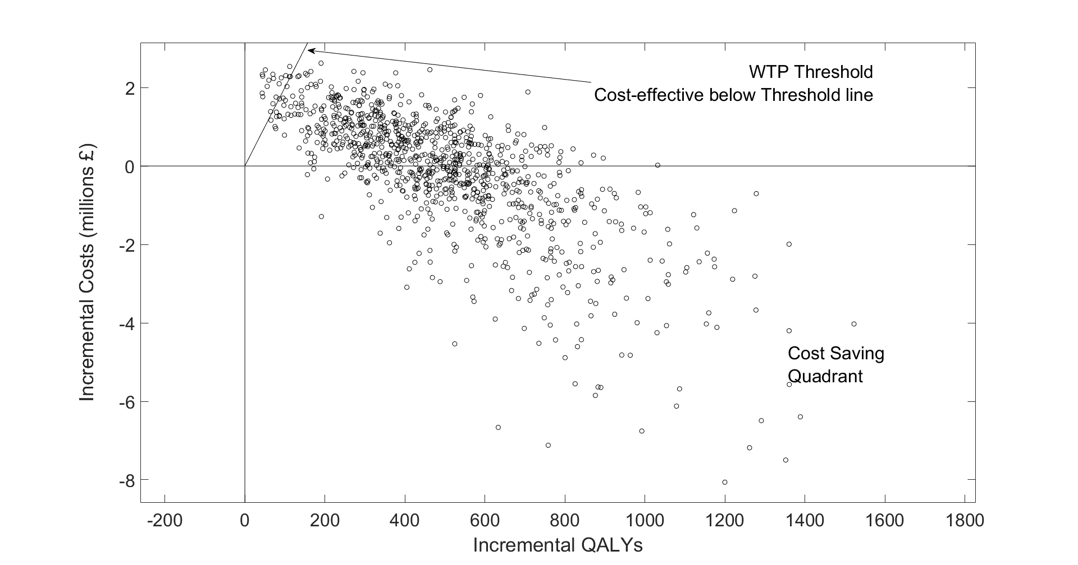

Dundee

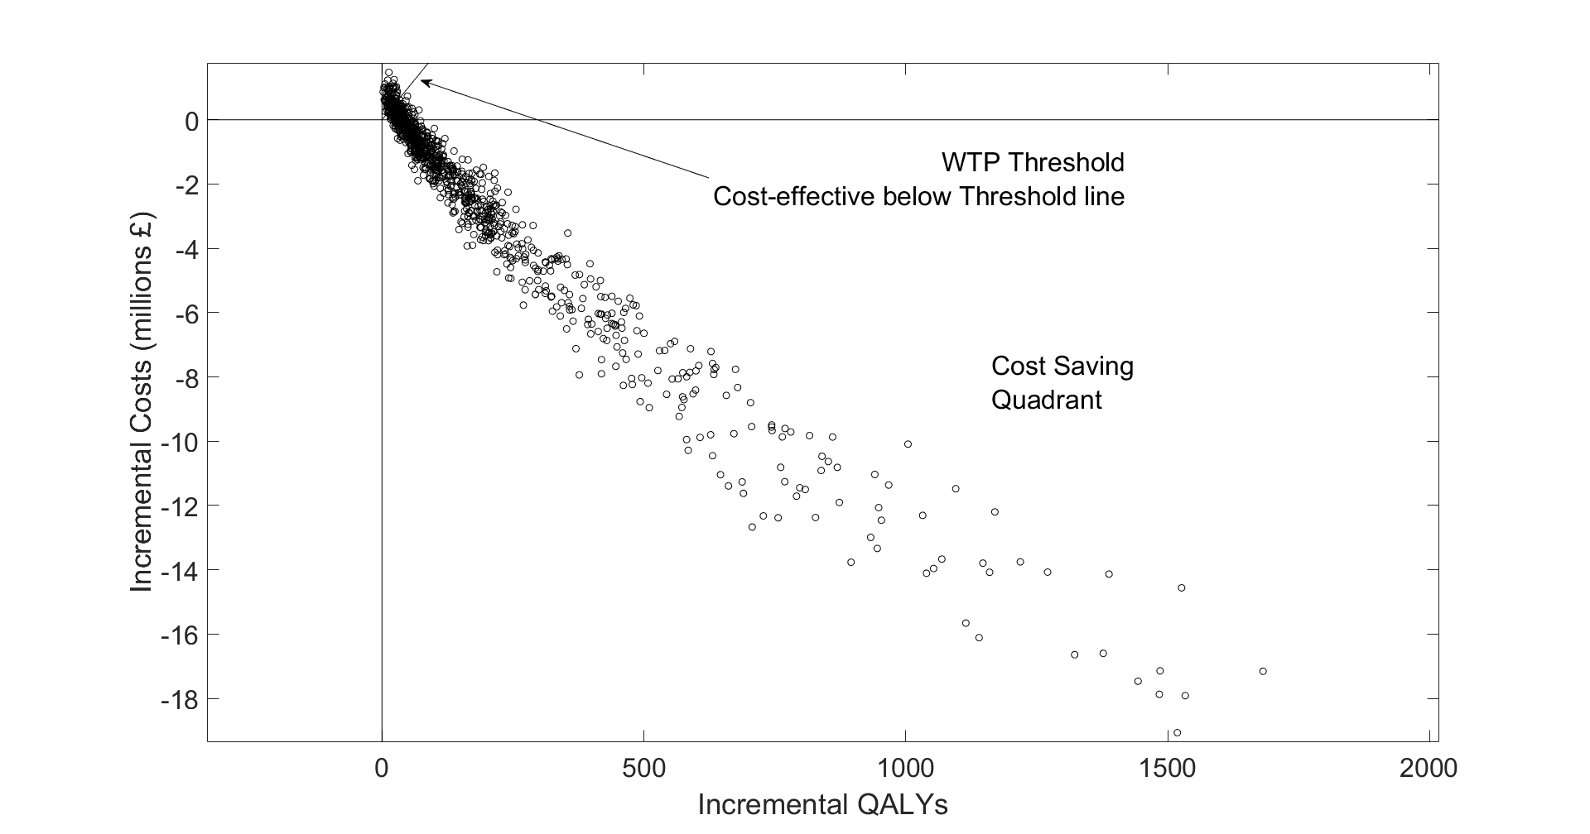

Walsall

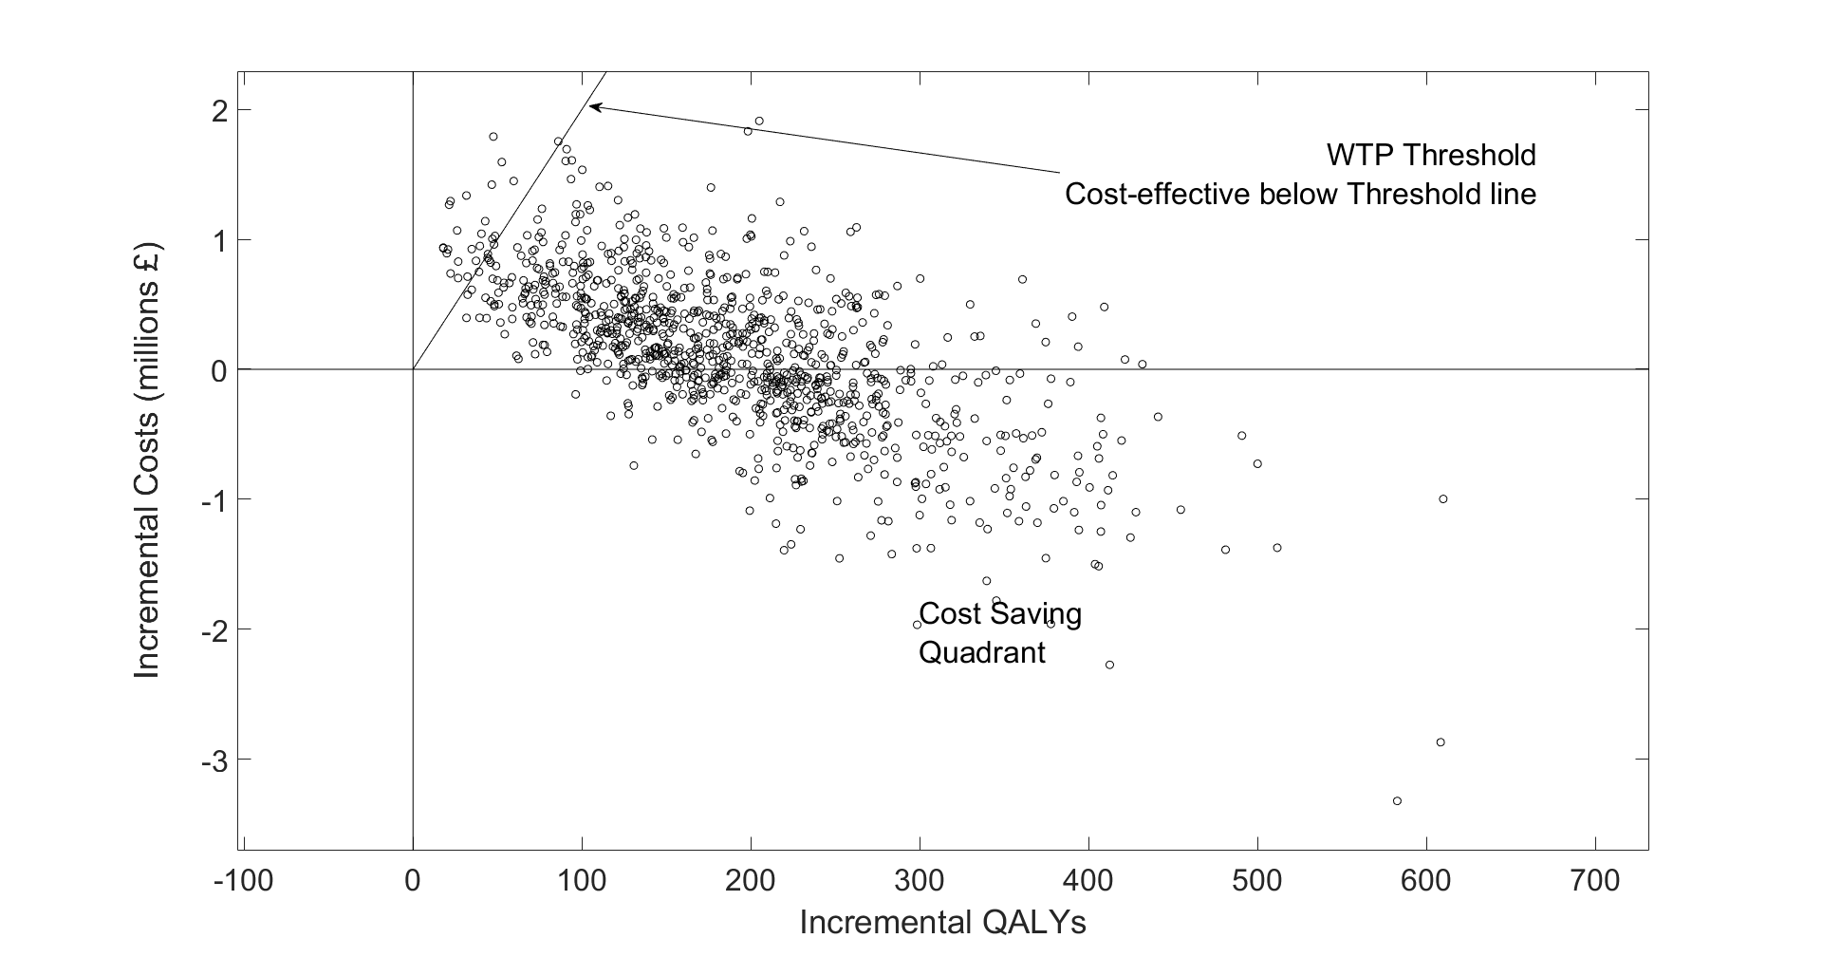

WTP, willingness to pay threshold; QALY, quality adjusted life year.

Figure S4

Bristol

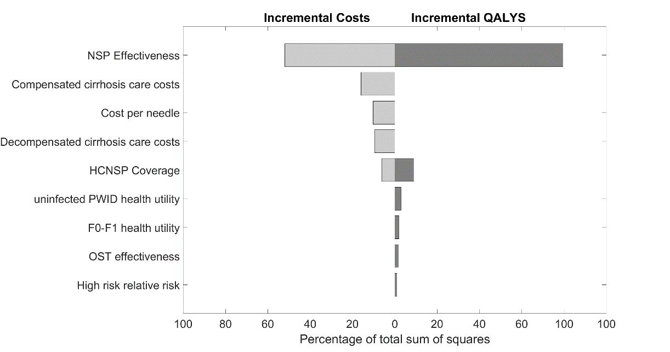

Dundee

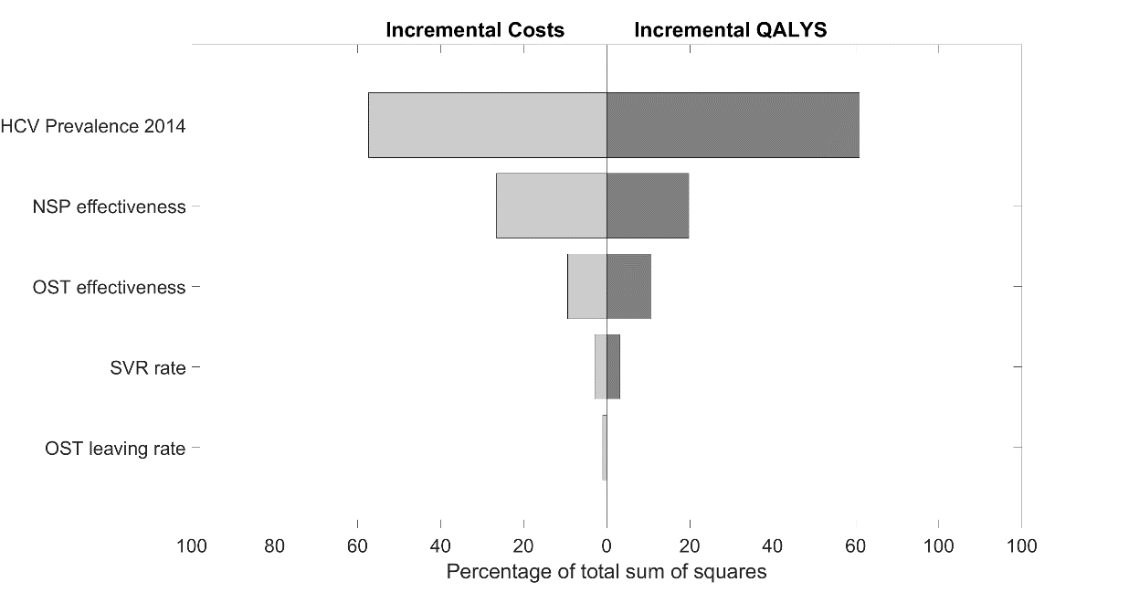

Walsall

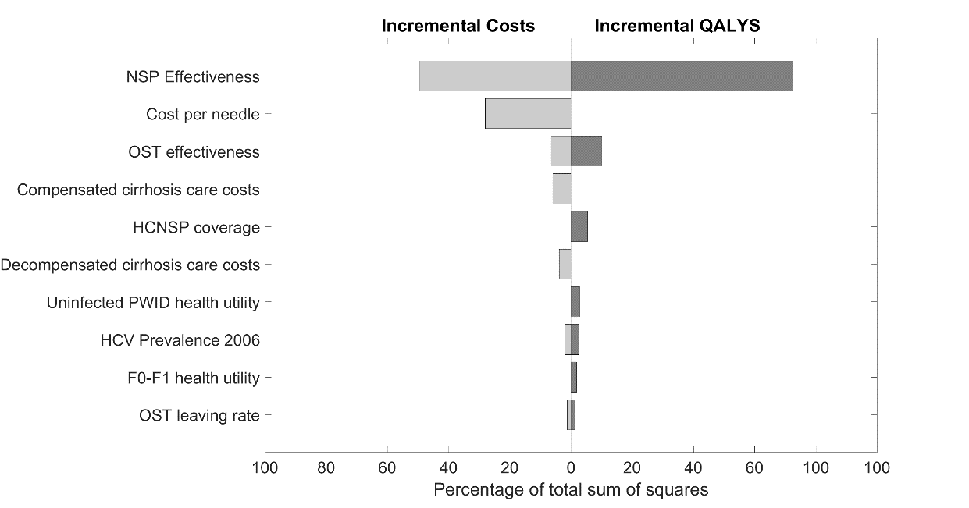

Figure S5

Bristol

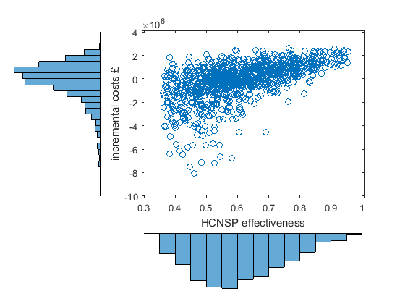

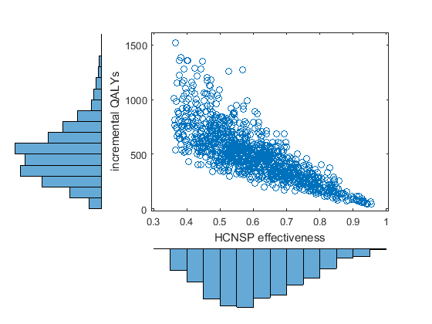

Dundee

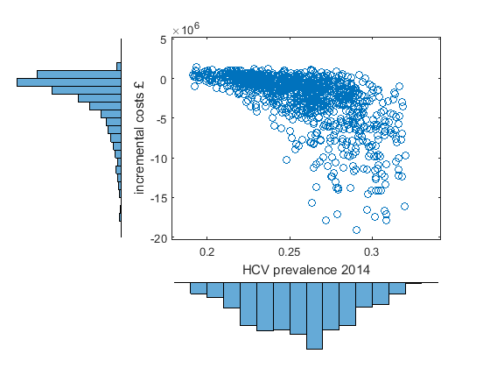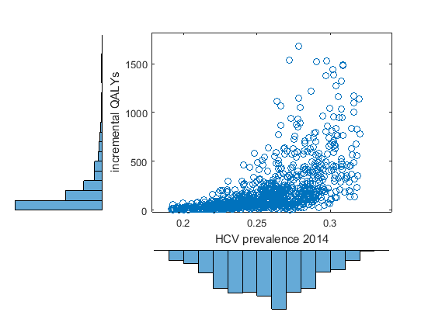

1. Drummond M, Australia Departament of Health and Ageing, Health Outcomes International, National Centre in H I V Epidemiology and Clinical Research. Return on investment in Needle and Syringe Programs in Australia : Report. 2002:161.

2. WHO. Guide to starting and managing needle and syringe programmes. 2007:64.

3. Hope VD, McVeigh J, Marongiu A, Evans-Brown M, Smith J, Kimergård A, et al. Prevalence of, and risk factors for, HIV, hepatitis B and C infections among men who inject image and performance enhancing drugs: a cross-sectional study. BMJ open. 2013;3:e003207.

4. PSSRU. Unit Costs of Health & Social Care 2013. 2013:226.

5. Wright M, Grieve R, Roberts J, Main J, Thomas HC, Investigators UKMHCT. Health benefits of antiviral therapy for mild chronic hepatitis C: randomised controlled trial and economic evaluation. Health technology assessment (Winchester, England). 2006;10:1-113, iii.

6. Martin NK, Vickerman P, Dore GJ, Grebely J, Miners A, Cairns J, et al. How should HCV treatment be prioritized in the direct-acting antiviral era? An economic evaluation including population prevention benefits. Journal of hepatology. 2016.

7. Kimber J, Copeland L, Hickman M, Macleod J, McKenzie J, De Angelis D, et al. Survival and cessation in injecting drug users: prospective observational study of outcomes and effect of opiate substitution treatment. BMJ. 2010;341:c3172.

8. Turner KM, Hutchinson S, Vickerman P, Hope V, Craine N, Palmateer N, et al. The impact of needle and syringe provision and opiate substitution therapy on the incidence of hepatitis C virus in injecting drug users: pooling of UK evidence. Addiction. 2011;106(11):1978-88.

9. Sutton AJ, Gay NJ, Edmunds WJ, Hope VD, Gill ON, Hickman M. Modelling the force of infection for hepatitis B and hepatitis C in injecting drug users in England and Wales. BMC Infect Dis. 2006;6:93.

10. Public Health England. People who inject drugs: HIV and viral hepatitis unlinked anonymous monitoring survey tables (pyschoactive): 2016 update. London; 2016.

11. Vickerman P, Martin N, Turner K, Hickman M. Can needle and syringe programmes and opiate substitution therapy achieve substantial reductions in hepatitis C virus prevalence? Model projections for different epidemic settings. Addiction. 2012;107(11):1984-95.

12. Kemp PA, Neale J, Robertson M. Homelessness among problem drug users: prevalence, risk factors and trigger events. Health Soc Care Community. 2006;14(4):319-28.

13. Platt L, Sweeney S, Ward Z, Guinness L, Hickman M, Hope V, et al. Assessing the impact and cost-effectiveness of needle/syringe provision on hepatitis C transmission among people who inject drugs in the United Kingdom: analysis of pooled datasets and economic modelling Public Health Research. 2017;5(5).

14. Mills HL, Colijn C, Vickerman P, Leslie D, Hope V, Hickman M. Respondent driven sampling and community structure in a population of injecting drug users, Bristol, UK. Drug Alcohol Depend. 2012;126(3):324-32.

15. Micallef JM, Kaldor JM, Dore GJ. Spontaneous viral clearance following acute hepatitis C infection: a systematic review of longitudinal studies. J Viral Hepat. 2006;13(1):34-41.

16. Shepherd J, Jones J, Hartwell D, Davidson P, Price A, Waugh N. Interferon alfa (pegylated and non-pegylated) and ribavirin for the treatment of mild chronic hepatitis C: a systematic review and economic evaluation. Health Technol Asses. 2007;11(11):1-+.

17. Bruno S, Zuin M, Crosignani A, Rossi S, Zadra F, Roffi L, et al. Predicting Mortality Risk in Patients With Compensated HCV-Induced Cirrhosis: A Long-Term Prospective Study. American Journal of Gastroenterology. 2009;104(5):1147-58.

18. Morgan RL, Baack B, Smith BD, Yartel A, Pitasi M, Falck-Ytter Y. Eradication of Hepatitis C Virus Infection and the Development of Hepatocellular Carcinoma: A Meta-analysis of Observational Studies. Annals of Internal Medicine. 2013;158(5):329-37.

19. van der Meer AJ, Veldt BJ, Feld JJ, et al. Association between sustained virological response and all-cause mortality among patients with chronic hepatitis c and advanced hepatic fibrosis. JAMA. 2012;308(24):2584-93.

20. European Association for the Study of the L. EASL Recommendations on Treatment of Hepatitis C 2016. Journal of Hepatology. 2017;66(1):153-94.

21. Jones HE, Welton NJ, Ades A, Pierce M, Davies W, Coleman B, et al. Problem drug use prevalence estimation revisited: heterogeneity in capture–recapture and the role of external evidence. Addiction. 2015.

22. Hay G, Rael dos Santos A, Millar T. Estimates of the Prevalence of Opiate Use and/or Crack cocaine Use, 2010/11: Sweep 7 report. London; 2013.

23. King R, Bird SM, Overstall A, Hay G, Hutchinson SJ. Injecting drug users in Scotland, 2006: Listing, number, demography, and opiate-related death-rates. Addict Res Theory. 2013;21(3):235-46.

24. Cornish R, Macleod J, Strang J, Vickerman P, Hickman M. Risk of death during and after opiate substitution treatment in primary care: prospective observational study in UK General Practice Research Database. BMJ. 2010;341:c5475.

25. Craine N, Hickman M, Parry JV, Smith J, Walker AM, Russell D, et al. Incidence of hepatitis C in drug injectors: the role of homelessness, opiate substitution treatment, equipment sharing, and community size. Epidemiol Infect. 2009;137(9):1255-65.

26. Martin NK, Foster GR, Vilar J, Ryder S, Cramp ME, Gordon F, et al. HCV treatment rates and sustained viral response among people who inject drugs in seven UK sites: real world results and modelling of treatment impact. J Viral Hepat. 2015;22(4):399-408.

27. Harris RJ, Thomas B, Griffiths J, Costella A, Chapman R, Ramsay M, et al. Increased uptake and new therapies are needed to avert rising hepatitis C-related end stage liver disease in England: Modelling the predicted impact of treatment under different scenarios. Journal of Hepatology. 2014;61(3):530-7.

28. Kohli A, Shaffer A, Sherman A, Kottilil S. Treatment of hepatitis c: A systematic review. JAMA. 2014;312(6):631-40.

29. Smith DJ, Combellick J, Jordan AE, Hagan H. Hepatitis C virus (HCV) disease progression in people who inject drugs (PWID): A systematic review and meta-analysis. Int J Drug Policy. 2015;26(10):911-21.

30. Public Health England, Health Protection Scotland, Public Health Wales, Public Health Agency Northern Ireland. Shooting Up: Infections among people who inject drugs in the UK, 2014. London; 2015.

31. Vickerman P, Grebely J, Dore GJ, Sacks-Davis R, Page K, Thomas DL, et al. The More You Look, the More You Find: Effects of Hepatitis C Virus Testing Interval on Reinfection Incidence and Clearance and Implications for Future Vaccine Study Design. J Infect Dis. 2012;205(9):1342-50.

32. Hay G, Gannon M, MacDougall J, Millar T, Eastwood C, McKeganey N. National and regional estimates of the prevalence of opiate use and/ or crack cocaine use 2006/07: a summary of key findings. Home Office Research Report 9. . London; 2008.

33. Hickman M, Hope V, Brady T, Madden P, Jones S, Honor S, et al. Hepatitis C virus (HCV) prevalence, and injecting risk behaviour in multiple sites in England in 2004. J Viral Hepat. 2007;14(9):645-52.

34. Hope VD, Hickman M, Ngui SL, Jones S, Telfer M, Bizzarri M, et al. Measuring the incidence, prevalence and genetic relatedness of hepatitis C infections among a community recruited sample of injecting drug users, using dried blood spots. J Viral Hepat. 2011;18(4):262-70.

35. Mills HL, Johnson S, Hickman M, Jones NS, Colijn C. Errors in reported degrees and respondent driven sampling: implications for bias. Drug Alcohol Depend. 2014;142:120-6.

36. Public Health England. Hepatitis C in the UK 2015 report. 2015.

37. Information Services Division Scotland. Injecting equipment provision in Scotland survey 2013/14. Scotland; 2015.

38. Vickerman P, Martin NK, Hickman M. Understanding the trends in HIV and hepatitis C prevalence amongst injecting drug users in different settings-Implications for intervention impact. Drug Alcohol Depend. 2012;123(1-3):122-31.