**The landscape of childbirth care: delivering a new understanding of the scale, scope, coverage and capability of services**

**Authors:**

Oona M.R. Campbell1 (PhD),Clara Calvert1 (PhD),Adrienne Testa1 (MSc), Matthew Strehlow2 (MD), Lenka Benova1 (PhD), Emily Keyes3 (MSPH), France Donnay4 (MD),David Macleod1 (MSc), Sabine Gabrysch5 (PhD), Luo Rong6 (MM), Carine Ronsmans1,7 (DrPH), Salim Sadruddin8 (PhD), Marge Koblinsky9 (PhD), Patricia Bailey3 (DrPH)

**Affiliations:**

1London School of Hygiene and Tropical Medicine, London, UK

2Stanford University School of Medicine, Stanford, CA, USA

3FHI 360, Durham, NC, USA

4Women's Health Consultant, NICHAD (Network of International Consultants in Health and Development)

5Institute of Public Health, Heidelberg University, Heidelberg, Germany

6National Center for Women and Children Health, Chinese Disease Prevention Control Center, Beijing, China

7West China School of Public Health, Sichuan University

8World Health Organization, Geneva, Switzerland

9USAID, Office of Health, Infectious Diseases and Nutrition, Maternal and Child Health, Washington DC, USA

**Author Contributions:**

Conceptualisation: OC, CC, AT, MS, FD, MK, PB; Literature search: OC, CC, AT, MS, SG, MK, SS; Data analysis: CC, LB, EK, DM, CR, LR, PB; Figures: CC, LB, SG, EK, DM, LR, PB; Data interpretation: all authors contributed; Writing: OC, CC, AT, MS, EK, PB, with all other authors commenting on multiple versions

**Conflict of Interest:** We declare no conflict of interest

**Acknowledgements:**

The Bill and Melinda Gates Foundation and the MacArthur Foundation supported this work.

We thank: the Ghana Health Services for access to the Ghana 2010 Assessment data; the Mozambique Ministry of Health and National Institute for Health for access to the Mozambique 2012 assessment data; the Ethiopia Federal Ministry of Health for access to the Ethiopia 2008 assessment data; the DHS for access to SPAs and surveys; Robert Scherpbier, Sufang Guo, Xiaona Huang from UNICEF, China, and Hu Wenling from the National Center for Women and Children Health, Chinese Disease Prevention Control Center, Beijing, for access to facility assessment data from China; Luisa Kunz for help accessing German data; Masao Iwagami, Kazuyo Machiyama & Kevin Quigley for help accessing and interpreting Japanese data; Kerry Wong for preparing Supplementary Figure 3; Jerker Liljestrand and Sean Duffy for commenting on a draft.

**Key words**: heath systems, maternal health services, emergency medical services, low and middle-income countries, emergency obstetric care, routine intrapartum care, geographical access, indicators, maternity waiting homes, alongside midwifery-led units

**Abstract:**

All women need access to high-quality maternity services -- but what do we know about the healthcare available to and used by women? Focussing on low- and middle- income countries, we present data that policy-makers and planners can use to evaluate whether maternal health services are functioning to meet needs of women, nationally, and potentially sub-nationally. We describe configurations of intrapartum care systems, focussing in particular on where, and with whom, deliveries take place. The necessity of ascertaining actual facility capability and providers’ skills is highlighted, as is the paucity of information on maternity waiting homes and transport as mechanisms for linking women to care. Furthermore, we stress the importance of assessing routine provision of care (not just emergency care), and contextualise this within geographic circumstances (e.g., in sparsely-populated regions versus dense urban areas). While no single model-of-care fits all contexts, we discuss implications of the models we observe, and consider changes that might improve services and accelerate response to future challenges. Areas needing attention include minimizing over-intervention while responding to the changing disease burden. Clearly conceptualizing, systematically measuring, and effectively tackling the coverage and configuration challenges to implementing high quality, respectful maternal healthcare services is crucial to ensure that every woman can give birth without risking her life, or that of her baby.

|  |
| --- |
| Key Messages   1. Facility and skilled birth attendant (SBA) deliveries are increasing. This investment should yield multiple benefits, reducing maternal and perinatal mortality, and improving maternal and neonatal well-being. 2. Yet progress is not as great as expected. Words like SBA and emergency obstetric care (EmOC) can mask poor quality care; we need to ensure skilled providers for routine and emergency childbirth care, along with timely access to such care. 3. National health plans need to ensure women, especially the most remote/vulnerable, can reach intrapartum services in a timely way: this requires understanding the current use of routine and emergency transport, and patterns of relocation (before the start of labour) to stay near the planned childbirth locale (maternity waiting homes). 4. It is unethical to encourage women to give birth in places with low facility capability, no referral mechanism, with unskilled providers, or where content of care is not evidence-based: this must be remedied as a matter of priority. We should only promote childbirth in facilities that can guarantee at least a basic emergency obstetric care standard. 5. Low- and middle-income countries could promote births in comprehensive EmOC facilities, as most high-income countries have done. However, such models can be associated with unnecessary intervention and high costs. To support normal birth, providing alongside midwifery-led units (AMUs) may be a good choice for many women. AMUs have the additional advantage of eliminating the need for inter-facility emergency transfer, though they do not address bottlenecks around initial access. 6. The current indicator of SBA coverage is a unidimensional and limited metric with which to characterise complex services. We need to use a more diverse range of indicators to capture the nature and content of care being provided; these data are readily available. |

# Introduction

The Millennium Development Goal (MDG) to reduce maternal mortality did not recommend specific configurations of maternal healthcare services, but aimed implicitly, as reflected in its tracking indicators, to ensure high coverage of skilled birth attendant (SBA) at delivery and antenatal care (ANC). Underlying these choices were assumptions that high coverage of SBA and ANC would put women and their babies in contact with professionals who could manage uneventful pregnancy, labour and birth, and either prevent, or detect and treat, or appropriately refer complications. Additionally, ANC was an opportunity to arrange appropriate childbirth care.

The end of the MDG era showed progress: from 1990 to 2013, global coverage of SBA increased from 57% to 74%, 1+ ANC visits from 65% to 83%, and 4+ ANC visits from 37% to 64%.1,2 However some countries continue to have high MMRs, despite high SBA and ANC coverage. This could arise because SBA and ANC indicators track *contacts* with care and not the *content* of care; a “quality gap” may remain despite increasing coverage.3,4 Furthermore, features beyond SBA and ANC coverage are likely to be influential. For example, a high population density and short travel times should facilitate access to emergency obstetric care (EmOC), and women’s health-profiles and life-circumstances may additionally drive health-outcomes.

There is minimal comparative tracking of countries’ maternal healthcare provision, apart from the two aforementioned MDG indicators. Supplementary Panel 1 presents key indicators and benchmarks currently used. In the new era of Sustainable Development Goal (SDG) targets, we must redress the shortcomings of using unidimensional and limited metrics to characterise complex services. We focus on intrapartum care. Supplementary Panel 2 briefly describes the status of family planning, abortion, antenatal and postnatal services. The continuum of care is important, but we privilege childbirth services because they are more complex to provide, and because good intrapartum and immediate postpartum care reduce maternal, foetal, and neonatal deaths, and promote health, well-being, and enhanced child development.5

A useful starting point is to lay out pathways that could theoretically lead individual women to receive adequate intrapartum care with SBAs (Figure 1). Informed by this framework, we present a multi-facetted characterization of the main configurations of childbirth services currently used by women in low- and middle-income countries (LMICs), with some data presented on high-income countries (HICs) for comparison. We begin with the prevailing patterns of where, and with whom, deliveries take place. We then detail the levels of facilities, and facility and staff capabilities, and touch on other aspects of quality, followed by a section on strategies for linking women to such intrapartum services. Financing innovations, also essential for improving access and quality, are addressed by Koblinsky and colleagues.6 Finally, we discuss whether current models of service-delivery are likely to be fit-for-purpose, and indicate the scope for future change. We make recommendations for data collection for better planning, provision, and tracking.

Our exploration of childbirth services presents evidence from 50 countries. We drew on literature, particularly reviews, and, for a sub-set of 29 LMICs, we conducted our own analyses (Supplementary Methods).

# Where do births take place, and with whom?

As well as increases in SBA coverage, some countries have increased facility deliveries at astonishing rates (Supplementary Figure 1). The intersection of ‘with whom’ and ‘where’ births take place captures the endpoint of the paths women take in a given context (Figure 1). A provider’s designation (midwife, obstetrician) should indicate skills, while a facility’s designated level (hospital, health-centre, health-post) should signal its capability to provide certain elements of care (e.g. comprehensive emergency obstetric care (CEmOC), basic emergency obstetric care (BEmOC), or routine-only care), and whether it is obliged to refer complications elsewhere for treatment.7 Numerous unstandardized terms are used to describe provider cadres and facility levels. For example, freestanding midwifery units or private midwife’s clinics generally resemble health centres, inasmuch as they might be expected to provide BEmOC (e.g. MgSO4), but not aspects of CEmOC (caesarean-section and blood transfusion). Figure 2 shows these childbirth care configurations for 50 countries, with nearly as many patterns as countries. Providers range from no one, to non-SBAs, to midwives, to doctors; there are settings where births occur mostly at home (e.g. Chad 2000-4), predominantly at lower-level health facilities (e.g. Senegal 2010-14), or entirely at hospitals (e.g. Jordan 2008-12). Figure 3 shows the main cadre of birth attendant in facilities varies – from countries where midwives/nurses attend the majority of lower- and higher-level facility births (e.g. Mali 2008-12), to those where doctors prevail (e.g. Ukraine 2003-7). In some, lower-level facilities births are predominantly with midwives/nurses, while hospital births are with doctors (e.g. Indonesia 2008-12). Countries with mostly hospital births (Figure 3, upper right) vary in their dominant SBA cadre.

# Are staff skilled?

Skilled staff are essential to provide high-quality intrapartum care to each woman and newborn, and are a determinant of facility capability, and a requirement for adequate home-based childbirth care (Figure 1, table component). Skill includes the ability to communicate in a caring, respectful manner, plus the knowledge and technical skills to give appropriate, well-timed care.8,9 Unfortunately, in many settings women receive neither; systematic reviews show substantial disrespect and abuse, and numerous studies show low provider skills and confidence,8,9,10-13 For example, a study of nine sub-Saharan African countries showed most did not train SBAs to manually removing placentas.8 Some countries designate cadres as SBAs, despite them lacking requisite midwifery skills.12,14.

Staff numbers matter too. Ninety percent of maternal deaths happen in 58 countries with only 17% of the world’s midwives and doctors.15 Data compiled from 132 countries revealed 64 did not meet the minimum critical threshold of 23 midwives, nurses and doctors per 10,000 population, needed to implement primary care programmes, including intrapartum care (Supplementary Panel 1).16 There are shortages of other key providers such as anaesthetists.17 Furthermore, providers are often mal-distributed (e.g. concentrated in urban areas or in the private sector). Low-density settings (remote and rural) are particularly challenging to provision; providers prefer working in teams and may resist placements without amenities such as schools.18-20 Location and facility size often correlate with resources available for hiring, training, supervision, and retention. With insufficient staff, some women cannot get timely care, and end up delivering alone or with non-SBAs, such as cleaners, despite being in facilities.21

# What capability do facilities have?

To give high-quality intrapartum care, skilled staff require an enabling environment, and facilities that receive women 24 hours-a-day, 7 days-a-week (24/7). Specialist back-up care should be part of the plan, via transfer to another facility if needed. Figure 1 designates facilities as capable of providing CEmOC, BEmOC, or routine care only. The last is included for completeness because facilities should at a minimum be able to manage some complications, stabilize women and guarantee transfer to a hospital (i.e., be BEmOC-capable), as well as to care competently and empathetically for routine, uncomplicated births.22

Researchers have evaluated the capability of facilities to provide EmOC across many settings using eight “signal functions” including, for example, provision of parenteral antibiotics (one of six “basic” functions) and caesarean section (one of two “comprehensive” functions).23 Facilities designated as “hospitals” or even “CEmOC facilities,” vary widely in their actual capability to provide such care. Measurement of “signal functions” frequently extends to include neonatal resuscitation (EmONC), but we avoided reporting this because we concur with those who would expand EmONC beyond just resuscitation.24 Unfortunately, we lacked data for a broader definition. In nine LMICs, we explored the volume of deliveries, the actual capability of facilities to provide emergency and routine childbirth care, and whether facilities had basic infrastructure.

## Volume of deliveries

Facilities of different levels usually have different numbers of beds, providers and provider skill-mixes, and different volumes of deliveries handled. Variations across countries reflect differences in geography and population densities, philosophies and policies for childbirth, and healthcare systems, but the sizes and numbers of facilities also reflect potential difficulties in organizing, providing, and accessing care.

Across eight sub-Saharan African countries and China, over 70% of facilities conducting deliveries were low-volume (fewer than 500 births per year), and only conducted a small proportion of all facility births (Supplementary Figure 2). For example, in Namibia, 86% of facilities were low-volume, and conducted only 17% of all facility births. Across the nine countries, 17%-47% of facility births were in low-volume facilities. Among HICs, few countries have more than a fifth of births in low-volume facilities, and many had none.25 The nine LMICs also had some very high-volume facilities (10,000+ deliveries per year), while reports indicate facilities conducting as many as 48,000 deliveries per year.26

## Emergency obstetric care capability

Facility capability to deliver EmOC was often poor (Figure 4a, columns A). For example, in Kenya only 16% of facilities could provide EmOC, illustrated in green. Taking into account that more functional facilities had a higher volume of deliveries shifted the balance favourably (Figure 4a, column B). In Kenya, 43% of facility deliveries were in EmOC-capable facilities. However, even this more favourable picture demonstrated that in four of eight countries evaluated, the majority of births were in facilities incapable of providing all five BEmOC functions – a vital gap in maternal healthcare provision. Facilities in China were considerably more likely to provide EmOC than those in sub-Saharan Africa.

## Routine childbirth care

Despite the SBA strategy essentially promoting facility birth, little attention is paid to routine intrapartum care in facilities. Signal functions for routine care, capturing selected aspects of monitoring and prevention (e.g. partograph, routine administration of uterotonics and infection prevention), and functions for basic infrastructure were first proposed 15 years after those for EmOC.24 In six LMICs with relevant data, we showed facilities were generally better equipped to provide routine care than EmOC (Figure 4b). In Mozambique for example, approximately half of facility deliveries were in EmOC-capable facilities (Figure 4a, column B), but over 75% were in facilities capable of all routine care signal functions (Figure 4b, column B). Nevertheless, an unacceptably high proportion of births occurred in facilities incapable of providing adequate-quality routine care.

## Basic infrastructure

A national study in Tanzania shows 56% of facilities conducting deliveries lack water and sanitation,27 and a systematic review shows 66% of hospitals in sub-Saharan countries lack electricity.28 Figure 4c shows many facilities were open 24/7, but lacked both water and reliable electricity.

## Quality of intrapartum care at the individual level

High-quality care also requires that all components of routine and emergency care be provided consistently, respectfully, in a timely fashion, and affordably to all women needing it. However, with some exceptions,29 coverage of specific elements of care is rarely available at national-level in LMICs, because of the challenges in gathering such individual-level data from health management information systems (HMIS), non-electronic medical records, or surveys. Individual women’s care can be very poor, even when providers and facilities are capable of providing it.30

# What does it take to access care?

Accessing health services remains a challenge for women in many countries; in 2013, met need for SBA delivery worldwide was 74%. A 2015 systematic review of met need for EmOC, an indicator which signposts women’s use of facilities for complications (assuming 15% of all pregnancies will require such care), estimated that the percentage of women with complications who actually attended EmOC facilities was 21% in low- and 32% in middle-income settings.31 Economic and cultural barriers play a role, but an additional reason is the lack of nearby EmOC facilities; few countries meet the benchmark of five (fully functioning, as defined by the performance of all signal functions) EmOC facilities per 20,000 births.32 Another reason is the lack of transport to link women to care. The spatial distribution of women entering into labour, in relation to the location of facilities of a given level, determines distance. Distance, along with mode-of-transport and difficulty of travel (road infrastructure, road quality, traffic or safety), then determines travel-time, and affects the timeliness of obtaining routine and emergency childbirth care.33

## Strategies to link women to services

Strategies connecting women to routine services (e.g. ANC or childbirth) frequently differ from those linking them to emergency services. Access to routine intrapartum care requires that women be transported to health facilities, or that staff and supplies are transported to women’s homes (Figure 1). Alternatively, women can move close to services late in pregnancy, before entering labour. We describe these strategies in Panel 1. For emergencies, referral systems and coordinated emergency transport are needed to transfer patients and communicate critical health records to receiving hospitals.34-37

### Emergency transport

Emergency transport is divided into formal and informal systems. Most HICs, and increasing numbers of LMICs, have formal emergency medical services (EMS) systems providing ambulance transport and care for patients with all types of emergencies. Four main EMS models exist: 1) no defined formal system, 2) basic life support (BLS), 3) advanced life support (ALS), and 4) on-scene physicians providing advanced life support (Doc-ALS).38,39 Most LMICs lack formal EMS systems, or operate BLS systems. In contrast, HICs typically utilize ALS (e.g. United States, UK) or Doc-ALS (e.g. Germany, France) systems. While evidence suggests that Doc-ALS is superior for severely-injured trauma patients, limited research has failed to demonstrate significant differences in outcomes between BLS, ALS, and Doc-ALS for other emergency patients; there are no controlled trials specifically evaluating emergency obstetric patients.40-43

Emergency medical technician training should at a minimum include emergency resuscitation and pre-hospital decision skills, such as who should be allowed in the ambulance, and whether in instances with only one provider, the ambulance driver should pull over to help manage an emergency requiring two sets of hands, or keep driving. For emergency conditions such as major trauma and acute myocardial infarction, bypassing lower-level facilities for higher ones is appropriate because additional transport time is outweighed by improved services and care at higher levels.34,44 Because of the risk to both mother and baby, and the time needed to set inter-facility referral in motion,45 women who cannot be managed *in situ* might be better off being transferred directly to the nearest functioning CEmOC facility; laws, or memoranda of understanding, facilitate this.

Functional EMS systems are resource-intensive, demanding a coordinated call-centre and ambulance response team. Mature EMS systems in HICs operate single toll-free access numbers, managed by call-centres whose agents dispatch appropriate ambulance services; ambulances are located to optimize response time and resources.38,46 The numbers of ambulances required per population vary depending on local factors, such as road conditions, population density, distance, and culturally acceptable response times.47

In LMICs, ambulance numbers are increasing rapidly; however, a lack of system-wide coordination compromises their reach and impact (Supplementary Figure 4a). Unlike in HICs, many LMICs rely on facility-based ambulances, and lack single access phone numbers, providers trained in pre-hospital care, or ideal accessibility (Supplementary Figure 4b). Facility-based ambulances allow providers a dual role, providing both pre-hospital and in-hospital care. This reduces staffing needs, but the absence of designated ambulance providers results in the ambulances themselves being underutilised. Placing ambulances at remote, lower-level facilities (health centres), further strains limited staffing resources. Finally, supplying villages with community-based emergency vehicles has shown some initial success, but sustainability, cost, and scale-up are poorly studied.48 Panel 2 presents a case study on Cambodia.

### Alongside Midwifery-led Units

Alongside Midwifery-led Units (AMUs), which co-locate the equivalent of lower-level facilities on hospital sites, are an approach to having women deliver in lower-capability units while eliminating travel-time to CEmOC capability if transfer is needed.49,50 Such models are used in the South Africa51 (known as “onsite midwife-led birth units”) and in the UK. However, while AMUs may address high hospital costs, overcrowding, and over-intervention, and obviate the need for inter-facility emergency transport, they do not resolve issues of the routine transport of women in labour, especially from remote locations.

Other types of fragmentation hinder linkages as well. In some countries (e.g. Indonesia), hospitals and health centres fall under different government departments with little direct relationship. Sub-national administrative boundaries, decentralised funding, and multiple public- and private-sector funding streams can complicate care for women. Referral protocols that do not recognise the urgency of many obstetric complications to reach the nearest CEmOC facility, can fatally delay care.

# Discussion

The MDG5 indicators of SBA and ANC coverage are insufficient to characterise the maternal healthcare systems of countries, or indicate the likelihood of achieving good outcomes. Unless we address other aspects linked to quality and timeliness, ensuring respectful care, and other elements of coverage, we risk over-estimating our achievements. Policy-makers need information to contextualise their countries along a number of potentially successful pathways to high quality and effective services, to identify breaches in these paths, and review their direction of travel.

The SDG era gives us an opportunity to review, refine, and plan carefully to ensure health-system developments better meet the needs of pregnant and delivering women and their babies, as well as of women needing other reproductive and general health services. Our conceptual framework (Figure 1) illustrates that for childbirth, the essential features to explore are the birth location and its capability, the skills of the birth attendant, and the ability of women to access routine and emergency care. A clear understanding of these features, coupled with an appreciation of the geography and other contextual factors of a setting, is needed to comprehensively illustrate the current situation of maternal care for multi-country or sub-national comparisons, and to develop evidence-informed options. We see great variability in these maternal health-system features across countries, some of which achieve good results, and others that do not.

## What existing patterns tell us

**Home births**

Among the 50 countries, home births ranged from 0.1%-90%. The ability to achieve safe and respectful care for home births depends on who attends, and how successfully home births are integrated into effective formal-sector services, including via EMS. In general, the higher the home birth percentage, the lower the percentage of these that were with SBAs (e.g. in Ethiopia (2007-11), 90% of births were at home, of which only 0.4% were with SBAs). Most LMIC home births were either with traditional births attendants (e.g. 89% in Bangladesh (2007-11)), with relatives/family (e.g. 61% in Ethiopia (2007-11)), or alone (e.g. 34% in Rwanda (2006-10)).

When non-SBAs attend home births, potential interventions include birth-preparedness and complication-readiness,52,53 and linkages to the formal health-system.52,54 Generally, this configuration is associated with high MMRs and poor perinatal outcomes.7

When SBAs attend substantial proportions of home births (e.g. Indonesia, Sierra Leone, Cambodia), women need ways to call them when labour starts and SBAs may need transport to get there. For such models to yield low MMRs, midwives and doctors should be competent in providing routine care and emergency first-aid. They also need to be integrated into formal systems of training, supervision, and skills-retention, even if they work privately. In HICs, home births were less than 5%, except in the Netherlands (15% in 2013) and, when planned, were mostly with SBAs. Recent evidence-based UK guidelines show home births with midwives are safe for multigravida with uncomplicated pregnancies.55 Planned out-of-hospital births in the US have worse perinatal outcomes, but nearly a quarter had no SBA and over a third lacked insurance compared to <1% of planned hospital births.56 We lack comparable clarity for LMICs. There are historic examples of success with SBA-attended home births, for example in Malaysia,7,57 but evaluation of the national Indonesian midwifery programme showed that while SBAs for home births increased, MMRs remained high, even among women who received professional care.58,59 This suggests home-based midwifery care may fail, possibly because midwives were insufficiently trained or skilled, care was not well-timed, and access barriers to EmOC remained, and even widened.

Irrespective of attendant, home births need EMS options to get women to hospitals should complications arise. This is a bottleneck, with few national-scale emergency transport schemes in LMICs. For example, in Ethiopia (2007-11), where 90% of women delivered at home, household ownership of motorised vehicles was low, there was no universal access telephone number for EMS and few patients were transported by ambulance. Although Ethiopia is redressing low coverage (its national survey (2010-14) shows 16% facility birth,60 and others show 43%61), such a configuration cannot, and does not, achieve low MMRs – Ethiopia’s MMR is 353.62 Many women in many countries live far from EmOC-capable facilities, and motorized transport is inaccessible or unaffordable in some rural areas. In urban areas, traffic may delay arrival. Emergency transport innovations, including those instigated by women’s groups, have been proposed but not scaled-up.63 India may provide a pragmatic future model via its EMS innovations.64,65 Inappropriate family decision-making can also delay emergency care-seeking and also needs to be addressed.

In summary, where home-based models of care predominate, most women and family decision-makers are unable to navigate the pathways to care, as evidenced by the low proportions of expected emergencies that actually arrive at facilities,31 and the resultant high MMRs (Figure 2).

**Facility births**

Global expansion of SBA coverage has occurred largely via increased facility delivery, which is now almost universal in some LMICs, and most HICs. In the 50 countries, facility births ranged from 10%-99% of all births, with hospitals comprising 17%-100% of all facility births. Yet, given that facility births constitute formal-sector provision, it is deplorable that many facilities fail to provide skilled, high-quality, respectful care. The majority of facilities we studied in sub-Saharan Africa, but not China, were ill-equipped to provide EmOC, especially lower-level facilities. Similar unacceptable findings are reported elsewhere.66,67 Moreover, many facilities could not even provide routine childbirth care or lacked necessities such as electricity or water. Such functions must improve to enable high-quality and respectful care, and to improve patient and provider satisfaction.

Some women’s report of delivering in facilities without an SBA: 0-5% of facility births in most LMICs, but in Senegal (2009-14), for example, as high as 28% of births in lower-level facilities and 8% in hospitals. Others demonstrate that providers classified as SBAs are not actually skilled,11 and that numbers of staff deployed are frequently too low, exacerbating low facility capability.68 Women in many settings leave facilities quickly, without discharge checks.69 All this begs the question why we encourage women to deliver in such circumstances of low facility capability, poor provider skills, and inadequate lengths of stay, and must be remedied as a matter of priority.

The imperative for countries that have achieved demand for facility birth, and ensured some form of access, is to improve quality, including EmOC capability, and inter-facility linkages and EMS. Countries with nearly all deliveries in facilities have opted largely for births in hospitals with caesarean-section capability. Trends in HICs have been towards centralising health services, leading to fewer, larger-volume facilities and less rural provision. The changes in HICs are driven partly by desires to improve patient-safety and cut costs, and indirectly by challenges that remote facilities face in recruiting and retaining providers, and by increased regulations reducing profitability of private-sector maternity services.70-75 Having fewer units, on the other hand, erodes patient choice and increases travel-time,71 and very large hospitals can be difficult to manage. The “mega-hospitals”, with 10,000+ births per year, seen in some countries can yield peculiar ecologies of non evidence-based childbirth practices, including high levels of augmentation, caesarean-section, crowding, and very short lengths-of-stay.30,76

We can see that countries with nearly universal hospital births are approaching, or are already below, the new 2030 MMR target of 70 or less, irrespective of the front-line cadre.77 The 2014 Lancet Midwifery Series provides hypothetical evidence for midwives as the preferred main SBA and front-line provider.78 In countries with the majority of facility-births in hospitals, the mix of cadres varies: in Morocco (2000-4) and Namibia (2009-13), for example, midwives predominate, with a non-trivial proportion of doctor-led births, while in, Ukraine (2003-7), and the US (2013), doctors lead. Figure 2 indicates we have insufficient data on the front-line provider (particularly for HICs) to compare maternal and neonatal outcomes in countries where different cadres predominate.

Some countries, such as Bangladesh and Haiti, have low coverage of SBA and facility birth, but women who do get facility care are mainly in hospitals (rather than lower-level facilities), and attended by doctors. This pattern either reflects grossly unequal availability and accessibility where only a privileged minority access care, or alternatively could arise if emergency referral functions, and hospital-based providers primarily attend women with complications.79 In Bangladesh, travel-times are short, so women with complications can reach hospitals quickly, possibly explaining why the country’s MMR is relatively low considering its low SBA coverage.80 In other settings, this pattern reflects sizeable inequality and condemns many women and newborns to death.

The 2006 Lancet Maternal Survival Series promoted childbirth in lower-level facilities capable of providing BEmOC, and ideally staffed with midwives, for LMICs.22 The reasoning related to shorter travel times, lower cost, and a greater likelihood of avoiding over-intervention. Some countries appear at first glance to have adopted this model (e.g. Senegal and Uganda); we question this appearance in view of our findings that health centres in many settings have sub-optimal capabilities and are not BEmOC-capable. Tanzania expects deliveries to occur at even lower-levels: health-posts and dispensaries.81 Such low-volume facilities are numerous, and of particular concern despite often being the closest ones to remote rural women. Even if provisioned as childbirth venues, their staff may have insufficient training or opportunities to practice and maintain competency in intrapartum care, and EMS links are frequently poor.82,83

## What do we want for the future?

Facility and SBA deliveries are increasing, but in many LMICs, urban and richer women use these services much more than rural and poorer women.84 To serve women, and achieve universal coverage, we need to remedy this. Moreover, we can no longer “pretend” to provide life-saving care, using words like SBA and EmOC to mask poor quality; we need to actually provide skill and emergency care, by ensuring adequate numbers and training of staff, improving the capability and basic infrastructure of facilities, ensuring timely referral where necessary, and ensure women get appropriate high-quality content of care.30

Chronic under-investment in the health workforce and the resultant global shortage of healthcare workers is well known and extends to SBAs, particularly in LICs.85 Ultimately, over-burdened, under-skilled and under-appreciated health workers are compromised to deliver quality maternal healthcare, and lack resilience to shocks (e.g. as in the recent Ebola outbreak).20,86,87 Unfortunately, we find few national examples of substantially growing an SBA workforce in a short time-frame.88 Initiatives to increase provider numbers have included training staff to work in abroad (e.g. Cuba),89 recruiting staff from others countries (e.g. Cuban doctors in Brazil90 and Africa91), scaling-up training programmes to locally train sufficient numbers (e.g. in Indonesia and South Africa92-95) and task-shifting (e.g. Mozambique).96,97 The Lancet Commission *Health professionals for a new century*,98 suggests ways to sustainably improve health worker education in general, and programmes exist in a number of countries (including e-health distance-learning approaches in Rwanda, and modernising curricula and developing continuing, in-service education in Mozambique, Sudan, Thailand and Yemen).99 However, evidence that these achieve sustainable, long-term success is limited. Rollout of task-shifting programmes has been hampered by political, capacity, quality and other resource challenges,95,100 and while task-shifting programmes increase healthcare coverage in some cases, success is not at sufficient scale to improve population-level maternal health outcomes, with some notable exceptions.101,102 Team-work, as recommended in the 2006 Lancet Maternal Survival series, is an alternative potential solution.18

We support facility delivery, but not in facilities that fail to reach at least BEmOC standards, unless countries are explicit about how such places will cater for emergencies. It could be argued that LMICs should emulate HICs, and opt for births in CEmOC-capable facilities. We need to be mindful, however, that such models are associated with high intervention rates in some HICs, and even higher ones among wealthier women in poorly regulated LMIC health-systems.30,103 Some HICs (e.g. the UK) are increasingly encouraging low-risk women to opt for home births with SBAs, or birth in lower-level “free-standing, midwifery-led units”, or in AMUs.104

Average travel-times to the lowest-level facilities are generally shortest, but frequently these cannot even provide routine, much less emergency, care. To improve geographic access for women in labour and timeliness of care, governments could improve functionality of lower-level facilities, or institute maternity waiting homes (MWH), or support routine transport to EmOC-capable facilities. Either all women who enter into labour must be within travelable distances to comprehensive facilities, or if they can only reach lower-level facilities, these must have well-functioning maternal care, with excellent EMS linking strategies.

We focussed on the pathways linking women to intrapartum services. Looking more widely, we recognize the continuum of care105 and the need to link across services, and develop new non-traditional maternity services that respond to the obstetric transition being observed globally.106 Ensuring maternal health systems synergize with emerging neonatal strategies and structures is also beneficial. Multi-country reviews of health system bottlenecks for newborns identify solutions we would endorse for women, including workforce planning to increase numbers and upgrade specific skills, incentives for rural workers, financial protection, and dynamic leadership including innovation and community empowerment.107

## Data needs: moving towards universal indicators for maternal health services

The data we collated and analysed demonstrate how previously underutilised information can describe the configurations of maternal health services better. Our main sources were the DHS and health-facility assessments. Together, they enabled us to illustrate the diversity of maternal health models across a range of LMICs, and to pinpoint some common bottlenecks preventing women from receiving high-quality routine or emergency childbirth care. These same sources can generate the same indicators at sub-national level. Complementary indicators, on GDP, health-expenditure, policies (such as the legality of abortion), and estimates of the extent of private-sector coverage, content of ANC, caesarean-section rates, length-of-stay, postnatal care coverage, and unmet need for family planning, can round-off our understanding, particularly if tabulated by indices of inequality, and coupled with health status indicators, such as obesity and HIV prevalence, MMR, severe morbidity, and foetal and neonatal mortality. Ultimately, strong national data systems need to be built to inform policy, and focus investment and resources, ideally linked and aligned to similar processes for newborns.

We acknowledge some data limitations. Firstly, the facility designation and the cadre of the health professional are often recalled by women (e.g. in the DHS) and are subject to recall errors or be an inaccurate reflection of the actual facility capability108 or providers’ actual skills.11,109 Secondly, some data were over ten years old, which is problematic when extensive changes occur (e.g. Ethiopia or India). This underlines the importance of relatively frequent data collection. HMIS, such as DHIS2, 110 could rectify this, provided it includes private providers (since these conduct many deliveries).111 HMIS also have the advantage of providing sub-national, district-level data.

In addition, we identified some critical data gaps. Signal functions for routine maternal (and for newborn care) need to be more widely adopted, collected via public- and private-sector facility assessments, and ideally, be updateable and in the public domain. The ultimate challenge is to measure how many women actually receive key elements of routine childbirth care and whether all women requiring emergency care actually receive it, respectfully and promptly. Unnecessary intervention also needs to be captured. This requires investments to improve record-keeping and change HMIS, as was done successfully in Ecuador.29 The maternal and newborn research communities need to come to consensus on which coverage, quality, and timeliness indicators they can effectively field at scale. These indicators need to be defined clearly and implemented consistently to compare across countries.

Parallel investments in developing tools for planning, monitoring, and advocacy are also vital. For example, consensus on the numbers of births a full-time midwife can do per month, and tools enabling managers to accurately calculate staffing requirements overall, and on a daily basis, would support more effective planning, deployment and cost-savings.112 Linking to existing planning tools, such as the OneHealth Tool, would extend reach, and help countries achieve human resource plans for maternal, foetal and newborn care.5,113 Similarly, more sophisticated use of mathematical and geographical models now available have great potential to inform better service configurations. For example, a study in Ethiopia modelled the impact on coverage of adding vehicles and communication capability or of upgrading strategically located facilities, and changing the configuration of referral networks.46

# Conclusion

A powerful body of data is available to examine current configurations of childbirth care, and to begin to evaluate whether maternal services meet the needs of women. Given the enormous range of contexts, we cannot recommend one configuration of care. These decisions need to be made locally and nationally. However, we can reiterate that facility deliveries only make sense if they can provide safe routine services, as well as BEmOC and referral capability to guarantee women with complications are appropriately managed in a timely manner. We note a number of missed opportunities to generate evidence, with particularly limited data on routine care, MWHs, transport, and inter-facility transfers. Considerable investments are needed to enable the national and global stakeholders to identify critical gaps in national and sub-national service delivery, agree indicators, collect and analyse data, and take up and act on evidence.

While it is not novel to call for better understanding, data, and planning, this is an opportune time to re-evaluate existing metrics, given pressures to re-organize and diversify maternal services in the SDG era. National governments and providers have to ensure quality services. UN agencies, donors, national governments, and private actors can work to harmonise new indicators, improve routine data collection and real-time analysis, and systematise periodic household and facility surveys. Clearly conceptualizing, systematically measuring, and effectively tackling the coverage and configuration challenges to implementing high quality, respectful maternal healthcare is crucial to ensure that every woman can give birth without risking her life, or that of her baby.

# Figures and Panels

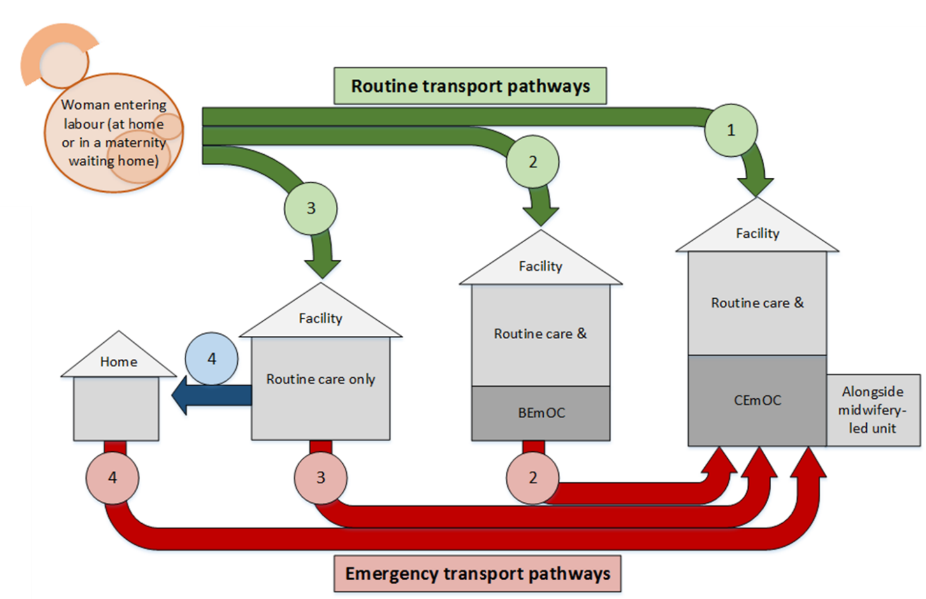

|  |  |  |  |  |  |  |
| --- | --- | --- | --- | --- | --- | --- |
|  | **Requirements for each pathway & option for routine and emergency care** | | | | | |
| **Options to ensure SBA delivery** | **Routine Pathway** | **Routine transport at start of labour** | **Provision of quality care for routine childbirth** | **Complications Pathway** | **Emergency transport for complications** | **Provision of quality care for complications (EmOC)** |
| Woman/family:   * Makes decision on intended place of childbirth * Has ability to reach intended location, including by relocating to a maternity waiting home (MWH) (transport & communication) | Facility has adequate:   * Staff cadres & skills for routine childbirth * Staff numbers * Equipment, drugs & supplies * 24/7 opening times & basic infrastructure | Attendant:   * Recognizes need for emergency care * Can identify & reach CEmOC facility (e.g. using emergency medical service) | Facility has adequate:   * Staff cadres & skills to manage complications * Staff numbers * Equipment, drugs & supplies * Blood supply * 24/7 opening times & basic infrastructure |
| **Facility with routine care & CEmOC** |  | Woman travels from home/MWH to CEmOC facility | Uncomplicated childbirth at CEmOC facility, potentially in an alongside midwifery-led unit (AMU) |  | Travel not required; if in AMU, move to obstetric ward co-located on the same site | Complicated childbirth managed at CEmOC facility |
| **Facility with routine care & BEmOC** |  | Woman travels from home/MWH to BEmOC facility | Uncomplicated childbirth at BEmOC facility |  | Woman who cannot be managed at BEmOC facility travels to CEmOC facility |
| **Facility with routine care only** |  | Woman travels from home/MWH to routine-only facility | Uncomplicated childbirth at routine-only facility |  | Woman travels from routine-only facility to CEmOC facility |
| **Home with SBA** |  | SBA travels to woman’s home | Uncomplicated childbirth at home |  | Woman travels from home to CEmOC facility |

**Figure 1: Conceptual framework of pathways leading to adequate childbirth care options (skilled birth attendance for uncomplicated childbirth and access to emergency obstetric care to manage complications), and the requirements for each pathway and option to be successful** SBA: skilled birth attendant; EmOC: emergency obstetric care; BEmOC: basic emergency obstetric care; CEmOC comprehensive emergency obstetric care; AMU: alongside midwifery-led unit; 24/7: twenty four hours a day, seven days a week

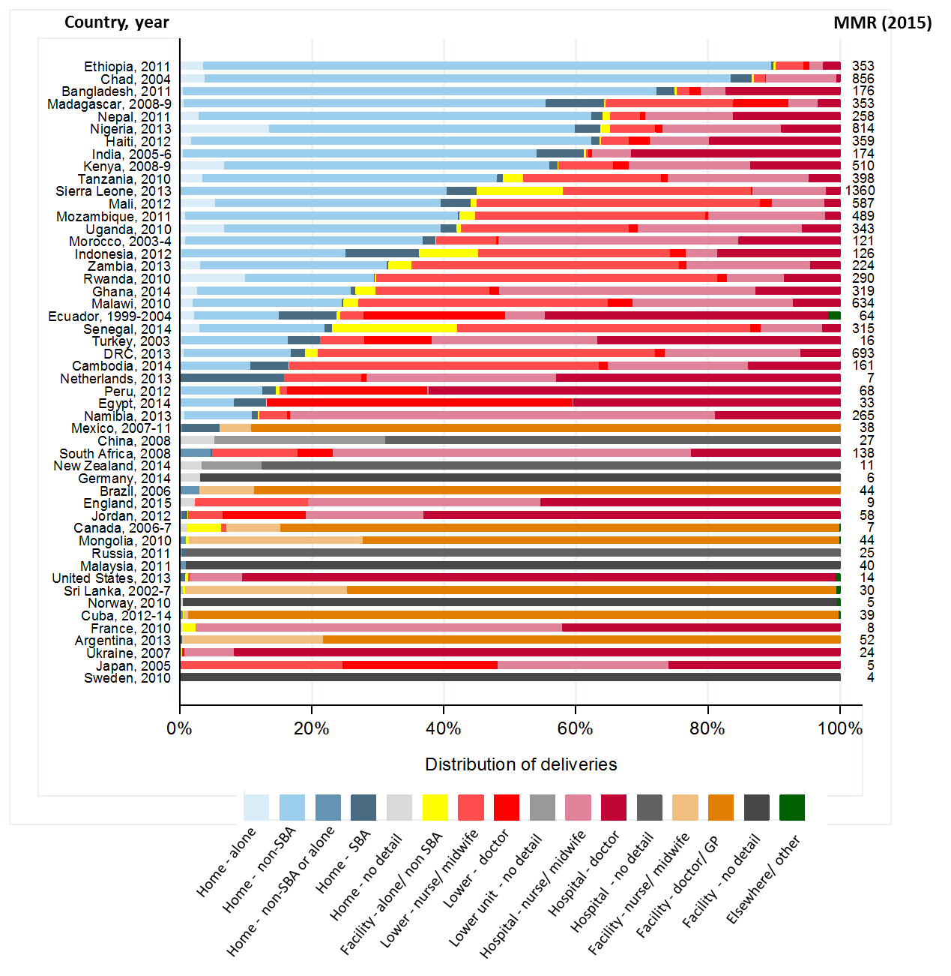

Figure 2: Distribution of deliveries by childbirth location and provider attending birth, by country, year of data collection, and MMR in 2015. MMR: maternal mortality ratio; SBA: skilled birth attendant



Figure 3: Percentage of births in facilities, by facility level and cadre of attendant, for selected countries. SBA: skilled birth attendant

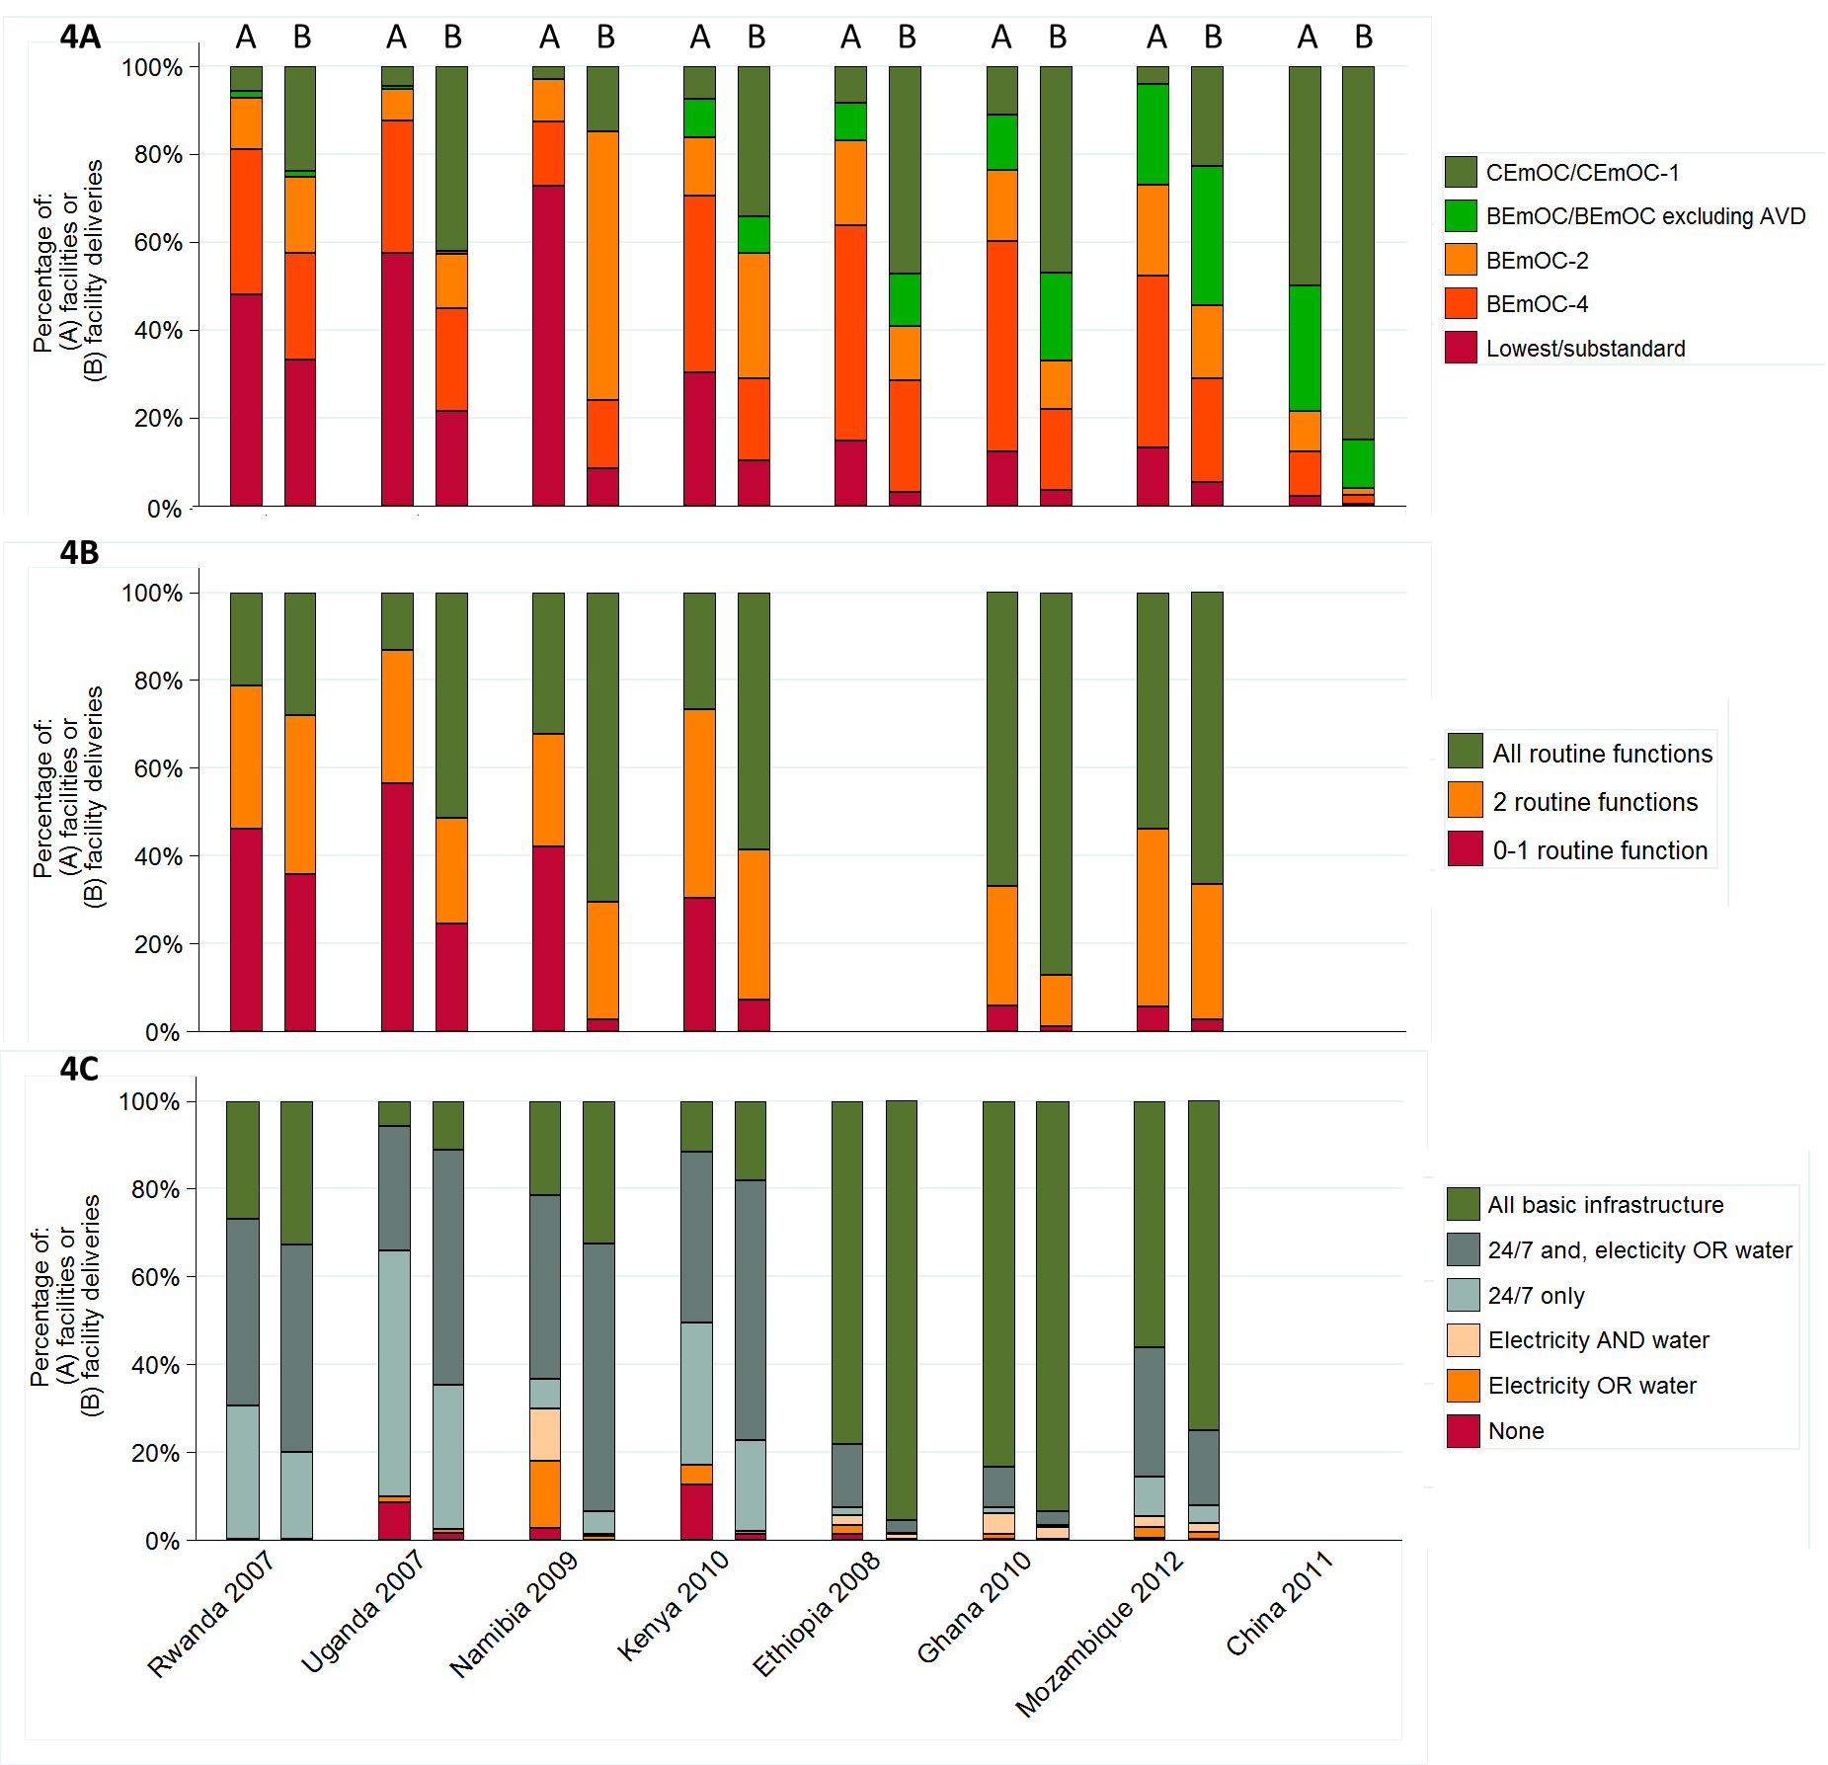

Figure 4 Percentage Facility capability by weighting (A = weighted by traditional survey weights; B = additionally weighted by number of deliveries in each facility), by country.

4a: EmOC capability; 4b: Routine childbirth care capability (infection prevention, partograph, & routine administration of uterotonic); 4c: Facilities with basic infrastructure

(NB. Differences in definitions drive some between-country differences; see supplementary material)

EmOC: emergency obstetric care; BEmOC: basic emergency obstetric care; CEmOC comprehensive emergency obstetric; CEmOC-1: CEmOC excluding assisted vaginal delivery (AVD). BEmOC-2: BEmOC excluding two signal functions; BEmOC-4: BEmOC excluding four signal functions; 24/7: service twenty-four hours a day, seven days a week

|  |
| --- |
| **Panel 1: Routine transport systems and maternity waiting homes: getting women to routine childbirth services** Routine transport Emergency complications that cannot be managed *in situ* generally require women to reach high-level facilities rapidly, but even routine transport for women in labour has to be relatively swift.114,115 The lack of reliable transportation hampers timely care-seeking, with rural populations spending substantial travel time, and incurring high transport costs.107,116-118  Readily available transport and short travel times have a dramatic impact on facility delivery. 119 In HICs, rural areas have higher rates of motorized vehicle ownership compared to urban locales.120 In contrast, many LMICs have very low rates of motorized vehicle ownership in rural areas, which further exacerbate disparities in access to high-quality obstetric care. Supplementary Figure 3 illustrates this for Kenya, showing that small proportions of households within DHS clusters owned any form of motorized vehicle. Phone ownership, which facilitates communication, was higher than for vehicles, particularly in urban areas, but was still low in sparsely-populated areas.  To improve transport, countries such as India, Nepal, and South Sudan have established fully or partially subsidised transport for women seeking routine obstetric care.64,65,121 Providing formal transport services should increase the rate of facility births, especially among rural and low-income women, but further study of these programmes’ designs (e.g. staffing, costs, and sustainability) is needed. Travel-times to facilities alone do not delineate the entire picture; multiple factors, including perceived low-quality service, lead women and families to bypass smaller local facilities for more EmOC-capable facilities further away.122,119 The impact and appropriateness of obstetric patients without known complications bypassing services is poorly studied, but bypassing can indicate dysfunction at lower-levels, and cause dysfunction at higher ones, via over-crowding. Maternity waiting homes In hard-to-reach areas, women in labour setting out for a distant facility may well deliver *en route*, particularly in LMICs where air transport of women (or SBAs) to a childbirth site is neither available nor financially viable.123 One solution is for women to move and stay adjacent to health facilities towards the end of pregnancy, reducing travel-times in labour. These locales can be formal health-sector “maternity waiting homes” (MWHs) or “patient hotels”, or private hotel or hostel accommodation, or the homes of relatives or friends, sometimes referred to as “informal maternity-waiting homes”. MWHs are recommended interventions, although the evidence is weak.124 We know little about the scale of MWH provision, or the proportion of women using them, although some countries reportedly make considerable use of this approach (e.g. Mongolia,125 Cuba,126 and Peru).127 In Canada in 2006-07, 5.8% of women travelled more than a day before birth to another city, town, or community to give birth.128 |

|  |
| --- |
| **Panel 2: Emergency transport systems in Cambodia**  Over the past decades, Cambodia’s MMR dropped from 1020 per 100,000 live-births in 1990, to 484 in 2000, to 161 in 2015, meeting the MDG5 target.62,129 In 2014, 83% of births occurred in facilities, and 89% were assisted by an SBA, compared to 22% and 44%, respectively, in 2005. Related services also improved: by 2014, 95% of women had at least one ANC visit, 76% had 4+ ANC visits, and 85% received postnatal care within 2 days of birth. Modern contraception had increased to 39% and unmet need was down to 13%. Induced abortion is legal up to 12 weeks gestation. The government-backed EmONC improvement plan (2010-2014) and finances to provide services,130 coupled with efforts to expand and strengthen financial schemes that assist low-income patients to use services, have been instrumental in Cambodia’s progress.*131,132*  Despite this forward momentum, and the fact that the vast majority of the population reside within two hours of a health centre, significant gaps remain in the number and distribution of functional EmONC services across Cambodia, with 2.35 EmONC-capable facilities and 1.31 Comprehensive EmONC-capable facilities per 500,000 population. Global benchmarks require 5 and 1 respectively. EmONC services are highly concentrated in urban centres, leaving rural areas without essential services.130,133 Only around 24% of all births occurred in functional EmONC facilities. The majority of designated EmONC facilities not achieving functional status were health centres incapable of assisted vaginal delivery, manual removal of placenta, or giving parental anticonvulsants or neonatal resuscitation.  Referral systems linking patients to available EmOC services remain a challenge in Cambodia. Despite nearly all health centres having a phone service and being located within two hours of higher-level care, and hospitals having functional on-site ambulances, breaks in the referral system persist. Very few health centres have their own emergency transport, and health centre staff are routinely responsible for helping patients arrange their own transport (60%).130 National policies require trained staff to accompany patients during transport, a practice utilized in three-quarters of referrals by health centres. However, the accompanying staff is frequently a midwife or nurse without emergency medical technician training.  In 2015, Cambodia was granted 200 new ambulances from China that were distributed to public facilities across the country, bringing the estimated total number of functional ambulances nationwide to greater than 400 – approximately one ambulance for every 35,000 people. Recommendations for LMICs range from 1 ambulance for every 20,000 population to 1 per 100,000.47,134 Ambulances remain primarily hospital-based and hospital-administered. No centralized access number or dispatch system exists, leading to a vast underutilization of ambulances, protracted response times, and vehicles falling into disrepair. Obstetric emergencies are among the most common reasons for seeking emergency transport, with fees being reimbursed by government and donor-backed low-income assistance programs.135,136 Unfortunately, rates charged to patients vary widely, and reimbursements often fail to cover the entire cost of transport.135 Taken together, these challenges have led to a lower than expected numbers of referrals and unnecessary delays in care.  Multiple quality improvement efforts are underway to improve linkages between facilities in Cambodia. Quarterly Midwifery Coordination Alliance Team meetings have successfully brought together health centre midwives, Operational District administrators, and local and provincial referral hospital staff to review referrals, discuss improvement opportunities, and conduct education on key maternal care practices. Additionally, current efforts to standardize referral guidelines and promote provincial-level obstetric care hotlines will help Cambodia continue its recent progress in advancing maternal health. |

# References

1. World Health Organization. World health statistics 2015. Geneva: World Health Organization, 2015.

2. United Nations Inter-agency and Expert Group on MDG Indicators. The Millennium Development Goals Report 2014. New York: United Nations, 2014.

3. Hodgins S. Achieving better maternal and newborn outcomes: coherent strategy and pragmatic, tailored implementation. *Global Health: Science and Practice* 2013; **1**(2): 146-53.

4. Kinney MV, Kerber KJ, Black RE, et al. Sub-Saharan Africa's mothers, newborns, and children: where and why do they die? *PLoS medicine* 2010; **7**(6): e1000294.

5. de Bernis L, Kinney MV, Stones W, et al. Stillbirths: ending preventable deaths by 2030. *The Lancet* 2016.

6. Koblinsky M, Moyer CA. *The Lancet* 2016.

7. Koblinsky MA, Campbell O, Heichelheim J. Organizing delivery care: what works for safe motherhood? *Bulletin of the World Health Organization* 1999; **77**(5): 399.

8. Bohren MA, Vogel JP, Hunter EC, et al. The Mistreatment of Women during Childbirth in Health Facilities Globally: A Mixed-Methods Systematic Review. *PLoS medicine* 2015; **12**(6): e1001847; discussion e.

9. Freedman LP, Ramsey K, Abuya T, et al. Defining disrespect and abuse of women in childbirth: a research, policy and rights agenda. *Bulletin of the World Health Organization* 2014; **92**(12): 915-7.

10. Adegoke A, Utz B, Msuya SE, van den Broek N. Skilled Birth Attendants: who is who? A descriptive study of definitions and roles from nine Sub Saharan African countries. *PloS one* 2012; **7**(7): e40220.

11. Hussein J, Bell J, Nazzar A, Abbey M, Adjei S, Graham W. The skilled attendance index: proposal for a new measure of skilled attendance at delivery. *Reproductive health matters* 2004; **12**(24): 160-70.

12. Ariff S, Soofi SB, Sadiq K, et al. Evaluation of health workforce competence in maternal and neonatal issues in public health sector of Pakistan: an Assessment of their training needs. *BMC health services research* 2010; **10**: 319.

13. Kildea S, Larsson M, Govind S. A review of midwifery in Mongolia utilising the 'Strengthening Midwifery Toolkit'. *Women and birth : journal of the Australian College of Midwives* 2012; **25**(4): 166-73.

14. Footman K, Benova L, Goodman C, et al. Using multi‐country household surveys to understand who provides reproductive and maternal health services in low‐and middle‐income countries: a critical appraisal of the Demographic and Health Surveys. *Tropical Medicine & International Health* 2015; **20**(5): 589-606.

15. Global Health Workforce Alliance. Global Health Workforce Crisis. 2013.

16. World Health Organization. The 2014 update. Global Health Workforce Statistics. Geneva.

17. Meara JG, Leather AJ, Hagander L, et al. Global Surgery 2030: evidence and solutions for achieving health, welfare, and economic development. *Lancet* 2015; **386**(9993): 569-624.

18. Koblinsky M, Matthews Z, Hussein J, et al. Going to scale with professional skilled care. *The Lancet* 2006; **368**(9544): 1377-86.

19. Lehmann U, Dieleman M, Martineau T. Staffing remote rural areas in middle-and low-income countries: a literature review of attraction and retention. *BMC health services research* 2008; **8**(1): 19.

20. Filby A, McConville F, Portela A. What Prevents Quality Midwifery Care? A Systematic Mapping of Barriers in Low and Middle Income Countries from the Provider Perspective. *PloS one* 2016; **11**(5): e0153391.

21. Chaturvedi S, De Costa A, Raven J. Does the Janani Suraksha Yojana cash transfer programme to promote facility births in India ensure skilled birth attendance? A qualitative study of intrapartum care in Madhya Pradesh. *Global health action* 2015; **8**.

22. Campbell OM, Graham WJ. Strategies for reducing maternal mortality: getting on with what works. *The Lancet* 2006; **368**(9543): 1284-99.

23. World Health Organization, UNFPA, UNICEF, AMDD. Monitoring emergency obstetric care: a hand book. World Health Orgnaization: Geneva, 2009.

24. Gabrysch S, Civitelli G, Edmond KM, et al. New signal functions to measure the ability of health facilities to provide routine and emergency newborn care. 2012.

25. Zeitlin J, Mohangoo A, Delnord M, et al. The second European Perinatal Health Report: documenting changes over 6 years in the health of mothers and babies in Europe. *Journal of epidemiology and community health* 2013: jech-2013-203291.

26. Saleh WF, Ragab WS, Aboulgheit SS. Audit of maternal mortality ratio and causes of maternal deaths in the largest maternity hospital in Cairo, Egypt (Kasr Al Aini) in 2008 and 2009: lessons learned. *Afr J Reprod Health* 2013; **17**(3): 105-9.

27. Benova L, Cumming O, Gordon BA, Magoma M, Campbell OM. Where there is no toilet: water and sanitation environments of domestic and facility births in Tanzania. *PloS one* 2014; **9**(9): e106738.

28. Adair-Rohani H, Zukor K, Bonjour S, et al. Limited electricity access in health facilities of sub-Saharan Africa: a systematic review of data on electricity access, sources, and reliability. *Global Health: Science and Practice* 2013; **1**(2): 249-61.

29. Hermida J, Robalino ME, Vaca L, Ayabaca P, Romero P, Vieira L. Scaling up and institutionalizing continuous quality improvement in the free maternity and child care program in Ecuador. *Latin America and Caribbean Regional Health Sector Reform Initiative Report Bethesda, MD: University Research Co LLC* 2005.

30. Miller S, Abalos E, Chamillard M, et al. Beyond "Too Little, Too Late" and "Too Much, Too Soon": A pathway towards evidence-based, respectful maternity care worldwide. *The Lancet* 2016; **Forthcoming**.

31. Holmer H, Oyerinde K, Meara JG, Gillies R, Liljestrand J, Hagander L. The global met need for emergency obstetric care: a systematic review. *BJOG : an international journal of obstetrics and gynaecology* 2015; **122**(2): 183-9.

32. Countdown to 2015. A Decade of Tracking Progress for Maternal, Newborn and Child Survival. The 2015 Report. Geneva, 2015.

33. Tanser F, Gijsbertsen B, Herbst K. Modelling and understanding primary health care accessibility and utilization in rural South Africa: An exploration using a geographical information system. *Social Science & Medicine* 2006; **63**(3): 691-705.

34. Dogba M, Fournier P, Dumont A, Zunzunegui MV, Tourigny C, Berthe-Cisse S. Mother and newborn survival according to point of entry and type of human resources in a maternal referral system in Kayes (Mali). *Reproductive health* 2011; **8**: 13.

35. Austin A, Gulema H, Belizan M, et al. Barriers to providing quality emergency obstetric care in Addis Ababa, Ethiopia: Healthcare providers’ perspectives on training, referrals and supervision, a mixed methods study. *BMC Pregnancy and Childbirth* 2015; **15**: 74.

36. Wiegers TA, de Borst J. Organisation of emergency transfer in maternity care in the Netherlands. *Midwifery* 2013; **29**(8): 973-80.

37. Fournier P, Dumont A, Tourigny C, Dunkley G, Dramé S. Improved access to comprehensive emergency obstetric care and its effect on institutional maternal mortality in rural Mali. *Bulletin of the World Health Organization* 2009; **87**(1): 30-8.

38. Roudsari BS, Nathens AB, Arreola-Risa C, et al. Emergency Medical Service (EMS) systems in developed and developing countries. *Injury* 2007; **38**(9): 1001-13.

39. World Health Organization. Prehospital trauma care systems. World Health Organization: Geneva, 2005.

40. Stiell IG, Spaite DW, Field B, et al. Advanced life support for out-of-hospital respiratory distress. *The New England journal of medicine* 2007; **356**(21): 2156-64.

41. Roudsari BS, Nathens AB, Cameron P, et al. International comparison of prehospital trauma care systems. *Injury* 2007; **38**(9): 993-1000.

42. Botker MT, Bakke SA, Christensen EF. A systematic review of controlled studies: do physicians increase survival with prehospital treatment? *Scandinavian journal of trauma, resuscitation and emergency medicine* 2009; **17**: 12.

43. Ryynanen OP, Iirola T, Reitala J, Palve H, Malmivaara A. Is advanced life support better than basic life support in prehospital care? A systematic review. *Scandinavian journal of trauma, resuscitation and emergency medicine* 2010; **18**: 62.

44. Hartl R, Gerber LM, Iacono L, Ni Q, Lyons K, Ghajar J. Direct transport within an organized state trauma system reduces mortality in patients with severe traumatic brain injury. *The Journal of trauma* 2006; **60**(6): 1250-6; discussion 6.

45. Raj SS, Manthri S, Sahoo PK. Emergency referral transport for maternal complication: lessons from the community based maternal death audits in Unnao district, Uttar Pradesh, India. *International journal of health policy and management* 2015; **4**(2): 99.

46. Bailey PE, Keyes EB, Parker C, Abdullah M, Kebede H, Freedman L. Using a GIS to model interventions to strengthen the emergency referral system for maternal and newborn health in Ethiopia. *International journal of gynaecology and obstetrics: the official organ of the International Federation of Gynaecology and Obstetrics* 2011; **115**(3): 300-9.

47. Ludwig G. The waiting game some patients don't have the luxury of time. *JEMS : a journal of emergency medical services* 2010; **35**(7): 26.

48. Ensor T, Green C, Quigley P, Badru AR, Kaluba D, Kureya T. Mobilizing communities to improve maternal health: results of an intervention in rural Zambia. *Bulletin of the World Health Organization* 2014; **92**(1): 51-9.

49. Soltani H, Sandall J. Organisation of maternity care and choices of mode of birth: a worldwide view. *Midwifery* 2012; **28**: 146 - 9.

50. Sandall J, Soltani H, Gates S, Shennan A, Devane D. Midwife-led continuity models versus other models of care for childbearing women. *Cochrane Database Syst Rev* 2013; **8**(8).

51. Hofmeyr G, Mancotywa T, Silwana-Kwadjo N, Mgudlwa B, Lawrie T, Gulmezoglu A. Audit of a new model of birth care for women with low risk pregnancies in South Africa: the primary care onsite midwife-led birth unit (OMBU). *BMC Pregnancy and Childbirth* 2014; **14**(1): 417.

52. World Health Organization. WHO recommendations on health promotion interventions for maternal and newborn health 2015. 2015.

53. Soubeiga D, Gauvin L, Hatem MA, Johri M. Birth Preparedness and Complication Readiness (BPCR) interventions to reduce maternal and neonatal mortality in developing countries: systematic review and meta-analysis. *BMC pregnancy and childbirth* 2014; **14**(1): 129.

54. Sibley LM, Sipe TA, Barry D. Traditional birth attendant training for improving health behaviours and pregnancy outcomes. *Cochrane Database Syst Rev* 2012; **8**: Cd005460.

55. Tanday S. Midwife-led units safest for straightforward births 2014. National Instituture for Health and Care Excellence (accessed 15/09/2015.

56. Snowden JM, Tilden EL, Snyder J, Quigley B, Caughey AB, Cheng YW. Planned Out-of-Hospital Birth and Birth Outcomes. *The New England journal of medicine* 2015; **373**(27): 2642-53.

57. Pathmanathan I, Liljestrand J. Investing in maternal health: learning from Malaysia and Sri Lanka: World Bank Publications; 2003.

58. Ronsmans C, Scott S, Qomariyah S, et al. Professional assistance during birth and maternal mortality in two Indonesian districts. *Bulletin of the World Health Organization* 2009; **87**(6): 416-23.

59. Hatt L, Stanton C, Makowiecka K, Adisasmita A, Achadi E, Ronsmans C. Did the strategy of skilled attendance at birth reach the poor in Indonesia? *Bulletin of the World Health Organization* 2007; **85**(10): 774-82.

60. Central Statistical Agency. Ethiopia Mini Demographic and Health Survey 2014. Addis Ababa, Ethiopia, 2014.

61. IDEAS. IDEAS Ethiopia Report. 2016 - Forthcoming.

62. Alkema L, Chou D, Hogan D, et al. Global, regional, and national levels and trends in maternal mortality between 1990 and 2015, with scenario-based projections to 2030: a systematic analysis by the UN Maternal Mortality Estimation Inter-Agency Group. *The Lancet*.

63. Prost A, Colbourn T, Seward N, et al. Women's groups practising participatory learning and action to improve maternal and newborn health in low-resource settings: a systematic review and meta-analysis. *Lancet* 2013; **381**(9879): 1736-46.

64. Sidney K, Ryan K, Diwan V, De Costa A. Utilization of a State Run Public Private Emergency Transportation Service Exclusively for Childbirth: The Janani (Maternal) Express Program in Madhya Pradesh, India. *PloS one* 2014; **9**(5): e96287.

65. Kumutha J, Rao GV, Sridhar BN, Vidyasagar D. The GVK EMRI maternal and neonatal transport system in India: a mega plan for a mammoth problem. *Seminars in fetal & neonatal medicine* 2015; **20**(5): 326-34.

66. Nesbitt RC, Lohela TJ, Manu A, et al. Quality along the Continuum: A Health Facility Assessment of Intrapartum and Postnatal Care in Ghana. *PloS one* 2013; **8**(11): e81089.

67. Erim DO, Kolapo UM, Resch SC. A Rapid Assessment of the Availability and Use of Obstetric Care in Nigerian Healthcare Facilities. *PloS one* 2012; **7**(6): e39555.

68. United Nations Population Fund. The State of the World's Midwifery 2011: Delivering Health, Saving Lives, 2011.

69. Campbell OM, Cegolon L, Macleod D, Benova L. Length of Stay After Childbirth in 92 Countries and Associated Factors in 30 Low- and Middle-Income Countries: Compilation of Reported Data and a Cross-sectional Analysis from Nationally Representative Surveys. *PLoS medicine* 2016; **13**(3): e1001972.

70. Combier E, Charreire H, Le Vaillant M, et al. Perinatal health inequalities and accessibility of maternity services in a rural French region: closing maternity units in Burgundy. *Health & place* 2013; **24**: 225-33.

71. Bosanquet N, Ferry J, Lees C, Thornton J. Maternity services in the NHS. *London: Reform* 2005; **35**.

72. Van Teijlingen E, Pitchforth E. Rural maternity care: Can we learn from Wal-Mart? *Health & place* 2010; **16**(2): 359-64.

73. Grzybowski S, Kornelsen J, Schuurman N. Planning the optimal level of local maternity service for small rural communities: a systems study in British Columbia. *Health Policy* 2009; **92**(2): 149-57.

74. Schuurman N, Randall E, Berube M. A spatial decision support tool for estimating population catchments to aid rural and remote health service allocation planning. *Health Informatics J* 2011; **17**(4): 277 - 93.

75. Kornelsen J, MacKie C. The role of risk theory in rural maternity services planning. *Rural and remote health* 2013; **13**(2206).

76. Khalil K, Elnoury A, Cherine M, et al. Hospital Practice Versus Evidence‐Based Obstetrics: Categorizing Practices for Normal Birth in an Egyptian Teaching Hospitala. *Birth* 2005; **32**(4): 283-90.

77. World Health Organization. Strategies towards ending preventable maternal mortality (EPMM). 2015.

78. Renfrew MJ, McFadden A, Bastos MH, et al. Midwifery and quality care: findings from a new evidence-informed framework for maternal and newborn care. *The Lancet* 2014; **384**(9948): 1129-45.

79. Matthews Z, Channon A, Neal S, Osrin D, Madise N, Stones W. Examining the “urban advantage” in maternal health care in developing countries. *PLoS medicine* 2010; **7**(9): e1000327.

80. Chowdhury ME, Ahmed A, Kalim N, Koblinsky M. Causes of maternal mortality decline in Matlab, Bangladesh. *Journal of Health, Population, and Nutrition* 2009; **27**(2): 108-23.

81. Tanzania Ministry of Health and Social Welfare. The National Road Map Strategic Plan to Accelerate Reduction of Maternal, Newborn and Child Deaths in Tanzania 2008-2015, 2008.

82. Janakiraman V, Lazar J, Joynt KE, Jha AK. Hospital volume, provider volume, and complications after childbirth in US hospitals. *Obstetrics & Gynecology* 2011; **118**(3): 521-7.

83. Clapp MA, Melamed A, Robinson JN, Shah N, Little SE. Obstetrician Volume as a Potentially Modifiable Risk Factor for Cesarean Delivery. *Obstetrics & Gynecology* 2014; **124**(4): 697-703.

84. Campbell OM, Benova L, MacLeod D, et al. Family planning, antenatal and delivery care: cross‐sectional survey evidence on levels of coverage and inequalities by public and private sector in 57 low‐and middle‐income countries. *Tropical Medicine & International Health* 2016; **21**(4): 486-503.

85. ten Hoope-Bender P, de Bernis L, Campbell J, et al. Improvement of maternal and newborn health through midwifery. *The Lancet*; **384**(9949): 1226-35.

86. Nam SL, Blanchet K. We mustn't forget other essential health services during the Ebola crisis. *BMJ (Clinical research ed)* 2014; **349**: g6837.

87. Campbell J, Cometto G, Rasanathan K, et al. Improving the resilience and workforce of health systems for women’s, children’s, and adolescents’ health. 2015.

88. Global Health Workforce Alliance Scaling Up, Saving Lives 2008.

89. Huish R. How Cuba's Latin American School of Medicine challenges the ethics of physician migration. *Social science & medicine* 2009; **69**(3): 301-4.

90. Kirk JM, Kirk EJ, Walker C. Mais Médicos: Cuba's Medical Internationalism Programme in Brazil. *Bulletin of Latin American Research* 2015: n/a-n/a.

91. Hammett D. Physician Migration in the Global South between Cuba and South Africa. *International Migration* 2014; **52**(4): 41-52.

92. Alexander L, Igumbor EU, Sanders D. Building capacity without disrupting health services: public health education for Africa through distance learning. *Hum Resour Health* 2009; **7**(28): 1-8.

93. Chopra M, Lawn JE, Sanders D, et al. Achieving the health Millennium Development Goals for South Africa: challenges and priorities. *The Lancet* 2009; **374**(9694): 1023-31.

94. Gupta N, Maliqi B, França A, et al. Human resources for maternal, newborn and child health: from measurement and planning to performance for improved health outcomes. *Hum Resour Health* 2011; **9**(1): 16.

95. Lehmann U, Van Damme W, Barten F, Sanders D. Task shifting: the answer to the human resources crisis in Africa? *Human Resources for Health* 2009; **7**(1): 49.

96. Schneeberger C, Mathai M. Emergency obstetric care: Making the impossible possible through task shifting. *International Journal of Gynecology & Obstetrics* 2015; **131, Supplement 1**: S6-S9.

97. Black RE, Levin C, Walker N, Chou D, Liu L, Temmerman M. Reproductive, maternal, newborn, and child health: key messages from Disease Control Priorities 3rd Edition. *Lancet* 2016.

98. Frenk J, Chen L, Bhutta ZA, et al. Health professionals for a new century: transforming education to strengthen health systems in an interdependent world. *The Lancet*; **376**(9756): 1923-58.

99. Global Health Workforce Alliance W. A universal truth: no health without a workforce. World Health Organization Geneva; 2013.

100. Fauveau V, Sherratt DR, De Bernis L. Human resources for maternal health: multi-purpose or specialists. *Human Resources for Health* 2008; **6**(1): 21.

101. Fulton BD, Scheffler RM, Sparkes SP, Auh EY, Vujicic M, Soucat A. Health workforce skill mix and task shifting in low income countries: a review of recent evidence. *Hum Resour Health* 2011; **9**(1): 1.

102. Hofmeyr GJ, Haws RA, Bergström S, et al. Obstetric care in low-resource settings: What, who, and how to overcome challenges to scale up? *International Journal of Gynecology & Obstetrics* 2009; **107, Supplement**: S21-S45.

103. Shaw D, Guise JM, Shah N, et al. Drivers of maternity care in high income countries: can health systems support woman-centred care? *The Lancet* 2016; **Forthcoming**.

104. NICE. Intrapartum care for healthy women and babies. NICE guidelines [CG190], 2014.

105. Kerber KJ, de Graft-Johnson JE, Bhutta ZA, Okong P, Starrs A, Lawn JE. Continuum of care for maternal, newborn, and child health: from slogan to service delivery. *The Lancet* 2007; **370**(9595): 1358-69.

106. Souza J, Tunçalp Ö, Vogel J, et al. Obstetric transition: the pathway towards ending preventable maternal deaths. *BJOG: An International Journal of Obstetrics & Gynaecology* 2014; **121**(s1): 1-4.

107. Dickson KE, Simen-Kapeu A, Kinney MV, et al. Every Newborn: health-systems bottlenecks and strategies to accelerate scale-up in countries. *Lancet* 2014; **384**(9941): 438-54.

108. Kayongo M, Rubardt M, Butera J, Abdullah M, Mboninyibuka D, Madili M. Making EmOC a reality—CARE's experiences in areas of high maternal mortality in Africa. *International Journal of Gynecology & Obstetrics* 2006; **92**(3): 308-19.

109. Graham WJ, Bell JS, Bullough CH. Can skilled attendance at delivery reduce maternal mortality in developing countries. *Safe motherhood strategies: a review of the evidence* 2001; **17**: 97-130.

110. DHIS2. DHIS2 Overview. 2015. www.dhis2.org.

111. Benova L, Macleod D, Footman K, Cavallaro F, Lynch CA, Campbell OMR. Role of the private sector in childbirth care: cross-sectional survey evidence from 57 low- and middle-income countries using Demographic and Health Surveys. *Tropical Medicine & International Health* 2015: n/a-n/a.

112. Ball J, Washbrook M, The Royal College of Midwives. Working with Birthrate Plus.

113. World Health Organization. The United Nations OneHealth Costing Tool. 2011.

114. Pirkle CM, Fournier P, Tourigny C, Sangare K, Haddad S. Emergency obstetrical complications in a rural African setting (Kayes, Mali): the link between travel time and in-hospital maternal mortality. *Maternal and child health journal* 2011; **15**(7): 1081-7.

115. Sabde Y, De Costa A, Diwan V. A spatial analysis to study access to emergency obstetric transport services under the public private “Janani Express Yojana” program in two districts of Madhya Pradesh, India. *Reproductive health* 2014; **11**: 57-.

116. Richard F, Ouédraogo C, Compaoré J, Dubourg D, De Brouwere V. Reducing financial barriers to emergency obstetric care: experience of cost-sharing mechanism in a district hospital in Burkina Faso. *Tropical Medicine & International Health* 2007; **12**(8): 972-81.

117. Banu M, Akter M, Begum K, Choudhury RH, Nasreen HE. 'The clock keeps ticking'--the role of a community-based intervention in reducing delays in seeking emergency obstetric care in rural Bangladesh: a quasi-experimental study. *Public health* 2014; **128**(4): 332-40.

118. Gabrysch S, Campbell OM. Still too far to walk: literature review of the determinants of delivery service use. *BMC Pregnancy & Childbirth* 2009; **9**: 34.

119. Gabrysch S, Cousens S, Cox J, Campbell OM. The influence of distance and level of care on delivery place in rural Zambia: a study of linked national data in a geographic information system. *PLoS medicine* 2011; **8**(1): 150.

120. Statista. Distribution of household car or van ownership in England in 2012/2013, by rural/urban classification. 2015. http://www.statista.com/statistics/314941/rural-urban-distribution-of-car-ownership-in-england/ (accessed 15/09/2015 2015).

121. Groppi L, Somigliana E, Pisani V, et al. A hospital-centered approach to improve emergency obstetric care in South Sudan. *International journal of gynaecology and obstetrics: the official organ of the International Federation of Gynaecology and Obstetrics* 2015; **128**(1): 58-61.

122. Kruk ME, Mbaruku G, McCord CW, Moran M, Rockers PC, Galea S. Bypassing primary care facilities for childbirth: a population-based study in rural Tanzania. *Health policy and planning* 2009; **24**(4): 279-88.

123. Eckermann E, Deodato G. Maternity waiting homes in Southern Lao PDR: the unique 'silk home'. *The journal of obstetrics and gynaecology research* 2008; **34**(5): 767-75.

124. World Health Organization. WHO recommendations on health promotion interventions for maternal and newborn health. World Health Organization: Geneva, 2015.

125. Yadamsuren B, Merialdi M, Davaadorj I, et al. Tracking maternal mortality declines in Mongolia between 1992 and 2007: the importance of collaboration. *Bulletin of the World Health Organization* 2010; **88**(3): 192-8.

126. Gorry C. Cuban maternity homes: a model to address at-risk pregnancy. *MEDICC review* 2011; **13**(3): 12-5.

127. Fraser B. Peru makes progress on maternal health. *Lancet* 2008; **371**(9620): 1233-4.

128. Public Health Agency of Canada. What Mothers Say: The Canadian Maternity Experiences Survey. Ottawa, 2009.

129. National Institute of Statistics, Directorate General for Health, ICF International. Cambodia Demographic and Health Survey 2014 Phnom Penh, Cambodia, and Rockville, Maryland, USA, 2015.

130. Cambodia Ministry of Health. Cambodia EmONC Improvement Plan For Implementation January 2010–December 2015. A plan to support and increase the availability and utilisation of quality functional EmONC throughout Cambodia. 2009.

131. Hardeman W, Van Damme W, Van Pelt M, Por I, Kimvan H, Meessen B. Access to health care for all? User fees plus a Health Equity Fund in Sotnikum, Cambodia. *Health policy and planning* 2004; **19**(1): 22-32.

132. Damme WV, Leemput LV, Hardeman W, Meessen B. Out‐of‐pocket health expenditure and debt in poor households: evidence from Cambodia. *Tropical Medicine & International Health* 2004; **9**(2): 273-80.

133. Ministry of Health Cambodia (MBS Research Team). Review of the Cambodian Emergency Obstetric and Newborn Care Improvement Plan 2010-2015. Phnom Penh, Cambodia: Ministry of Health.

134. Sasser S, Varghese M, Kellermann A, Lormand J-D. Prehospital trauma care systems. Prehospital trauma care systems. Geneva: World Health Organization; 2005.

135. Jacobs B, Men C, Sam OS, Postma S. Ambulance services as part of the district health system in low‐income countries: a feasibility study from Cambodia. *The International journal of health planning and management* 2015.

136. Yan LD, Mahadevan SV, Yore M, et al. An observational study of adults seeking emergency care in Cambodia. *Bulletin of the World Health Organization* 2015; **93**(2): 84-92.