Figure 1 TOP
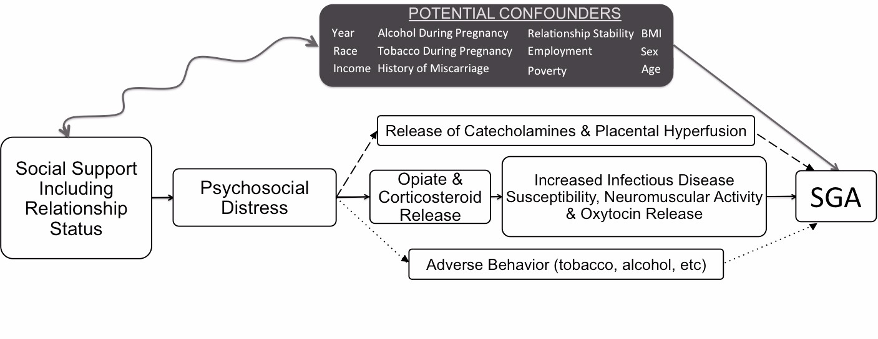

Figure 1. Hypothesized Pathways Between Marital Status and SGA. Although the pathways appear mutually exclusive there is likely overlap between all three.

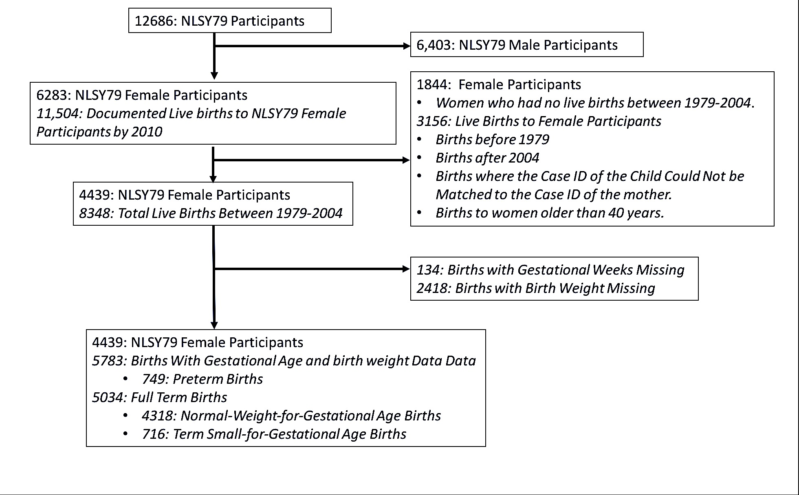
FIGURE 2 TOP
Figure 2. Results Consort Diagram.
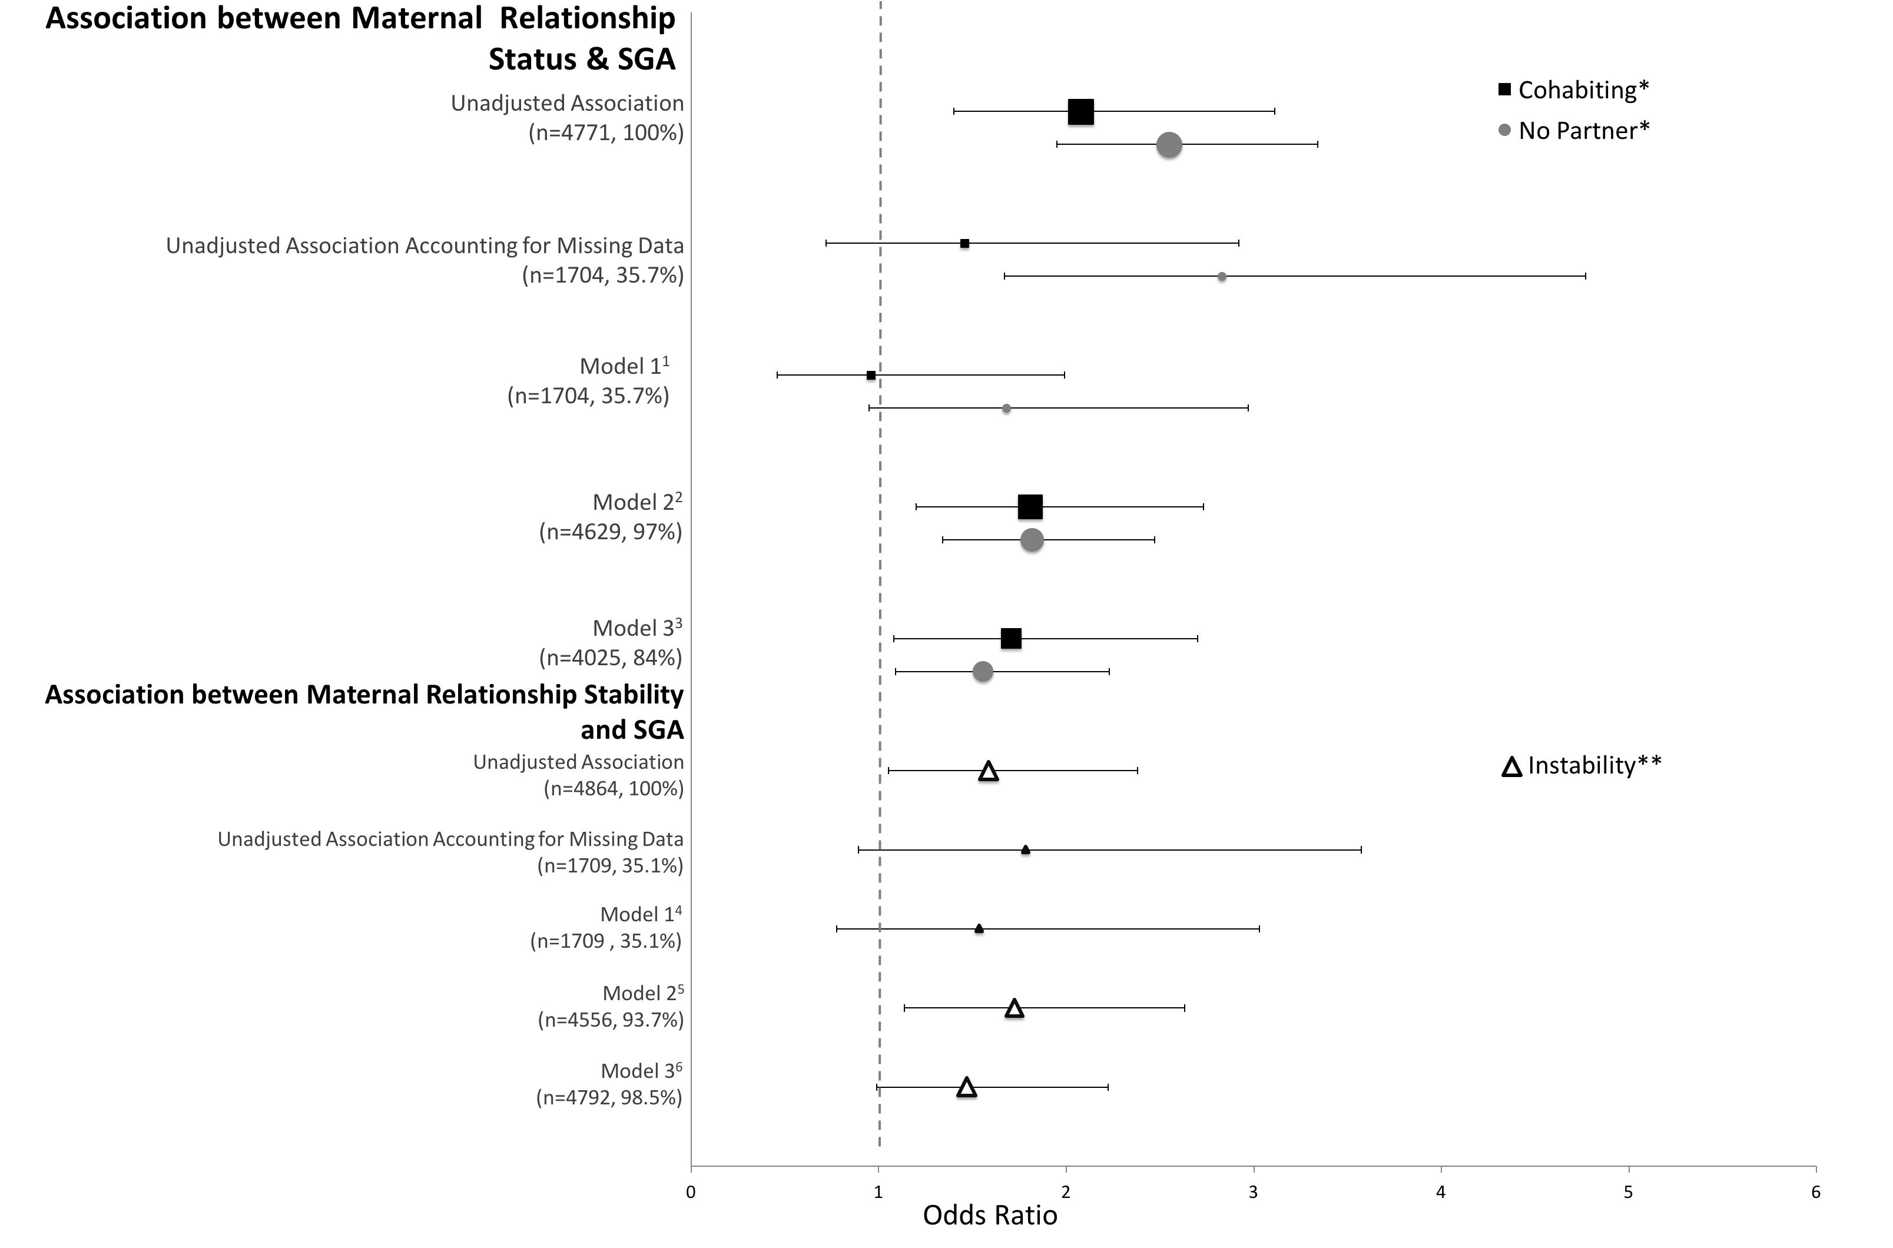
FIGURE 3 TOP
Figure 3. Association between SGA and Maternal Relationship Status & SGA and Maternal Relationship Stability: Odds Ratio Plot. *Reference: Married Women; **Reference: Instability with Reference Stability 1. Adjusted for Race, Sex, Relationship Stability, Age, Year, Income, Poverty, Alcohol, Tobacco, Employment, Depression, History of Miscarriage, & BMI. 2. Adjusted for Race, Sex, Relationship Stability, History of Miscarriage, Employment, Age & Year. 3. Adjusted for Race, Stability, Poverty, & Tobacco. 4. Adjusted for Race, Sex, Age, Year, Income, Poverty, Alcohol, Tobacco, Employment, Depression, History of Miscarriage, & BMI. 5. Adjusted for Race, Sex, Relationship Stability, History of Miscarriage, Employment, Age & Year. 6. Adjusted for Tobacco.

Figure Caption Sheet

Figure 1. Hypothesized pathways between relationship Status and SGA. Although the pathways appear mutually exclusive there is likely overlap between all three.

Figure 2. Results consort diagram.

Figure 3. Association between SGA and maternal relationship status & SGA and maternal relationship stability: odds ratio plot. *Reference: Married Women; **Reference: Instability with Reference Stability 1. Adjusted for Race, Sex, Relationship Stability, Age, Year, Income, Poverty, Alcohol, Tobacco, Employment, Depression, History of Miscarriage, & BMI. 2. Adjusted for Race, Sex, Relationship Stability, History of Miscarriage, Employment, Age & Year. 3. Adjusted for Race, Stability, Poverty, & Tobacco. 4. Adjusted for Race, Sex, Age, Year, Income, Poverty, Alcohol, Tobacco, Employment, Depression, History of Miscarriage, & BMI. 5. Adjusted for Race, Sex, Relationship Stability, History of Miscarriage, Employment, Age & Year. 6. Adjusted for Tobacco.

