White and grey matter damage in primary-progressive MS: the chicken or the egg?

Benedetta Bodini^{1,2}, MD, PhD, Declan Chard¹, PhD, FRCP, Daniel R Altmann^{1,3}, PhD, Daniel Tozer¹, PhD, David H Miller^{1,4}, FMedSci, Alan J Thompson^{1,4}, FRCP, Claudia Wheeler-Kingshott¹, PhD, Olga Ciccarelli^{1,4}, MD, PhD

¹ Department of Neuroinflammation Queen Square MS Centre, University College of London Institute of Neurology, London, UK; ² Department of Neuroimaging, Institute of Psychiatry, King’s College London, London, UK; ³ London School of Hygiene and Tropical Medicine, University of London, London, UK. ⁴ NIHR UCL/UCLH Biomedical Research Centre

Title: 79 characters; Number of figures: 2; Number of tables: 3; Number of words in the abstract: 250; Number of words of the manuscript: 2979; Number of references: 30. The statistical analysis was conducted by Dr Daniel Altmann, London School of Hygiene and Tropical Medicine, University of London, London, UK.

Address for correspondence: Dr Benedetta Bodini, Department of Neuroinflammation, Queen Square MS Centre, Institute of Neurology, University College of London, WC1N 3BG London, UK. E-mail address: b.bodini@ucl.ac.uk; Telephone number: +44 203 448 4469.
Disclosures

The NMR Research Unit is supported by the MS Society of Great Britain and Northern Ireland and the Department of Health UCL/UCLH Biomedical Research Centre.
Benedetta Bodini is funded by the ECTRIMS postdoctoral research fellowship. Declan Chard receives research support from the Multiple Sclerosis Society of Great Britain and Northern Ireland, and the National Institute for Health Research (NIHR) UCL/UCLH Biomedical Research Centre; has received honoraria (paid to UCL) from Bayer, Teva and the Serono Symposia International Foundation for faculty-led education work, and Teva for advisory board work; meeting expenses from Teva and Novartis; and holds stock in GlaxoSmithKline.
Daniel Altmann is partially funded by the Multiple Sclerosis Society of Great Britain and Northern Ireland, and, unconnected to this work, has received an honorarium from Merck.
Daniel Tozer’s position is partially funded by the commercial companies Biogen Idec and Novartis. This funding is for work on clinical trials unconnected with this work.
David H Miller has received honoraria from Biogen Idec, Novartis, GlaxoSmithKline, and Bayer Schering, and research grant support for doing MRI analysis in multiple sclerosis trials sponsored by GlaxoSmithKline, Biogen Idec, and Novartis.
Alan J Thompson has received honoraria for consultancy from Eisai Ltd, BTG International, Novartis; honoraria and support for travel for lecturing from Serono Symposia International Foundation and Novartis, support for travel for consultancy from MSIF; honorarium from Sage for editorship of Multiple Sclerosis Journal.
Claudia Wheeler-Kingshott is on the advisory board for BG12 (Biogen) and receives grants (PI and co-applicant) from ISRT, EPSRC, Wings of Life, MS Society, Biogen Idec and Novartis.
Olga Ciccarelli receives research grant support from the Multiple Sclerosis Society of Great Britain and Northern Ireland, the National Institute for Health Research (NIHR) UCL/UCLH Biomedical Research Centre, the International Spinal Cord Research Trust (ISRT) and the Engineering and Physical Sciences Research Council (EPSRC); she acts as consultant for Novartis, Bayer Schering, Biogen and GE, and payments are made to the UCL Institute of Neurology.

Abstract
Objective: The temporal relationship between white matter (WM) and grey matter (GM) damage in vivo in early primary-progressive multiple sclerosis (PPMS) was investigated testing two hypotheses: (i) WM tract abnormalities predict subsequent changes in the connected cortex (“primary WM damage model”); and (ii) cortical abnormalities predict later changes in connected WM tracts (“primary GM damage model”).

Methods: Forty-seven early PPMS patients and 18 healthy controls (HC) had conventional and magnetisation transfer (MT) imaging at baseline; a subgroup of 35 patients repeated the protocol after 2 years. Masks of the cortico-spinal tracts, genu of the corpus callosum and optic radiations (OR) and of connected cortical regions were used for extracting the mean MT ratio (MTR). Multiple regressions within each of five tract-cortex pairs were performed, adjusting for the dependent variable's baseline MTR; tract lesion load and MTR, spinal-cord area, age and gender were examined for potential confounding.

Results: The baseline MTR of most regions was lower in patients than HC. The tract-cortex pair relationships in the “primary WM damage model” were significant for the bilateral motor pair and right visual pair, while those in the "primary GM damage model" were only significant for the right motor pair. Lower lesion MTR at baseline was associated with lower MTR in the same tract NAWM at 2-year in three tracts.

Conclusion: These results are consistent with the hypothesis that in early PPMS cortical damage is for the most part a sequela of NAWM pathology, which, in turn, is predicted by abnormalities within WM lesions.

Introduction:

Little is known about the pathological relationship linking white matter (WM) and grey matter (GM) damage in multiple sclerosis (MS). Post-mortem studies provide a snapshot of pathology in WM and GM, and have demonstrated demyelination and neuro-axonal damage in both tissues¹⁻⁶. However, a key question is to what extent pathological abnormalities in the GM are related to contiguous WM damage, either as a cause or consequence, or are the result of independent disease mechanisms. Longitudinal MRI studies represent a valuable approach to explore the dynamic associations between WM and GM pathology. Patients with early PPMS should be an informative group in which to explore this question, as brain MRI lesion load is smaller compared with relapse-onset MS.

We have previously investigated in early PPMS the spatial relationship between pathology in WM tracts and connected GM areas using cross-sectional MRI data⁷. We found that in some brain regions, pathology in WM tracts is correlated with that in the adjacent GM regions⁷.

Here we sought to determine if (i) pathology in WM tracts is associated with (i.e. “predicts”) subsequent changes in connected cortical GM (“primary WM damage model”) or (ii) pathology in cortical GM is associated with (i.e. “predicts”) subsequent changes in the connected normal-appearing (NA)WM tracts (“primary GM damage model”) in early PPMS, recognising that both may occur simultaneously perhaps with one dominating. We also investigated the relationship between tract-specific lesions at baseline and NAWM/GM abnormalities changes over time. Microstructural changes were assessed using Magnetization Transfer Ratio (MTR), as lower MTR has been shown to reflect demyelination and neuronaxonal loss in MS^{8,9}.

Methods:

Subjects and study design
MRI and clinical data, including the Expanded Disability Status Scale (EDSS) scores¹⁰ from 47 people with definite or probable PPMS¹¹, no other known neurological condition, and a history of clinical progression of less than 5 years, were analysed in this study (Table 1). All patients had MR imaging at baseline, while a subgroup of 35 patients repeated the imaging protocol 24 months later (mean time interval 24.5 months, standard deviation (SD) 1.5). The MRI scans of four out of these 35 patients were unusable because of movement artefacts. A group of 18 healthy subjects (included if in good general health, no known history of medical conditions known to affect the brain, and without contraindications to MRI scanning) underwent the same imaging protocol (Table 1).

Standard Protocol Approvals, Registrations, and Patient Consents
This work was approved by the Joint Medical Ethics Committee of the National Hospital for Neurology and Neurosurgery and the UCL Institute of Neurology, London, and written informed consent was obtained by all participants.

Image Acquisition
Imaging was performed using a 1.5-T GE Signa scanner (General Electric, Milwaukee, IL). At baseline and 24 months, all subjects had a three-dimensional inversion-prepared fast spoiled gradient recall (3D-FSPGR) T1-weighted (T1-w) sequence of the brain, and a fast spin echo scan (i.e., proton-density-weighted (PD-w) and T2-weighted (T2-w) scans), and a magnetisation transfer (MT) dual echo interleaved spin-echo sequence (details on MRI sequences are given in the Supplementary Material). In the PPMS groups, a fast‐spoiled gradient echo of the spinal cord was performed; a series of five contiguous 3mm axial slices (perpendicular to the spinal cord) were reformatted using the centre of the C2/C3 disc as the caudal landmark.

To generate a set of tract and associated cortical GM templates, spin echo diffusion-weighted (DW) echo planar imaging scans were obtained from a separate group of 23 healthy controls (12 women; mean age 35.1 years, SD 7.9).

Image analysis

Using the method described by Tozer et al.¹², templates for the following WM tracts and their associated cortical GM were derived (Figure 1A):

- The left and right motor pair (composed of cortico-spinal tract (CST) and connected GM in the pre- and post-central cortex);
- The callosal pair (consisting of the genu of the corpus callosum (CC) and its connected GM region in the frontal lobe);
- The left and right visual pair (composed of the optic radiation (OR) and its connected GM area in the visual cortex).

Using the baseline and 24-month MRI data from the PPMS and control groups, native space MTR maps were calculated¹³. Tract-cortex pair templates were transformed into native space¹² (Figure 1B) and visually checked for registration errors, allowing WM tract and associated cortical GM MTR to be determined. In the PPMS group, WM lesions were delineated on the PD images, and lesions masks were binarised. The PD/T2-weighted scans were co-registered to the MTR maps and associated lesion masks moved into native MTR space. The WM lesion masks were subtracted from the WM component of each tract-cortex pair at each time-point, so leaving NAWM. In the PPMS group, the total volume of the each WM tract (including lesions and NAWM) and associated cortical GM regions were calculated computing the number of voxel for each region, and tract-cortex specific NAWM and GM mean MTR values determined. Except for lesion volumes, the same measures were derived from the healthy control data.

Since spinal cord damage is thought to play an important role in the pathogenesis of PPMS¹⁴, in the patient group, the cord cross-sectional area at the C2-3 level was calculated as previously described¹⁵.

Statistics
Changes in EDSS between baseline and two years were assessed using the sign test.

Differences in mean MTR and volume between patients and controls at baseline and 24 months in WM tracts and cortical GM regions were assessed using multiple regressions, with age and gender as covariates. Where regression residuals showed deviations from normality and homoscedasticity (all relatively minor), a non-parametric bias-corrected and accelerated bootstrap¹⁶ was performed (1000 replicates). Where a potentially influential datapoint was identified, bootstrapped regression was repeated omitting it. In the PPMS group changes in mean MTR of the WM lesions, the NAWM, and the connected GM area from baseline to 24 months, were tested for using one-sample t-tests. Univariable (pairwise) associations between MTR values in each tract pair were assessed with Pearson correlation, and the effect of omitting potentially influential datapoints explored. To assess cross-sectional associations between WM and GM pathology in the PPMS group, multiple regression was used between each tract-cortex pair’s NAWM mean MTR and the corresponding GM region mean MTR; age, gender, disease duration, NAWM and GM volumes, tract-specific lesion MTR and volume, and spinal-cord area were separately included (because of the relatively small number of patients) as potentially confounding covariates.

To assess the temporal relationship between tract-specific NAWM and GM value, we tested two models in each tract-cortex pair: (i) the “primary WM damage model”, to examine if early NAWM MTR predicts late GM MTR; (ii) the “primary GM damage model”, to examine if early GM MTR predicts late NAWM MTR. In order to enable joint testing (to reduce the number of tests), and to permit direct testing of the primary WM versus GM models, these models were implemented with multivariate regressions: for (i), the “primary WM damage model”, five simultaneous regressions (for each of the five tracts) regressed the 24-month GM MTR outcome on the tract-specific baseline NAWM MTR predictor; the corresponding tract-specific baseline GM MTR was a covariate for each regression, to ensure that any baseline NAWM versus 24-month GM association was not explained by cross-sectional baseline NAWM versus GM association, which could induce the longitudinal association without prior WM damage. The null hypothesis, that baseline was not associated with 24-month MTR in any of the tracts, was jointly tested as a single hypothesis that all five baseline MTR coefficients (one in each regression), were zero. For (ii), the “primary GM damage model”, the simultaneous regressions used 24-month NAWM MTR with tract-specific baseline GM MTR predictors, adjusting for corresponding baseline NAWM MTR. To examine whether age, gender, disease duration, NAWM or GM global volumes, tract-specific lesion MTR or volume, or spinal cord area explained the associations, these were included singly as covariates in each tract regression. The role of early lesions in contributing to later NAWM or GM damage was assessed when tract-specific baseline lesion volume was included in the (i) and (ii) multivariate models above.

Analyses were performed in Stata 13 (Stata Corporation, College Station, Texas, USA); the multivariate regressions were carried out using the Stata structural equation modeling (SEM) command, using, as estimation method, maximum likelihood with missing values; this requires the assumptions of multivariate normality, and that the mechanism for missing data is either completely at random or associated with variables in the model. Results are reported as significant at p<0.05.

Results

Clinical assessment

Patients clinically deteriorated over the follow-up period (baseline: median EDSS 4.5, range 1.5-7; two years: median EDSS 6, range 1.5-8; p=0.017).

Baseline difference in MTR and volume between patients and healthy controls and MTR evolution over the follow-up

At baseline, patients showed reduced MTR in the NAWM of the bilateral CST compared to controls, but did not differ significantly in the GM MTR of the connected motor cortex (Table 2, e-Figure 1). Patients showed significantly lower MTR than controls at baseline in the callosal tract and connected cortex, and in the right OR and bilateral visual cortex (Table 2, e-Figure 1). Regional differences in NAWM and GM volume between patients and controls at baseline are reported in e-Table 1.

In patients, a statistically significant decrease in mean MTR over 24 months was seen in the GM of the left visual cortex (percentage of change in MTR over time= -1.27%, p=0.045), while a trend towards a significant decrease over the follow-up was found in the GM of the right visual cortex (percentage of change in MTR over the follow-up = -0.89%, p=0.051) (e-Table 2).

Correlation between WM and GM MTR at each time-point

In the patient group at baseline, a lower mean MTR of each tract’s NAWM was significantly associated with a lower mean MTR of the corresponding GM target in the left motor pair (r=0.36, p=0.014), in the callosal pair (r=0.56, P<0.001) and in the left and right visual pair (both r=0.53, p<0.001), but not in the right motor pair (r=0.17, p=0.260). When adjusting for potential confounders, these associations remained significant for the callosal and the visual pairs.
At 24 months, a lower mean MTR of each tract was associated with a lower mean MTR of the corresponding GM region in all tract-cortex pairs independently of all the other covariates, except for the left motor pair when adjusting for baseline whole WM MTR (e-Figure 2).

The “primary WM damage model”

The joint test for the “primary WM damage model” gave p=0.006, rejecting the hypothesis of no association in any of the tracts: specifically, a lower baseline MTR of tract NAWM was associated with lower GM MTR of the connected cortex at 24 months in the bilateral motor pair and in the right visual pair, adjusting for tract-specific baseline GM MTR (Table 3A, Figure 2, e-Figure 2). The inclusion of age, gender, disease duration, baseline NAWM and GM volumes, baseline lesion MTR and lesion volume, and baseline spinal cord area in the model did not materially alter the results.

The “primary GM damage model”

In the “primary GM damage model”, although the joint test was again significant (p=0.007), this was driven by a single significant association in the right motor cortex, where a lower baseline GM MTR predicted higher right CST MTR at 24 months after adjusting for baseline NAWM tract MTR (Table 3B, Figure 2, e-Figure 2). When including age, gender, disease duration, baseline NAWM and GM volumes, baseline lesion MTR and lesion volume, and baseline spinal cord area in the model, results did not change materially.

Correlation between lesional metrics at baseline and tissue damage at two years

In all tract-cortex pairs, no significant association was found between tract-specific lesion MTR and volume at baseline, and the corresponding cortical region’s GM MTR at 24 months. Lower tract-specific lesion MTR at baseline was associated with lower MTR in the same tract NAWM at 24 months in all tracts, except the visual tracts bilaterally.

Discussion

Our results are consistent with an evolving relationship between anatomically linked GM and WM pathology in early PPMS. WM changes appear to predict subsequent GM abnormalities, more so than GM abnormalities predict subsequent WM damage. Over the two years of observation, abnormalities in NAWM rather than the WM lesions appeared to have a greater association with later GM damage. Over the same period, baseline WM lesion measures predicted subsequent changes in NAWM. Overall, this is consistent with a sequence of events, unfolding over two or more years, arising from WM lesions, through NAWM change, and leading to subsequent GM abnormalities.

At baseline, MTR in NAWM tracts was significantly lower in patients than in healthy controls (i.e. CST, GCC and OR) and in the corresponding GM targets, with the exception of the left OR and the motor cortex bilaterally, consistent with previous findings in this same cohort^{7,17-19}. The relative sparing of motor cortex is in line with previous MTR studies on patients with relapsing-remitting MS^{20,21}.
Cross-sectional correlations between NAWM and GM damage at each time-point were significant in all tract-cortex pairs, except in the right motor tract-cortex-pair, confirming our previous results⁷, which indicate that pathological processes affecting the two compartments are correlated. Allowing for these baseline tract-cortex associations, statistical tests of the “primary WM damage model” was more consistently and robustly significant than those testing the “primary GM damage model”. Interestingly, baseline T2-w lesion load did not materially alter the models, i.e. that over the two years of observation GM changes were mostly related to NAWM abnormalities rather than lesions. However, baseline T2-w lesion load was associated with subsequent NAWM abnormalities, and so the ultimate consequence of lesion formation may include cortical changes, albeit taking more than two years to become manifest.

Axons are the cellular component linking WM lesions, WM tracts and cortical GM, and axonal degeneration in WM lesions²² and NAWM²³, could well be the initiating element leading to subsequent cortical neuronal pathology^{3,24}. Several mechanisms within WM may contribute towards axonal pathology including glutaminergic excitotoxicity, disrupted intra-axonal transport, and mitochondrial dysfunction³. It has also been suggested that the pathogenesis of PPMS, when compared with relapse-onset disease, is primarily one of cellular degeneration, and that this may begin years before the first onset of symptoms²⁵. This would provide a plausible mechanism connecting a primary WM axonal pathology with a subsequent neuronal loss in the connected GM areas.

When the “primary GM damage model” was tested, the only significant finding was the association in the right motor pair between lower baseline MTR in the right motor cortex and the higher MTR in the right CST at 24 months; this association, is not consistent with a “primary GM damage” hypothesis. In any case, it is possible that this correlation was induced by an outlying data point. It should be noted that this study specifically recruited people with clinically early PPMS, and our results may not be applicable to people with long standing progressive MS. There is increasing evidence from histopathology and imaging studies that suggests that a substantial proportion of GM pathology, in particular subpial demyelination and cortical neurodegeneration, develops independently of WM damage^{26,27,28}: This component of GM damage is thought to be influenced by meningeal inflammation, which is particularly prominent in long-standing progressive MS²⁹⁻³⁰. As such, it is possible that a ‘’primary GM damage model’’ may play a more substantial role later on in PPMS.

While we have interpreted our results as being consistent with tract-mediated processes, they could also represent coincident but independent development of regional pathology, with pathological changes in NAWM and GM progressing at similar rate. However, in this case it would then be expected to see baseline GM MTR predicting subsequent NAWM MTR in the same tract-cortex pairs in which the “primary WM damage model” was significant, but only in one of the three significant pairs did we find this. Our results do not exclude the possibility of both dependent and independent components working in parallel, with one prevailing over the other at different stages of disease or in different brain regions. Further results from longer longitudinal studies, investigating the dynamics of WM and GM changes in a larger number of brain regions, are needed to confirm and generalise our conclusions, which should be interpreted with caution also in light of the amount of missing values at 24 months. To reduce the impact of missing MTR values, we relied on multivariate normality and ‘missing-at-random’ assumptions ,which allowed all available data points to be used. While there was no evidence to suggest violation of these assumptions, they are inherently difficult to assess.

Given the challenges of gathering large clinical and MRI datasets, we used previously acquired data for this work. Inaccuracies in tract alignment with cortical targets (and so associated partial volume effects) could have limited our sensitivity to tract-cortex associations. Sequences tuned to detect GM lesions were not available when these data were collected, and unseen GM lesions are likely to increase the variability of GM MTR across subjects, and therefore further decrease our sensitivity to finding associations in the “primary WM” damage model. As this was a retrospective study, we were limited in our scope to select healthy control scan data obtained over a comparable time period, giving rise to relatively poor matching with older MS subjects. Although there was very little evidence of an association between age or gender and MTR values, the patient versus healthy control adjusted differences may still have been influenced in part by this age distribution mismatch. Moreover, some MTR values lying in the tails of the data influenced the strength and significance of some correlations. As such, the results from this dataset should be interpreted with due caution, and further studies, informed by our methods, are required to clarify the actual strength of associations in the tract-cortex pairs.

In conclusion, our results in patients with early PPMS suggest a temporal evolution of pathology from WM to GM, and more specifically, from lesions to NAWM and from NAWM to GM.

Acknowledgements
We thank the patients and healthy volunteers who took part in this study. B. Bodini was funded by the ECTRIMS post-doctoral fellowship. The NMR Research Unit is supported by the UK Multiple Sclerosis Society, and the National Institute for Health Research (NIHR) UCL/UCLH Biomedical Research Centre.

Author contributions
Benedetta Bodini, Declan Chard and Olga Ciccarelli designed and carried out the study and the writing up of the manuscript. Claudia Wheeler-Kingshott, Daniel Tozer and Daniel Altmann were involved in the imaging and statistical analysis of data. David Miller and Alan Thompson critically revised the manuscript for intellectual content.

References

1. Bjartmar C, Trapp BD. Axonal and neuronal degeneration in multiple sclerosis: mechanisms and functional consequences. Curr Opin Neurol 2001;14(3):271-278.
2. Kutzelnigg A, Lucchinetti CF, Stadelmann C, et al. Cortical demyelination and diffuse white matter injury in multiple sclerosis. Brain 2005;128:2705-2712.
3. Geurts JJ, Barkhof F. Grey matter pathology in multiple sclerosis. Lancet Neurol 2008;7(9):841-851.
4. Geurts JJ, Stys PK, Minagar A, et al. Gray matter pathology in (chronic) MS: modern views on an early observation. J Neurol Sci 2009;282(1-2):12-20.
5. Howell OW, Rundle JL, Garg A, et al. Activated microglia mediate axoglial disruption that contributes to axonal injury in multiple sclerosis. J Neuropathol Exp Neurol 2009;69(10):1017-33.
6. Singh S, Metz I, Amor S, et al. Microglial nodules in early multiple sclerosis white matter are associated with degenerating axons. Acta Neuropathol 2013;125(4):595-608.
7. Bodini B, Khaleeli Z, Cercignani M, et al. Exploring the relationship between white matter and gray matter damage in early primary progressive multiple sclerosis: an in vivo study with TBSS and VBM. Hum Brain Mapp 2009;30(9):2852-61.
8. Schmierer K, Scaravilli F, Altmann DR, et al. Magnetization transfer ratio and myelin in postmortem multiple sclerosis brain. Ann Neurol 2004;56(3):407-15.
9. Moll NM, Rietsch AM, Thomas S, et al. Multiple sclerosis normal-appearing white matter: pathology-imaging correlations. Ann Neurol 2011; Nov;70(5):764-73.
10. Kurtzke JF. Rating neurologic impairment in multiple sclerosis: an expanded disability status scale (EDSS). Neurology 1983;33(11):1444-52.
11. Thompson AJ, Montalban X, Barkhof F, et al. Diagnostic criteria for primary progressive multiple sclerosis: a position paper. Ann Neurol 2000;47(6):831-5.
12. Tozer DJ, Chard DT, Bodini B, et al. Linking white matter tracts to associated cortical grey matter: a tract extension methodology. Neuroimage 2012;59(4):3094-3102.
13. Grossman RI, Gomori JM, Ramer KN, et al. Magnetization transfer: theory and clinical applications in neuroradiology. Radiographics 1994;14(2):279-290.
14. Miller DH, Leary SM. Primary-progressive multiple sclerosis. Lancet Neurol 2007;6(10):903-12.
15. Losseff NA, Webb SL, O'Riordan JI, et al. Spinal cord atrophy and disability in multiple sclerosis. A new reproducible and sensitive MRI method with potential to monitor disease progression. Brain 1996;119(3):701-708.
16. Carpenter JR, Bithall JF. Bootstrap confidence intervals: when, which, what? A practical guide for medical statisticians. Statistics in Medicine 2000; 19:1141-1164.
17. Sepulcre J, Sastre-Garriga J, Cercignani M, et al. Regional gray matter atrophy in early primary progressive multiple sclerosis: a voxel-based morphometry study. Arch Neurol 2006;63(8):1175-1180.
18. Ramio-Torrenta L, Sastre-Garriga J, Ingle GT, et al. Abnormalities in normal appearing tissues in early primary progressive multiple sclerosis and their relation to disability: a tissue specific magnetisation transfer study. J Neurol Neurosurg Psychiatry 2006;77(1):40-45.
19. Khaleeli Z, Cercignani M, Audoin B, et al. Localized grey matter damage in early primary progressive multiple sclerosis contributes to disability. Neuroimage 2007;37(1):253-61.
20. Audoin B, Davies G, Rashid W, et al. Voxel-based analysis of grey matter magnetisation transfer ratio maps in early relapsing remitting multiple sclerosis. Mult Scler 2007;13(4):483-9.
21. Derakhshan M, Caramanos Z, Narayanan S, et al. Surface-based analysis reveals regions of reduced cortical magnetization transfer ratio in patients with multiple sclerosis: a proposed method for imaging subpial demyelination. Hum Brain Mapp 2014; 35(7):3402-13.
22. Trapp BD, Peterson J, Ransohoff RM, et al. Axonal transection in the lesions of multiple sclerosis. N Engl J Med 1998;338(5):278-285.
23. Geurts JJ, Kooi EJ, Witte ME, et al. Multiple sclerosis as an "inside-out" disease. Ann Neurol 2010;68(5):767-768.
24. Filippi M, Rocca MA, Barkhof F, et al. Association between pathological and MRI findings in multiple sclerosis. Lancet Neurol 2012;11(4):349-360.
25. Stys PK, Zamponi GW, van MJ, et al. Will the real multiple sclerosis please stand up? Nat Rev Neurosci 2012;13(7):507-514.
26. Popescu BF, Pirko I, Lucchinetti CF. Pathology of multiple sclerosis: where do we stand? Continuum (Minneap Minn) 2013;19: 901-21.
27. Mistry N, Abdel-Fahim R, Mougin O, et al. Cortical lesion load correlates with diffuse injury of multiple sclerosis normal appearing white matter. Mult Scler 2014;20(2):227-33.
28. Steenwijk MD, Daams M, Pouwels PJ, et al. What explains gray matter atrophy in long-standing multiple sclerosis? Radiology 2014;272(3):832-42.
29. Magliozzi R, Howell O, Vora A, et al. Meningeal B-cell follicles in secondary progressive multiple sclerosis associate with early onset of disease and severe cortical pathology. Brain 2007;130(4):1089-1104.
30. Choi SR, Howell OW, Carassiti D, et al. Meningeal inflammation plays a role in the pathology of primary progressive multiple sclerosis. Brain 2012 135(10):2925-37.

Figure 1.

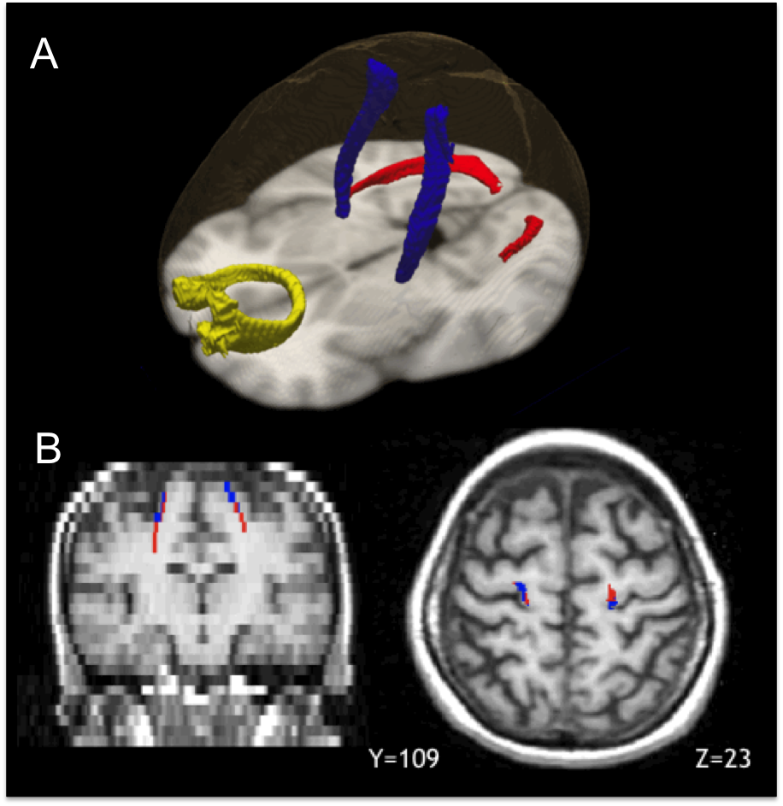

Figure 2.

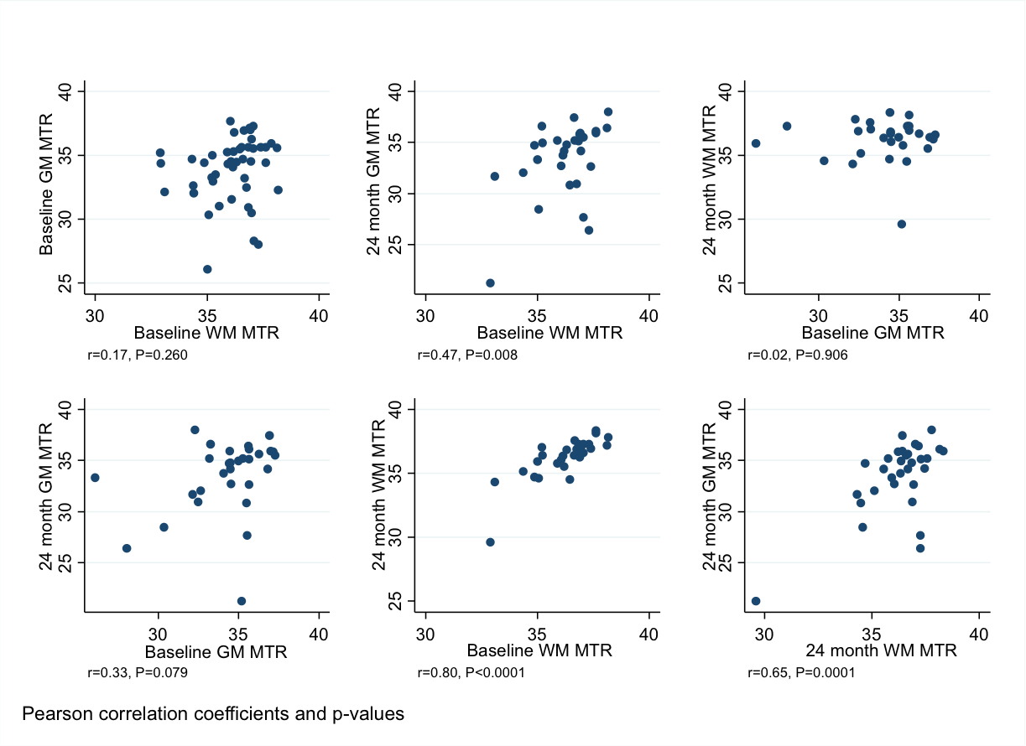

Figure legends

Figure 1. Reconstruction of the five tract-cortex pairs
A. The left and right motor pair (composed of CST and connected GM in the pre- and post-central cortex, voxels in blue), the callosal pair (voxels in yellow, consisting of the genu of the CC and its connected GM region in the frontal lobe) and the left and right visual pair (voxels in red, composed of OR and its connected GM area in the visual cortex), reconstructed from the DTI control group in standard space. B. Left and right CST (voxels in red), and associated voxels in the precentral/postcentral cortex (voxels in blue) in a single patient, overlaid onto the patient’s T1-w image in native space.

Figure 2. Tract-specific associations between baseline and 24-month MTR values.
In these panels are reported the six scatter plots between the four MTR measures (baseline NAWM and GM, 24-month NAWM and GM) for the right motor tract-cortex pair. The 24m GM against baseline NAWM and 24m NAWM against baseline GM are the unadjusted pairwise versions of the ‘’primary WM damage’’ and ‘’primary GM damage” models for this tract-cortex pair.

Tables and table legends
Table 1

Characteristics | Patients | Healthy Controls
Number | 47 | 18
Age, years (mean (SD)) | 43.9 (11.2) | 35.2 (6.02)
Gender, female/male | 18/29 | 11/7
Disease duration, years (mean (SD)) | 3.4 (0.9) | -
EDSS, median (range) | 4.5 (1.5-7) | -
T2 lesion load, ml (mean (SD)) | 15.4 (17.3) | -
Spinal cord area, mm² (mean (SD)) | 70.3 (9.4) | -

Table 1. Demographic, clinical and radiological characteristics of patients and healthy controls at study entry.

Table 2

 | NAWM  patients  mean (SD) MTR | WM  controls  mean (SD) MTR | p-values  patients  vs  controls | GM  patients  mean (SD) MTR | GM  controls  mean (SD) MTR | p-values  patients  vs  controls
Motor pair  - Left  - Right | 36.2 (1.4)  36.1 (1.3) | 37.2 (0.59)  37.0 (0.66) | p=0.002  p=0.006 | 35.1 (2.4)  33.9 (2.5) | 35.7 (1.2)  35.3 (1.8) | p=0.392  p=0.235
Callosal pair | 38.1 (1.7) | 39.5 (0.46) | p<0.001 | 32.4 (1.3) | 33.6 (0.97) | p=0.004
Optic pair  - Left  - Right | 34.1 (2.0)  34.4 (1.9) | 35.5 (1.4)  36.1 (0.85) | p=0.080^{b}  p=0.002 | 31.2 (1.7)  32.2 (1.4) | 32.6 (1.4)  33.6 (0.94) | p=0.011^{a,b}  p=0.001

ªThis comparison lost significance when an influential datapoint was omitted.
^{b}Under a crude Bonferroni correction, multiplying all p-values by the number of tests, these two p-values are no longer significant at the 5% error rate.

Table 2. Mean MTR values at baseline in GM and WM regions in patients and healthy controls, with p-values of the comparison between the two groups adjusting for age and gender.

Table 3

A.

Tract-cortex pairs | Baseline WM MTR standardised regression coefficient † | 95% confidence interval | P-value | Partial correlation coefficients  WM GM
Left motor pair | 0.32 | 0.03, 0.60 | P=0.031 | 0.40 | 0.53
Right motor pair | 0.47 | 0.21, 0.72 | P<0.001 | 0.45 | 0.36
Callosal pair | -0.25 | -0.60, 0.10 | P=0.161 | -0.12 | 0.67
Left visual pair | 0.08 | -0.15, 0.31 | P=0.476 | 0.22 | 0.82
Right visual pair | 0.22 | 0.01, 0.43 | P=0.036 | 0.33 | 0.83

† The standard regression coefficient reported is the number of standard deviations by which
24m GM MTR is estimated to increase per one standard deviation increase in baseline WM MTR.

B.

Tract-cortex  pair | Baseline GM MTR standardised regression coefficient † | 95% confidence interval | P-value | Partial correlation coefficient  WM GM
Left motor pair | -0.08 | -0.20, 0.04 | P=0.218 | 0.77 | -0.56
Right motor pair | -0.28 | -0.44, -0.12 | P=0.001 | 0.71 | -0.62
Callosal pair | -0.03 | -0.22, 0.17 | P=0.800 | 0.82 | -0.30
Left visual pair | 0.08 | -0.06, 0.23 | P=0.237 | 0.89 | 0.16
Right visual pair | 0.17 | -0.07, 0.41 | P=0.172 | 0.83 | 0.31

† The standard regression coefficient reported is the number of standard deviations by which 24m WM MTR is estimated to increase per one standard deviation increase in baseline GM MTR

Table 3: A. Standardised regression coefficients for the “primary WM damage” multivariate model, where, for each of the five pairs, 24-month GM MTR is regressed on the tract-specific baseline NAWM MTR predictor, adjusting for the corresponding tract-specific baseline GM MTR. B. Standardised regression coefficients for the “primary GM damage” multivariate model, where, for each of the five pairs, 24-month WM MTR is regressed on the tract-specific baseline GM MTR predictor, adjusting for the corresponding tract-specific baseline NAWM MTR.

Electronic Figure 1

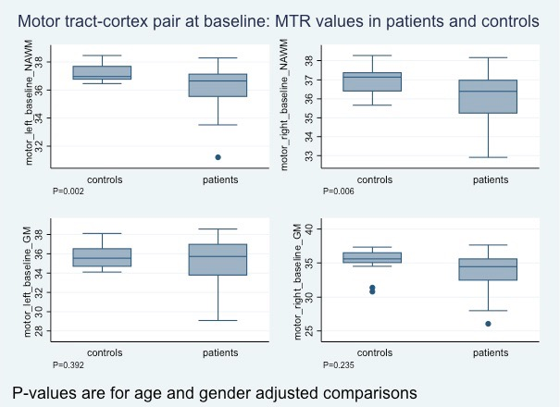

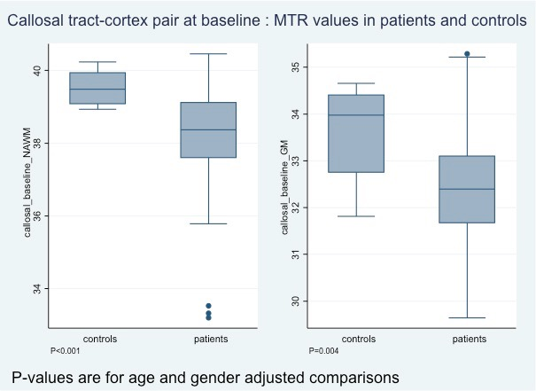

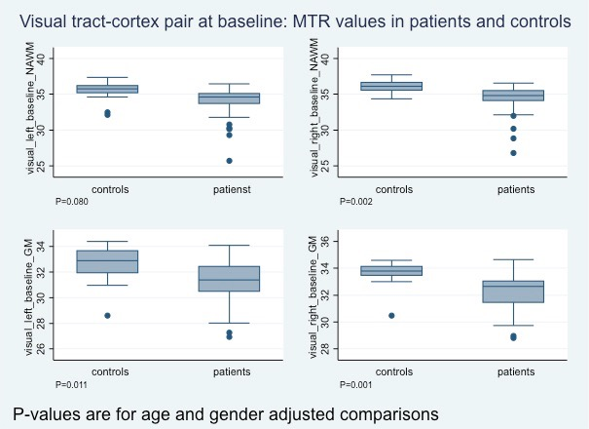

Electronic Figure 1: Box plots of baseline MTR values in the five tract-cortex pairs in patients and healthy controls.

Electronic Figure 2

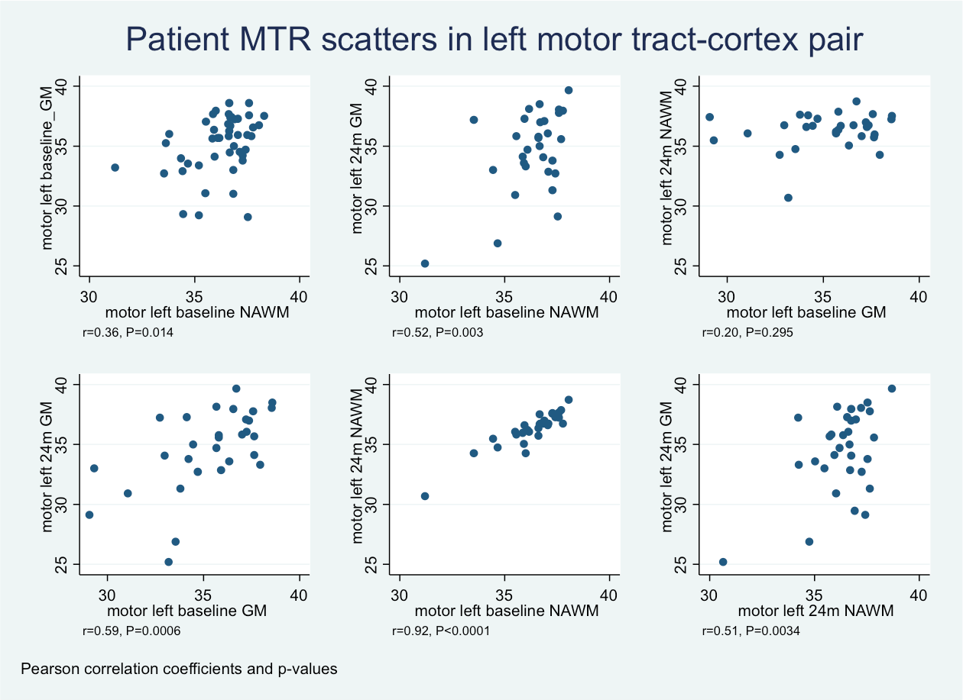

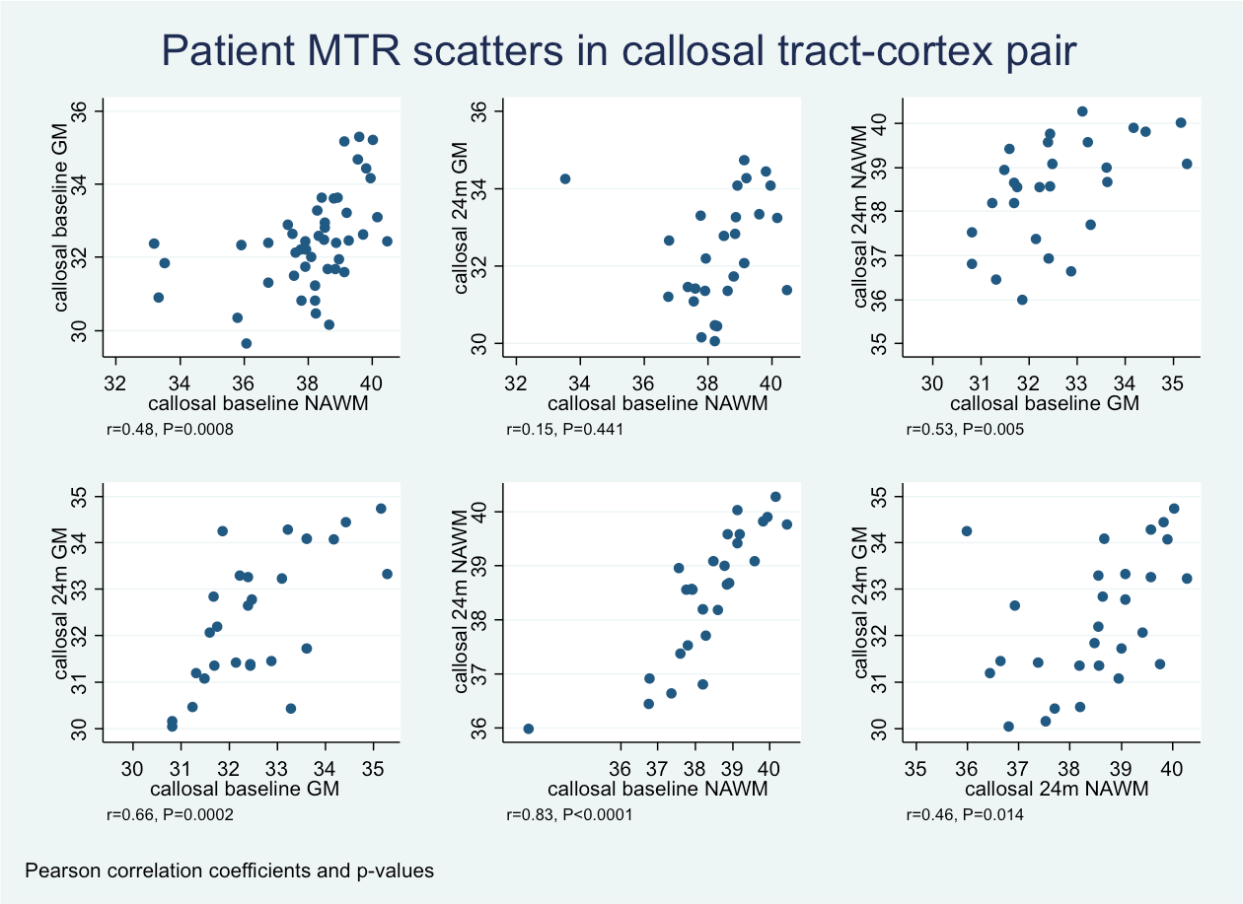

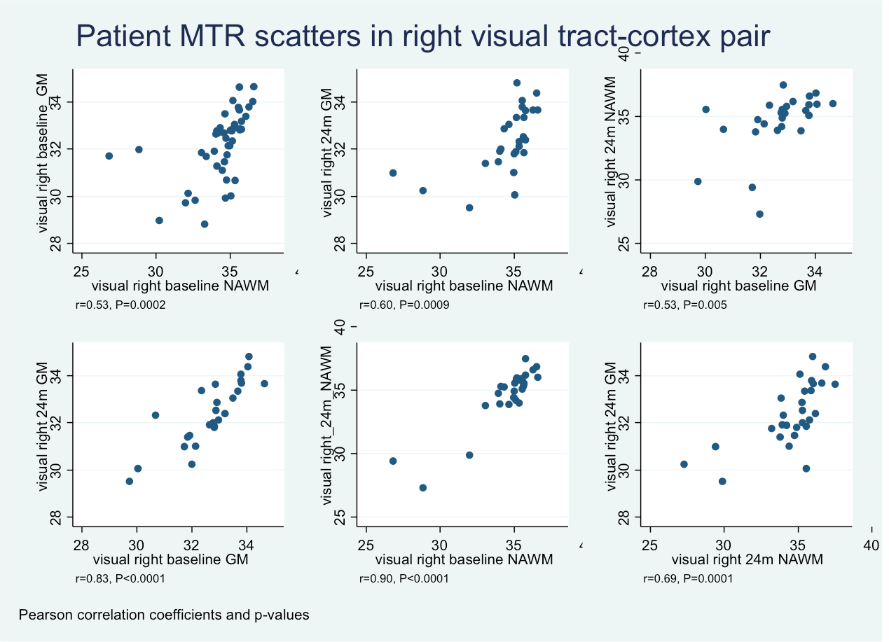

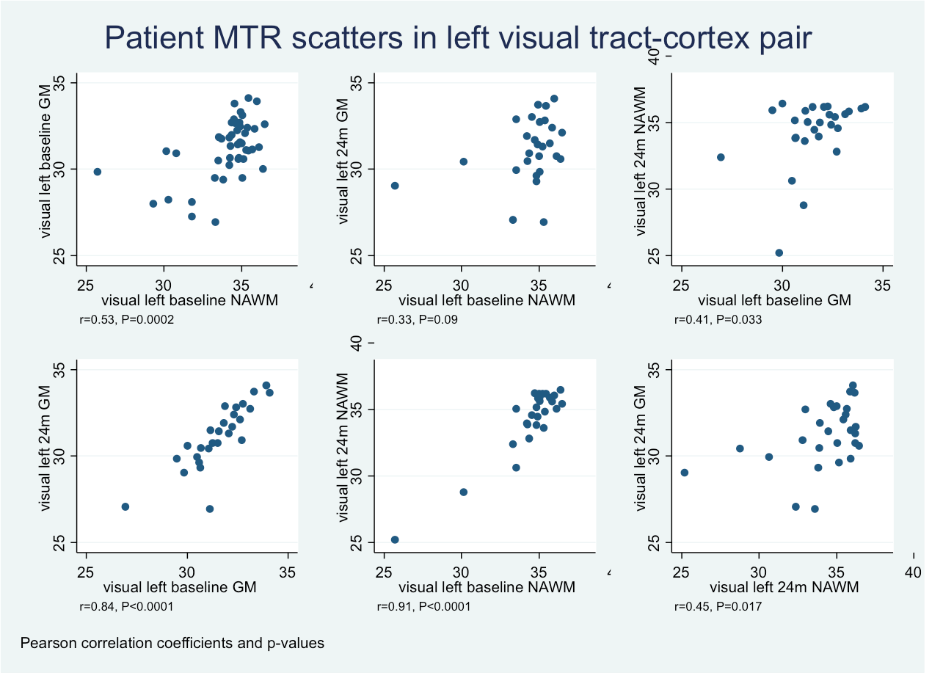

E-figure 2 In these panels are reported the six scatter plots between the four MTR measures (baseline NAWM and GM, 24-month NAWM and GM) for the left motor, callosal, and visual tract-cortex-pairs. The 24m GM against baseline NAWM and 24m NAWM against baseline GM are the unadjusted pairwise versions, for each tract-cortex pair, of the ‘’primary WM damage’’ and ‘’primary GM damage” models.

Electronic table 1

Region | Side | NAWM volume |  |  | GM volume
 |  | MS | Control | p-value | MS | Control | p-value
Motor pair | Left | 209.5  (50.1) | 254.8  (29.2) | P<0.001 | 32.8  (12.5) | 41.3 (15.3) | P=0.176
 | Right | 225.2  (53.3) | 251.8  (39.6) | P<0.027 | 40.2  (12.8) | 46  (14.5) | P=0.120
Callosal pair | NA | 454.2  (119.0) | 862.3  (80.9) | P<0.001 | 292.1  (64.4) | 526.2  (98.3) | P<0.001
Optic pair | Left | 250.9  (66.2) | 278.5  (47) | P=0.051 | 346.3  (55.8) | 351.2  (66.7) | P=0.791
 | Right | 576.7  (147.0) | 686.3  (80.7) | P=0.002 | 716.9  (114.3) | 705.9  (85.3) | P=0.801

Electronic table 1. Baseline mean (SD) volume values in NAWM and GM regions in patients and healthy controls, with p-values of the comparison between the two groups (obtained with multiple regression analyses adjusted for age and gender).

Electronic Table 2

Region | Side | NAWM  Absolute mean MTR change, SD*, pu (% change in mean MTR)  0-24 months | p-values  p_values for mean MTR change, (confidence interval)  0-24 months | WM lesions  Absolute mean MTR change, SD*, pu  (% change in mean MTR )  0-24 months | p-values  p_values for mean MTR change,  (confidence interval)  0-24 months | GM  Absolute mean MTR change, SD*, pu  (% change in mean MTR )  0-24 months | p-values  p-value for mean MTR change,  (confidence interval)  0-24 months
Motor pair | Left  Right | -3.8, 59.9, (0.10%)  -5.1, 97.1, (-0.14%) | 0.728,(26.2,18.52)  0.773, (-41.4, 31.1) | +39.6,178.5,(+1.3%)  +82.5, 215.7,(-2.53%) | 0.359,(-49,1,128.4)  0.134,(-193.4,28.4) | -69.1,278.3,(-1.85%)  -78.9, 370.1,(-1.97%) | 0.45,(-216.12,102.6)  0.253,(-217, 59.3)
Callosal pair | NA | +14.1,75.8,(+0.40%) | 0.344, (-15.9, 44.1) | +7.9, 209.3, (+0.34%) | 0.852, (-78.5, 94.3) | -21.6, 110.9, (-0.63%) | 0.322, (-65.4, 22.3)
Visual pair | Left  Right | -18.1, 105.7,(-0.57%)  +10.0, 100.3, (+0.32%) | p=0.382, (-59.9, 23.7)  0.609, (-29.7, 49.7) | -54.6, 262.5 (-1.49%)  -27.4, 180.2, (-0.87%) | 0.329, (168.1,58.9)  0.473, (105.4,50.5) | -39.8, 98.0, (-1.27%)  -29.4, 75.6 (-0.89%) | 0.045, (-78.6, -1)  0.051, (-58.9, 0.13)

*SD of the MTR change

Electronic Table 2. Absolute and percentage change of mean MTR values in NAWM, WM lesions and GM in patients over the follow-up period, with p-values testing for significant change. Due to the number of tests and the borderline significance, the two borderline p-values should be interpreted with caution.

Supplementary Material

MRI Sequences

Brain:

- Three-dimensional inversion-prepared fast spoiled gradient recall T1-weighted (T1-w) sequence: field of view (FOV) 300 x225 mm², matrix size 256 x160, reconstructed to 256x256 for a final in plane resolution of 1.17 mm, 124 axial slices, 1.5-mm thickness;
- Fast spin echo scan that collects a proton-density-weighted (PD-w), a T2-weighted (T2-w), and a magnetisation transfer (MT) dual echo interleaved spin-echo sequence: FOV 240x180 mm², matrix size 256x256, 28 axial slices, 5-mm thickness;
- Spin echo diffusion-weighted (DW) echo planar, whole-brain and cardiac-gated imaging scans FOV 240x240 mm2, matrix size 96x96 (reconstructed to 128x128), image resolution 2.5x2.5x3 mm3 (reconstructed to 1.9x1.9x3 mm3), TE 95 ms, TR 7 RRs, maximum b-factor 1000 smm-2; three series, each collecting 14 axial slices of 3-mm thickness, which were interleaved off-line; diffusion gradients were applied along 25 optimized directions, and three images with no diffusion weighting were also acquired.

Spinal cord:
1. Inversion prepared gradient echo : 60 1‐mm slices, TR = 15.6 ms, TE = 4.2 ms, inversion time (TI) = 450 ms, FA 20°, matrix 256 × 256.
Appendix I

Description of missing values

Of the 10 MTR variables in the model (WM and GM in 5 tract-cortex pairs): at baseline, MTR data was missing for only one out of the 47 MS patients, and for the rest of the group all 10 MTR figures were available; at 24 months, in 3 MS patients 6 variables were missing for the callosal and visual pairs (due to suboptimal image registration). Sixteen patients had missing values in all ten variables: 1) four of these had MRI scans at 24 months but the images were unusable because of movement artifacts; it is plausible, though of course unverifiable, that these scans are missing 'at random', unrelated to the values which would have been recorded had the scans been viable; 2) four patients only had clinical assessment at 24 months, but no MRI assessment: a plausible reason for this is that they found the scanning experience too disagreeable, so subsequently accepted only clinical assessment; again, though unverifiable, there is no strong reason to suppose that their attitude towards having a scan is associated with the values which would have been observed had they been scanned, that is, are missing not at random; 3) four patients missed the 24-month MRI scan, but are known to have had subsequent MRI scans and clinical assessments; we cannot speculate on the reason for these patients missing the scans, but there is again no strong reason for supposing that they are missing not at random; 4) finally, a further four attended neither clinical nor MRI assessments beyond baseline, and again there is no information on why this was the case; however, there is no good reason to suspect that their subsequent non-attendance was related to the MTR values which they would have produced had they been scanned subsequently.

Moreover, at baseline these 16 patients were very similar to the patients who were subsequently observed at 24 months in terms of age (missing mean 44.3, observed 44.7 years), gender (missing percentage female 38%, observed 36%), disease severity (missing MRI 24m EDSS median 5.5, observed 6) and duration (missing mean 3.4, observed 3.3 years), and MTR values: all the WM MTR values in the 16 subsequently missing patients were within 1.5% of those for the subsequently observed patients, except for the left visual, which was 2.5% lower in the 16; and for GM MTR within 2.5% of the values in subsequently observed patients except for left and right visual (2.7% and 3.2% lower)."

