Diabetic Retinopathy Screening: Experiences from Northern Tanzania

Charles R Cleland^{1*}, Matthew J Burton², Claudette Hall³, Anthony Hall⁴, Paul Courtright⁵, William U Makupa¹, Heiko Philippin^{1,2}

¹ Eye Department, Kilimanjaro Christina Medical Centre, Moshi, Tanzania.
² International Centre for Eye Health, Clinical Research Department, London School of Hygiene & Tropical Medicine, London.
³University Maastricht, Faculty of Psychology and Neuroscience, Department of Work & Social Psychology, P.O. Box 616, 6200 MD Maastricht, The Netherlands.
⁴Newcastle Eye Hospital Research Foundation, 182 Christo Road, Waratah, NSW, 2289, Australia.
⁵Kilimanjaro Centre for Community Ophthalmology, Division of Ophthalmology, University of Cape Town, Cape Town, South Africa.

*Corresponding author: Charles Cleland, Eye Department, Kilimanjaro Christian Medical Centre, Moshi, Tanzania. Tel: +44 7799621382. E-mail: crcleland87@gmail.com.

It is estimated that the numbers of adults with diabetes mellitus (DM) in sub-Saharan Africa (SSA) will almost double by 2035 to 41·5 million.¹ The World Health Organization (WHO) has included diabetic retinopathy (DR) on the priority list of eye diseases that can be partly treated or prevented and has recommended that eye care services for people with diabetes be incorporated into VISION 2020 national plans.²

The early detection and timely management of DR can preserve vision, however, many people with diabetes are asymptomatic until their visual loss is beyond the optimal stage for management.³ Currently, few countries in SSA have DR screening services. The Kilimanjaro Diabetic Programme (KDP), established in 2010 in the Kilimanjaro Region of northern Tanzania (population 1·5 million), was one of the first such screening services in SSA.⁴

The KDP was established through the combined efforts of government representatives, endocrinologists, ophthalmologists, epidemiologists, social scientists, and hospital directors. Prior to the implementation of the KDP, there were few dedicated diabetic clinics in peripheral hospitals in Kilimanjaro Region, with minimal organisation of diabetes care. The KDP helped establish dedicated diabetic clinics in 18 peripheral hospitals, which subsequently became the centres through which the mobile DR screening team operated.

Funding for the KDP was from AusAid through CBM Australia until the end of 2014; since then more limited programme activities have been supported by the Kilimanjaro Christian Medical Centre (KCMC) Eye Department.

All persons with diabetes attending the 18 peripheral hospitals in Kilimanjaro Region are registered with the KDP. Each clinic is visited by the KDP team approximately one day per month, on dedicated diabetic clinic days. People living with diabetes within the catchment area of the clinic are informed when the KDP team will visit and are invited to attend. Currently, there is no recall system for patients who miss screening days. During each visit, fundus photographs are taken of all patients using a Topcon retinal camera (TRC NW6). The images are stored on a laptop and later uploaded to a central database at KCMC. An ophthalmology resident (ophthalmologist in training) grades all the images, with a consultant ophthalmologist grading 20% of the images for quality control. Ophthalmology residents receive training in DR grading from a consultant vitreo-retinal surgeon (WM) at KCMC. Following grading, patients are either called or texted informing them of the result of their screening and whether or not they need to attend KCMC Eye Department and if so, how urgently.

By the beginning of 2015, 5729 individuals were registered with the KDP and 3463 (60·4%) had been screened for retinopathy. Of those screened, 71·7% had at least one fundus image taken. The overall prevalence of any diabetic retinopathy in those screened was 27·9% (95%CI 26·4% – 29·5%). Maculopathy was present in 16·1% (95%CI 14·8-17·4%) and proliferative retinopathy in 2·9% (95%CI 2·3-3·5%). The prevalence estimates for DR in SSA are varied and are largely from clinic-based studies, which estimate the prevalence of any DR ranging from 7.0 to 62.4%, proliferative DR from 0 to 6.9%, and any maculopathy from 1.2 to 31.1%.⁵ There are very few high quality population based or cohort studies on DR prevalence in SSA.

A challenge for the KDP has been patient adherence with both screening and follow-up after screening. The coverage of the KDP is relatively low: 60·4% of registered patients have been screened for retinopathy. Evidence from the UK shows that as the coverage of DR screening services increases, so does cost-effectiveness.⁶ However, in a rural African setting full coverage is unlikely to be achieved and evidence from South Africa shows that DR screening with coverage of 65% is still cost-effective.⁷ As only one camera is used by the KDP (largely due to cost) it is infrequently available at the peripheral hospitals. An increased number of cameras, through the availability of an alternative, lower cost device, would allow more frequent screening events at peripheral hospitals and could increase coverage. There are a number of available models that could serve as an alternative. However, there is limited data on their sensitivity and specificity for grading DR. This is an important area for research and is currently being undertaken within the KDP.

Patients are referred to KCMC after screening if they need further investigations or treatment. The presence of a central database with comprehensive clinical details and patient contact information and the use of mobile phones and SMS messages to contact patients, has facilitated follow-up. However, despite the above, only 40·2% of referred patients attended their eye hospital referral appointment. The low level of follow-up is likely to be related to a combination of cost, limited patient understanding of DR and the challenging logistics of attending referral appointments. Further qualitative research is needed to understand the low attendance rates and to develop strategies to improve follow-up.

A success of the KDP, in addition to general improvement of services for people with diabetes, has been increasing awareness of DM amongst healthcare workers and community members. During implementation of the KDP, posters were displayed in all diabetic clinics and local radio broadcasts provided information about diabetes and its complications. This facilitated integration between general medical care and the DR screening service. Further involvement of general medical staff in the screening of DR might improve coverage and contribute to sustainability.

The management of diabetes and its complications presents a major challenge in SSA. It is important that screening services are developed for DR that maximise coverage and facilitate sustainability. This could be partly achieved by integrating screening programmes into well functioning general medical services as well as increasing the availability of lower-cost fundus cameras at diabetes clinics would. Public health messages that educate the population about the risks of, and treatment options for diabetic retinopathy, coupled with an organised screening service and clear referral and treatment pathways are needed if the growing burden of blindness in sub-Saharan Africa is to be managed effectively.

Acknowledgements
The KDP was funded by AusAID through CBM Australia. MJB is supported by Wellcome Trust (Grant no. 098481/Z/12/Z). HP is supported by CBM and Seeing is Believing.

Author Contributions
CH, AH, and PC designed the KDP; HP designed and programmed the database. CRC and HP performed the statistical analysis. CRC drafted and MJB, HP, PC contributed to the manuscript. All authors read and approved the final manuscript.

Competing Interests
None.
Figure 1
Kilimanjaro Region, Northern Tanzania
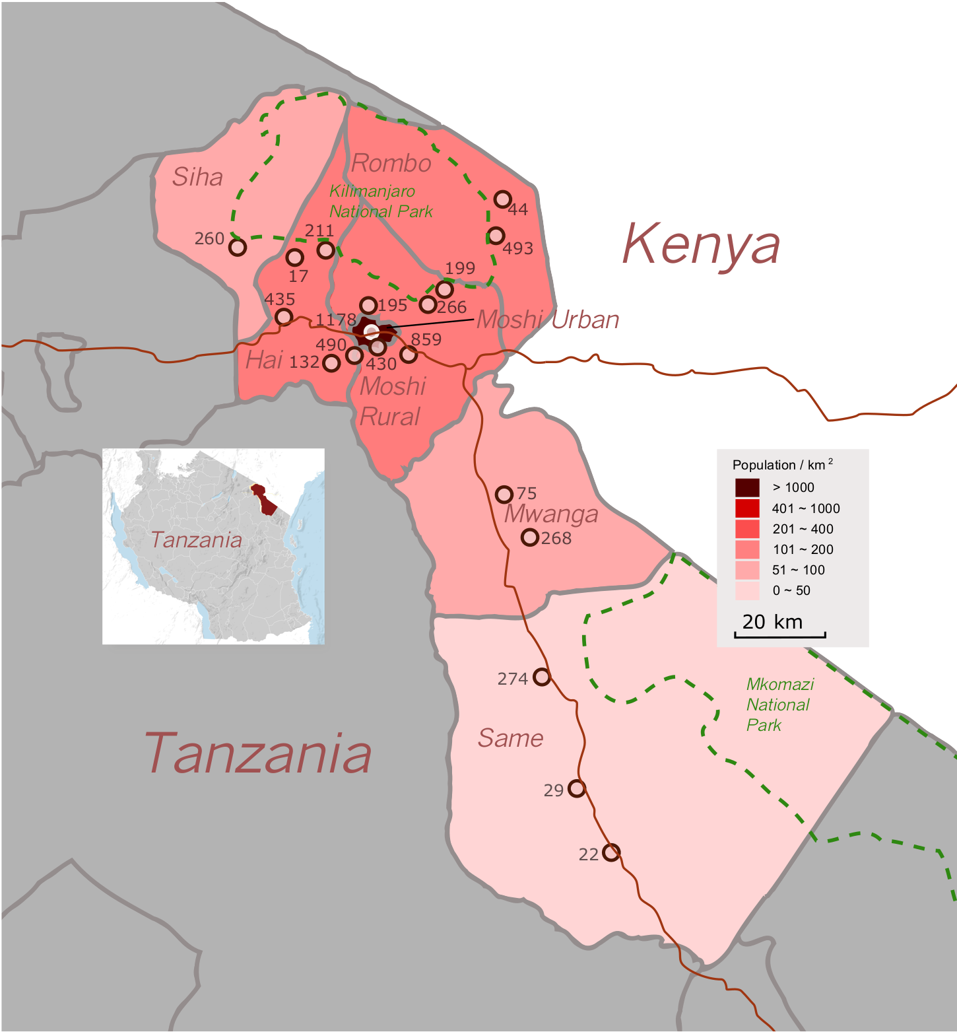

Map of Kilimanjaro Region highlighted in red. Each dot represents a diabetic clinic, the white dot representing KCMC. The number next to each dot corresponds to the total number of diabetic patients registered with the Kilimanjaro Diabetic Programme in each hospital.

References

1 International Diabetes Federation. IDF Diabetes Atlas. http://www.idf.org/diabetesatlas (accessed October 1st, 2015).
2 World Health Organization. Priortiy Eye Disases. http://www.who.int/blindness/causes/priority/en/index5.html (accessed October 1st, 2015).
3 Lee SJ, McCarty CA, Sicari C, et al. Recruitment methods for community-based screening for diabetic retinopathy. Ophthalmic Epidemiol 2000; 7: 209–18.
4 Poore S, Foster A, Zondervan M, Blanchet K. Planning and developing services for diabetic retinopathy in Sub-Saharan Africa. Int J Health Policy Manag 2015; 4: 19–28.
5 Burgess PI, MacCormick IJC, Harding SP, Bastawrous A, Beare N a. V, Garner P. Epidemiology of diabetic retinopathy and maculopathy in Africa: a systematic review. Diabet Med J Br Diabet Assoc 2013; 30: 399–412.
6 James M, Turner DA, Broadbent DM, Vora J, Harding SP. Cost effectiveness analysis of screening for sight threatening diabetic eye disease. BMJ 2000; 320: 1627–31.
7 Maberley D, Walker H, Koushik A, Cruess A. Screening for diabetic retinopathy in James Bay, Ontario: a cost-effectiveness analysis. CMAJ Can Med Assoc J J Assoc Medicale Can 2003; 168: 160–4.

