Title page
Title: Incidence of major smoking-related cancers: trends among adults aged 20-44 in France from 1982 to 2012
Authors and affiliations:
Julia Gilhodes ^{1,2}, Aurélien Belot ^{1,2,3}, Anne-Marie Bouvier ^{4,5}, Laurent Remontet ², Patricia Delafosse ^{4,6}, Karine Ligier ^{4,7}, Agnès Rogel ¹
¹ Institut de Veille Sanitaire, Département des Maladies Chroniques et Traumatismes, 12 rue du val d’Osne, 94410 Saint Maurice
² Hospices Civils de Lyon, Service de Biostatistique, F-69003, Lyon, France ; Université de Lyon, F-69000, Lyon, France ; Université Lyon 1, F-69100, Villeurbanne, France ; CNRS, UMR 5558, Laboratoire de Biométrie et Biologie Evolutive, Equipe Biostatistique-Sante, F-69100, Villeurbanne, France
³ Cancer Research UK Cancer Survival Group, Faculty of Epidemiology and Population Health, Department of Non-Communicable Disease Epidemiology, London School of Hygiene & Tropical Medicine, Keppel St, London WC1E 7HT, UK
⁴ Francim, Réseau francais des registres des cancers, Francim, F-31073 Toulouse, France
⁵ Registre Bourguignon des Cancers Digestifs INSERM U866, CHU Dijon, Université de Dijon, Faculté de Médecine, Dijon, France
⁶ Registre du cancer du département de l’Isere, CHU de Grenoble, F-38000 Grenoble, France
⁷ Registre général des cancers de Lille et de sa région, F-59120 Loos, France

Running Title: Smoking-related cancers trends among adults aged 20-44 in France
Keywords : cancer, young adults, epidemiology, incidence, smoking, cancer registry
Corresponding Author :
Agnès Rogel
Institut de Veille Sanitaire
12 rue du val d’Osne, 94410 Saint Maurice
Phone : 33 1 55 12 54 16
Fax : 33 1 55 12 54 16
Email : a.rogel@invs.sante.fr
The authors declare that there are no conflicts of interest.
Manuscript: 3588 words, 3 tables, 3 figures, 1 Appendix

Abstract
Background. Tobacco is currently the largest risk factor of lung, lip-oral cavity- pharynx (LOCP) and esophagus cancers. Variations over time in tobacco consumption have led to changes in incidence in the general population. Data on incidence of these cancer sites in adults aged 20-44 years old are scarce. Our objective was to provide estimates of incidence trends for these cancers in France over the last 30 years among this age group.
Methods. Observed incidence data over the 1982-2010 period for the 20-44 age-group were provided from 6 cancer registries (8 for esophagus) covering approximately 6% of the French population. Age-period-cohort models were used on the observed period and estimates of cancer incidence for France in 2012 were provided based on short-term predictions.
Results. In men, a sharp decline was observed over time for LOCP and esophagus cancers, lung cancer seeing only a slight decline. In women, a large increase was seen for lung cancer incidence, while LOCP cancer incidence did not vary significantly.
Conclusion. Smoking behaviors among adults aged 20-44 impact incidence trends of Lung, LOCP and esophagus cancers, although other factors are involved, mainly for LOCP and esophagus. Our results highlight the importance of prevention efforts which particularly target women aged 20-44. Efforts to curb tobacco smoking in men should also be pursued.

Introduction
In France, cancer incidence estimates for populations under 24 years of age are regularly performed by childhood cancer registries (1, 2). National cancer incidence estimates for the general population are also regularly performed (3-5). As the risk of cancer increases with age, cancer incidence values are strongly influenced by the incidence in adults aged over 50. Although cancer patterns and trends among young adults - defined here as cases aged between 20 and 44 years old - may differ from those of their older counterparts, they are rarely studied. Sir Richard Doll highlighted the value of studying cancer incidence trends in adults aged 20-44, stating that it would help to identify the causes of cancer arising from recent changes in exposure to carcinogens (6). In the case of increased incidence, these trends help to provide early warning signals. In the case of reduced incidence, they provide a rapid indication of the effectiveness of a prevention policy or strategy in reducing exposure (7). Even when the prognosis is very good, cancer diagnosis in early adulthood can lead to psychological problems and consequences on quality of life, especially as this period of life is expected to be very positive in terms of health. Moreover, the risk of second cancer is high when first diagnosis occurs early in life.
It is estimated that 80% of lung cancers are caused by smoking, while the figure for LOCP and esophagus cancers is 60% (8, 9). As the age of first-time smokers continues to decrease, the incidence of these cancers among young adults constitutes a public health concern. Consequently, performing related studies may lead to improved methods of prevention (10). The objective of the present study was to investigate incidence trends in these three cancer sites (i.e., lung, LOCP and esophagus cancers), which are predominantly affected by smoking behaviors among adults aged 20-44.

Materials
Incidence data from 6 general cancer registries (for the administrative districts Calvados, Doubs, Isère, Bas-Rhin, Somme, and Tarn), all covering the entire period 1982-2010 were used. Additional incidence data obtained from the Burgundy region’s digestive cancer registries (covering two administrative districts, Côte d'Or and Saône-et-Loire), were used for incidence trends of esophagus cancers. The three cancer sites studied were defined according to the International Classification of Diseases for Oncology, third edition (ICD-O-3). Lung cancers were defined by topography codes C33 and C34, LOCP by all topography codes between C00 and C14 and esophagus by topography code C15. All malignant tumors except hematological tumors were included. The population data - detailed by administrative district, sex, age and year - were provided by the Institut National de la Statistique et des Etudes Economiques (Insee). The number of observed cases detailed by sex and age group for each cancer site is reported in Table 1. As the number of cancer cases for esophagus cancer in women aged 20-44 was quite low, we only focused on men for this cancer site.

Methods
Models
Incidence cases were tabulated using one-year intervals for age, cohort and period, thus treating these variables as continuous. The same tabulation was used for the corresponding person-years. To estimate the incidence trends in adults aged 20-44, we fitted an age-cohort model to incidence data separately for each sex, using smoothing splines in a Generalized Additive Model to describe the age and cohort effects. The degrees of freedom (df) for the age and cohort smoothing splines were chosen successively by minimizing the Akaike Information Criteria among df’s candidates from 1 to 20. Two approaches were used. First, we considered a “restricted approach” which only included cases for the 20-44 age-group. In order to compare cancer incidence of adults aged 20-44 with incidence of older age-groups (and to provide more stable estimates), a “global approach” - similar to the approach used to estimate national cancer incidence (4) – was also performed. Accordingly, the cancer incidence for three distinct age classes ([20-44], [45-69], [70-++]) was deduced, aggregating the 1-year age specific incidence estimates in each age-class. Briefly, this “global approach” was based on fitting two kinds of age-period-cohort models to the complete data (i.e. considering all the age-groups): a simple age-cohort model and an age-cohort model using the term ${period}^{2}$. The model finally used included the term ${period}^{2}$ only if this term was significant using a likelihood-ratio test (α = 1%). For both approaches, because the last year for which incidence was observed was 2010, short-term projection was necessary to provide estimates up to 2012 (using the above-described statistical models with the numbers of person-years available up to 2012). Statistical analyses were performed using R software (version 2.15.0) with the library gam (11).

Indicators
We use the truncated age-standardized rate in order to compare populations comprising different age structures(12), with weights obtained from the world standard. Additional indicators used here to describe trends are the net Cumulative Risk (CR) and the Estimated Annual Percent Change (EAPC) with confidence intervals(13). The net CR between 20 and 44 years old is the probability of having cancer between 20 and 44, assuming that there are no competing causes of death. It is defined as follows:
$$CR=100*\left\{1-\exp{( -\sum_{i= 20}^{44}{λ_{i} )}}\right\} (1)$$
where $λ_{i}$ represents the i^{th} age-specific incidence rate.
The EAPC represents the percent change of the incidence rate between two consecutive years.
Denoting${ λ}_{A}$ and $λ_{B}$ the incidence rate of year A and year B, respectively (with B=A+1), we obtain: $λ_{B}$= ${ λ}_{A}$ (1+ EAPC)
The EAPC can be estimated through an age-drift model and we can easily build a confidence interval for the EAPC using the standard error of the drift (13). The age-drift model is a simplified version of the age-cohort model where the cohort effect is parameterized using only the linear component. In our study, the age-drift model can be defined using either cohort or period for the linear trend, as these two models are identical (because age is equal to cohort plus period) (14). We chose to use a period-drift model to deduce directly the EAPC.

Results
Trends in adults aged 20-44
Lung
For lung cancer, the 20-44 age-group represented 3.8% of the observed cases over the period 1982-2010 (Table 1). A slight but significant decrease was observed for lung cancer incidence among young men over the period 1982-2012 (EAPC = -2.3% [-2.91;-1.68]) (Table 3). In contrast, a large increase in incidence of this cancer was seen in young women (EAPC = 4.3% [3.2;5.4]). Incidence rates in 2012 were equal between men and women aged 20-44, the sex ratio in 2012 being 1.1 (Table 2). Trends over the period 2005-2012 were less worrying as a greater decline in men and a less marked increase in women were observed (Figures 1-2). Moreover, the CR of lung cancer in men between those 20-44 years old decreased according to the birth cohort, whereas in women, an increase was observed. More specifically, the CR varied from 0.21 to 0.11% in men and from 0.01 to 0.11% in women, for the 1940 and 1970 birth cohorts, respectively (Figure 3).

Lip, Oral Cavity and Pharynx
For LOCP cancers, adults aged 20-44 accounted for 11.2% of the observed cases (Table 1). In men, the incidence of LOCP strongly decreased over the 1982-2012 period (EAPC = -4.41% [-4.97; -3.85]) (Table 3). In women, the incidence of this cancer increased slightly but not significantly over the same period (EAPC = 0.73% [-0.55;2.03]) (Table 3). Furthermore, the incidence in men was still higher than in women, with a sex ratio of 1.7 in 2012 (Table 2). Recent trends among the 20-44 age-group seem less favorable as we observed a smaller decrease in incidence in men and a slight new increase in women from 2005 onwards (Figures 1-2). Finally, the CR decreased markedly according to birth cohort among young men, an increase instead being observed in women. More specifically, CR varied from 0.38 to 0.10% in men and from 0.03 to 0.04% in women, for birth cohorts 1940 and 1970, respectively (Figure 3).

Esophagus
With respect to esophagus cancer among men, 3.5% of cases were observed for men aged 20-44.
A significant decline in esophagus cancer incidence was observed in men over the 1982-2012 period (EAPC = -6.24 [-7.42; -5.04]) (Table 3, figure 1). However, esophagus cancer was barely present in young men, with an incidence rate of 0.4 cases per100 000 person-years in 2012 (Table 2). Finally, the CR decreased from 0.07 to 0.01% in young men for the 1940 and 1970 birth cohorts, respectively (Figure 3).

Comparison with older age groups
In the “global approach”, after fitting the two age-cohort models for the complete data, the term period² was only statistically significant for LOCP in men. For lung cancer, trends were more favorable for adults aged 20-44 than for older individuals, a greater decline being observed in young men and a lower increase in young women (Figures 1-2). For LOCP, trends were similar for both sexes, the same results (i.e. a more favorable pattern in 20-44 age-group than in older age-groups) being seen for each age-group and for both sexes. For esophagus cancer, both approaches led to the similar result: the decline of the incidence of esophagus cancer in men irrespective of age.

Discussion
This study provides a picture of major smoking-related cancer incidence in the French 20-44 years old population over a 30-year period. The FRANCIM network dataset includes a large amount of population-based data collected uniformly irrespective of the period and the place of diagnosis. Although studies of cancer incidence in this age group are sparse, increased incidence trends, primarily related to smoking among adults aged 20-44, can help provide early warning signals. Reduced incidence trends provide prompt indication of the effectiveness of a prevention policy or strategy to reduce exposure.
One limitation of the study is the extension of the results to France as we used incidence data observed by cancer registries on approximately 6% of the French population, covering six administrative districts (eight for esophagus cancer). The quality and exhaustiveness of these registries are certified every four years through an audit by the National Institute of Health and Medical Research (INSERM), the French Institute for Public Health Surveillance (InVS, Institut de veille sanitaire), and the French National Cancer Institute (INCa, Institut national du cancer). Among the administrative districts covered by the registries in this study, two (three for esophagus: Bas-Rhin, Isère and Cote d’Or for esophagus) included a city among the 20th biggest cities in France while the other can be considered as covering “rural areas”.
Methodological difficulties were encountered in this study. The number of cancer cases among young adults was low. Accordingly, modelling the incidence of the 20-44 age group was difficult. Moreover, it should also be notify that our results for adults aged 20-44 were mainly driven by the 35-44 age subgroup, as the observed number of cases for the 20-34 age subgroup was low. However, the number of cases was nonetheless sufficient to demonstrate a significant cohort effect, which has also been described in several publications (15, 16).
Two methodological approaches – the restricted and global approaches - were performed and compared in this study. We did this to (i) reinforce confidence in the results produced if both approaches provided the same results, and (ii) to consider a different trade-off between bias and variance with each approach. The restricted approach was implemented first because it focusses on the relevant age group. One of the important aspects of this approach was the possibility to estimate the annual percentage change in incidence with its 95% confidence interval for adults aged 20-44 only by fitting an age-drift model to this age group(13). However, the restricted approach may lead to instability and high variability of estimates because of the small number of observed cases, associated with a lower bias as it is based only on the relevant age group. On the other hand, the global approach is more robust because of the larger size of the sample considered for modelling and can smooth out any 'noise' caused by random fluctuations (then avoiding instability of the estimates). In addition, the global approach allows direct comparison between the three age-groups trends to be performed. However, the models used in the global approach have to be flexible enough to allow for different trends between age-groups, and also avoid greater bias. The agreement between the results derived from the 2 approaches implemented is comforting: the global approach is flexible enough and the restricted approach is based on data that contains enough information to correctly describe incidence trends in adults aged 20-44.
Concerning the model used in this study, and in line with our previous studies (3-5), we made the a priori assumption that changes in incidence rates are mainly driven by the cohort effect (in addition to the age-effect). We did this because we believe that the prevalence of the main risk factors for these cancers varies according to the birth cohort. We confirmed this assumption by graphically checking whether the observed rates were proportional between periods or between cohorts(14). For the global approach, we needed a more flexible model defining incidence rates as a function of age, cohort and period, but because of the linear relationship between these 3 variables (period = age + cohort), no mathematical solution exists to extract age-, cohort- and period-specific effects from Age-Period-Cohort models without making (unverifiable) assumptions. Accordingly, following the practical advice of Wilmoth [(17), we started from the age-cohort model described previously (i.e. focusing only on the 2 variables age and cohort) and then tested to see a residual variation remained that may have been associated with the third variable (i.e. the period), by introducing the model term ${period}^{2}$. Notice that this model is equivalent to a model with an interaction between age and cohort, thus making it possible to have different patterns of age-effect for different cohorts. As shown in Figure 1 and in the Appendix, the model proposed in both approaches provided trend estimates of incidence rates very close to observed incidence rates. We did not report the age and cohort effects as our main objective was to provide trends and projections of incidence. Nevertheless, the cohort effect can be interpreted in the estimates of the Net Cumulative Risk according to the birth cohort.
We provided the EAPC over the whole period. Although breaking down the EAPC into different periods using a joinpoint analysis (18) is useful in certain situations (especially when a reversal of the trends is observed), this approach directly models incidence rates, and requires many user choices that can substantially modify the results (19). Accordingly, we preferred to use Age-Period-Cohort models which provide the possibility for incidence trends to be distinguished according to the age, the cohort and/or the period (14).
Lung cancer incidence significantly increased in young women in France between 1982 and 2012 whereas a slight decline was observed among young men. Similar patterns were observed for LOCP cancer incidence, the decrease in young men being less marked than that for lung cancer, while the increase observed in young adult women was not significant. In adults aged 20-44, esophagus cancer was rare among men and anecdotal in women. Our results are in line with those observed in other European countries, especially for men (20-23). A recent study of major tobacco-related cancers in Europe compared trends of lung, LOCP and esophagus cancer sites in Europe for the 35-74 years age group (24). It highlighted however that France is characterized by an increase in both smoking prevalence and lung cancer incidence rates in women, whereas the prevalence of smoking in most European countries is decreasing among men and women (25). In France in 2012, the incidence of major smoking-related cancer in women aged 20-44 was estimated to be equal to that of men. This is similar to Canada-Ontario in the late 1990s, where the incidence rate of lung cancer in young women aged 20–44 equaled (and even surpassed) the rate in young men(7). Despite the decline observed over the past decade France still has one of the highest lung cancer incidence rates in young men, approximately 2.5 times higher than that in the UK (22). Among women, the French incidence rate for this cancer mirrors the European average (21, 26). The same can be said for LOCP and esophagus cancers, especially for men aged 20-44 who have the highest incidence rates, approximately 2 times higher than those in Norway(22). However, in this age-group, the incidence of these two cancers remains very low among people compared with lung cancer incidence (27, 28). Very few studies have been carried out focusing on esophagus cancer in young adults, and detailed epidemiological studies are needed for this age-group. Lung cancer incidence trends in women aged 20-44 are worrying, as lung cancer is now the second biggest cause of cancer deaths among the French general population (4).
The rise in tobacco consumption in women may partly explain these observations. Tobacco consumption is also the major risk factor for LOCP and esophagus cancers. Women started to smoke massively twenty years later than men (25, 29). Women born between 1945 and 1965 belong to the generation of women’s emancipation. This generation was the target of marketing strategies by the tobacco industry. Between 1953 and 2001, an increase in the prevalence of smoking was observed in women aged 18-64 rising from 23% to 36% in the 25-34 age group and from 20% to 29% in the 35-49 age group(29). On the other hand, although smoking prevalence has continued to decrease in men since 1953, it remains higher in men than in women. The 15-30 year old age-group has the highest smoking prevalence and contains the highest proportion of persons who do not want to quit smoking (30). In 1990, French men aged 40-44 smoked on average 10 cigarettes a day over their lifetime whereas women smoked on average 3. In 2005, French men aged 40-44 smoked on average 8 cigarettes a day over their lifetime whereas French women age 40-44 smoked on average 5 (31). Estimated prevalence of daily smoking in France is among the highest found in the high-income countries (31, 32).One might hope that the French state policy strategy to sharply increase the price of tobacco and the emerging electronic cigarette would improve the situation. The trends outlined here are similar to those observed in a majority of the countries of Central and Southern Europe (33). The reduction of the incidence of these three cancer sites among young men may partly reflect a positive impact of prevention policies implemented, although this impact does not seem to impact women. The smoking behavior of French women seems to reflect the beginning of a tobacco epidemic in France (34).
Other established risk factors of lung cancer are environmental tobacco smoke, radon and asbestos exposure, and outdoor air pollution, but it is unlikely that these mainly influence lung cancer trends. The objective was to study incidence trends of cancer sites which are predominantly affected by smoking behaviors among adults aged 20-44. However, mainly for LOCP and esophagus, different risk factors than tobacco are involved in these trends: alcohol consumption and its interaction with smoking may also induce a large number of cases. Concerning alcohol, the mean consumption in France in 1961 was 26 liters of pure alcohol per person and decreased to 13 liters in 2006 (35). This is a very large decrease, but current consumption remains high compared with the US consumption of 9 liters. Although the decrease in alcohol consumption in France was observed for both sexes in our study, the decrease is greater in men because the starting level was much higher. This decreasing trend in France is mainly due to a reduction in wine consumption (36, 37). Occupational exposure (asbestos for example) and insufficient intake of fruit and vegetables are other risk factors of LOCP cancers (38). Infections by HPV which is particularly associated with oropharynx and tonsil cancers (38, 39), overweightness and obesity are other important risk factors of esophagus cancer. A study on trends of HPV-related and HPV-unrelated cancers of LOCP is currently ongoing in France to provide more detailed results on this specific topic.
Estimation of incidence trends by histologic subtype would have been interesting to reflect the maturity of tobacco epidemic (40), but would have required a higher number of observed cases. By looking only at the observed data (results not shown), adenocarcinoma was the primary lung cancer recorded among adults aged 20-44 over the study period. Squamous cell carcinoma were also very common, but were less frequent in women. However, for both sexes, a lower proportion of squamous cell carcinoma and a higher proportion of adenocarcinoma were observed in adults aged 20-44 compared with older age groups. For women aged 20-44, the proportion of small cell lung cancer was also lower than among those 45-69 years old.
For LOCP cancer, the majority of cases aged 20-44 concerned the oral cavity, tonsils -oropharynx (C09-10), pyriform sinus – hypopharynx – pharynx NOS (C12-C14). Squamous cell carcinoma is the major observed morphology. The majority of oesophagus cancer cases concerned the middle and upper thirds of the oesophagus for people aged 20-44 or over, and most morphologies were squamous cell carcinoma. The breakdown by histologic subtype (adenocarcinomas and squamous cell carcinomas) was similar between age groups.

Conclusion
Although cancer incidence among young adults remains low, it is an important public health concern. Recent trends among adults aged 20-44 are a good indicator for future incidence. For LOCP and esophagus cancers, future trends are difficult to predict because risk factors other than tobacco are involved. Lung cancer incidence trends among young women are a cause for worry. However, recent trends of lung cancer incidence in adults aged 20-44 are more favorable than those in older age groups. These results suggest that although tobacco-related cancers are rare in young adults in France, the increasing incidence in women suggests that this population should become a particular target of prevention campaigns. For men, efforts to curb tobacco smoking should be pursued.

Reference List

(1) Desandes E, Lacour B, Belot A, et al. [Cancer incidence and survival among adolescents and young adults in France (1978-1997)]. Bull Cancer 2007;94(4):331-7.
(2) Desandes E, Lacour B, Belot A, et al. Cancer incidence and survival in adolescents and young adults in France, 2000-2008. Pediatr Hematol Oncol 2013;30(4):291-306.
(3) Belot A, Grosclaude P, Bossard N, et al. Cancer incidence and mortality in France over the period 1980-2005. Rev Epidemiol Sante Publique 2008;56(3):159-75.
(4) Binder-Foucard F, Bossard N, Delafosse P, et al. Cancer incidence and mortality in France over the 1980-2012 period: solid tumors. Rev Epidemiol Sante Publique 2014;62(2):95-108.
(5) Remontet L, Esteve J, Bouvier AM, et al. Cancer incidence and mortality in France over the period 1978-2000. Rev Epidemiol Sante Publique 2003;51(1 Pt 1):3-30.
(6) Doll R. Progress against cancer: an epidemiologic assessment. The 1991 John C. Cassel Memorial Lecture. Am J Epidemiol 1991;134(7):675-88.
(7) Action Cancer Ontario: Le cancer chez les jeunes adultes au canada, Toronto, Canada, 2006. 2006 May.
(8) Agudo A, Bonet C, Travier N, et al. Impact of cigarette smoking on cancer risk in the European prospective investigation into cancer and nutrition study. J Clin Oncol 2012;30(36):4550-7.
(9) International Agency for Research on Cancer. Attributable causes of cancer in France in the year 2000. Lyon, France: IARC. 2007.
(10) Jemal A, Cokkinides VE, Shafey O, Thun MJ. Lung cancer trends in young adults: an early indicator of progress in tobacco control (United States). Cancer Causes Control 2003;14(6):579-85.
(11) Hastie T, Tibshirani R. Generalized additive models for medical research. Stat Methods Med Res 1995;4(3):187-96.
(12) Bray F. Age-standardisation. In: Parkin DM, Whelan S, Ferlay J, Teppo L, Thomas DB, editors. Cancer Incidence in Five continents, volume VIII. International Agency for Researc on Cancer; 2002.
(13) Rosenberg PS, Anderson WF. Age-period-cohort models in cancer surveillance research: ready for prime time? Cancer Epidemiol Biomarkers Prev 2011;20(7):1263-8.
(14) Carstensen B. Age-period-cohort models for the Lexis diagram. Stat Med 2007;26(15):3018-45.
(15) McCormack VA, dos SS, I, Koupil I, Leon DA, Lithell HO. Birth characteristics and adult cancer incidence: Swedish cohort of over 11,000 men and women. Int J Cancer 2005;115(4):611-7.
(16) Yang TO, Reeves GK, Green J, Beral V, Cairns BJ. Birth weight and adult cancer incidence: large prospective study and meta-analysis. Ann Oncol 2014;25(9):1836-43.
(17) Wilmoth JR. Variation in vital rates by age, period, and cohort. Sociol Methodol 1990;20:295-335.
(18) Kim HJ, Fay MP, Feuer EJ, Midthune DN. Permutation tests for joinpoint regression with applications to cancer rates. Stat Med 2000;19(3):335-51.
(19) Colonna M. [Descriptive analysis of trend of epidemiological observational data using JoinPoint: a user-friendly tool, seemingly]. Rev Epidemiol Sante Publique 2011;59(2):123-33.
(20) Bonifazi M, Malvezzi M, Bertuccio P, et al. Age-period-cohort analysis of oral cancer mortality in Europe: the end of an epidemic? Oral Oncol 2011;47(5):400-7.
(21) Bosetti C, Malvezzi M, Rosso T, et al. Lung cancer mortality in European women: trends and predictions. Lung Cancer 2012;78(3):171-8.
(22) Ferlay J, Soerjomataram I, Ervik M, et al. GLOBOCAN 2012 v1.0, Cancer Incidence and Mortality Worldwide: IARC CancerBase No. 11 [Internet]. Lyon, France: International Agency for Research on Cancer; 2013. Available from: http://globocan.iarc.fr, accessed on 21/10/2014. 2014.
(23) Malvezzi M, Bosetti C, Rosso T, et al. Lung cancer mortality in European men: trends and predictions. Lung Cancer 2013;80(2):138-45.
(24) Lortet-Tieulent J, Renteria E, Sharp L, et al. Convergence of decreasing male and increasing female incidence rates in major tobacco-related cancers in Europe in 1988-2010. Eur J Cancer 2013.
(25) OECD Health data: non-medical determinants of Health. OECD health statitics (database): Data extracted on 21 Oct 2014 13:03 UTC (GMT) from OECD.Stat. 2014.
(26) Strand TE, Malayeri C, Eskonsipo PK, et al. Adolescent smoking and trends in lung cancer incidence among young adults in Norway 1954-1998. Cancer Causes Control 2004;15(1):27-33.
(27) Braakhuis BJ, Visser O, Leemans CR. Oral and oropharyngeal cancer in The Netherlands between 1989 and 2006: Increasing incidence, but not in young adults. Oral Oncol 2009;45(9):e85-e89.
(28) Warnakulasuriya S. Global epidemiology of oral and oropharyngeal cancer. Oral Oncol 2009;45(4-5):309-16.
(29) Hill C, Laplanche A. Tabagisme et mortalité: aspects épidémiologiques. Bulletin Epidémiologique Hebdomadaire 2003.
(30) Guignard R, Beck F. Le tabagisme chez les jeunes de 15-30 ans. In: Beck F, Richard JB, editors. Les comportements de santé des jeunes : analyses du Baromètre santé 2010. Inpes; 2013.
(31) Hill C, Jougla E, Beck F. Le point sur l'épidémiologie du cancer du poumon dû au tabagisme. Bulletin Epidémiologique Hebdomadaire 2010;19-20:210-3.
(32) Ng M, Freeman MK, Fleming TD, et al. Smoking prevalence and cigarette consumption in 187 countries, 1980-2012. JAMA 2014;311(2):183-92.
(33) Zatonski W, Przewozniak K, Sulkowska U, West R, Wojtyla A. Tobacco smoking in countries of the European Union. Ann Agric Environ Med 2012;19(2):181-92.
(34) Thun M, Peto R, Boreham J, Lopez AD. Stages of the cigarette epidemic on entering its second century. Tob Control 2012;21(2):96-101.
(35) OFDT. Observatoire francais des drogues et des toxicomanies series stat alcool. 2014.
(36) Jegu J, Binder-Foucard F, Borel C, Velten M. Trends over three decades of the risk of second primary cancer among patients with head and neck cancer. Oral Oncol 2013;49(1):9-14.
(37) Ligier K, Belot A, Launoy G, et al. Descriptive epidemiology of upper aerodigestive tract cancers in France: incidence over 1980-2005 and projection to 2010. Oral Oncol 2011;47(4):302-7.
(38) de Martel C., Ferlay J, Franceschi S, et al. Global burden of cancers attributable to infections in 2008: a review and synthetic analysis. Lancet Oncol 2012;13(6):607-15.
(39) Forte T, Niu J, Lockwood GA, Bryant HE. Incidence trends in head and neck cancers and human papillomavirus (HPV)-associated oropharyngeal cancer in Canada, 1992-2009. Cancer Causes Control 2012;23(8):1343-8.
(40) Lortet-Tieulent J, Soerjomataram I, Ferlay J, et al. International trends in lung cancer incidence by histological subtype: adenocarcinoma stabilizing in men but still increasing in women. Lung Cancer 2014;84(1):13-22.

Tables

Table 1. Number of cases and percentages for each cancer sites by age-group during the period 1982-2010 and for 3 decades
 |  |  | Number of cases (percentage) by age-group
Cancer site | Sex | Period | [0-19] |  | [20-44] |  | [45-69] |  | [70-++] |  | Total
Lung | Men | 1982-2010 | 9 | 0% | 1462 | 3% | 26479 | 59% | 17266 | 38% | 45216 | 100%
 |  | 1982-1991 | 2 | 0% | 528 | 4% | 8051 | 62% | 4354 | 34% | 12935 | 100%
 |  | 1992-2001 | 5 | 0% | 577 | 4% | 9081 | 59% | 5856 | 37% | 15519 | 100%
 |  | 2002-2010 | 2 | 0% | 357 | 2% | 9347 | 56% | 7056 | 42% | 16762 | 100%
 | Women | 1982-2010 | 13 | 0% | 601 | 7% | 4446 | 50% | 3784 | 43% | 8844 | 100%
 |  | 1982-1991 | 4 | 0% | 103 | 7% | 742 | 50% | 639 | 43% | 1488 | 100%
 |  | 1992-2001 | 6 | 0% | 231 | 9% | 1305 | 49% | 1114 | 42% | 2656 | 100%
 |  | 2002-2010 | 3 | 0% | 267 | 6% | 2399 | 51% | 2031 | 43% | 4700 | 100%
LOCP | Men | 1982-2010 | 37 | 0% | 1765 | 8% | 16724 | 73% | 4449 | 19% | 22975 | 100%
 |  | 1982-1991 | 18 | 0% | 743 | 9% | 6299 | 74% | 1429 | 17% | 8489 | 100%
 |  | 1992-2001 | 8 | 0% | 708 | 9% | 5904 | 72% | 1576 | 19% | 8196 | 100%
 |  | 2002-2010 | 11 | 0% | 314 | 5% | 4521 | 72% | 1444 | 23% | 6290 | 100%
 | Women | 1982-2010 | 31 | 1% | 354 | 9% | 2107 | 55% | 1340 | 35% | 3832 | 100%
 |  | 1982-1991 | 6 | 1% | 103 | 11% | 512 | 53% | 349 | 36% | 970 | 100%
 |  | 1992-2001 | 11 | 1% | 122 | 9% | 695 | 54% | 462 | 36% | 1290 | 100%
 |  | 2002-2010 | 14 | 1% | 129 | 8% | 900 | 57% | 529 | 34% | 1572 | 100%
Esophagus | Men | 1982-2010 | 0 | 0% | 406 | 3% | 7430 | 64% | 3839 | 33% | 11675 | 100%
 |  | 1982-1991 | 0 | 0% | 196 | 4% | 3058 | 69% | 1234 | 27% | 4488 | 100%
 |  | 1992-2001 | 0 | 0% | 164 | 4% | 2562 | 64% | 1285 | 32% | 4011 | 100%
 |  | 2002-2010 | 0 | 0% | 46 | 1% | 1810 | 57% | 1320 | 42% | 3176 | 100%
 | Women | 1982-2010 | 0 | 0% | 38 | 2% | 739 | 44% | 910 | 54% | 1687 | 100%
 |  | 1982-1991 | 0 | 0% | 8 | 2% | 197 | 45% | 233 | 53% | 438 | 100%
 |  | 1992-2001 | 0 | 0% | 17 | 3% | 241 | 42% | 317 | 55% | 575 | 100%
 |  | 2002-2010 | 0 | 0% | 13 | 2% | 301 | 45% | 360 | 53% | 674 | 100%

Table 2. Estimated incidence rates for each cancer sites by sex in 2012 among adults aged 20-44
Cancer site | Sex | Crude Incidence Rate | Age-standardized Incidence Rate (Europe) | Age-Standardized Incidence Rate (World)
Lung | Men | 4.7 | 1.6 | 1.4
 | Women | 4.5 | 1.5 | 1.3
LOCP | Men | 4.2 | 1.4 | 1.2
 | Women | 2.3 | 0.8 | 0.7
Esophagus | Men | 0.4 | 0.1 | 0.1

Table 3. Estimated Annual Percent Change for each cancer sites by sex over the period 1982-2012 among adults aged 20-44
Cancer sites | Sex | Annual Percent Change (%)  1982-2012
Lung | Men | -2.30 [ -2.91; -1.68 ]
 | Women | 4.30 [ 3.20; 5.40 ]
LOCP | Men | -4.41 [ -4.97; -3.85 ]
 | Women | 0.73 [ -0.55; 2.03 ]
Esophagus | Men | -6.24 [ -7.42; -5.04 ]

Figures
FIGURE 1. Chronological trends for each cancer sites, men aged 20-44 (Restricted approach)
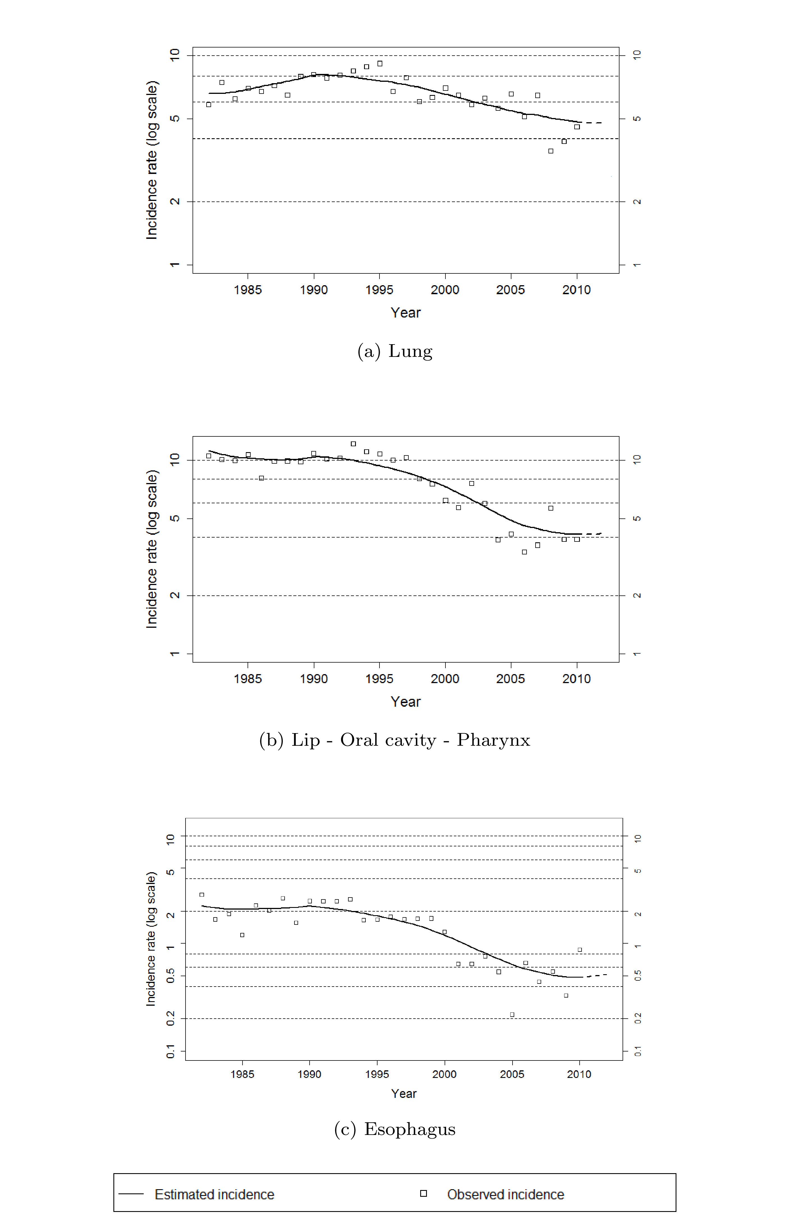
FIGURE 2. Chronological trends for each cancer sites, men aged 20-44 (Restricted approach)
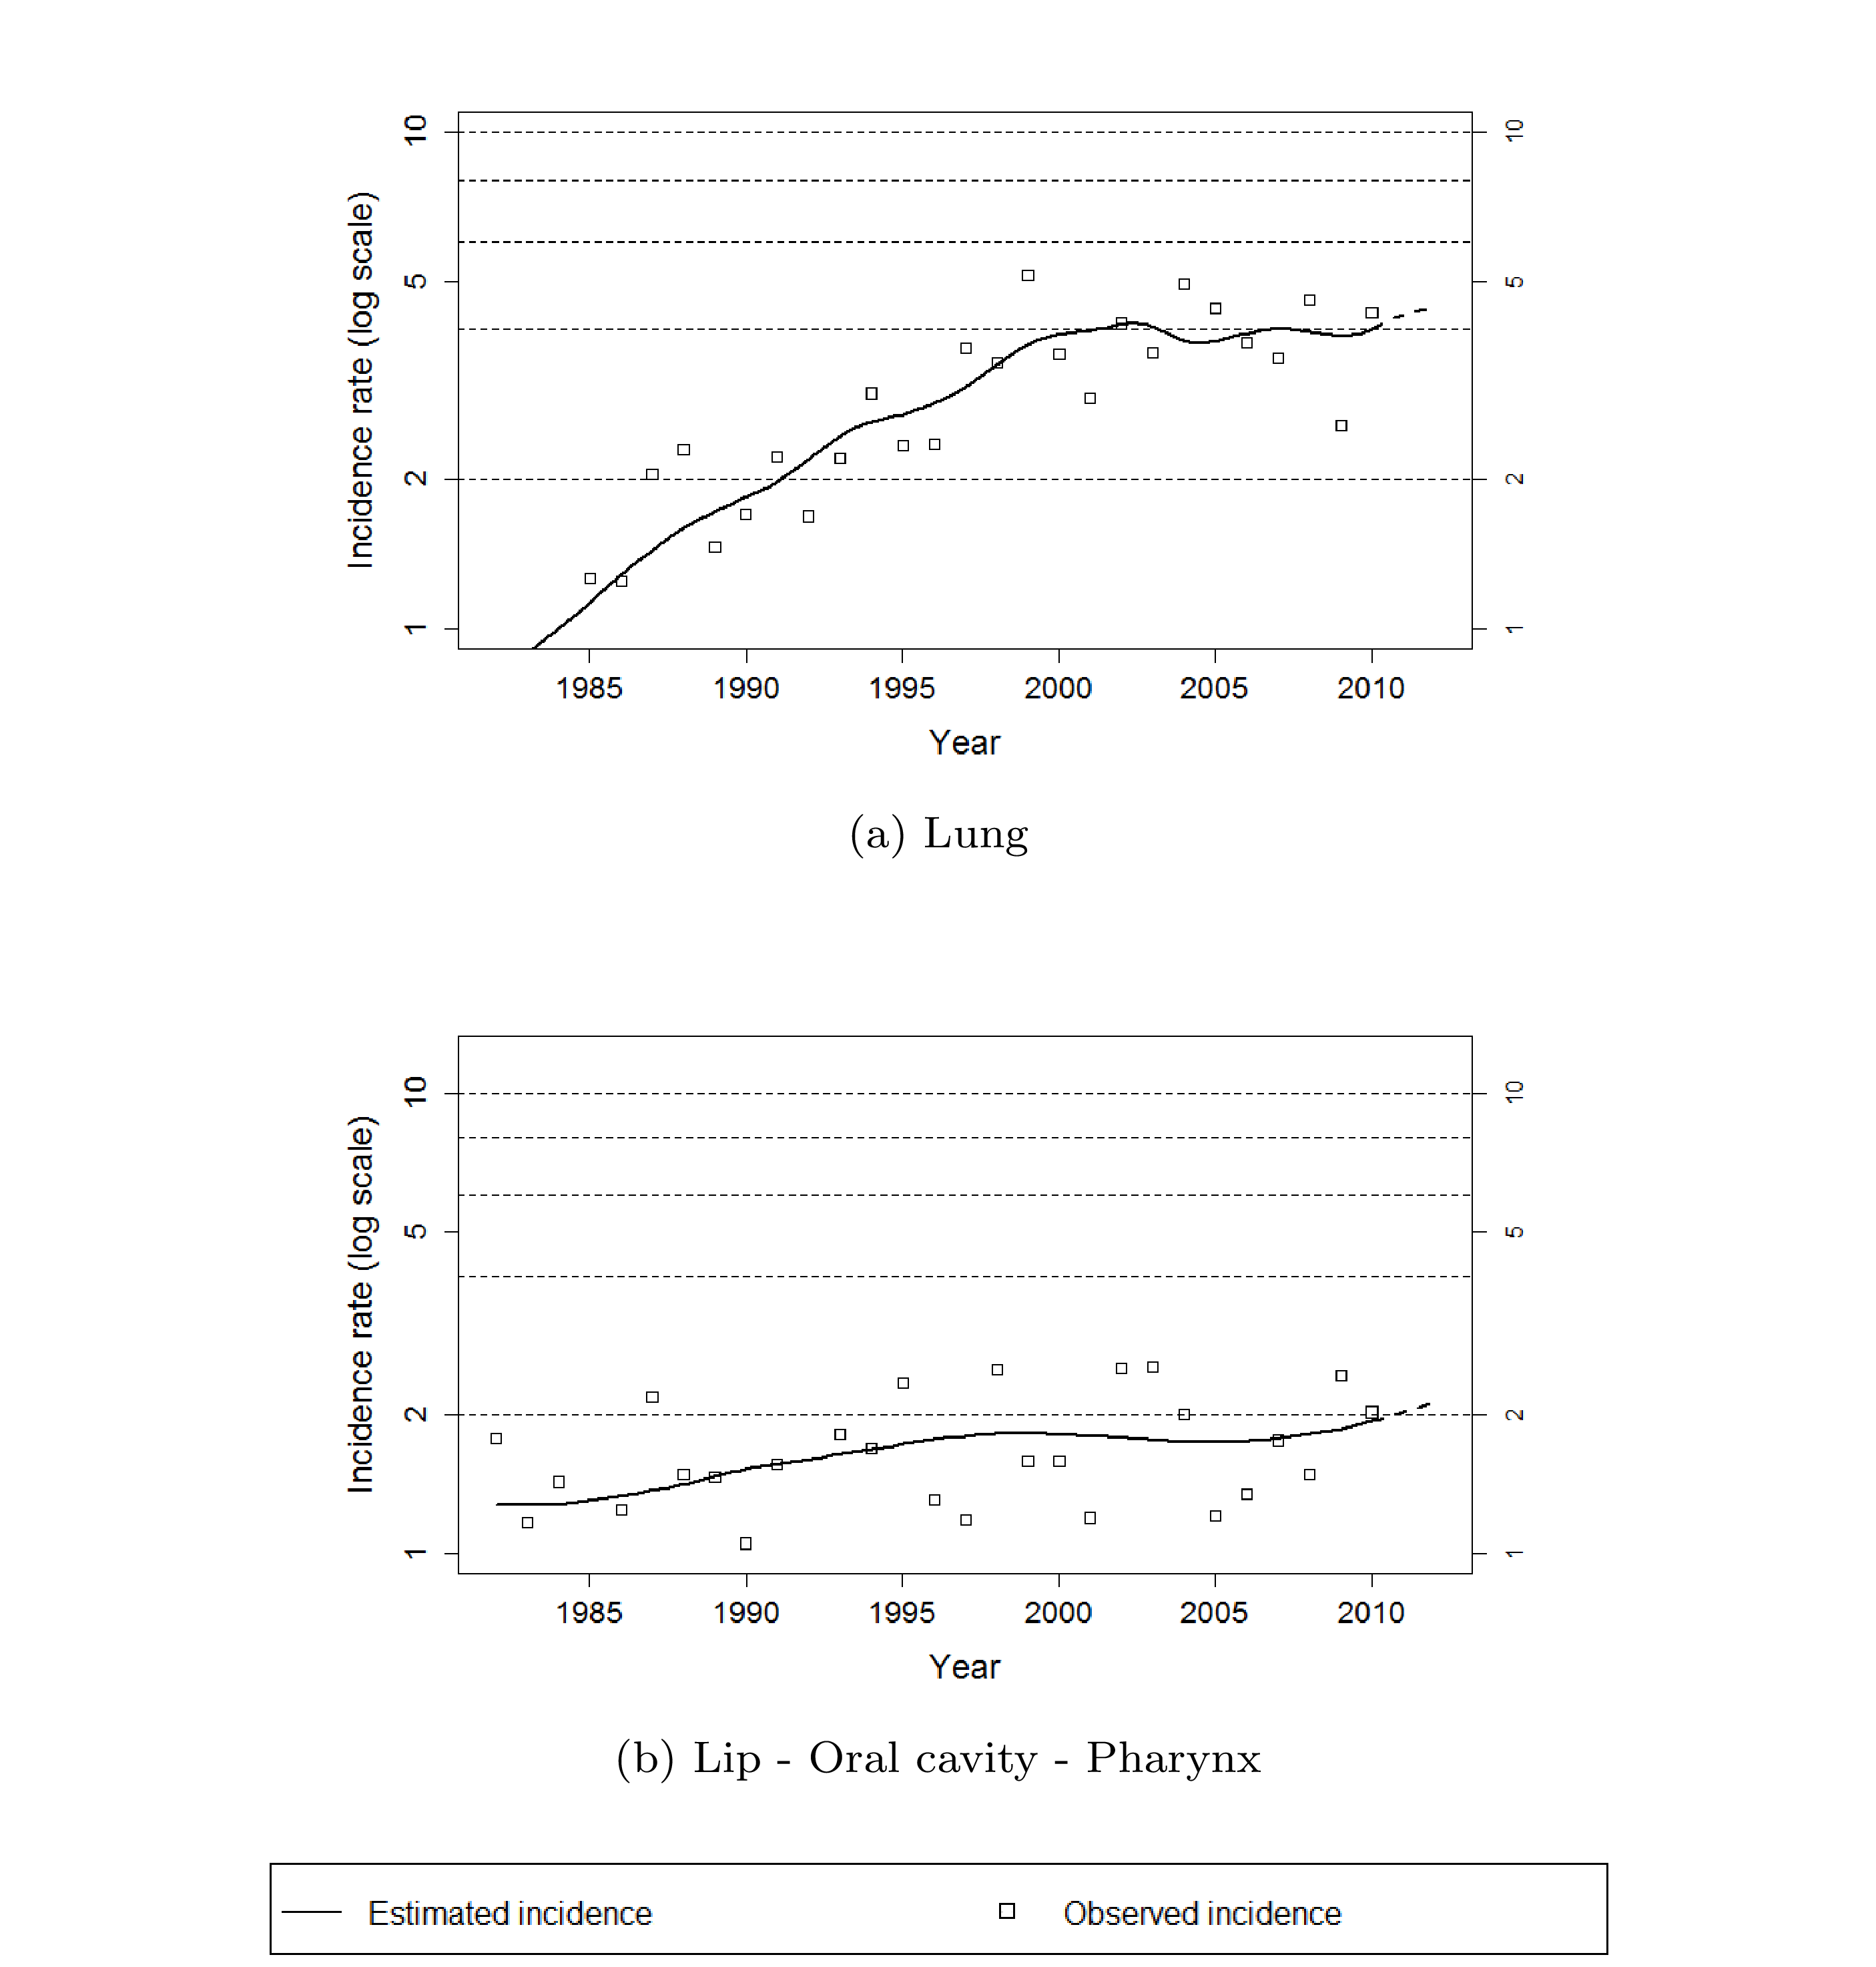

FIGURE 3. Cumulative risks for each cancer sites by sex (Restricted approach)

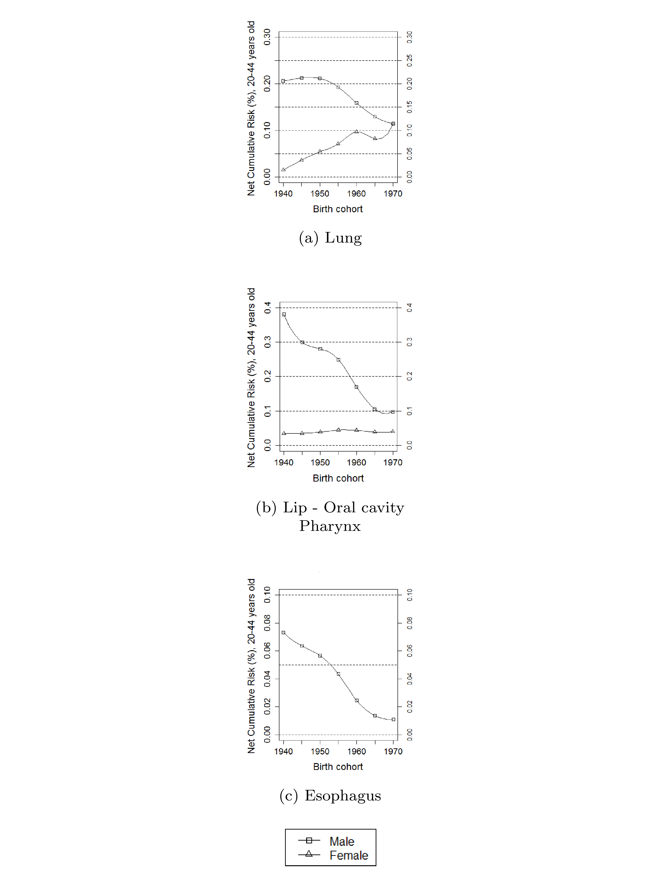

Appendix A. Supplementary results: comparison between the restricted and the global approach
Trends and net Cumulative Risks are presented for both restricted approach (left) and global approach (right). This allows the comparison between the two methods, but also, the comparison between the age-group 20-44 and the older.

FIGURE A.1 Chronological trends for each cancer sites, men aged 20-44, Restricted approach (left) and global approach (right)

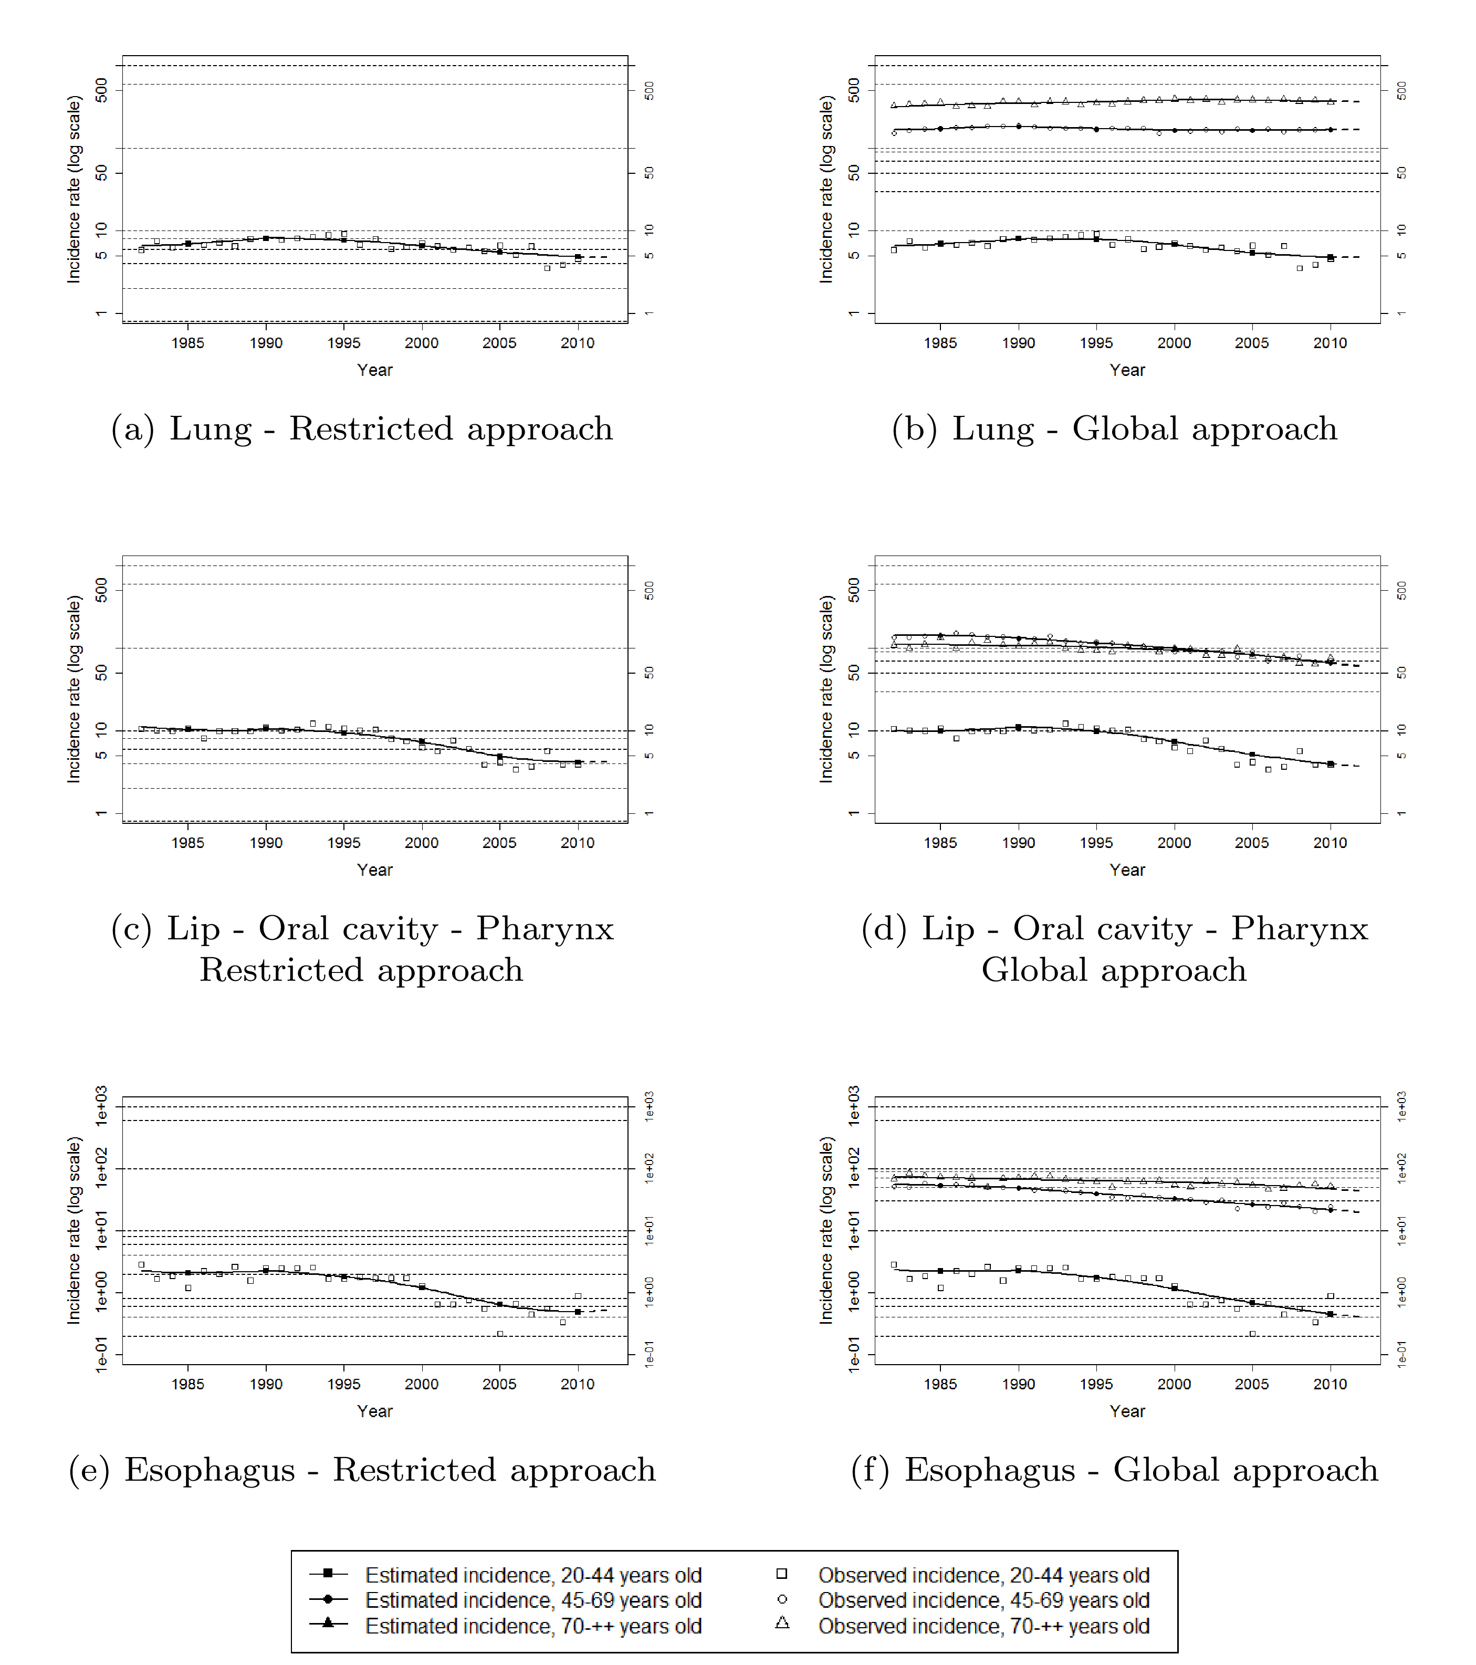

FIGURE A.2 Chronological trends for each cancer sites, women aged 20-44 Restricted approach (left) and global approach (right)

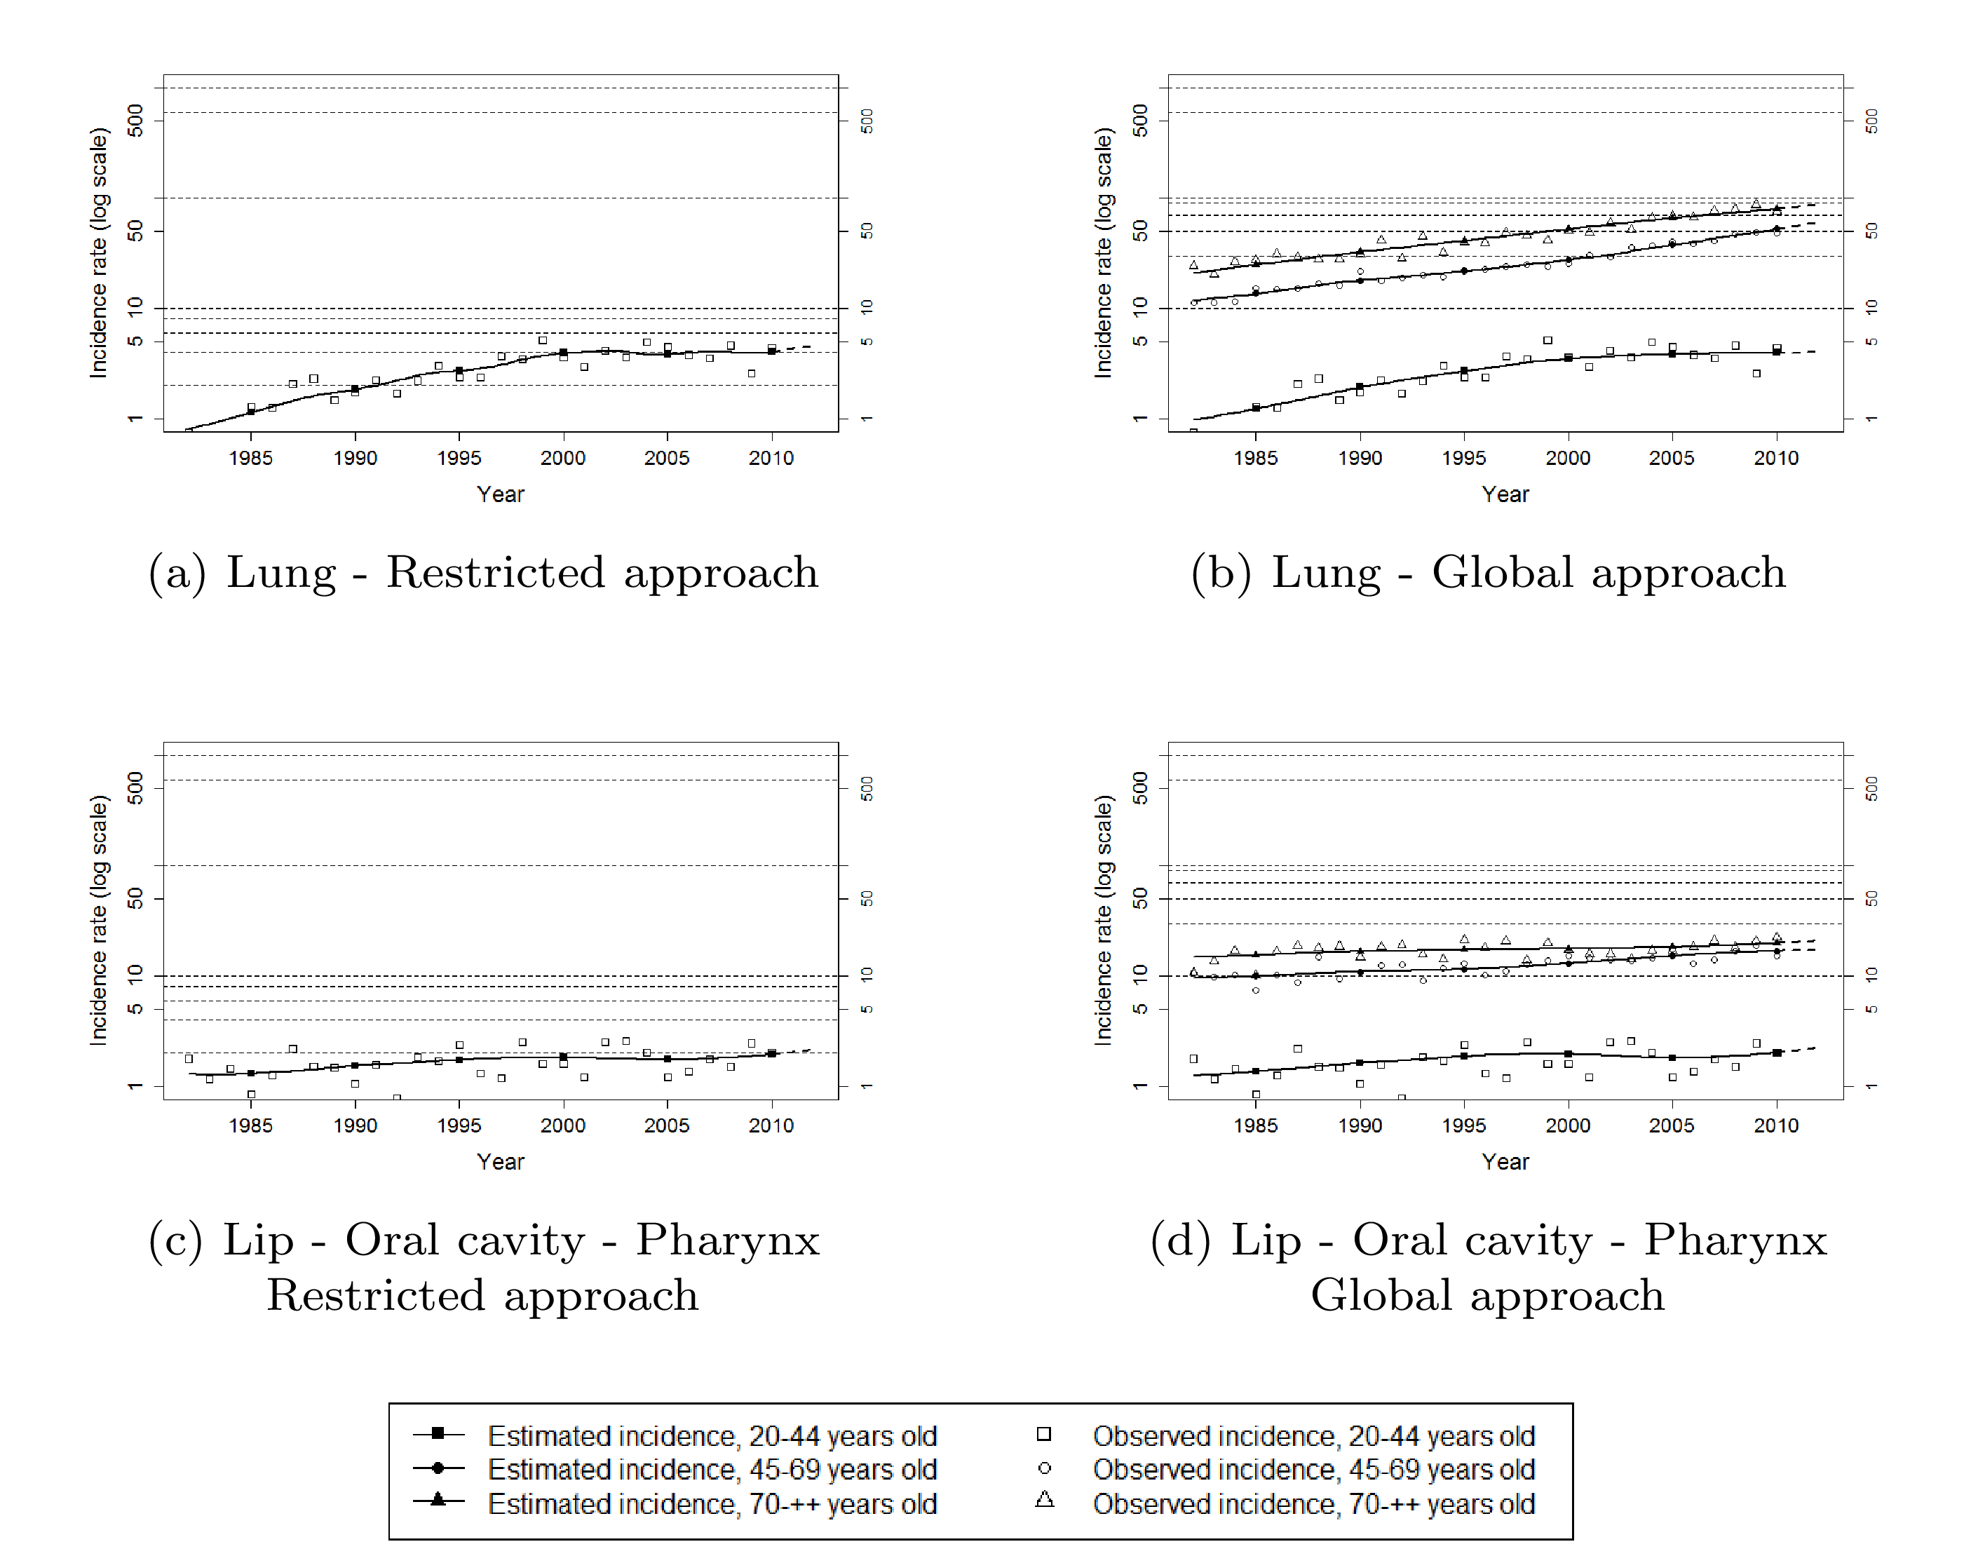

FIGURE A.3 Cumulative risks for each cancer sites by sex Restricted approach (left) and global approach (right)

