Pay-it-Forward Gonorrhea and Chlamydia Testing Among Men Who Have Sex With Men in China: A Randomized Controlled Trial
Fan Yang, PhD*, Tiange P Zhang, BS*, Weiming Tang, PhD*, Jason J Ong, PhD, Marcus Alexander, PhD, Laura Forastiere, PhD, Navin Kumar, MPhil, Katherine T Li, MD, Professor Fei Zou, PhD, Ligang Yang, MD, Guodong Mi, PhD, Yehua Wang, MS, Wenting Huang, MS, Amy Lee, BA, Weizan Zhu, BS, Danyang Luo, BS, Professor Peter Vickerman, PhD, Dan Wu, PhD, Professor Bin Yang, MD, Professor Nicholas A Christakis, MD, Joseph D Tucker, MD

Correspondence to: Dr. Joseph D. Tucker, University of North Carolina at Chapel Hill, Chapel Hill, NC, 27599, USA, jdtucker@med.unc.edu, +1 919 966 2536
*These three authors contributed equally.
University, Dermatology Hospital, Guangzhou, China (F Yang, W Tang, B Yang, L Yang); University of North Carolina at Chapel Hill, Project-China, Guangzhou, China (F Yang, T P Zhang, W Tang, K T Li, Y Wang, A Lee, W Huang, D Wu, J D Tucker); Southern Medical Loyola University Chicago Stritch School of Medicine, Maywood, Illinois, USA (T P Zhang); Central Clinical School, Monash University, Australia (J Ong); London School of Hygiene and Tropical Medicine, London, UK (D Wu, J Ong, J D Tucker); Yale Institute for Network Science, Yale University, New Haven, Connecticut, USA (M Alexander, L Forastiere, N Kumar, N A Christakis); Yale School of Public Health, Department of Biostatistics, New Haven, Connecticut, USA (L Forastiere); Massachusetts General Hospital, Boston, Massachusetts, USA (K T Li); University of North Carolina at Chapel Hill, Department of Biostatistics, North Carolina, USA (F Zou); Blued, Beijing, China (G Mi); Zhitong Guangzhou LGBT Center, Guangzhou, China (W Zhu, D Luo); School of Social and Community Medicine, University of Bristol, Bristol, UK (P Vickerman)

Summary
Background Many evidence-based preventive services are unaffordable. Pay-it-forward offers an individual a gift (e.g. a test for sexually transmitted diseases) and then asks whether they would like to give a gift (e.g. a future test) to another person. This study examined the effectiveness of a pay-it-forward program to increase gonorrhea and chlamydia testing among men who have sex with men (MSM) in China.
Methods We conducted a randomized controlled superiority trial at three HIV testing sites run by MSM community-based organizations between November 2018 to January 2019. We included MSM aged 16 and older seeking HIV testing who met indications for gonorrhea and chlamydia testing. Restricted randomization was employed using computer-generated permuted blocks. Thirty groups were 1:1:1 randomized into three arms: a pay-it-forward arm where men were offered free gonorrhea and chlamydia testing and then asked whether they would like to donate others’ tests; a pay-what-you-want arm where men were offered free testing and given the option to pay any desired amount for the test; and a standard-of-care arm where testing was offered at 150RMB (US$22). There was no masking to arm assignment. The primary outcome was gonorrhea and chlamydia test uptake ascertained by administrative records. We used generalized estimating equations to estimate intervention effect with one-sided 95% confidence intervals and a pre-specified superiority margin, 20%. The trial was registered (NCT03741725).
Findings Three hundred and one men were recruited and included in the analysis: 101 were randomized to pay-it-forward, 100 to pay-what-you-want, and 100 to standard-of-care. Test uptake in the pay-it-forward, pay-what-you-want, and standard of care arms were 56% (57/101), 46% (46/100), and 18% (18/100), respectively. The estimated difference in test uptake between pay-it-forward and standard-of-care was 38.4% (95% CI lower bound: 28.4%). Among men in the pay-it-forward arm, nearly all (54/57, 94.6%) chose to donate to support testing for others.
Interpretation Pay-it-forward strategy can increase gonorrhea and chlamydia testing among Chinese MSM and may be a useful tool for scaling up preventive services that carry a mandatory fee.
Funding NIH, TDR, the National Key Research and Development Program of China, Doris Duke Charitable Foundation, and SESH
Introduction

Many evidence-based preventive services are not affordable for individuals in resource-limited settings.(1, 2) Despite recommendations from the World Health Organization and others to make healthcare universally accessible,(3) individuals routinely pay out-of-pocket fees for vaccines, drugs, and diagnostics.(4) Mandatory fees decrease health service utilization and reduce equitable access by disproportionately affecting the poor.(5-7) Public sector programs that subsidize preventive services are under increasing financial strain(8) and altering prices is difficult.(9) Programs to reduce fees associated with preventive services have not been scaled up.(4, 10) Innovative strategies are needed to expand access to preventive services.

One novel strategy for promoting service uptake in health is the pay-it-forward health services provision model.(11) With pay-it-forward, one person receives a gift and then is asked whether he or she would like to give a similar gift to another person.(12) A single-city observational study used pay-it-forward to have men who have sex with men (MSM) receive a free gonorrhea/chlamydia test. Then each participant decides whether to donate toward the next person’s test. One observational study found that a pay-it-forward approach substantially increased gonorrhea and chlamydia testing among MSM.(11) Pay-it-forward changes the conventional transactional exchange between buyer and seller to a social exchange between gift receivers and givers.(13) This approach may increase trust and community engagement in health services which have been associated with sexually transmitted infection (STI) test uptake.(14)

Dual gonorrhea and chlamydia tests are available in many Chinese hospitals for approximately 22 USD.(15) Testing rates among Chinese MSM are low despite gonorrhea and chlamydia infections being highly prevalent (12.5% and 18.1% respectively, including urethral, rectal, and pharyngeal sites), often asymptomatic, and associated with increased risk of HIV transmission and acquisition.(16-18) Pay-it-forward may reduce financial barriers to testing while engaging local MSM communities.

The purpose of this multi-site, three-arm, randomized controlled trial (RCT) is to evaluate the effectiveness of a pay-it-forward model for increasing dual gonorrhea and chlamydia test uptake among Chinese MSM compared to a standard fee-based system. The primary outcome is uptake of dual gonorrhea and chlamydia testing. The secondary objective of this study is to evaluate the cost-effectiveness of the interventions in comparison to the standard of care.

Methods
Study setting and design
We conducted this multi-site RCT between November 2018 to January 2019 in two Chinese cities: Guangzhou (two sites in hospital-based STI clinics), and Beijing (in a community-based organization). All sites offered free HIV testing and were run by MSM community-based organizations (Guangzhou: Zhitong Guangzhou LGBT Center; Beijing: Blued) as a common service delivery mode in China.(19) HIV testing was performed using a third generation HIV rapid test (InTec, Xiamen, China). We chose those sites because they already provided HIV testing services, included laypersons (no physicians), and were affiliated with a local community-based organization, which is common for HIV testing service delivery in China for key populations. This provides a strong foundation for pay-it-forward and makes our research findings more generalizable. More details about the study setting are available in the study protocol.(20) The study was approved by ethics review committees at Southern Medical University Dermatology Hospital (China), University of North Carolina at Chapel Hill (USA), and Yale University (USA). This trial was registered on ClinicalTrials.gov (NCT03741725). We reported our findings according to the Consolidated Standards of Reporting Trials (CONSORT) cluster-extension guidelines.(21)

We employed a group-based RCT design based on the following reasons: First, the intervention was framed as a group-based intervention in terms of donations from more than one MSM supported testing costs. Second, research studies in China suggest that peer influences on HIV test uptake are important (22, 23) and that men who are accompanied for STI/HIV testing are significantly more likely to receive testing when accompanied by a partner(24). Our study design assigned partners within the same group, appreciating these social influences. Finally, our study was designed as a pragmatic trial in order to be relevant to other community-based sites that deliver HIV testing services. After discussions with our community partners, there was agreement that an individual-based RCT would interfere with normal clinical service provision and not be feasible in a real-world setting.

Participants
We recruited participants from men seeking HIV testing at the study sites. Participants were eligible if they were born biologically male, aged 16 years or older, ever had anal sex with a man, had not tested for gonorrhea and chlamydia in the past 12 months, and were willing to provide a cell phone number or WeChat ID for results notification. All participants provided written informed consent.

Randomization and masking
Groups of ten men were randomly assigned (1:1:1) to one of the three study arms: pay-it-forward, pay-what-you-want, or standard of care. A group was defined as a group of ten eligible men that arrived in order at the study site and agreed to participate. We chose a group size of ten based on sample size calculation and implementation consideration (Supplementary File 5). All men in the same group were assigned to the same study arm. Men who presented with partners were assigned to the same group as their partners.

We generated the randomization sequence using STATA 15 software prior to recruitment (Supplementary File 6).(25) Three groups, one from each arm, were bundled as a triplet and permutated within triplets to ensure balanced arms (1:1:1) at each site. After randomization, sites with a high volume of men visiting to test for HIV received more triplets, such that the study period remained relatively the same across sites. Study organizers and participants were not masked to arm assignment.

Procedures
The pay-it-forward program was developed using crowdsourcing to solicit community input.(11) Crowdsourcing has a group solve a problem and then share solutions with the community.(26) First, program procedures were designed through an iterative consultation process with community partners and were piloted at each of the three study sites. The pilot included a total of 43 men and based on its results, community partners and study staff optimized the standard operating procedure.(20) Second, the name of the program in Chinese was crowdsourced from the public using an open challenge contest.(27) Third, postcards with hand-written notes from earlier participants were presented to subsequent participants in the pay-it-forward arm. Figure 1 shows the key concepts of the pay-it-forward and pay-what-you-want models applied in gonorrhea and chlamydia testing.

Men in all three study arms were introduced to gonorrhea and chlamydia testing and the study procedures of their respective arm. Men in pay-it-forward were told that the standard price of the gonorrhea and chlamydia testing was 150RMB ($22US), and that previous participants who cared about them donated toward testing fees. Thus, men in the pay-it-forward arm received a free test, and then decided whether, and if so, how much to donate toward future testing for others. Participants were shown postcards and told that testing and donating were voluntary.

After being introduced to the testing and the study, men in the pay-what-you-want arm were told that the standard price of gonorrhea and chlamydia testing was 150 RMB ($22US), and that they would receive free testing and then decide the amount that they would like to pay for their own test.

Men in the standard of care arm received the same introduction to gonorrhea and chlamydia testing as the men in the other two arms. They were then told that the standard price of gonorrhea and chlamydia testing was 150 RMB (US$22) and they had to pay the full amount for their testing.

In all three arms, men who decided to test were asked about their sexual practices and advised to consider urine, rectal, or both urine and rectal dual gonorrhea and chlamydia testing. Their sample were immediately collected after they made the decision to test. All men were invited to complete a survey about their sexual history, testing history, and attitudes toward the testing program, and towards the MSM community at each site (Supplement File 1). Samples at all sites were transported to Southern Medical University Dermatology Hospital laboratory in Guangzhou for nucleic acid amplification testing (NAAT). We chose NAAT because of the superior sensitivity, higher specificity, and Chinese regulatory approval. Patients who tested positive were counseled and directed to the web page of the designated partner hospital in each city, where they would be able to make an appointment to receive treatment and follow-up. Details on procedures for sample processing, payment method, and laboratory testing can be found elsewhere.(20) The trial stopped once the pre-determined sample size was reached.

Outcomes
The primary outcome was gonorrhea and chlamydia test uptake immediately after the intervention as assessed by administrative records. Secondary outcomes included incremental cost per test and incremental cost per diagnosis. We categorized costs into fixed and variable costs from a health-provider perspective and with a within-trial time horizon. We first calculated the total economic cost for each arm, then divided these costs by the number of men tested and by the number of new gonorrhea or chlamydia cases detected in each study arm. We also report for each intervention the incremental cost-effectiveness ratios (ICERs) for cost per additional person tested and case identified. Details of the cost and cost-effectiveness analyses are summarized in the Supplemental File 2. Other psychosocial outcomes investigated include community engagement,(14) community connectedness,(28, 29) and social cohesion,(30, 31) measured using adapted scales that were piloted in the local context before the RCT.

Statistical analysis
We used descriptive analyses to examine participants’ socio-demographic characteristics in each arm. To account for potential correlation in outcomes within groups, generalized estimating equations modeling (GEE) was used to assess the population-averaged effect of the pay-it-forward and pay-what-you-want interventions on test uptake compared to standard of care. Correlation structure within groups was specified as equal correlation (the exchangeable option on STATA). Additionally, Huber/White/sandwich estimator of variance was used instead of the conventional variance estimator so that the model estimates were robust even if the correlation structure was mis-specified. A binomial distribution was specified for test uptake with the identity link function in order to obtain the absolute difference in the proportions of test uptake. Key sociodemographic variables incorporated into the model as covariates included age as a continuous variable and study site as a nominal variable to account for potential confounding. For details see Supplement File 4. A superiority margin of 0.2 (20% difference in probability of agreeing to test comparing interventions to standard of care) was pre-specified as a clinically significant difference in gonorrhea and chlamydia test uptake based on what would be clinically relevant and a previous modeling study(32). The sample size has sufficient power to detect this difference (Supplement File 5). For the test uptake proportion differences, per study design using superiority by a margin test, one-sided 95% confidence intervals were computed comparing pay-it-forward and pay-what-you-want respectively to standard of care, where the lower bounds were compared to the margin size of 0.2.

Results
Between December 2018 and January 2019, a total of 431 men were screened for study eligibility. Fifteen were deemed ineligible for having already participated in a pay-it-forward pilot study before (n=6), having tested for gonorrhea and/or chlamydia in the past 12 months (n=5), having never had anal sex with men (n=3), and not born biologically male (n=1). Then, 115 eligible men declined to participate due to lack of interest or a time conflict, resulting in a final sample of 301 men who were enrolled and assigned to groups. Figure 2 presents the study flow from recruitment to outcome assessment.

Table 1 presents the sociodemographic and sexual behavior characteristics of men assigned by arm. There was no statistically significant difference between those variables among men assigned to the three study arms. Overall, most men were 30 years old or younger (71.5%), never married (87.5%), and their highest education was a Bachelor’s or above (85.1%). Their annual income varied, with 11.5% in the lowest category (<2,680 USD, converted from Chinese Yuan), and 38.2% in the highest category (> 14,294 USD).

Approximately half of men (51.1%) reported having multiple sexual partners in the past three months, and 234 (81.5%) men reported having anal sex in the past three months. Among these, more than half (54.3%) reported consistent condom use during anal sex in the past three months.

Proportions of men agreeing to receive gonorrhea and chlamydia test in the pay-it-forward, pay-what-you-what, and standard of care arms were 56%, 46%, and 18% respectively (Table 2). GEE output suggested that the pay-it-forward arm was associated with a 38% increase in test uptake probability when compared to the standard of care arm. This effect estimate comes with a one-sided 95% confidence interval with the lower bound at 28%, greater than the 20% superiority margin. After adjusting for participants age and site, the finding remained unchanged (probability difference: 0.39, one-sided 95% CI lower bound: 0.28).

Compared to standard of care, the pay-what-you-what intervention was associated with a 28% absolute increase in the proportion of men receiving a gonorrhea and chlamydia test, with a lower bound, one-sided 95% CI of 16%, less than the 20% superiority margin but still greater than 0. After adjusting for participant age and site, this finding also remained unchanged (risk difference: 0.28, one-sided 95% CI lower bound: 0.15). As with the pay-it-forward arm, age and testing site location were not significantly associated with the primary outcome. Alternative multivariable models adjusting for additional covariates were tested and yielded similar results (Supplement File 4).

Among 121 participants who tested for gonorrhea and chlamydia (40.2%, 121/300), five (4.1%) men had gonorrhea infection and 19 (15.7%) men had chlamydia infection. Among all 301 men, seven (2.3%) had a positive test for HIV infection.

A complete cost and cost-effectiveness analysis is provided in Supplement File 2. In summary, the total health provider economic cost (including start-up, test kits, staff time, overheads) for pay-it-forward ($1125) and for pay-what-you-want ($967) were higher than that of the standard of care ($612). Of the 57 men who received testing through the pay-it-forward arm, 54 (94.6%) chose to donate some amount toward testing of future participants. Among the 46 men who tested through pay-what-you-want, 42 (91.3%) paid some amount for the tests they received. The ICER using economic costs per additional person tested was $12.68 (pay-what-you-want compared with standard of care) and $14.27 (pay-it-forward compared with pay-what-you-want). The ICER using financial costs per additional person tested was: $12.96 (pay-it-forward compared with standard of care) and pay-it-forward dominated (i.e. cheaper and more effective than) pay-what-you-want. Key study procedures and findings were summarized in a video (Supplement File 3).

Discussion
The goal of this study was to assess the superiority of a pay-it-forward strategy to standard of care in promoting STI testing among MSM in China. We found that a pay-it-forward strategy increased STI testing and generated a substantial portion of costs associated with testing. This extends the literature by using an RCT and suggests that pay-it-forward strategies may increase uptake of screening services that would otherwise be associated with fees.

We found that men in the pay-it-forward arm had higher gonorrhea and chlamydia test uptake. This finding is consistent with one observational study(11) and some literature supporting pay-it-forward outside of health.(12, 13, 33) This effect of pay-it-forward may be related to free testing and/or the specific context in which men knew that other men from their community cared about them. The high rates of test uptake in the pay-what-you-want arm suggests that free testing itself may be responsible for a substantial portion of the test uptake effect. However, the specific context of receiving a generous gift is likely to facilitate implementation and build trust in the service.

We found that nearly all men offered pay-it-forward voluntarily chose to donate to testing for future men. The total donation amount was $473 and the average donation amount was $8.29. This pay-it-forward donation covered 42% (473/1125) of the total economic cost for implementing pay-it-forward. The high donation rate and associated cost reduction suggest that pay-it-forward may help extend existing preventive services. This is particularly relevant to China and other low- and middle- income countries, where few resources have been allocated to non-HIV STI prevention and related services.(15, 18) Donations from a pay-it-forward program could allow more individuals to receive free or subsidized STI testing services. Pay-it-forward could be relevant in other settings in which groups of individuals pay mandatory fees for preventive services.

Our study has several limitations. This study was conducted in two metropolitan cities in China and making inferences to other settings should be done with caution. At the same time, there are many low- and middle- income settings in which well-defined populations pay fees for preventive health services. Several aspects of the trial were designed to enhance generalizability to other community-based HIV testing sites: no doctors were involved in implementation; protocols were streamlined into routine services; and messaging was simplified. Future studies should investigate the transferability of using pay-it-forward to promote preventive service uptake in other resource-constrained settings. Although there are other examples of MSM community financing for health services (34), the potential for this approach to be integrated into existing health systems has not been explored. Second, we evaluated this approach in a research context. We did not examine whether pay-it-forward might work in practice, although an earlier pragmatic study suggests that it could be implemented outside of research settings.(11) Our cost-effectiveness analysis used a short-term time horizon and did not calculate the disability-adjusted life years averted or quality adjusted life years gained. Therefore, our results are a conservative estimate of the likely benefit from the interventions, as earlier diagnosis and treatment of STIs could also reduce onward transmission of the STI to other sexual partners and reduce the morbidity from the STI. There is currently no consensus on the willingness to pay per additional person tested for chlamydia or gonorrhea, or for an additional person diagnosed with chlamydia or gonorrhea. However, one study of cost-utility of screening for chlamydia and gonorrhea among MSM reported potential cost-effectiveness for screening.(35)

This study has implications for research and policy. From a research perspective, this expands the limited trial data examining the effectiveness of interventions related to behavioral economics and social innovation. Further RCTs and qualitative research studies will be important to understand the pay-it-forward mechanism of action and scalability. Our study may have generated a “warm glow”, a rewarding positive feeling from doing one’s part to help others,(36) that seemed to inspire both participants and research staff, but this was not captured in our pre-specified outcomes. In this study, men could donate money for subsequent testers or write a simple postcard for other community members. Given that MSM are marginalized in China and many other LMIC settings, programs spurring social engagement, such as pay-it-forward, could potentially build collective agency and social cohesion. From a policy perspective, this intervention is not meant to replace public provision of STI testing services for subpopulations. However, this type of program may be useful as a temporary measure to generate testing demand and build trust in new services, prior to the introduction of more comprehensive public-funded programs.

In conclusion, pay-it-forward can increase gonorrhea and chlamydia testing among Chinese MSM. Our study offers an innovative solution to supplementing testing services through leveraging the power of the local community. Pay-it-forward may be a useful tool for the scale-up of preventative services that carry out-of-pocket fees.
Acknowledgements
We thank all study participants, community-based organization staff and volunteers, and staff members at Social Entrepreneurship to Spur Health (SESH) Global, Zhitong Guangzhou LGBT Center, BlueD, and Southern Medical University Guangdong Provincial Center for Skin Diseases and STI Control who contributed. We thank Huanyu Bao, Anne Sung, and Aoxiang Chang for their help with the infographic and video, and Guangyu Ji for his help with recruitment and coordination at the Blued testing site in Beijing during the study implementation.

Funding
This study received support from the National Institutes of Health (NIAID K24AI143471, NIA P30 AG034420, UL1TR002489, NIAID 5P30AI050410), UNICEF/UNDP/World Bank/WHO Special Programme for Research and Training in Tropical Diseases (TDR), the National Key Research and Development Program of China (2017YFE0103800), Doris Duke Charitable Foundation, and SESH (Social Entrepreneurship to Spur Health) Global. The content is solely the responsibility of the authors and does not necessarily represent the official views of the NIH. The content is solely the responsibility of the authors and does not necessarily represent the official views of the NIH.

Research in context
Evidence before this study
Gonorrhea and chlamydia are common sexually transmitted infections among men who have sex with men in many low and middle-income countries. However, there are few interventions focused on increasing gonorrhea and chlamydia test uptake. We performed a PubMed and Google Scholar search for studies reporting gonorrhea and chlamydia testing in Chinese MSM with the terms “MSM”, “China”, “testing” or “screening” or “intervention.” There were no data restrictions and the search was performed on 19 November 2019. We identified three studies showing that gonorrhea and chlamydia testing uptake are low among MSM in China. We found one observational study evaluating the impact of a pay-it-forward approach to increase gonorrhea and chlamydia testing. We did not find any randomized controlled trials or costing studies evaluating a pay-it-forward approach.
Added value of this study
This study examined a pay-it-forward model for gonorrhea and chlamydia testing among Chinese MSM. We found that a pay-it-forward model increased test uptake compared to the standard of care. The program generated donations from local MSM and was cost-effective. This study expands the literature by formally evaluating pay-it-forward using a randomized controlled trial.
Implications of all available evidence
Our research study found that pay-it-forward increased gonorrhea and chlamydia test uptake. The high rates of donating suggest substantial generosity, independent of income level. This appears to be a promising strategy for integrating HIV and sexually transmitted infection testing.

Author contributions

JT, TZ, FY, and WT conceived the study. TZ and FY led piloting and implementation. TZ, FY, MA, LF, DW and NK participated in survey development. FY, FZ, and WT provided statistical expertise. LY, GM, YW, WH, AL, WZ, and DW assisted with recruitment. PV and JO advised on modeling approaches. FY, YW, AL, WZ, LY, DL and WT led implementation in Guangzhou. TZ, WH, and GM led implementation in Beijing. JT, NC, BY, and WT provided oversight. JT and FY wrote the initial draft of the paper. All authors read and authorized the final version.

Conflicts of interest

The authors report no potential conflicts of interest.

Role of funding source

The funding sources had no part in the study design, collection, analysis, or interpretation of the data, writing of the report, and decision to submit the paper for publication.

Data sharing
All de-identified data, survey instruments, and informed consent will be available to researchers on the SESH website upon publication.

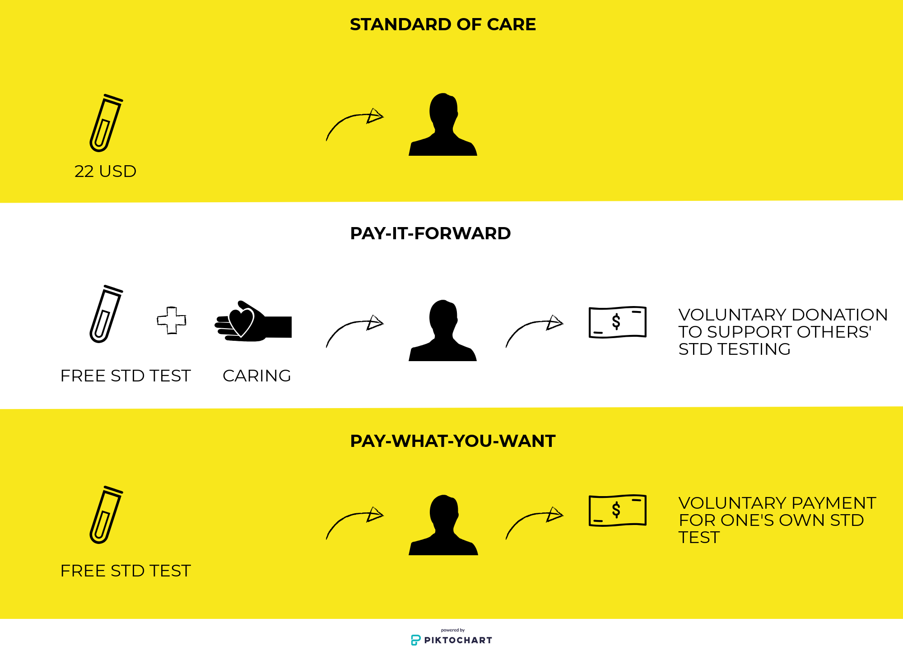
Figure 1. Concepts of standard of care, pay-it-forward, and pay-what-you-want gonorrhea/chlamydia testing. This schematic illustrates respective trial arms from the perspective of a participant. In standard of care, participant was offered a test at standard price ($22 USD). In pay-it-forward, the participant was offered a gift of a free test (“test kit”), and told that previous men donated to make this test possible as well as shown postcards written by previous men (“caring”). Then, the participant was asked whether they would donate toward testing for future men (“voluntary donation”). In pay-what-you-want, the participant was offered a free test (“test kit”). Then, the participant was told they could pay any desired amount for their own test (“voluntary payment”).

Enrollment
Assessed for eligibility (n=431)

Excluded (n=130)
- Not born biologically male: 1
- No previous anal sex with man: 3
- Participated in pay-it-forward: 6
- Tested for gonorrhea and chlamydia in past 12 months: 5
- Not interested and others: 115

Allocation
Randomized (n=301)

Allocated to pay-what-you-want (n=100)

Allocated to standard of care (n=100)

Allocated to pay-it-forward (n=101)

Analysis

Analyzed (n=100)

Analyzed (n=101)

Analyzed (n=100)

Figure 2. Study flow chart, 2018-2019.
Note: There is no loss-to-follow-up in this study. Participants made decisions on whether or not to test immediately after being assigned to their study arms.

Table 1. Sociodemographic and behavioral characteristics of MSM in three RCT arms, 2018-2019 (N= 288‡).

Characteristic | Total  n/N (%) | PIF*  n/N (%) | PWYW*  n/N (%) | SOC*  n/N (%)
Age (years)
<=30 | 206/288 (71.5) | 66/98 (67.4) | 74/93 (79.6) | 66/97 (68.0)
>30 | 82/288 (28.5) | 32/98 (32.7) | 19/93 (20.4) | 31/97 (32.0)
Mean ±SD | 28.1±7.1 | 28.6±7.8 | 26.6±5.6 | 29.1±7.5
Marital status
Never married | 252/288 (87.5) | 87/98 (88.8) | 84/93 (90.3) | 81/97 (83.5)
Other** | 36/288 (12.5) | 11/98 (11.2) | 9/93 (9.7) | 16/97 (16.5)
Highest Education
Middle school or below | 16/288 (5.6) | 5/98 (5.1) | 5/93 (5.4) | 6/97 (6.2)
High/vocational school | 27/288 (9.4) | 8/98 (8.2) | 9/93 (9.7) | 10/97 (10.3)
College or above | 246/288 (85.1) | 85/98 (86.7) | 79/93 (84.9) | 81/97 (83.5)
Annual income (USD)
< 2,680 | 33/288 (11.5) | 11/98 (11.2) | 13/93 (14.0) | 9/97 (9.3)
2,681-5,360 | 26/288 (9.0) | 7/98 (7.1) | 9/93 (9.7) | 10/97 (10.3)
5,361-8,934 | 43/288 (14.9) | 17/98 (17.4) | 15/93 (16.1) | 11/97 (11.3)
8,935-14,294 | 76/288 (26.4) | 23/98 (23.5) | 23/93 (24.7) | 30/97 (30.9)
>14,294 | 110/288 (38.2) | 40/98 (40.8) | 33/93 (35.5) | 37/97 (38.1)
Number of sex partners in the past 3 months
0-1 | 136/278 (48.9) | 47/96 (49.0) | 47/91(51.6) | 42/91 (46.2)
Multiple | 142/278 (51.1) | 49/96 (51.0) | 44/91 (48.4) | 49/91 (53.8)
Had anal sex in the past 3 months
Yes | 234/287 (81.5) | 84/98 (85.7) | 73/93 (78.5) | 77/96 (80.2)
No | 53/287 (18.5) | 14/98 (14.3) | 20/93 (21.5) | 19/96 (19.8)
Condom use frequency during anal sex in past 3 months†
Non-use | 14/234 (6.0) | 5/84 (6.0) | 5/73 (6.9) | 4/77 (5.2)
Sometimes | 24/234 (10.3) | 6/84 (7.1) | 9/73 (12.3) | 9/77 (11.7)
Often | 69/234 (29.5) | 21/84 (25.0) | 24/73 (32.9) | 24/77 (31.2)
Always | 127/234 (54.3) | 52/84 (61.9) | 35/73 (47.9) | 40/77 (51.9)
HIV testing frequency in past 2 years
Never tested  < Once every two years | 26/287 (9.1)  33/287 (11.5) | 6/98 (6.1)  15/98 (15.3) | 14/93 (15.1)  9/93 (9.7) | 6/96 (6.3)  9/96 (9.4)
Once a year | 63/287 (22.0) | 23/98 (23.5) | 16/93 (17.2) | 24/96 (25.0)
Every six months | 76/287 (26.5) | 26/98 (26.5) | 24/93 (25.8) | 26/96 (27.1)
Every three months | 73/287 (25.4) | 21/98 (21.4) | 25/93 (26.9) | 27/96 (28.1)
Monthly | 16/287 (5.6) | 7/98 (7.1) | 5/93 (5.4) | 4/96 (4.2)
Payment amount  Mean ±SD | 47.48±52.24 | 51.71±47.72 | 41.98±61.88 | N/A
*PIF=pay-it-forward, PWYW=pay-what-you-want, SOC=standard of care
** Includes engaged, married, divorced or separated.
† Question asked only to participants who reported having had anal sex in the past three months.
‡ Among all 301 study participants, 288 chose to fill out the survey questionnaire.

Table 2. Arm participation and dual test uptake (primary outcome analysis), 2018-2019 (N=301).

 | n/N (%) | No of groups | Intraclass correlation | Prob diff* | 95%CI** | Adjusted Prob diff† | 95% CI**,†
Pay-it-forward | 57/101 (56%) | 10 | 0.005 | 0.384 | 0.284 | 0.390 | 0.283
Pay-what-you-want | 46/100 (46%) | 10 | <0.001 | 0.280 | 0.163 | 0.278 | 0.153
Standard of care | 18/100 (18%) | 10 | 0.028 | 0.000 | -- | 0.000 | --
*95%CI: the lower bound one-sided 95% confidence interval
** Prob diff: The probability difference between intervention arms (pay-it-forward or pay-what-you-want) to standard of care.
†After adjusting for age and site.
References
1. Health Systems Financing: The Path to Universal Coverage. Geneva: World Health Organization; 2010.
2. Our common interest: report of the Commission for Africa. London: Commission for Africa; 2005.
3. Robert E, Ridde V. Global health actors no longer in favor of user fees: a documentary study. Global Health. 2013;9:29.
4. Lagarde M, Palmer N. The impact of user fees on health service utilization in low- and middle-income countries: how strong is the evidence? Bull World Health Organ. 2008;86(11):839-48.
5. Pariyo GW, Ekirapa-Kiracho E, Okui O, Rahman MH, Peterson S, Bishai DM, et al. Changes in utilization of health services among poor and rural residents in Uganda: are reforms benefitting the poor? Int J Equity Health. 2009;8:39.
6. Masiye F, Chitah BM, McIntyre D. From targeted exemptions to user fee abolition in health care: experience from rural Zambia. Soc Sci Med. 2010;71(4):743-50.
7. Ridde V, Haddad S, Heinmuller R. Improving equity by removing healthcare fees for children in Burkina Faso. J Epidemiol Community Health. 2013;67(9):751-7.
8. Lee GM, Santoli JM, Hannan C, Messonnier ML, Sabin JE, Rusinak D, et al. Gaps in vaccine financing for underinsured children in the United States. JAMA. 2007;298(6):638-43.
9. Strategies for Reconfiguring Cost Structure. Illinois, USA: Healthcare Financial Management Association; 2015.
10. Yates R. Universal health care and the removal of user fees. Lancet. 2009;373(9680):2078-81.
11. Katherine T Li WT, Dan Wu, Wenting Huang, Feng Wu, Amy Lee, Henry Feng, Stephen W Pan, Larry Han, Vincent Mak, Ligang Yang, Joseph D Tucker. Pay-it-forward strategy to enhance uptake of dual gonorrhea and chlamydia testing among men who have sex with men in China: a pragmatic, quasi-experimental study. Lancet Infect Dis. 2018;19:76-82.
12. Jung MH, Nelson LD, Gneezy A, Gneezy U. Paying more when paying for others. J Pers Soc Psychol. 2014;107(3):414-31.
13. Gray K, Ward AF, Norton MI. Paying it forward: generalized reciprocity and the limits of generosity. J Exp Psychol Gen. 2014;143(1):247-54.
14. Zhang TP, Liu C, Han L, Tang W, Mao J, Wong T, et al. Community engagement in sexual health and uptake of HIV testing and syphilis testing among MSM in China: a cross-sectional online survey. Journal of the International AIDS Society. 2017;20(1):21372.
15. Wu DL, K.; Tang, W.; Ong, J.J.; Huang, W.; Fu, H.; Lee, A.; Wei, C.; Tucker, J.D. Low chlamydia and gonorrhea testing rates among men who have sex with men in Guangdong and Shandong Provinces, China. Sexually transmitted diseases. 2018;Publish Ahead of Print - Issue - p.
16. Bernstein KT, Marcus JL, Nieri G, Philip SS, Klausner JD. Rectal gonorrhea and chlamydia reinfection is associated with increased risk of HIV seroconversion. J Acquir Immune Defic Syndr. 2010;53(4):537-43.
17. Cohen MS, Hoffman IF, Royce RA, Kazembe P, Dyer JR, Daly CC, et al. Reduction of concentration of HIV-1 in semen after treatment of urethritis: implications for prevention of sexual transmission of HIV-1. AIDSCAP Malawi Research Group. Lancet. 1997;349(9069):1868-73.
18. Yang LG, Zhang XH, Zhao PZ, Chen ZY, Ke WJ, Ren XQ, et al. Gonorrhea and chlamydia prevalence in different anatomical sites among men who have sex with men: a cross-sectional study in Guangzhou, China. BMC Infect Dis. 2018;18(1):675.
19. Yang F, Janamnuaysook R, Boyd MA, Phanuphak N, Tucker JD. Key populations and power: people-centred social innovation in Asian HIV services. The Lancet HIV. 2020;7(1):e69-e74.
20. Zhang TP, Yang F, Tang W, Alexander M, Forastiere L, Kumar N, et al. Pay-it-forward gonorrhea and chlamydia testing among men who have sex with men in China: a study protocol for a three-arm cluster randomized controlled trial. Infectious diseases of poverty. 2019;8(1):1-11.
21. Campbell MK, Elbourne DR, Altman DG. CONSORT statement: extension to cluster randomised trials. Bmj. 2004;328(7441):702-8.
22. Wei C, Muessig KE, Bien C, Yang L, Meng R, Han L, et al. Strategies for promoting HIV testing uptake: willingness to receive couple-based and collective HIV testing among a cross-sectional online sample of men who have sex with men in China. Sexually transmitted infections. 2014;90(6):469-74.
23. Hesketh T, Duo L, Li H, Tomkins A. Attitudes to HIV and HIV testing in high prevalence areas of China: informing the introduction of voluntary counselling and testing programmes. Sexually transmitted infections. 2005;81(2):108-12.
24. Tucker JD, Yang LG, Yang B, Zheng HP, Chang H, Wang C, et al. A twin response to twin epidemics: integrated HIV/syphilis testing at STI clinics in South China. Journal of acquired immune deficiency syndromes (1999). 2011;57(5):e106-11.
25. StataCorp. Stata Statistical Software: Release 15. College Station, TX: StataCorp LLC2017.
26. Tucker JD, Day S, Tang W, Bayus B. Crowdsourcing in medical research: concepts and applications. PeerJ 2019;6:e6762.
27. WHO/TDR/SESH/SIHI. Crowdsourcing in Health and Health Research: A Practical Guide. Geneva: WHO/TDR; 2018.
28. Frost DM, Meyer IH. Measuring community connectedness among diverse sexual minority populations. J Sex Res. 2012;49(1):36-49.
29. Swann WB, Jr., Gomez A, Seyle DC, Morales JF, Huici C. Identity fusion: the interplay of personal and social identities in extreme group behavior. J Pers Soc Psychol. 2009;96(5):995-1011.
30. Grover E, Grosso A, Ketende S, Kennedy C, Fonner V, Adams D, et al. Social cohesion, social participation and HIV testing among men who have sex with men in Swaziland. AIDS Care. 2016;28(6):795-804.
31. Lippman SA, Donini A, Diaz J, Chinaglia M, Reingold A, Kerrigan D. Social-environmental factors and protective sexual behavior among sex workers: the Encontros intervention in Brazil. Am J Public Health. 2010;100 Suppl 1:S216-23.
32. Xiridou M, Vriend HJ, Lugner AK, Wallinga J, Fennema JS, Prins JM, et al. Modelling the impact of chlamydia screening on the transmission of HIV among men who have sex with men. BMC Infect Dis. 2013;13:436.
33. Fowler JH, Christakis NA. Cooperative behavior cascades in human social networks. Proceedings of the National Academy of Sciences. 2010;107(12):5334-8.
34. Tucker JD, Muessig KE, Cui R, Bien CH, Lo EJ, Lee R, et al. Organizational characteristics of HIV/syphilis testing services for men who have sex with men in South China: a social entrepreneurship analysis and implications for creating sustainable service models. BMC Infect Dis. 2014;14:601.
35. Chesson HW, Bernstein KT, Gift TL, Marcus JL, Pipkin S, Kent CK. The cost-effectiveness of screening men who have sex with men for rectal chlamydial and gonococcal infection to prevent HIV Infection. Sex Transm Dis. 2013;40(5):366-71.
36. Andreoni J. Giving with impure altruism: Applications to charity and Ricardian equivalence. Journal of political Economy. 1989;97(6):1447-58.

Supplement File index
Supplement File 1. Survey instrument
Supplement File 2. Costing and cost-effectiveness analyses methods and results
Supplement File 3. Pay-it-forward summary video
Supplement File 4. Multivariable model results adjusting for different covariates
Supplement File 5. Sample size calculation for pay-it-forward and pay-what-you-want interventions
Supplement File 6. Randomization STATA code

Supplement File 7. CONSORT 2010 checklist of information to include when reporting a randomised trial

Supplement File 1. Survey instrument

A. Sociodemographics
The next set of questions will ask you to provide some information about yourself.

A1. Age: ____ years old
A2. Nationality
- Han Chinese 2. Other _________
A3. Current marital status:
- Never married
- Engaged or Married
- Separated or divorced
- Widowed
A4. Highest level of completed education:
- Elementary
- Middle school
- High school or vocational school
- Bachelor or associate degree
- Above bachelor’s degree
A5. What is your occupation?
o Student
o Civil servant
o Farmer
o Labor worker (blue collar)
o Office worker (white collar)
o Seller/service staff
o Technician
o Unemployed
o Other______

A6. What is your total individual monthly income from all sources?
- <1500 RMB/month
- 1500-3000 RMB/month
- 3001-5000 RMB/month
- 5001-8000 RMB/month
- >8000 RMB/month

A7. What is your gender identity?
- Male
- Female
- Transgender
- Unsure/Other

A8. What is your sexual orientation?
- Homosexual
- Bisexual
- Heterosexual
- Unsure/Other

B. Sexual behaviors
The next set of questions will ask you about your sexual behaviors with other men.

B1. What is your role during anal sex?
- Mostly receptive (bottom)
- Mostly insertive (top)
- Half and half (versatile)

B2. In the past 3 months, how many sex partners have you had? (Number)
____ partners
B3. In the past 3 months, have you had anal sex?
- Yes
- No (Skip to B5)

B4. In the past 3 months, when you had anal sex, how frequently did you use condoms?
- 0% condom use
- Less than 50% condom use
- More than 50% condom use
- 100% condom use

B5. In the past 3 months, have you had condomless vaginal sex?
- Yes
- No

B6. In the past 3 months, have you had condomless oral sex?
- Yes
- No
B7. In the past, have you told anyone about your sexuality or sexual history with men? (Select all that apply)
- Yes, my long-term female partner/wife
- Yes, my family members
- Yes, my friends
- Yes, my healthcare providers
- Yes, others:_________
- No one

C. Clinical Information
C1. Do you have any symptoms that you are worried may be due to an STI?
- Yes. Symptoms: _____________
- No

C2. Have you ever tested for HIV in the past?
- Yes
- No (Skip to C5)

C3. When was the last time you tested for HIV? (If cannot recall exactly, please estimate)
Year:________Month:______Day:________

C4. In the last two years, how frequently did you get tested for HIV?
- Less than once every two years
- Once a year
- Once every six months
- Once every three months
- Monthly

C5. Today, did you agree to get tested for gonorrhea and chlamydia?
- Yes (Go to C6)
- No (Go to C7)

C6 (Pay-it-forward arm). If you agreed to testing for gonorrhea and chlamydia today, what is the MAIN reason? (Choose ONE)
- “Pay It Forward” allowed for discounted testing
- “Pay It Forward” allowed paying kindness forward to community members
- Recent symptoms
- Recent high-risk sexual behavior
- Testing site’s staff told me to get tested
- A friend told me to get tested
- Other ____________________

C6 (Pay-what-you-want arm). If you agreed to testing for gonorrhea and chlamydia today, what is the MAIN reason? (Choose ONE)
- “Pay What You Want” allowed for discounted testing
- Recent symptoms
- Recent high-risk sexual behavior
- Testing site’s staff told me to get tested
- A friend told me to get tested
Other ____________________

C6 (Standard of care arm). If you agreed to testing for gonorrhea and chlamydia today, what is the MAIN reason? (Choose ONE)
- Because the research staff introduced gonorrhea and chlamydia testing
- Recent symptoms
- Recent high-risk sexual behavior
- Testing site’s staff told me to get tested
- Other ____________________

C7. If you did NOT agree to testing for gonorrhea and chlamydia today, why NOT? (select all that apply)
- I don’t know anything about gonorrhea or chlamydia
- I don’t want to know if I have gonorrhea or chlamydia
- I don’t need to get tested
- Too much of a hassle
- Too expensive
- I am worried about confidentiality
- I am afraid of pain/ discomfort
- I don’t want to leave sample today
- I am embarrassed to get tested in front of my friend/partner
- I am afraid that my results will be positive
- Other ____________________

D. Community Engagement
The next set of questions asks about your experiences with MSM-related causes, events and organizations in your community.

D1. Have you ever participated in online forums or discussions on social media (ie. Weixin, Weibo, Twitter, or other on-line communities) about issues related to the MSM community?
o Yes
o No

D2. Are you aware of any ongoing MSM-related community events?
o Yes
o No

D3. Have you ever encouraged someone to use MSM-related community resources, such as free HIV and syphilis testing services?
o Yes
o No

D4. Have you ever attended MSM-related community events?
o Yes
o No

D5. Have you ever donated to MSM-related causes, events, or organizations? (other than today)
o Yes
o No

D6. Have you ever volunteered for MSM-related causes, events, or organizations?
o Yes
o No

E. Community Connectedness
The following set of questions asks about your feelings toward the MSM. Here, “MSM community” broadly refers to the collective of individuals and community organizations that have an interest in MSM-related issues.

E1. You feel that you are a part of the MSM community.
- Strongly Agree
- Agree
- Disagree
- Strongly Disagree

E2. Participating in the MSM community is a positive thing for you.
- Strongly Agree
- Agree
- Disagree
- Strongly Disagree

E3. You are proud of the MSM community.
- Strongly Agree
- Agree
- Disagree
- Strongly Disagree

E4. It is important for you to be an advocate for the MSM community.
- Strongly Agree
- Agree
- Disagree
- Strongly Disagree

E5. If you and your peers work together, the problems in the MSM community can be solved.
- Strongly Agree
- Agree
- Disagree
- Strongly Disagree

E6. You really feel that any problems faced by the MSM community are also your own problems.
- Strongly Agree
- Agree
- Disagree
- Strongly Disagree

E7. The diagram below is designed to represent your relationship (“Self”) with LGBT as a group ("LGBT"). Please indicate your relationship by selecting the option that best captures your relationship with this LGBT as a group.
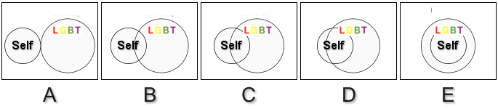

F. Social Cohesion
F1. You can count on other MSM in your group of friends if you need to borrow money.
- Strongly Agree
- Agree
- Disagree
- Strongly Disagree

F2. You can count on other MSM in your group of friends if you need to talk about your problems.
- Strongly Agree
- Agree
- Disagree
- Strongly Disagree

F3. You can count on other MSM in your group of friends if you need somewhere to stay.
- Strongly Agree
- Agree
- Disagree
- Strongly Disagree

F4. The group of MSM with whom you socialize with is an integrated group.
- Strongly Agree
- Agree
- Disagree
- Strongly Disagree

F5. You can trust the majority of the MSM you know.
- Strongly Agree
- Agree
- Disagree
- Strongly Disagree

F6. In general, MSM in your group of friends in the area where you live only worry about themselves
- Strongly Agree
- Agree
- Disagree
- Strongly Disagree

F7. In general the MSM you socialize with are always arguing amongst each other
- Strongly Agree
- Agree
- Disagree
- Strongly Disagree

G. Pay-It-Forward Participation (Pay-it-forward arm only)
G1. Today, you came to testing:
- By yourself (Skip to G3)
- Accompanied by someone else

G2. How would you describe your relationship to the person accompanying you?
1. Sex partner
2. MSM peer
3. Non-MSM peer
4. Family
5. Other, specify:____

G3. Did you choose to contribute any amount of money?
- Yes
- No

G4. What determined your contribution amount?
1. One’s own financial situation
2. Normal price of testing
3. Quality of testing service
4. Estimate of how much others contributed
5. Feel bad if not pay anything
6. Other, specify:______

G5. What do you believe are the main benefits to participating in the PIF program? (select all that apply)
- I can receive discounted GC/CT test
- I can experience warm glow through receiving donated testing
- It reduces my STI risk by making my community healthier
- It can help more MSM get tested
- It allows someone to help me, and then I can help someone else
- Other ____________________

G. Pay-What-You-Want Participation
(Pay-what-you-want arm only)
G1. Today, you came to testing:
- By yourself (Skip to G3)
- Accompanied by someone else

G2. How would you describe your relationship to the person accompanying you?
1. Sex partner
2. MSM peer
3. Non-MSM peer
4. Family
5. Other:____

G3. Did you choose to contribute any amount of money?
- Yes
- No

G4. What determined your contribution amount?
1. One’s own financial situation
2. Normal price of testing
3. Quality of testing service
4. Estimate of how much others contributed
5. Feel bad if not pay anything
6. Other:_______

G5. What do you believe are the main benefits to participating in the PIF program? (select all that apply)
- I can receive discounted GC/CT test
- I can experience warm glow through receiving discounted testing
- It reduces my STI risk by making my community healthier
- It can help more MSM get tested
- It allows MSM to have more control over testing price
- Other ____________________

Supplement File 2. Costing analysis results
Costing analysis
We estimated the full economic cost (i.e. includes the costs of all resources used to introduce the testing models) from a health provider perspective using a microcosting approach. We tracked the actual resource used in the trial and categorized cost items as either fixed or variable. For fixed costs (i.e. independent of number of tests conducted), we estimated the cost of start-up (training), capital (building rent), personnel support and office equipment. We annualized costs over an expected useful life of five years, including start-up costs, using a discount rate of 3%. For variable costs (i.e. dependent on the number of tests conducted), we estimated the cost of supplies used for chlamydia and gonorrhoea testing and personnel cost. All costs are reported in 2018 USD based on the exchange rates using OANDA currency conversions (1USD = 6.76 Yuan). We analyzed the cost in Excel 2019 (Microsoft, USA).

Cost-effectiveness analysis
Using parameters from Table S1, which were informed by the trial, we created a decision-tree model using TreeAge Pro 2019 (TreeAge Software Inc) to explore the cost-effectiveness of pay-it-forward, pay-what-you-want and the standard-of-care (Figure S1).

Table S1, Unit costs of pay-it-forward, pay-what-you-want, and standard of care used in the model
Tests performed | USD 2018 | Distribution
- PIF* | 57 | Beta (55.3, 41.7)
- PWYW* | 46 | Beta (45.2, 53.1)
- SOC* | 18 | Beta (18.2, 83.0)
Chlamydia or gonorrhoea diagnosed
- PIF | 8 | Beta (7.9, 48.2)
- PWYW | 8 | Beta (7.8, 37.0)
- SOC | 4 | Beta (3.8, 13.2)
Fixed cost PIF or PWYW or SOC | Unit cost per person tested
- Building rental | 0.40 | Gamma (36, 90)
- Office equipment | 0.08 | Gamma (36, 432)
- Start-up | 1.22 | Gamma (36, 30)
- Total fixed cost | 1.70
Variable cost PIF
- Supplies | 14.49 | Gamma (36,2)
- Personnel | 2.24 | Gamma (36, 16)
- Total variable cost | 16.73
Variable cost PWYW
- Supplies | 14.57 | Gamma (36, 2)
- Personnel | 2.75 | Gamma (36, 13)
- Total variable cost | 17.32
Variable cost SOC
- Supplies | 17.50 | Gamma (36, 2)
- Personnel | 7.03 | Gamma (36, 5)
- Total variable cost | 24.53
Donations/payment
- PIF | 8.29
- PWYW | 6.77
- SOC | 25.89
*PIF=pay-it-forward, PWYW=pay-what-you-want, SOC=standard of care

The total economic cost for the pay-it-forward ($1125) and for the pay-what-you-want ($967) arm was higher than that of the standard of care ($612). Of the 57 men who received testing through the pay-it-forward arm, 54 (94.6%) chose to donate some amount toward testing of future participants. Among the 46 men who tested through pay-what-you-want, 42 (91.3%) donated some amount toward future participants. The total donations/payment amount was $472.78 in the pay-it-forward arm, $311.39 in the pay-what-you-want arm, and $465.98 in the standard of care arm. The mean donation/payment amount was $8.29 (standard deviation, SD: $7.35) for men in the pay-it-forward arm (median: $7.73, IQR: $6.18), $6.77 (SD: $9.63) for men in the pay-what-you-want arm (median: $3.09, IQR: $6.36), and $25.89 in the standard of care arm (Three people in the standard of care arm tested for both urine and rectal samples, which increased the average price to higher than $22.) The economic cost per person tested was $19.72 in the pay-it-forward arm, $21.02 in the pay-what-you-want arm, and $34 in the standard of care arm, all compared to no testing. Accounting for the donations/payments made, the financial cost per person tested was: $11.43 in the pay-it-forward arm, $14.26 in the pay-what-you-want arm and $8.11 in the standard of care arm.

The economic cost per case detected was: $140.50 in the pay-it-forward arm, $120.88 in the pay-what-you-want arm, and $153.00 in the standard of care arm. Accounting for the donations/payments made, the financial cost per case detected was: $81.50 in the pay-it-forward arm, $82.00 in the pay-what-you-want arm, and $36.50 in the standard-of-care arm.
The ICER using economic costs per additional person tested was $14.27 (pay-it-forward compared with pay-what-you-want) and $12.68 (pay-what-you-want compared with standard of care). The ICER using economic costs per additional case detected was: $88.75 (pay-what-you-want compared with standard of care), and pay-what-you-want dominated (i.e. was cheaper and more effective than) pay-it-forward. The ICER using financial costs per additional person tested was: $12.96 (pay-it-forward compared with standard of care), and pay-it-forward dominated pay-what-you-want. The ICER using financial costs per additional case detected was: $126.34 (pay-it-forward compared with standard of care), and pay-it-forward dominated pay-what-you-want.

Figure S1, Decision tree model

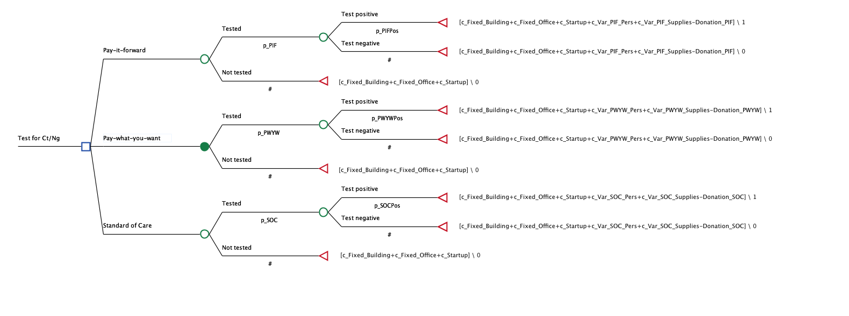

We calculated the incremental cost-effectiveness ratios for cost per test conducted and cost per chlamydia/gonorrhoea diagnosed. We chose a within-trial time horizon (i.e. less than one year). Projecting the long-term impact of chlamydia/gonorrhoea testing (i.e. accounting for secondary effects of infections averted) is beyond the scope of this analysis. Thus, we provide a conservative estimate of the value of these testing models. (Table S2)

Table S2, Costs, effectiveness and cost-effectiveness of pay-it-forward, pay-what-you-want and standard-of-care arms

Strategy | Economic Cost | Incremental cost | Effectiveness | Incremental effectiveness | ICER
Test
SOC* | 6.12 |  | 0.18
PWYW* | 9.67 | 3.55 | 0.46 | 0.28 | 12.68
PIF* | 11.24 | 1.57 | 0.57 | 0.11 | 14.27
Test positive
SOC | 6.12 |  | 0.04
PWYW | 9.67 | 3.55 | 0.08 | 0.04 | 88.75
PIF | 11.24 | 1.57 | 0.08 | 0 | Dominated
Strategy | Financial Cost | Incremental cost | Effectiveness | Incremental effectiveness | ICER
Test
SOC | 1.46 |  | 0.18
PIF | 6.52 | 5.05 | 0.57 | 0.39 | 12.96
PWYW | 6.56 | 0.04 | 0.46 | -0.11 | Dominated
Test positive
SOC | 1.46 |  | 0.04
PIF | 6.52 | 5.05 | 0.08 | 0.04 | 126.34
PWYW | 6.56 | 0.04 | 0.08 | 0 | Dominated
*PIF=pay-it-forward, PWYW=pay-what-you-want, SOC=standard of care

Univariate sensitivity analyses are presented as tornado diagrams in Figures S2-6. For ICERs of cost per additional person tested, the biggest drivers of cost-effectiveness were the variable costs of supplies and the probability of testing when comparing PWYW/PIF with standard of care (Figures S2-3). When comparing PWYW with PIF, the biggest drivers of cost-effectiveness were variable costs of supplies (Figure S4).

Figure S2 Tornado plot of the ICER of cost per additional person tested for PWYW vs. standard of care
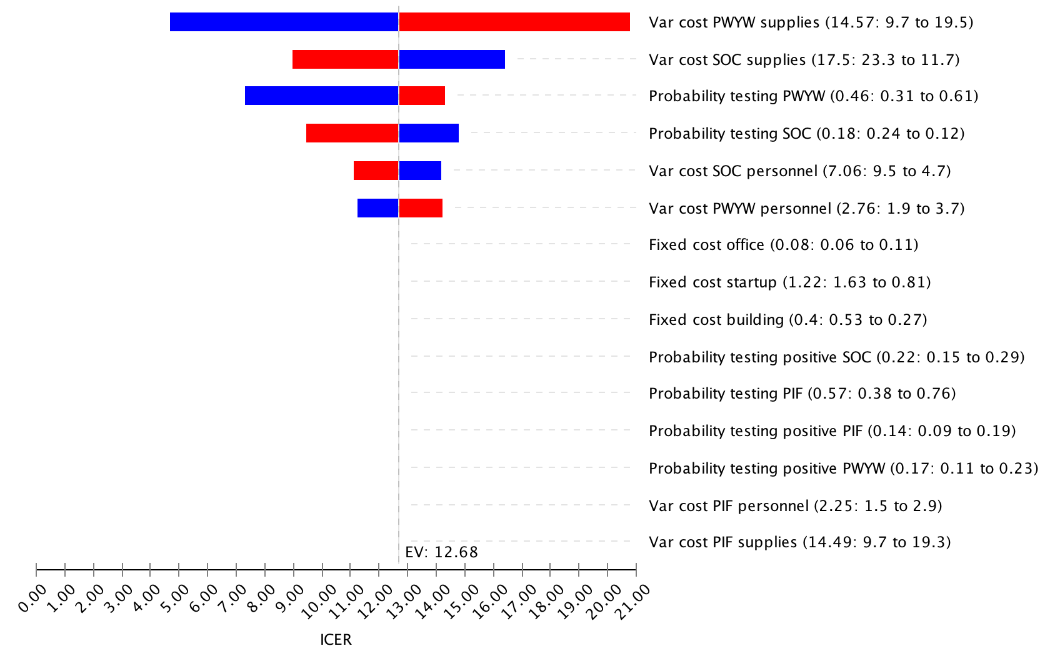

Figure S3 Tornado plot of the ICER of cost per additional person tested for PIF vs. standard of care
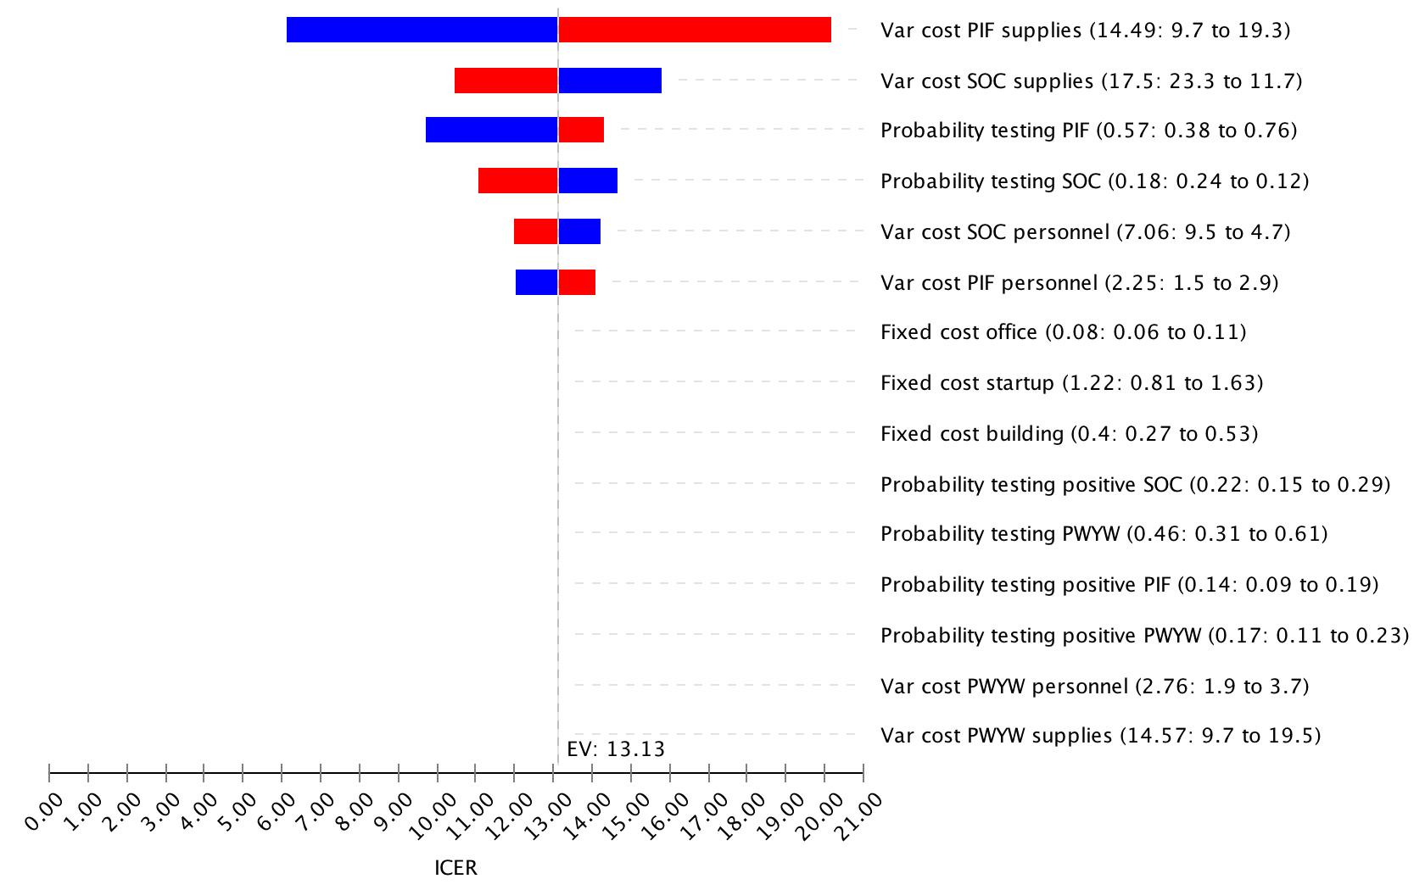

Figure S4 Tornado plot of the ICER of cost per additional person tested for PIF vs. PWYW
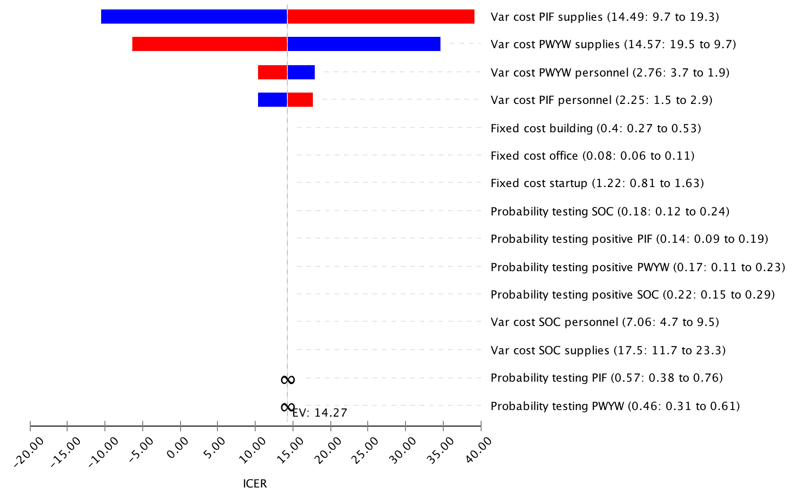

For ICERs of cost per additional case diagnosed, the biggest drivers of cost-effectiveness was the probability of testing positive (PWYW/PIF) when comparing PWYW/PIF with standard-of-care.

Figure S5, Tornado plot of the ICER of cost per additional case diagnosed for PWYW vs. standard of care
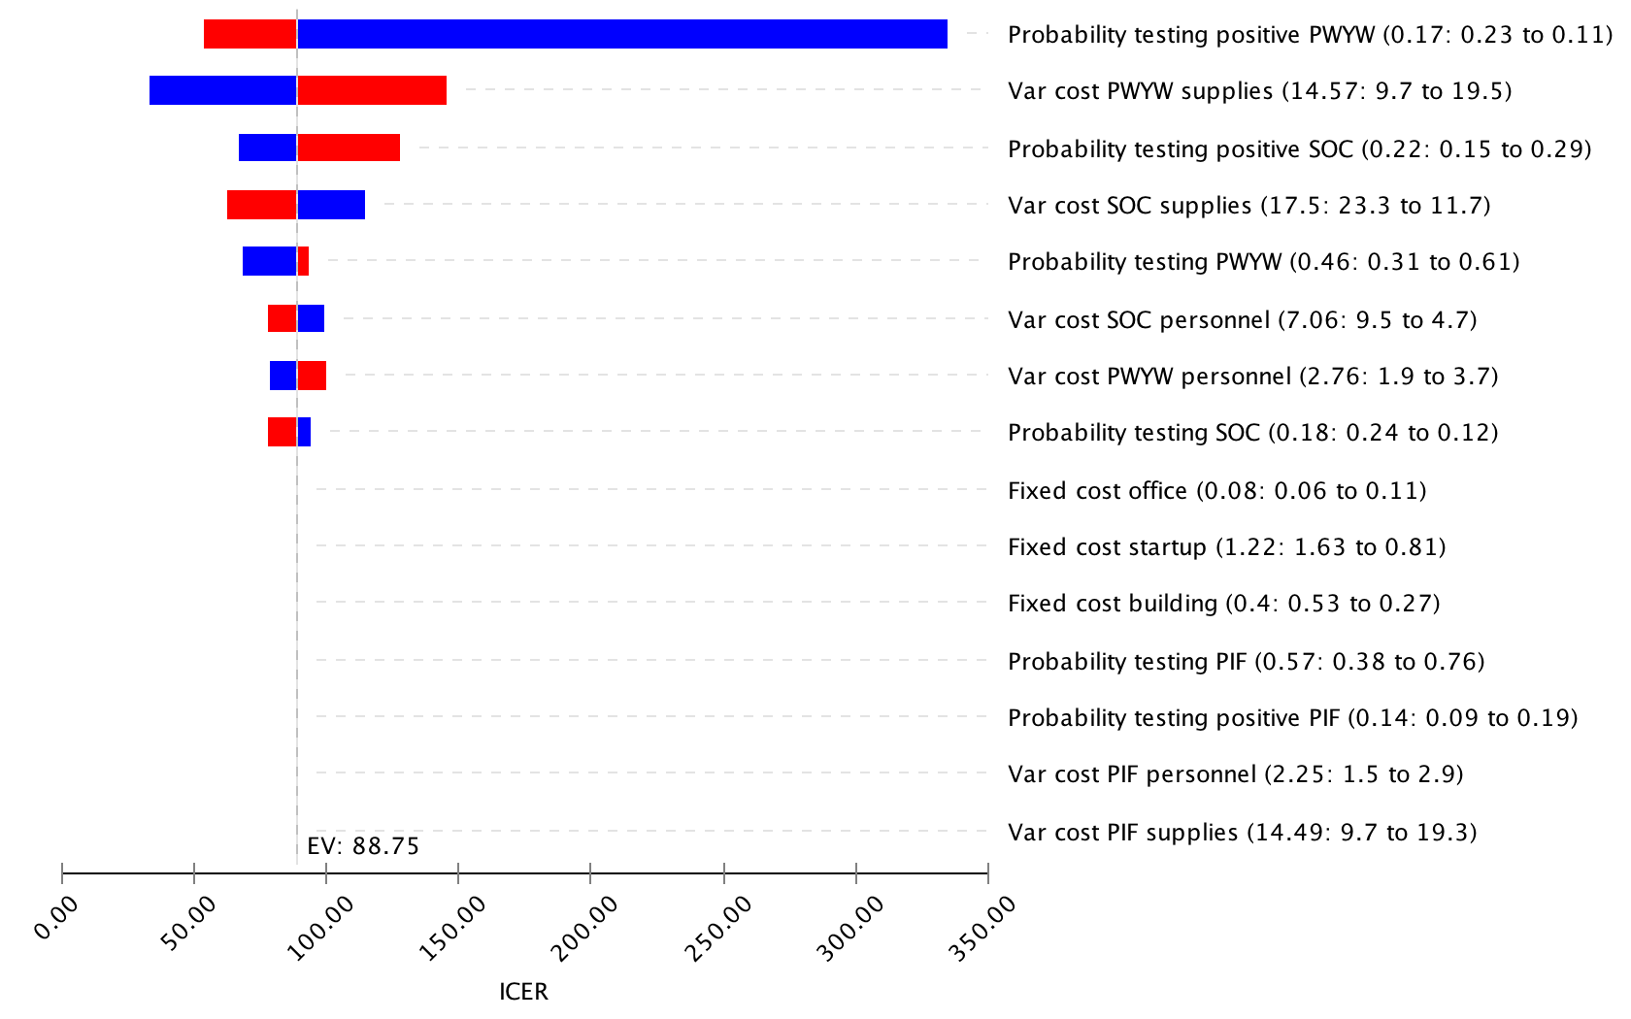

Figure S6, Tornado plot of the ICER of cost per additional case diagnosed for PIF vs. standard of care
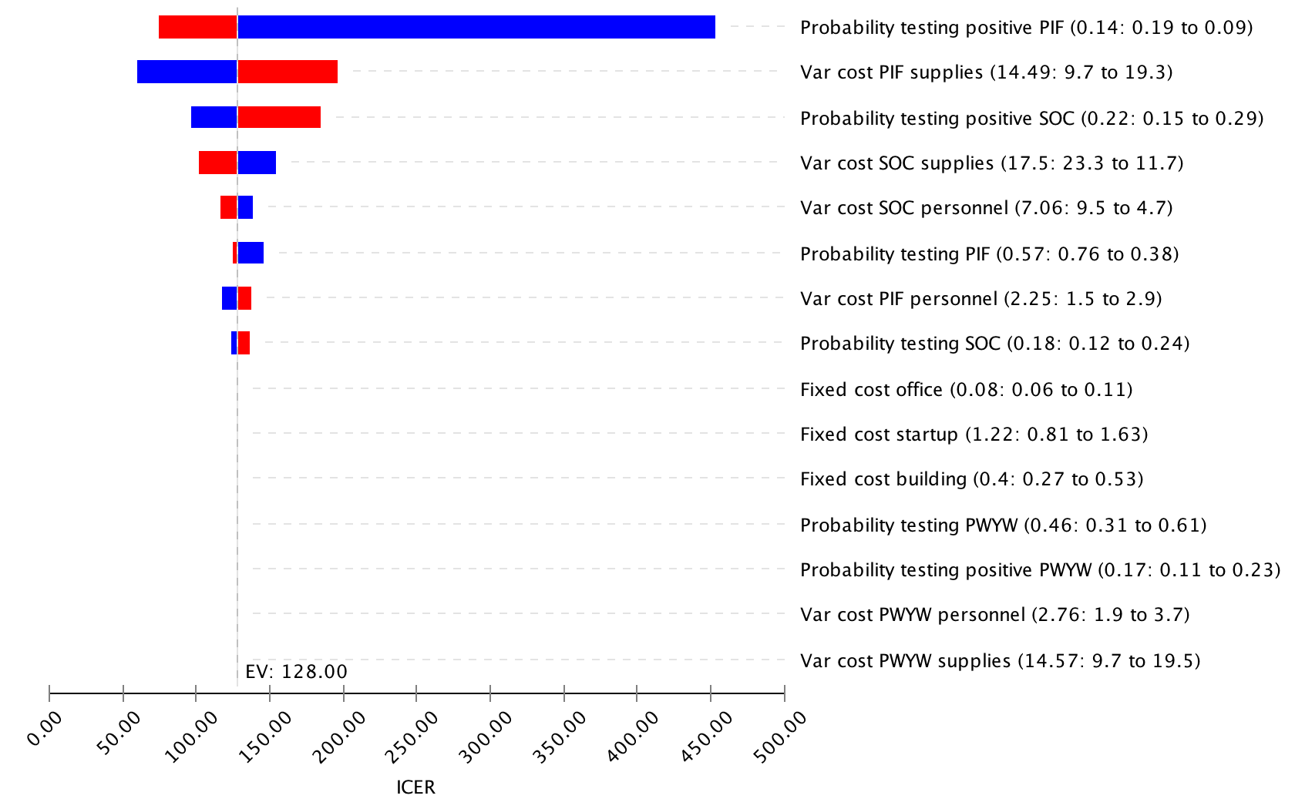

Probabilistic sensitivity analyses with 100,000 runs were conducted and presented in acceptability curves. These figures show the probability of being cost-effective (y-axis) depending on the willingness to pay thresholds (x-axis). Figure S7 shows that the pay-it-forward has a greater than 90% probability of being cost-effective than pay-what-you-want and standard of care, if the willingness to pay is greater than $50 per person tested.

Figure S7 Acceptability curve of the economic cost per person tested
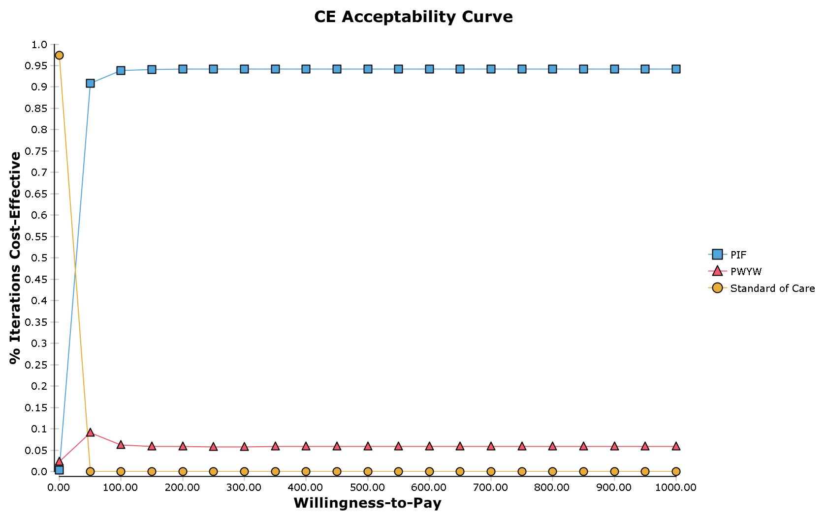

Figure S8 shows that the PIF or PWYW arms has a greater probability of being more cost-effectiveness than SOC if the willingness to pay is greater than $100 per case detected.

Figure S8, Acceptability curve of the economic cost per case detected
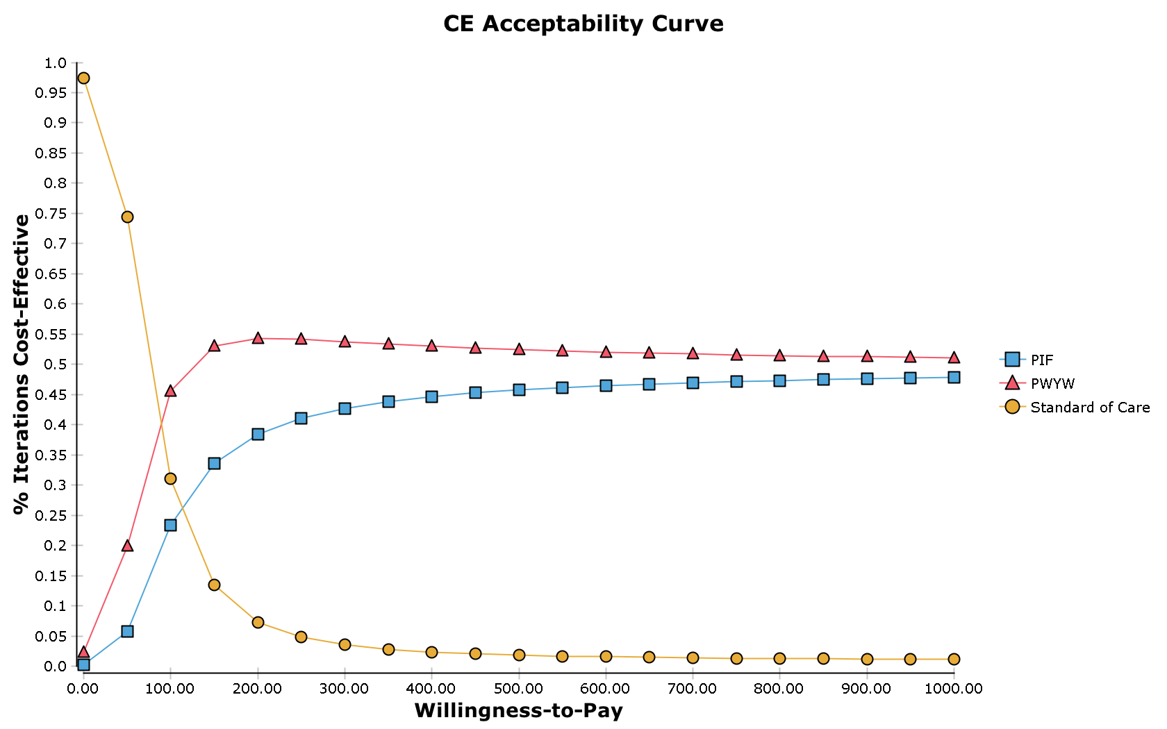

These conclusions from Figure S7 and S8, do not change if we take into account the donations/payments (see Figures S9 and S10).

Figure S9, Acceptability curve of the financial cost per person tested
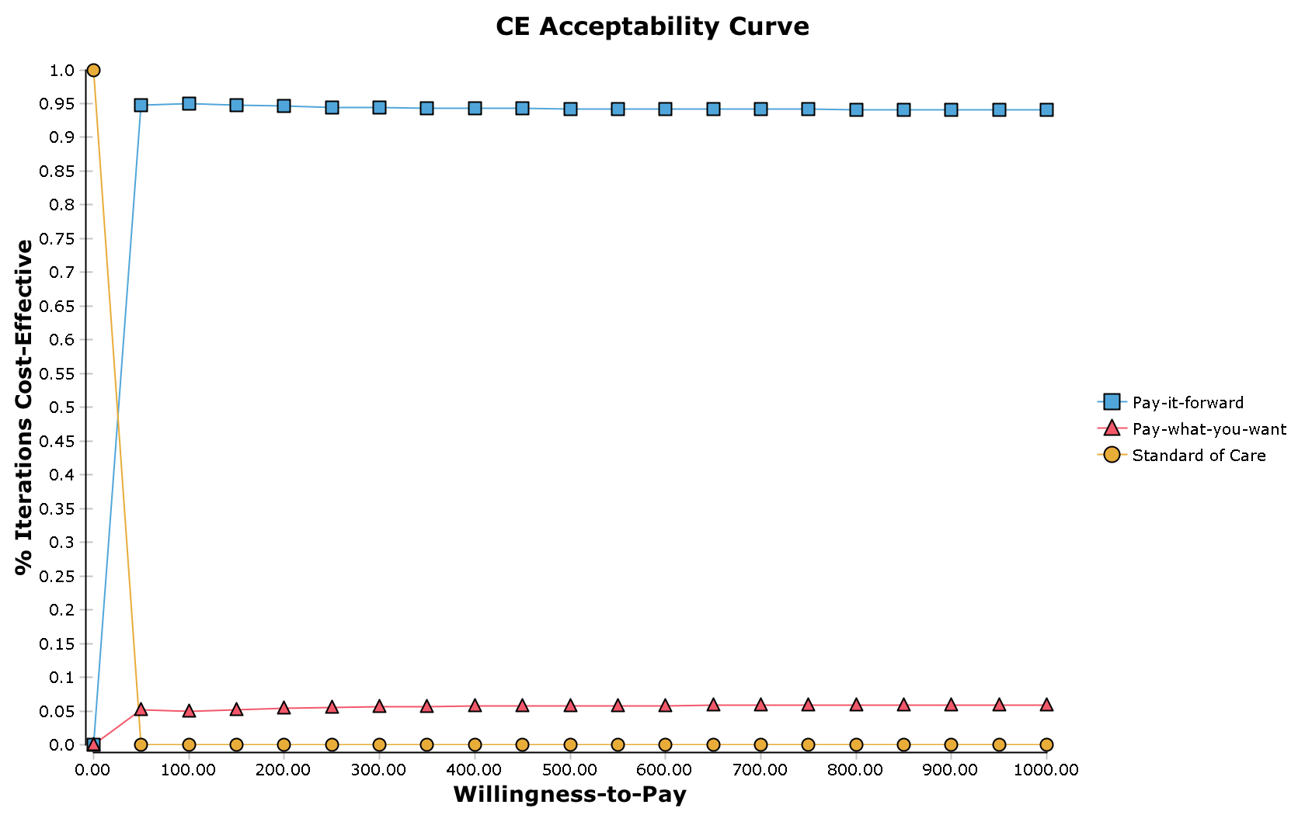

Figure S10, Acceptability curve of the financial cost per case detected
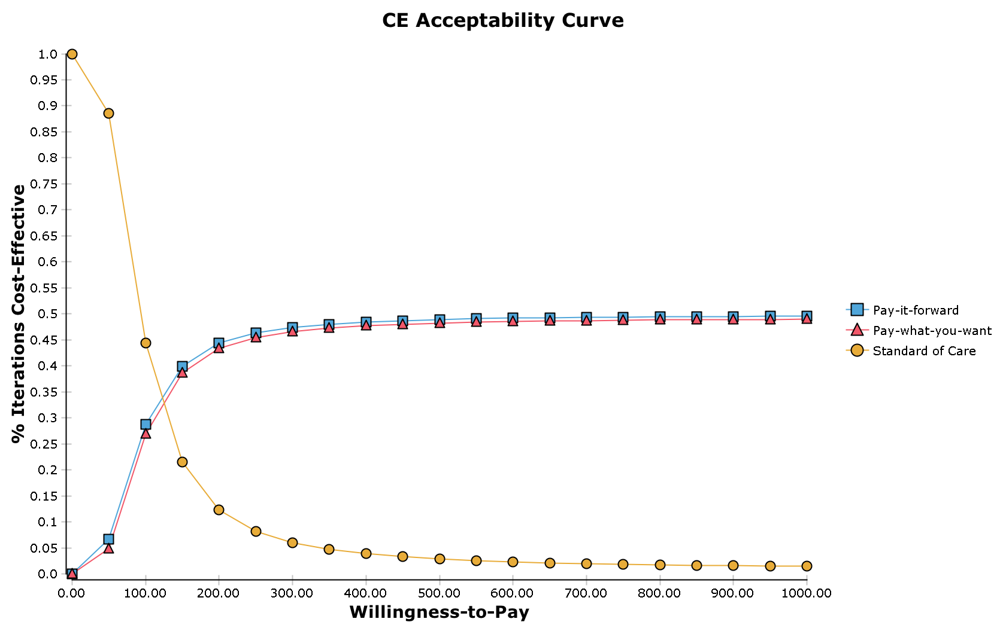

Supplement File 3. Pay-it-forward summary video
Download:
https://www.dropbox.com/s/buqiuq8q25ce1q3/PIF%20Video.mov?dl=0

Size: 483 MB

Supplement File 4. Models results adjusting for different covariates for primary outcome

 | Prob diff. | 95%CI lower bound | p-value
Pay-it-forward (v.s. standard of care)  Crude model  Model 1  Model 2  Model 3  Model 4  Model 5 | 0.384  0.390  0.390  0.389  0.388  0.390 | 0.284  0.283  0.278  0.278  0.281  0.282 | <0.001  <0.001  <0.001  <0.001  <0.001  <0.001
Pay-what-you-want (v.s. standard of care)  Crude model  Model 1  Model 2  Model 3  Model 4  Model 5 | 0.280  0.278  0.273  0.273  0.275  0.286 | 0.163  0.153  0.147  0.145  0.148  0.160 | <0.001  <0.001  <0.001  <0.001  <0.001  <0.001
Model 1: adjusted for age and site
Model 2: adjusted for age, site, and marital status.
Model 3: adjusted for age, site, marital status, and income.
Model 4: adjusted for age, site, marital status, income, and education
Model 5: adjusted for age, site, income, education (high/vocational school versus Bachelor’s degree and above), and sex role (insertive, receptive, half and half)
Note: None of the covariates was significantly associated with the outcome.

Supplement File 5. Sample size calculation for pay-it-forward and pay-what-you-want interventions

Pay-it-forward Superiority by a Margin Tests for the Difference of Two Proportions in a Group-Randomized Design

Summary Statements ─────────────────────────────────────────────────────────
Sample sizes of 30 in group 1 and 30 in group 2, which were obtained by sampling 3 groups
with 10 subjects each in group 1 and 3 groups with 10 subjects each in group 2, achieve
84.515% power to detect a superiority margin difference between the group proportions of
0.2000. The proportion in group 1 (the treatment group) is assumed to be 0.2600 under the null
hypothesis and 0.5400 under the alternative hypothesis. The proportion in group 2 (the control
group) is 0.0600. The test statistic used is the one-sided Z-Test (Unpooled). The intracluster
correlation is 0.0100, and the significance level of the test is 0.050

Numeric Results for Superiority Tests for the Difference of Two Proportions (Cluster-Randomized) ─────
Test Statistic: Z-Test (Unpooled)
H0: P1 - P2 ≤ D0. H1: P1 - P2 = D1 > D0.

Group 1 Group 2 Intra-
Clusters/ Clusters/ Group 2 Group 1 Group 1 Cluster
Items Items Prop Prop|H0 Prop|H1 Diff|H0 Diff|H1 Corr.
Power K1/M1 K2/M2 P2 P1.0 P1.1 D0 D1 ICC Alpha
0.84515 3/10 3/10 0.0600 0.2600 0.5400 0.2000 0.4800 0.0100 0.050
0.84588 4/10 4/10 0.0600 0.2600 0.5400 0.2000 0.4800 0.0500 0.050

Procedure Input Settings ──────────────────────────────────────────────────────
Design Tab
Solve For: Sample Size (K1)
Alternative Hypothesis: One-Sided (H1: D1 > D0)
Test Type: Z-Test (Unpooled)
Power: 0.80
Alpha: 0.05
M1 (Items per group in study Group 1): 10
K2 (groups in study Group 2): K1
M2 (Items per group in study Group 2): 10
Input Type: Differences
D0 (Difference|H0 = P1.0 - P2): 0.2
D1 (Difference|H1 = P1.1 - P2) 0.48
P2 (Group 2 Proportion): 0.06
ICC (Intracluster Correlation): 0.01 0.05

Report Definitions
H0 is an abbreviation for the null hypothesis. This is the hypothesis being evaluated by the statistical test.
H1 is an abbreviation for the alternative hypothesis. This hypothesis gives the 'true' parameter values.
Power is the probability of rejecting a false null hypothesis. It should be close to one.
K1 and K2 are the number of groups in each study group.
M1 and M2 are the average number of items (subjects) per group in each study grou[.
P2 is the proportion for group 2. This is the standard, reference, baseline, or control group.
P1.0 is the proportion for group 1 (treatment group) assuming the null hypothesis (H0).
P1.1 is the proportion for group 1 (treatment group) assuming the alternative hypothesis (H1).
D0 = P1.0 - P2 is the superiority margin. It is the difference assuming H0.
D1 = P1.1 - P2 is the actual difference at which the power is calculated.
ICC is the intracluster correlation.
Alpha is the probability of rejecting a true null hypothesis.

Pay-what-you-want Superiority by a Margin Tests for the Difference of Two Proportions in a Group-Randomized Design

Summary Statements ─────────────────────────────────────────────────────────
Sample sizes of 80 in group 1 and 80 in group 2, which were obtained by sampling 8 groups
with 10 subjects each in group 1 and 8 groups with 10 subjects each in study group 2, achieve
80.448% power to detect a superiority margin difference between the group proportions of
0.2000. The proportion in group 1 (the treatment group) is assumed to be 0.2600 under the null
hypothesis and 0.4200 under the alternative hypothesis. The proportion in group 2 (the control
group) is 0.0600. The test statistic used is the one-sided Z-Test (Unpooled). The intracluster
correlation is 0.0100, and the significance level of the test is 0.050.

Numeric Results for Superiority Tests for the Difference of Two Proportions (Cluster-Randomized) ─────
Test Statistic: Z-Test (Unpooled)
H0: P1 - P2 ≤ D0. H1: P1 - P2 = D1 > D0.

Group 1 Group 2 Intra-
Clusters/ Clusters/ Group 2 Group 1 Group 1 Cluster
Items Items Prop Prop|H0 Prop|H1 Diff|H0 Diff|H1 Corr.
Power K1/M1 K2/M2 P2 P1.0 P1.1 D0 D1 ICC Alpha
0.80448 8/10 8/10 0.0600 0.2600 0.4200 0.2000 0.3600 0.0100 0.050
0.81580 11/10 11/10 0.0600 0.2600 0.4200 0.2000 0.3600 0.0500 0.050

Procedure Input Settings ──────────────────────────────────────────────────────
Design Tab
Solve For: Sample Size (K1)
Alternative Hypothesis: One-Sided (H1: D1 > D0)
Test Type: Z-Test (Unpooled)
Power: 0.80
Alpha: 0.05
M1 (Items per group in study Group 1): 10
K2 (Groups in study Group 2): K1
M2 (Items per group in study Group 2): 10
Input Type: Differences
D0 (Difference|H0 = P1.0 - P2): 0.2
D1 (Difference|H1 = P1.1 - P2) 0.36
P2 (Group 2 Proportion): 0.06
ICC (Intracluster Correlation): 0.01 0.05

Report Definitions
H0 is an abbreviation for the null hypothesis. This is the hypothesis being evaluated by the statistical test.
H1 is an abbreviation for the alternative hypothesis. This hypothesis gives the 'true' parameter values.
Power is the probability of rejecting a false null hypothesis. It should be close to one.
K1 and K2 are the number of groups in study groups 1 and 2, respectively.
M1 and M2 are the average number of items (subjects) per group in study groups 1 and 2, respectively.
P2 is the proportion for group 2. This is the standard, reference, baseline, or control group.
P1.0 is the proportion for group 1 (treatment group) assuming the null hypothesis (H0).
P1.1 is the proportion for group 1 (treatment group) assuming the alternative hypothesis (H1).
D0 = P1.0 - P2 is the superiority margin. It is the difference assuming H0.
D1 = P1.1 - P2 is the actual difference at which the power is calculated.
ICC is the intracluster correlation.
Alpha is the probability of rejecting a true null hypothesis.

Summary: Based on implementation considerations, we decided on a total of ten groups for each arm in testing the hypotheses that pay-it-forward/pay-what-you-want is superior to standard of care in terms of increasing test uptake.

Supplement File 6. Randomization

STATA code used to generate the random allocation sequence of the three study groups in a triplet:

** 1: PIF
** 2: PWYW
** 3: SOC

*** block 1: ShengPi (study site 1)
*** block 2& 3: ShiPi (study site 2)
*** block 4 to 10: BlueD (study site 3)

set obs 30
egen id = seq(), to(3)
egen block = seq(), block(3)
set seed 666666
gen random = uniform()
sort block random
list block id, noobs clean

Supplement File 5. CONSORT 2010 checklist for a randomised controlled trial
Section/Topic | Item No | Checklist item | Reported on page No
Title and abstract
 | 1a | Identification as a randomised trial in the title | Page 1
 | 1b | Structured summary of trial design, methods, results, and conclusions (for specific guidance see CONSORT for abstracts) | Page 2-3
Introduction
Background and objectives | 2a | Scientific background and explanation of rationale | Page 4-5
 | 2b | Specific objectives or hypotheses | Page 5
Methods
Trial design | 3a | Description of trial design (such as parallel, factorial) including allocation ratio | Page 5-6
 | 3b | Important changes to methods after trial commencement (such as eligibility criteria), with reasons | N/A
Participants | 4a | Eligibility criteria for participants | Page 6
 | 4b | Settings and locations where the data were collected | Page 5
Interventions | 5 | The interventions for each group with sufficient details to allow replication, including how and when they were actually administered | Page 7-9
Outcomes | 6a | Completely defined pre-specified primary and secondary outcome measures, including how and when they were assessed | Page 9
 | 6b | Any changes to trial outcomes after the trial commenced, with reasons | N/A
Sample size | 7a | How sample size was determined | Page 7
 | 7b | When applicable, explanation of any interim analyses and stopping guidelines | N/A
Randomisation:
Sequence generation | 8a | Method used to generate the random allocation sequence | Page 7 & supplementfile 6
 | 8b | Type of randomisation; details of any restriction (such as blocking and block size) | Page 7
Allocation concealment mechanism | 9 | Mechanism used to implement the random allocation sequence (such as sequentially numbered containers), describing any steps taken to conceal the sequence until interventions were assigned | Page 7
Implementation | 10 | Who generated the random allocation sequence, who enrolled participants, and who assigned participants to interventions | Page 6-8
Blinding | 11a | If done, who was blinded after assignment to interventions (for example, participants, care providers, those assessing outcomes) and how | Page 7
 | 11b | If relevant, description of the similarity of interventions | N/A
Statistical methods | 12a | Statistical methods used to compare groups for primary and secondary outcomes | Page 10
 | 12b | Methods for additional analyses, such as subgroup analyses and adjusted analyses | Page 10
Results
Participant flow (a diagram is strongly recommended) | 13a | For each group, the numbers of participants who were randomly assigned, received intended treatment, and were analysed for the primary outcome | Page 11
 | 13b | For each group, losses and exclusions after randomisation, together with reasons | Page 11 & Figure 2
Recruitment | 14a | Dates defining the periods of recruitment and follow-up | Page 9
 | 14b | Why the trial ended or was stopped | Page 9
Baseline data | 15 | A table showing baseline demographic and clinical characteristics for each group | Page 21
Numbers analysed | 16 | For each group, number of participants (denominator) included in each analysis and whether the analysis was by original assigned groups | Page 20
Outcomes and estimation | 17a | For each primary and secondary outcome, results for each group, and the estimated effect size and its precision (such as 95% confidence interval) | Page 11-13
 | 17b | For binary outcomes, presentation of both absolute and relative effect sizes is recommended | Page 11-13
Ancillary analyses | 18 | Results of any other analyses performed, including subgroup analyses and adjusted analyses, distinguishing pre-specified from exploratory | Page 11-13
Harms | 19 | All important harms or unintended effects in each group (for specific guidance see CONSORT for harms) | N/A
Discussion
Limitations | 20 | Trial limitations, addressing sources of potential bias, imprecision, and, if relevant, multiplicity of analyses | Page 14-15
Generalisability | 21 | Generalisability (external validity, applicability) of the trial findings | Page 14
Interpretation | 22 | Interpretation consistent with results, balancing benefits and harms, and considering other relevant evidence | Page 13-14
Other information
Registration | 23 | Registration number and name of trial registry | Page 2&6
Protocol | 24 | Where the full trial protocol can be accessed, if available | Page 6
Funding | 25 | Sources of funding and other support (such as supply of drugs), role of funders | Page 3
* This checklist was retrieved from www.consort-statement.org.

