TITLE - Campylobacter jejuni
DESCRIPTIVE TITLE - Campylobacter jejuni: Survival Instincts

Ozan Gundogdu^{1*}and Brendan W. Wren^{1*}
London School of Hygiene & Tropical Medicine,
Department of Infection Biology,
Faculty of Infectious & Tropical Diseases,
Keppel Street, London, WC1E 7HT

*Corresponding authors
Corresponding author email address: ozan.gundogdu@lshtm.ac.uk and brendan.wren@lshtm.ac.uk

ABSTRACT (100 words)
Campylobacter jejuni is considered to be the most common bacterial cause of human gastroenteritis worldwide. C. jejuni can cause bloody diarrhea, fever and abdominal pains in humans along with post infectious sequelae such as Guillain-Barré syndrome (a paralytic autoimmune complication). C. jejuni infections can be fatal, particularly among young children. C. jejuni are distributed in most warm-blooded animals, therefore the main route of transmission is generally foodborne, via the consumption and handling of meat products (particularly poultry). C. jejuni is microaerophilic and oxygen sensitive, however it appears to be omnipresent in the environment, one of many Campylobacter contradictions.

TAXONOMY (50 words)
Phylum: Proteobacteria; Class: Epsilonproteobacteria; Order: Campylobacterales; Family: Campylobacteraceae; Genus: Campylobacter; Species: C. jejuni. C. jejuni has two sub-species, C. jejuni subsp. jejuni and C. jejuni subsp. doylei. Interestingly it has been described that the Epsilonproteobacteria within the Proteobacteria may not be warranted, and that this group should be reassigned to a novel phylum (1).

PROPERTIES (100 words)
C. jejuni is a Gram-negative bacterium classified as microaerophilic and capnophilic, and requires atmospheric conditions of 3-10% oxygen and 5-10% carbon dioxide for optimal growth, with a growth temperature range between 30°C - 47°C. C. jejuni can be curved, rod-shaped or spiral, with a size range of 0.2 - 0.8 μm width and 0.5 - 5.0 μm length, with amphitrichous flagella. The bacterium is oxidase positive and energy is typically obtained from amino acids or tricarboxylic acid cycle intermediates rather than the utilisation of carbohydrates.

GENOME (200 words)
C. jejuni strain NCTC11168 was among the first bacterial genomes sequenced with an estimated size of 1.64 Mb (30.6% G+C) and 1,654 predicted open reading frames (ORFs). This genome was later re-annotated to 1,643 ORFs. The NCTC11168 genome is unusual with the lack of insertion, phage-associated and repeat sequences. However, it has a high prevalence of homopolymeric tracts resulting in the slip-strand mispairing of genes encoding surface structures such as the capsule and the lipooligosaccharide (LOS). No type III or IV secretion systems were identified, however a general N-linked glycosylation system that post translationally modifies over 70 proteins was identified. C. jejuni displays extensive ongoing genetic variation, which arise from intragenomic mechanisms as well as genetic exchange between strains and other species (2). The genomic diversity and plasticity of C. jejuni is demonstrated with the existing large number of sequence types (STs), host generalist and specialist strains. Further C. jejuni strains have since been sequenced from human, animal and environmental sources and have varied genotypic and phenotypic characteristics (e.g. C. jejuni 81-176 harbouring plasmids pVir and pTet). Recent studies have also identified an increasing number of strains with type VI secretion systems (T6SSs) (3). However, in contrast to other enteric pathogens relatively few genomes have been sequenced and the true global diversity and representation of the C. jejuni pan-genome remains to be determined.

PHYLOGENY (150 words)
The Epsilonproteobacteria class of Proteobacteria consist of the renowned Helicobacter and Campylobacter species. There are currently 17 species and six subspecies assigned to the genus Campylobacter. The most frequently reported are C. jejuni (subspecies jejuni) and C. coli. The vast majority of Epsilonproteobacterial species exist in deep-sea hydrothermal vents (e.g. Sulfurimonas spp), perhaps indicating an ancient origin of the Campylobacter genus. These bacteria characteristically exhibit chemolithotrophy; organisms that can derive their cellular carbon from carbon dioxide, thus able to grow without organic compounds or light. Some deep-sea vent Epsilonproteobacteria also share potential virulence genes from pathogenic counterparts, e.g. CiaB and hemolysin. Interestingly, many of the deep-sea vent species have the unusual N-linked general protein glycosylation system first identified in C. jejuni NCTC11168. Thus, evolutionary links exist between important human/animal pathogens such as Campylobacter and Helicobacter, and their non-pathogenic chemolithoautotrophic deep-sea vent distant relatives.

KEY FEATURES AND DISCOVERIES (400 words)
Despite specific microaerobic growth requirements (4), C. jejuni is ubiquitous in the ambient environment and must have genetic regulatory mechanisms to withstand aerobic stresses. C. jejuni possesses a range of enzymes that are involved in the breakdown of reactive oxygen species (ROS), e.g. KatA and SodB. C. jejuni also comprises regulators involved in the oxidative stress response such as PerR, Fur, RrpA, RrpB and CosR. Many of these regulators have dual functions and are often linked with metabolic functions such as iron homeostasis. One key attribute of C. jejuni aiding its survival is the ability to form and survive in biofilms and under stress to form viable but nonculturable cells.

Key structures such as LOS, capsule and flagella have been investigated with the aim of understanding C. jejuni survival and pathogenesis. Flagella, which are modified by an O-linked glycosylation system, have been hypothesized not only to play a role in motility, but may also act as a secretion system discharging effectors such as CiaB. More recently, T6SSs have been identified in an increasing number of C. jejuni strains and the presence of T6SSs has been associated with a response to oxidative stress (5). C. jejuni produces a cytolethal distending toxin which has been reported to arrest at the G₁/S or G₂/M transition of the cell cycle, depending on the cell type. Adherence factors such as FlpA and CadF, which bind to fibronectin on epithelial cells have also been studied. It has been reported that C. jejuni primarily uses a microtubule-dependent process for penetration, and once inside the host cell, exists within a Campylobacter-containing vacuole (CCV). C. jejuni is able to modify the CCV to meet its metabolic needs and also interfere with the canonical endocytic pathway, preventing C. jejuni killing within lysosomes (6). Outer membrane vehicles (OMVs) have also been explored which can act as cargo delivery vehicles, possibly containing and delivering virulence related proteins (7).

In summary, the historical lack of a convenient animal model reproducing human disease has been a major hurdle in understanding the pathogenesis of Campylobacter infection, with only recently new models being available (8). Perhaps the biggest impact of C. jejuni research is the discovery and exploitation of the N-linked glycosylation system and its subsequent transfer to E. coli cells for glycobiotechnological applications (9). These include the development of low-cost recombinant glycoconjugate vaccines against many bacterial species, including C. jejuni.

OPEN QUESTIONS
Many questions remain and still perplex Campylobacteriologists including:
- How can a microaerophilic organism survive and be omnipresent in the environment?
- How does C. jejuni causes disease including diarrhea and post immune complications?
- Does C. jejuni survive intracellularly during human infection? If so what are the molecular mechanisms?
- Why are avians, particularly poultry, so susceptible to colonisation with C. jejuni?
- How can avians tolerate trillions of C. jejuni cells without having overt disease, yet only 500 cells cause severe disease in human hosts?
- Why does Campylobacteriosis present differently in low income countries (watery diarrhea) compared to high income countries (bloody diarrhea)?
- Has farming intensification in high income countries led to the expansion of selective clonal lineages that are different to strains from low income countries that often have T6SSs?

Funding information
We acknowledge the support of the Biotechnology and Biological Sciences Research Council Institute Strategic Programme BB/R012504/1 constituent project BBS/E/F/000PR10349.

Conflicts of interest
The authors declare that there are no conflicts of interest.

RECOMMENDED READING
1. Waite DW, Vanwonterghem I, Rinke C, Parks DH, Zhang Y, Takai K, et al. Comparative Genomic Analysis of the Class Epsilonproteobacteria and Proposed Reclassification to Epsilonbacteraeota (phyl. nov.). Frontiers in Microbiology. 2017;8(682).
2. Young KT, Davis LM, Dirita VJ. Campylobacter jejuni: molecular biology and pathogenesis. Nat Rev Microbiol. 2007;5(9):665-79.
3. Ugarte-Ruiz M, Stabler RA, Dominguez L, Porrero MC, Wren BW, Dorrell N, et al. Prevalence of Type VI Secretion System in Spanish Campylobacter jejuni Isolates. Zoonoses Public Health. 2015;62(7):497-500.
4. Taylor AJ, Kelly DJ. The function, biogenesis and regulation of the electron transport chains in Campylobacter jejuni: new insights into the bioenergetics of a major food-borne pathogen. Adv Microb Physiol. 2019;74:239-329.
5. Liaw J, Hong G, Davies C, Elmi A, Sima F, Stratakos A, et al. The Campylobacter jejuni Type VI Secretion System Enhances the Oxidative Stress Response and Host Colonization. Front Microbiol. 2019;10:2864.
6. Burnham PM, Hendrixson DR. Campylobacter jejuni: collective components promoting a successful enteric lifestyle. Nat Rev Microbiol. 2018;16(9):551-65.
7. Davies C, Taylor AJ, Elmi A, Winter J, Liaw J, Grabowska AD, et al. Sodium Taurocholate Stimulates Campylobacter jejuni Outer Membrane Vesicle Production via Down-Regulation of the Maintenance of Lipid Asymmetry Pathway. Front Cell Infect Microbiol. 2019;9:177.
8. Giallourou N, Medlock GL, Bolick DT, Medeiros PHQS, Ledwaba SE, Kolling GL, et al. A novel mouse model of Campylobacter jejuni enteropathy and diarrhea. PLOS Pathogens. 2018;14(3):e1007083.
9. Wacker M, Linton D, Hitchen PG, Nita-Lazar M, Haslam SM, North SJ, et al. N-linked glycosylation in Campylobacter jejuni and its functional transfer into E. coli. Science. 2002;298(5599):1790-3.

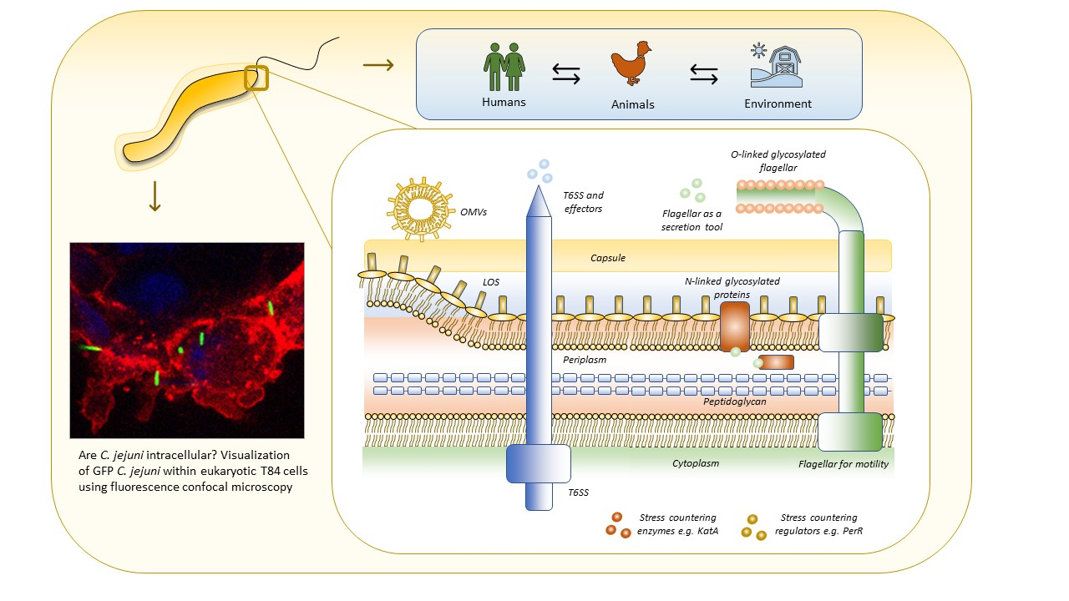

Graphical Abstract – (Top left) C. jejuni model. (Top right) C. jejuni transmission routes between humans, animals (particularly avian species) and the environment. (Bottom left) Are C. jejuni intracellular? Visualization of GFP C. jejuni within eukaryotic T84 cells using fluorescence confocal microscopy. Live bacteria (OD₆₀₀ 0.1) were added and co-incubated with T84 cells for 2 h. Cells were fixed with paraformaldehyde, washed with PBS, stained and mounted. Cells were immunostained with anti-WGA to indicate membranes (Red) with DAPI to indicate nuclei (Blue), with C. jejuni GFP (Green) (courtesy of Dr Abdi Elmi). (Bottom right) Major factors aiding C. jejuni survival include stress countering enzymes and their respective regulators, type VI secretion system (T6SS), O- and N- linked glycosylation systems, capsule, LOS, outer membrane vesicles and the flagella for motility and secretion of effectors.

